Apache OpenOffice
Version 4.1
Getting Started Guide

AOO Documentation Team

Copyright
This document is Copyright © 2023by The Apache Software Foundation. You may distribute it and/or modify it under the terms of the Creative Commons Attribution License, version 3.0 or later (https://creativecommons.org/licenses/by/3.0/).
Apache, Apache OpenOffice, and OpenOffice.org are trademarks of the Apache Software Foundation. Used with permission. .
Acknowledgments
This book is updated from Taming Apache OpenOffice 3.4 (by Jean Hollis Weber), which was adapted from Getting Started with OpenOffice.org 3.3 (by the OOoAuthors team) with additional material adapted from Getting Started with LibreOffice 3.4 (by the ODF Authors Team).
Publication date and software version
Published May 01, 2023. Based on Apache OpenOffice 4.1.

Contents
Preface 7
Who Is This Book For? 7
What's in This Book? 7
Where to Get More Help 7
What You See May Be Different 8
What Are All These Things Called? 8
Using Apache OpenOffice on macOS 9
Chapter 1
Introducing Apache OpenOffice 10
What Is Apache OpenOffice? 10
Advantages of Apache OpenOffice 11
Minimum Requirements 12
How to Get and Install the Software 13
Extensions and Add-Ons 13
Starting Apache OpenOffice 13
Parts of the Main window 15
Starting a New Document 20
Opening an Existing Document 21
Saving a Document 22
Password Protection 22
Using the Navigator 23
Using the Open and Save As Dialogs 25
Undoing and Redoing Changes 26
Reloading a Document 27
Closing a Document 27
Closing Apache OpenOffice 28
Chapter 2
Using Styles and Templates 29
What Is a Template? 29
What Are Styles? 29
Applying Styles 31
Modifying Styles 33
Creating New (Custom) Styles 34
Copying and Moving Styles 36
Deleting Styles 38
Using a Template to Create a Document 38
Creating a Template 39
Adding Templates Using the Extension Manager 41
Editing a Template 42
Changing the Template Assigned to a Document 43
Setting a Default Template 43
Organizing Templates 44
Examples of Style Use 45
Chapter 3
Getting Started with Writer 48
What Is Writer? 48
The Writer Interface 48
Changing Document Views 51
Moving Quickly through a Document 52
Working with Documents 53
Working with Text 54
Formatting Text 63
Formatting Pages 67
Adding Comments to a Document 71
Creating a Table of Contents 72
Creating Indexes and Bibliographies 72
Adding Images and Other Graphics 73
Adding Tables, Spreadsheets, and Charts 73
Adding a Movie or Sound 74
Printing 75
Using Mail Merge 75
Tracking Changes to a Document 75
Using Fields 76
Linking to Another Part of a Document 76
Using Master Documents 79
Creating Fill-in Forms 79
Chapter 4
Getting Started with Calc 80
What Is Calc? 80
Spreadsheets, Sheets, and Cells 80
Parts of the Main Calc Window 81
Opening and Saving CSV files 84
Navigating Within Spreadsheets 86
Selecting Items in a Sheet or Spreadsheet 89
Working with Columns and Rows 91
Working with Sheets 93
Viewing Calc 96
Entering Data Using the Keyboard 99
Speeding Up Data Entry 101
Validating Cell Contents 104
Editing Data 105
Formatting Data 106
Auto-formatting Cells and Sheets 110
Formatting Spreadsheets Using Themes 111
Using Conditional Formatting 112
Hiding and Showing Data 112
Sorting Records 114
Using Formulas and Functions 115
Analyzing Data 115
Printing 116
Chapter 5
Getting Started with Impress 123
What Is Impress? 123
Starting Impress 123
The Main Impress Window 124
Workspace Views 129
Creating a New Presentation 134
Formatting a Presentation 138
Adding and Formatting Text 141
Adding Pictures, Tables, Charts, Media Files, and Other Objects 146
Working with Master Pages and Styles 149
Adding Comments to a Presentation 155
Setting Up the Slide Show 156
Running a Slide Show 157
Chapter 6
Getting Started with Draw 159
What Is Draw? 159
Parts of the Main Draw Window 160
Choosing and Defining Colors 162
Positioning Objects with Snap Functions 163
Positioning Objects with Guiding Lines 165
The Basic Drawing Shapes 166
Drawing Geometric Shapes 171
Selecting Objects 172
Moving and Dynamically Adjusting an Object’s Size 174
Editing Objects 175
Using Styles 178
Special Effects 178
Combining Multiple Objects 181
Aids for Positioning Objects 181
Inserting and Editing Pictures 182
Working with 3D Objects 182
Exporting Graphics 182
Adding Comments to a Drawing 182
Chapter 7
Getting Started with Base 184
What Is Base? 184
Planning a Database 185
Creating a New Database 186
Creating Database Tables 187
Defining Relationships 194
Creating a Database Form 197
Accessing Other Data Sources 211
Using Data Sources in Apache OpenOffice 212
Creating Queries 216
Creating Reports 224
Chapter 8
Getting Started with Math 228
What is Math? 228
Getting Started 228
Entering a Formula 229
Customization 235
Formula Layout 236
Numbering Equations 239
Chapter 9
Printing, Exporting, and E-mailing 241
Introduction 241
Quick Printing 241
Controlling Printing 241
Exporting to PDF 251
Exporting to Other Formats 258
E-mailing Documents 258
Digital Signing of Documents 262
Removing Personal Data 263
Chapter 10
Graphics, the Gallery, and Fontwork 264
Introduction 264
Adding Images to a Document 264
Modifying and Positioning Graphics 268
Managing the Gallery 268
Creating an Image Map 271
Using Apache OpenOffice’s Drawing Tools 273
Using Fontwork 275
Chapter 11
Setting Up and Customizing Apache OpenOffice 282
Choosing Options for All of Apache OpenOffice 282
Choosing Options for Loading and Saving Documents 296
Choosing Language Settings 301
Choosing Internet Options 303
Controlling AutoCorrect Functions 304
Customizing Apache OpenOffice 305
Adding Functionality with Extensions 313

Preface

Who Is This Book For?
Anyone who wants to get up to speed quickly with Apache OpenOffice will find this book valuable. You may be new to office software, or you may be familiar with another office suite.

What's in This Book?
This book introduces the main components of Apache OpenOffice:
- Writer (word processing)
- Calc (spreadsheets)
- Impress (presentations)
- Draw (vector graphics)
- Base (database)
- Math (equation editor)
It also covers some features common to all components, including setup and customization, styles and templates, and printing.

Where to Get More Help
This book, the built-in Help system, and user support systems assume that you are familiar with your computer and basic functions such as starting a program, opening and saving files.

Help System
Apache OpenOffice comes with an extensive Help system. This is your first line of support for using the program.
To display the full Help system, press F1 or select OpenOffice Help from the Help menu. In addition, you can choose whether to activate Tips, Extended tips, and the Help Agent (using Tools > Options > OpenOffice > General).
If Tips are enabled, place the mouse pointer over any of the icons to see a small box (“tooltip”) with a brief explanation of the icon’s function. For a more detailed explanation, select Help > What's This? and hold the pointer over the icon.

Free Online Support
The Apache OpenOffice community not only develops software, but provides free, volunteer-based support. See this web page: https://www.openoffice.org/support/index.html
Users can get comprehensive online support from the community through the mailing list at users@openoffice.apache.org and the Apache OpenOffice Community Forum at https://forum.openoffice.org/en/forum/. The forum requires a subscription before questions can be posted, though they can be viewed by anyone. The subscription is needed to control spamming and is not used for any other purpose.

What You See May Be Different
Apache OpenOffice runs on Windows, Linux, and macOS operating systems, each of which has several versions and can be customized by users (fonts, colors, themes, window managers).
The pictures in this book were taken from a variety of computers and operating systems. Some pictures will therefore not look exactly like what you see on your computer.

What Are All These Things Called?
The terms used in Apache OpenOffice for most parts of the user interface (the parts of the program you see and use, in contrast to the behind-the-scenes code that actually makes it work) are the same as for most other programs.
A dialog is a special type of window. Its purpose is to inform you of something, or request input from you, or both. It provides controls for you to use to specify how to carry out an action. The technical names for common controls are shown in Figure 1; not shown is the list box (from which you select an item). In most cases we do not use the technical terms in this book, but it is useful to know them because the Help and other sources of information often use them.
In most cases, you can interact only with the dialog (not the document itself) as long as the dialog remains open. When you close the dialog after use (usually, clicking OK or another button saves your changes and closes the dialog), then you can again work with your document.
Some dialog windows can be left open as you work, so you can switch back and forth between the dialog and your document. An example of this type is the Find & Replace dialog.
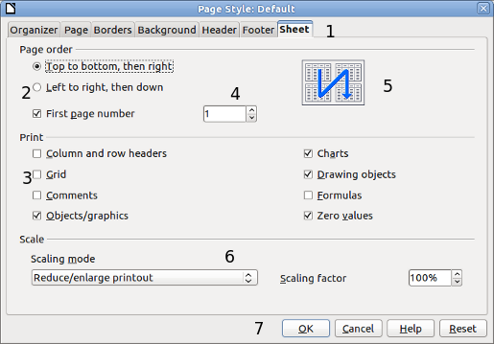
Figure 1: Dialog showing common controls:
1 = Tabbed page (not strictly speaking a control)
2 = Radio buttons (only one can be selected at a time)
3 = Checkbox (more than one can be selected at a time)
4 = Spin box (click the up and down arrows to change the number shown in the text box next to it, or type in the text box)
5 = Thumbnail or preview
6 = Drop-down list from which to select an item
7 = Push buttons

Using Apache OpenOffice on macOS
Some keystrokes and menu items are different on macOS from those used in Windows and Linux. The table below gives some common substitutions for the instructions in this book. For a more detailed list, see the application Help.
Windows or Linux | macOS equivalent | Effect
Tools > Options menu selection | OpenOffice > Preferences | Access setup options
Right-click | Control+click | Open a context menu
Ctrl (Control) | z (Command) | Used with other keys
F11 | z+T | Open the Styles and Formatting window

Chapter 1
Introducing Apache OpenOffice

What Is Apache OpenOffice?
Apache OpenOffice is a freely available, full-featured office productivity suite. Its native file format is OpenDocument, an open standard format that is supported by several office suites but is not controlled by any one company and has been adopted by some governments (e.g., the United Kingdom) as a required file format for publishing and accepting documents. Apache OpenOffice can also open and save documents in many other formats, including those used by various versions of Microsoft Office.
Apache OpenOffice includes the following components.

Writer (word processor)
Writer is a feature-rich tool for creating letters, books, reports, newsletters, brochures, and other documents. You can insert graphics and objects from other components into Writer documents. Writer can export files to several versions of Microsoft Word files, Adobe’s Portable Document Format (PDF), HTML and other formats.

Calc (spreadsheet)
Calc has all the advanced analysis, charting, and decision-making features expected from a high-end spreadsheet. It includes over 300 functions for financial, statistical, and mathematical operations, among others. The Scenario Manager provides “what if” analysis. Calc generates 2-D and 3-D charts, which can be integrated into other Apache OpenOffice documents. You can also open and work with Microsoft Excel workbooks and save them in some Excel formats. Calc can also export spreadsheets to PDF and HTML.

Impress (presentations)
Impress provides all the common multimedia presentation tools, such as special effects, animation, and drawing tools. It is integrated with the advanced graphics capabilities of Apache OpenOffice’s Draw and Math components. Slide shows can be further enhanced with Fontwork’s special effects text, as well as sound and video clips. Impress is compatible with Microsoft’s PowerPoint file format and can also save your work in numerous graphics formats.

Draw (vector graphics)
Draw is a vector drawing tool that can produce everything from simple diagrams or flowcharts to 3-D artwork. Its Smart Connectors feature allows you to define your own connection points. You can use Draw to create drawings for use in any of Apache OpenOffice’s other components, and you can create your own clip art and add it to the Gallery. Draw can import graphics from many common formats and save them in over 20 formats, including PNG, HTML, and PDF.

Base (database)
Base provides tools for day-to-day database work within a simple interface. It can create and edit forms, reports, queries, tables, views, and relations, so that managing a connected database is much the same as in other popular database applications. Base provides many features, such as the ability to analyze and edit relationships from a diagram view. In its default configuration, Base uses HSQLDB, which is included in Apache OpenOffice, as its database engine and stores the database tables in the Base document. It can also use dBASE, Microsoft Access, MySQL, Oracle, or any ODBC compliant or JDBC compliant database engine and connect to external tables.

Math (formula editor)
Math is Apache OpenOffice’s formula or equation editor. You can use it to create complex equations that include symbols or characters not available in standard font sets. While it is most commonly used to create formulas in other documents, such as Writer and Impress files, Math can also work as a standalone tool. You can save formulas in the standard Mathematical Markup Language (MathML) format for inclusion in web pages and other documents not created by Apache OpenOffice.

Advantages of Apache OpenOffice
Here are some of the advantages of Apache OpenOffice over proprietary office suites:
- No licensing fees. Apache OpenOffice is free for anyone to use and distribute at no cost. There are no hidden charges now or in the future.
- Open source. You can distribute, copy, and modify the software as much as you wish, in accordance with the Apache 2 license.
- Cross-platform. Apache OpenOffice runs on several hardware architectures and under multiple operating systems, such as Microsoft Windows, macOS, and Linux.
- Extensive language support. The user interface for Apache OpenOffice is available in several languages, along with spelling, hyphenation, and thesaurus dictionaries. It supports bidirectional text and complex text layout for many scripts.
- Consistent user interface. All the components have a similar “look and feel,” making them easy to use and master.
- Integration. The components of Apache OpenOffice are well integrated with one another.
  - All the components share a common spelling checker and other tools, which are used consistently across the suite. For example, the drawing tools available in Writer are also found in Calc, with similar but enhanced versions in Impress and Draw.
  - You do not need to know which application was used to create a particular file. For example, you can open a Draw file from Writer; it will open automatically in Draw.
- Granularity. Usually, if you change an option, it affects all components. However, Apache OpenOffice options can be set at a component level or even document level.
- File compatibility. In addition to its native OpenDocument formats, Apache OpenOffice includes support for opening and saving files in many common formats including Microsoft Office (does not include saving in the newer formats DOCX, XLSX for example), HTML, XML and PDF (export only).
- No vendor lock-in. Apache OpenOffice uses OpenDocument, an XML (eXtensible Markup Language) file format developed as an industry standard by OASIS (Organization for the Advancement of Structured Information Standards). These files can easily be unzipped and read by any text editor, and their framework is open and published.
- You have a voice. Enhancements, software fixes, and release dates are community-driven. You can join the community and affect the course of the product you use.

Minimum Requirements
Apache OpenOffice 4.1 requires one of the following operating systems:
- Microsoft Windows XP, 2003, 2012, Vista, 7, 8, 8.1, 10 or 11
- GNU/Linux Kernel version 2.6 and glibc 2.5 or higher
- macOS 10.7 (Lion) or higher
For more details, see https://www.openoffice.org/dev_docs/source/sys_reqs_aoo41.html
Some features (wizards, some accessibility features, and the HSQLDB database engine) require that a Java Runtime Environment (JRE) be installed on your computer. Although Apache OpenOffice will work without Java support, those features will not be available. The current versions of Apache OpenOffice work reliably with a variety of JREs including Oracle Java, versions 6, 7 and 8, openJDK, versions 6, 7 and 8 and AdoptOpenJDK, versions 8 and 11. You should use the most recent version of whichever JRE you choose for the best security and reliability.
Note | For Microsoft Windows,a 32-bit JRE MUST be installed, even on a 64-bit machine

How to Get and Install the Software
You can download the installation package (approximately 150 MB) from the project’s website, https://www.openoffice.org/download/index.html. The download process automatically redirects to a SourceForge web page which starts the download without the need to take any action on that page.
To install Apache OpenOffice, follow the same procedure that you used to install other software.

Extensions and Add-Ons
Extensions and add-ons that enhance Apache OpenOffice are collected in the official extensions repository, https://extensions.openoffice.org/. Most are free, but some are not. See Chapter 11 (Setting up and Customizing Apache OpenOffice) for more information.

Starting Apache OpenOffice
In general, you start Apache OpenOffice the same way you start any other program on your computer.
On Windows and Linux, entries for Apache OpenOffice and each of its components appear in the system menu of your computer. On macOS, only an entry for Apache OpenOffice is added to the Applications menu. You can make a desktop icon for Apache OpenOffice or a component in the same way you can make a desktop icon for any other program; see your operating system’s help for how to do this.
- Clicking on the Apache OpenOffice menu entry, desktop icon, or tile opens the Apache OpenOffice Start Center (Figure 14 on page 21) from where you can select the individual components. You can also choose to open an existing file or use a template.
- On Windows, you can use the Quickstarter (see below).
- You can double-click on the filename of a document with an OpenDocument extension such as .odt, .ods, .odp in a file manager such as Windows Explorer, Finder on macOS, or Nautilus on Linux. The appropriate component will start, and the document will be loaded.

Note for Windows Users
If you have associated Microsoft Office file types with Apache OpenOffice, then when you double-click on a *.doc (Word) file, it opens in Writer; *.xls (Excel) files open in Calc, and *.ppt (PowerPoint) files open in Impress.
If you did not associate the file types, then when you double-click on a Microsoft Word document, it opens in Microsoft Word (if Word is installed on your computer), Excel files open in Excel, and PowerPoint files open in PowerPoint.
You can search the Windows help for Default Apps to see how to associate each file type with OpenOffice. In addition to associating Microsoft Office file types with OpenOffice, it may also be necessary to reestablish the association between OpenOffice and its native file formats when a Windows update causes Microsoft Office to claim those file types.

Using the Quick-Starter Under Windows
The Quick-starter is an icon that is placed in the Windows system tray during system startup. It indicates that Apache OpenOffice has been loaded and is ready to use. (The Quickstarter shortens the startup time for Apache OpenOffice components by about half.) If the Quickstarter is disabled, see “Reactivating the Quick-Starter” if you want to enable it.

Using the Quick-Starter Icon
Right-click the Quick-starter icon in the system tray to open a pop-up menu (Figure 2) from which you can open a new document, open the Templates and Documents dialog, or choose an existing document to open. You can also double-click the Quickstarter icon to directly open the Templates and Documents dialog.
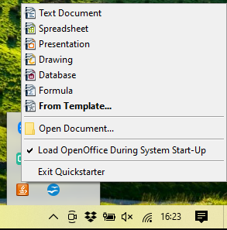Figure 2: Quickstarter pop-up menu

Disabling the Quick-Starter
To close the Quickstarter, right-click on the icon in the system tray, and then click Exit Quickstarter on the pop-up menu. The next time the computer is restarted, the Quick-starter will be loaded again.
To prevent Apache OpenOffice from loading during system startup, deselect the Load OpenOffice during system start-up item on the pop-up menu. You might want to do this if your computer has insufficient memory, for example.

Reactivating the Quick-Starter
If the Quickstarter has been disabled, you can reactivate it by selecting the Load OpenOffice during system start-up checkbox in Tools > Options > OpenOffice > Memory.

Using the Quick-Starter in Linux and macOS
Apache OpenOffice under Linux has a Quick-starter that looks and acts like the one described above for Windows. (The checkbox on the Memory page is labeled Enable systray quickstarter. If you do not have this checkbox, the Quick-starter module is not installed on your system.)
macOS provides similar functionality through a pop-up menu from the dock.

Parts of the Main window
The main window is similar in each component of Apache OpenOffice, although some details vary. See the chapters in this book about Writer, Calc, Draw, and Impress for descriptions of those details.
Common features include the menu bar, the standard toolbar, and the formatting toolbar at the top of the window and the status bar at the bottom.

Figure 3: Elements of the main Writer window
Sidebar`
Standard
Toolbar
Formatting
Toolbar
Status Bar
Menus
Rulers

Menu Bar
The Menu bar is located across the top of the Apache OpenOffice window, just below the Title bar. (On macOS it is at the top of the screen in the same location as the menu bar for other programs.) When you choose one of the menus listed below, a sub-menu drops to show commands.
- File contains commands that apply to the entire document such as Open, Save, and Export as PDF.
- Edit contains commands for editing the document such as Undo: xxx (where xxx is the command to undo) and Find & Replace. It also contains commands to cut, copy, and paste selected parts of your document.
- View contains commands for controlling the display of the document such as Zoom and Web Layout.
- Insert contains commands for inserting elements into your document such as Header, Footer, and Picture.
- Format contains commands, such as Styles and Formatting and AutoCorrect, for formatting the layout of your document.
- Table shows all commands to insert and edit a table in a text document.
- Tools contains functions such as Spelling and Grammar, Customize, and Options.
- Window contains commands for the display window.
- Help contains links to the OpenOffice Help file, What’s This?, and information about the program.

Toolbars
Apache OpenOffice has several types of toolbars: docked, floating, and tear-off. Docked toolbars can be moved to different locations or made to float, and floating toolbars can be docked.
The top docked toolbar is called the Standard toolbar. The Standard toolbar is consistent across the OpenOffice applications.
The second toolbar at the top is the Formatting toolbar. It is a context-sensitive bar that shows the relevant tools in response to the cursor’s current position or selection. For example, when the cursor is on a graphic, the Formatting bar provides tools for formatting graphics; when the cursor is in text, the tools are for formatting text.

Displaying or Hiding Toolbars
To display or hide toolbars, choose View > Toolbars, then click on the name of a toolbar in the list. An active toolbar shows a check mark beside its name. Tear-off toolbars are not listed in the View menu.

Submenus and Tear-Off Toolbars
Toolbar icons with a small triangle to the right will display submenus, tear-off toolbars, and other ways of selecting things, depending on the icon.
Figure 4 shows a tear-off toolbar from the Drawing toolbar.
The tear-off toolbars can be floating or docked along an edge of the screen or in one of the existing toolbar areas. To move a floating tear-off toolbar, drag it by the title bar. See “Moving Toolbars” below.
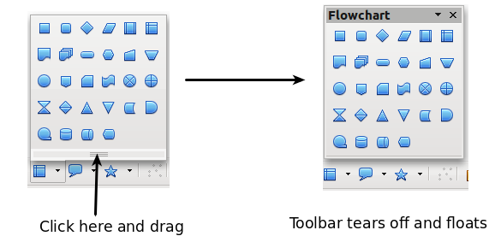
Figure 4: Example of a tear-off toolbar

Floating Toolbars
Apache OpenOffice includes several additional context-sensitive toolbars, whose defaults appear as floating toolbars in response to the cursor’s current position or selection. For example, when the cursor is in a table, a floating Table toolbar appears, and when the cursor is in a numbered or bullet list, the Bullets and Numbering toolbar appears. You can dock these toolbars to the top, bottom, or side of the window, if you wish (see “Moving Toolbars” below).

Moving Toolbars
To move a docked toolbar, place the mouse pointer over the toolbar handle (the small vertical bar to the left of the toolbar), hold down the left mouse button, drag the toolbar to the new location, and then release the mouse button (Figure 5). To move a floating toolbar, click on its title bar and drag it to a new location (Figure 6).
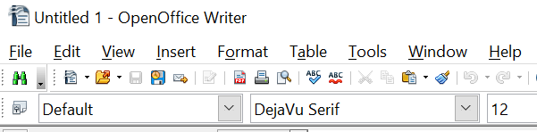

Figure 5: Moving a docked toolbar
Handles of docked toolbars

Figure 6: Moving a floating toolbar

Docking Floating Windows and Toolbars
Toolbars and some windows, such as the Navigator and the Styles and Formatting window, are dock-able. You can move, resize, or dock them to an edge.
To dock a window or toolbar, hold down the Ctrl key and double-click on the frame of the floating window (or in a vacant area near the icons at the top of the floating window) to dock it in its last position.
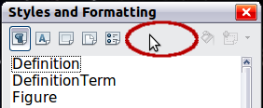Figure 7: Ctrl+click to dock or undock
To undock a window, hold down the Ctrl key and double-click on the frame (or a vacant area near the icons at the top) of the docked window.

Customizing Toolbars
You can customize toolbars in several ways, including choosing which icons are visible and locking the position of a docked toolbar. You can also add icons and create new toolbars, as described in Chapter 11.
To access a toolbar’s customization options, use the down-arrow at the end of the toolbar or on its title bar.

Figure 8: Customizing toolbars
To show or hide icons defined for the selected toolbar, choose Visible Buttons from the drop-down menu. Visible icons are indicated by an outline around the icon. Click on icons to hide or show them on the toolbar.
Figure 9: Selection of visible toolbar icons

Right-Click (context) Menus
You can quickly access many menu functions by right-clicking on a paragraph, graphic, or other object. A context menu will pop up. Often the context menu is the fastest and an easier way to reach a function. If you are not sure where a function is located in the menus or toolbars, you can frequently find it by right-clicking.

Status Bar
The status bar is located at the bottom of the workspace. It provides information about the document and convenient ways to quickly change some features. It is similar in Writer, Calc, Impress, and Draw, although each component includes some component-specific items.

Figure 10: Left end of status bar in Writer
Figure 11: Right end of status bar in Writer
Common status bar items are described below.
Page, sheet, or slide number
Shows the current page, sheet, or slide number and the total number of pages, sheets, or slides in the document. Double-click on this field to open the Navigator. Other uses of this field depend on the component.
Page style or slide design
Shows the current page style or slide design. To edit the current page style or slide design, double-click on this field.
Unsaved changes
An asterisk (*) appears here if changes to the document have not been saved.
Digital signature
If the document has been digitally signed, an icon shows here. You can double-click the icon to view the certificate.
Object information
Displays information relevant to the cursor’s position or the selected element of the document. Double-clicking in this area usually opens a relevant dialog.
Zoom slider and percent
To change the view magnification, drag the Zoom slider, or click on the + and — signs, or right-click on the zoom level percent to pop up a list of magnification values from which to choose. Double-clicking on the zoom level percent opens the Zoom & View Layout dialog.

Sidebar
The Sidebar (Figure 12) is located on the right side of the edit views of Writer, Calc, Impress, and Draw. It contains one or more decks, based on the current document context. Decks are organized into panels. A tab bar on the right side of the sidebar allows you to switch between different decks.
All four components contain the Properties, Styles, Gallery, and Navigator decks. Some components have additional decks, such as Master Pages, Custom Animation, and Slide Transition for Impress and Functions for Calc.
A panel is like a combination of a toolbar and a dialog. For example, you can freely mix working on the text in the main edit window and using the Styles panel in the sidebar to change text attributes.
Toolbars and Sidebar panels share many functions. For example, the buttons for making text bold or italic exist in both the Formatting toolbar and the Properties panel.
If the Sidebar is not visible, you can show it by using View > Sidebar on the menu bar. To hide the Sidebar, click on the gray Hide button on the left. Click on the same button to show the Sidebar again.
To undock the Sidebar and make it floating, and to dock a floating Sidebar, use the Sidebar settings drop-down list at the top of the tab bar (see Figure 12 ). From the same list you can choose which items to show in the Sidebar.


Figure 12: Properties panel of Sidebar in Writer
Settings
Tabs
Tab Title
Panel Title
Panel Contents
Deck
MoreOptions


Figure 13: Floating (undocking) or docking the Sidebar

Starting a New Document
You can start a new, blank document in Apache OpenOffice in several ways.
When Apache OpenOffice is open, but no document is open (for example if you close all the open documents but leave the program running), the Start Center is shown. Click one of the icons to open a new document of that type, or click the Templates icon to start a new document using a template.
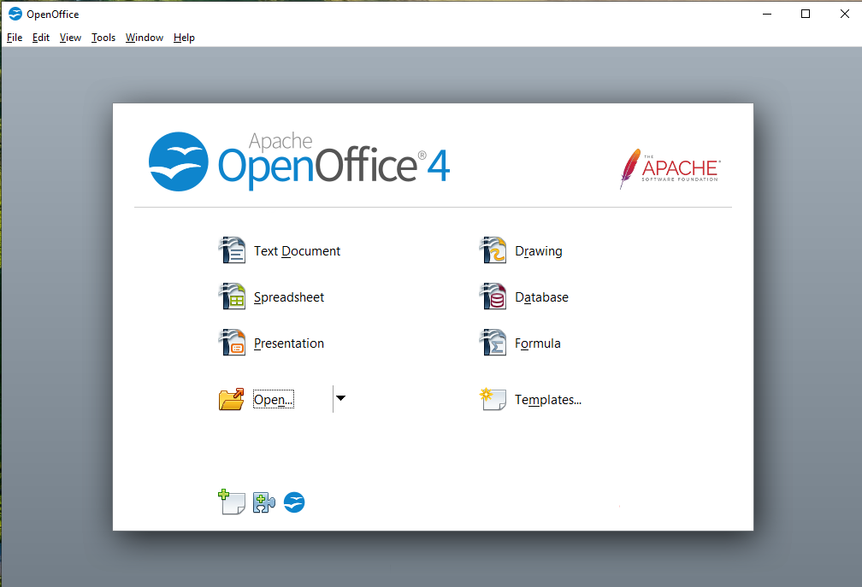 Figure 14: Apache OpenOffice Start Center
You can also start a new document in one of the following ways.
- Use File > New and choose the type of document.
- Use the arrow next to the New button on the main toolbar. From the drop-down menu, select the type of document to be created.
- Press Ctrl+N on the keyboard.
- Use File > Wizards for some special types of documents.
If a document is already open in Apache OpenOffice, the new document opens in a new window.

Opening an Existing Document
When no document is open, the Start Center provides an icon for opening an existing document or choosing from a list of recently-edited documents.
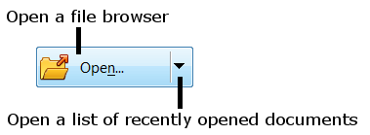
You can also open an existing document in one of the following ways.
- Choose File > Open.
- Click the Open button on the main toolbar.
- Press Ctrl+O on the keyboard.
In each case, the Open dialog appears. Select the file you want, and then click Open. If a document is already open in Apache OpenOffice, the second document opens in a new window.
In the Open dialog, you can reduce the list of files by selecting the type of file you are looking for. For example, if you choose Text documents as the file type, you will only see documents Writer can open (including .odt, .doc, .txt); if you choose Spreadsheets, you will see .ods, .xls, and other files that Calc opens.
You can also open an existing document that is in an OpenDocument format by double-clicking on the file’s icon on the desktop or in a file manager such as Windows Explorer.
If you have associated Microsoft Office file formats with Apache OpenOffice, you can also open these files by double-clicking on them.

Saving a Document
To save a new document, do one of the following:
- Press Ctrl+S.
- Choose File > Save from the menu bar.
- Click the Save button on the main toolbar.
When the Save As dialog appears, enter the file name, verify the file type (if applicable), and click Save.
To save an open document with the current file name, choose File > Save. This will overwrite the last saved state of the file.

Password Protection
To protect an entire document from being viewable without a password, use the option on the Save As dialog to enter a password.
- On the Save As dialog, select the Save with password option, and then click Save. You will receive a prompt (Figure 15).
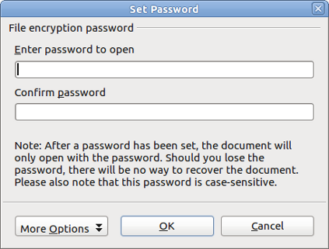
Figure 15: Entering a password for a document
- Type the same password in both fields, and then click OK. If the passwords match, the document is saved password protected. If the passwords do not match, you receive an error message. Close the message box to return to the Set Password dialog and enter the password again.
Caution   | Apache OpenOffice uses a very strong encryption mechanism that makes it almost impossible to recover the contents of a document if you lose the password.
Writer and Calc provide a second level of protection, which allows a file to be viewed but not changed without a password; that is, the file opens in read-only mode.
To protect a document from being changed:
- Choose More Options from the Set Password dialog.
- Enter the password in the Enter password to allow editing field. Repeat the password in the Confirm password field. Click OK.

Saving a Document Automatically
You can choose to have Apache OpenOffice save a temporary version of your file automatically. This temporary version is stored separately from the original file, and it allows AutoRecovery if the program should crash. However, automatic saving does not overwrite the last saved state of the file and does not substitute for periodically saving your work. To set up automatic file saving:
- Choose Tools > Options > Load/Save > General.
- Mark Save AutoRecovery information every, and set the time interval.

Using the Navigator
The Navigator lists objects contained in a document, collected into categories. For example, in Writer it shows Headings, Tables, Text frames, Comments, Graphics, Bookmarks, and other items, as shown in Figure 16. In Calc it shows Sheets, Range Names, Database Ranges, Graphics, Drawing Objects, and other items. In Impress and Draw it shows Slides, Pictures, and other items.
To open the Navigator, click its icon on the sidebar or the Standard toolbar, or press F5, or choose View > Navigator on the menu bar. The Sidebar is often the most convenient location for the Navigator.
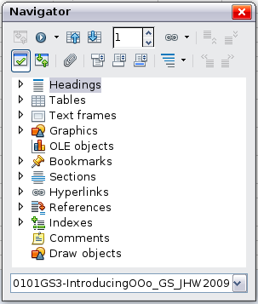
Figure 16: The Navigator
Click the marker (+ or triangle) by any of the categories to display the list of items in that category.
To hide the list of categories and show only the toolbars at the top, click the List Box On/Off icon . Click this icon again to show the list box.
The Navigator provides several convenient ways to move around a document and find items in it:
- When a category is showing the list of objects in it, double-click on an object to jump directly to that object’s location in the document.
- Objects are easier to find if you have given them names when creating them, instead of keeping Apache OpenOffice’s default graphics1, graphics2, Table1, Table2, and so on—which may not correspond to the position of the object in the document.
- If you only want to see the content in a certain category, highlight the category and click the Content View icon . Until you click the icon again, only the objects of that category will be displayed.
- Click the Navigation icon to display the Navigation toolbar (Figure 17). Here you can pick one of the categories and use the Previous and Next icons to move from one item to the next. This is particularly helpful for finding items like bookmarks and indexes, which can be difficult to see.
- The names of the icons (shown in the tooltips) change to match the selected category; for example, Next Graphic or Next Bookmark.
- To jump to a specific page in the document, type its page number in the box at the top of the Navigator.
A bit of experimentation with the other icons will demonstrate their functions. Some component-specific uses are described in the chapters on Writer and the other components.
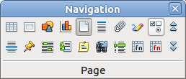
Figure 17: Navigation toolbar

Using the Open and Save As Dialogs
You can choose whether to use the OpenOffice Open and Save As dialogs or the ones provided by your operating system.
To view or change which type of dialog OpenOffice uses:
- Choose Tools > Options > OpenOffice > General.
- Select the Use OpenOffice dialogs option.
This section discusses the OpenOffice Open and Save As dialogs. Figure 18 shows the Save As dialog; the Open dialog is similar.
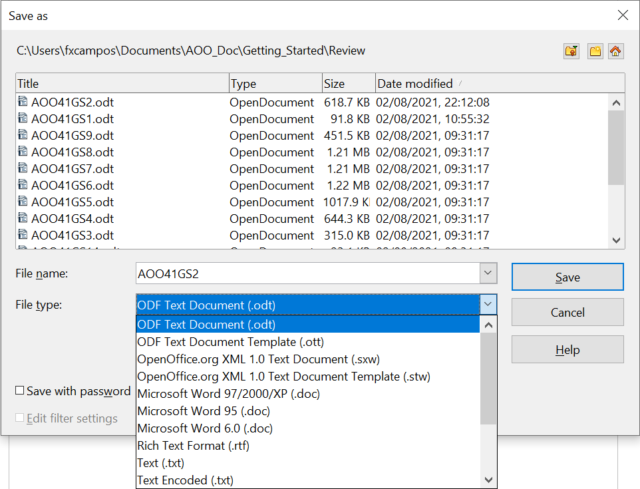

Figure 18: The OpenOffice Save As dialog
The three buttons in the top right of the OpenOffice Open and Save As dialogs are, from left to right:
- Go Up One Level in the folder (directory) hierarchy. Click and hold this button for a second to open a list of higher level folders; to go to one of the folders on the list, move the mouse pointer over its name and release the mouse button.
- Create New Folder.
- Default Directory.
For documents (in OpenDocument format) that have been saved with more than one version, use the Version drop-down to select which version you wish to open in read-only mode. For Microsoft Office documents, only the current version can be opened.
Use the File type field to specify the type of file to be opened or the format of the file to be saved.
The Read-only option on the Open dialog opens the file for reading and printing only. Consequently, most of the toolbars disappear, and most menu options are disabled. An Edit File button is displayed on the Standard toolbar to open the file for editing.
You can open files from the Web by typing a URL in the File name field on the Open dialog.

Undoing and Redoing Changes
To undo the most recent change, press Ctrl+Z, or click the Undo icon on the Standard toolbar, or choose Edit > Undo from the menu bar.
The Edit menu shows the latest change that can be undone (see below for an example from Writer).
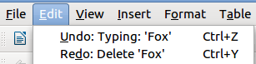
Figure 19: Edit > Undo last action
Click the small triangle to the right of the Undo icon to get a list of all the changes that can be undone. You can select multiple changes and undo them at the same time.
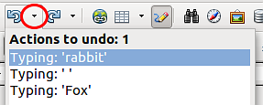
Figure 20: List of actions that can be undone
After changes have been undone, Redo becomes active. To redo a change, select Edit > Redo, or press Ctrl+Y or click on the Redo icon. As with Undo, click on the triangle to the right of the arrow to get a list of the changes that can be reapplied.
To modify the number of changes Apache OpenOffice remembers, choose Tools > Options > OpenOffice > Memory and in the Undo section change Number of steps. Be aware that asking Apache OpenOffice to remember more changes consumes more computer memory.

Reloading a Document
Reloading is useful in two situations.
- You may want to discard all the changes made in an editing session after the last document save.
- You may have made some formatting changes that do not show until the document has been closed and reopened; reloading has the same result.
To reload a document, go to File > Reload on the Menu bar. If you have made changes to a file since the last save, a confirmation dialog will warn you that reloading will discard your last changes. Choose whether to save or discard the changes.
On reloading the document, the File dialog does not open, because the file is already selected.

Closing a Document
To close a document, choose File > Close.
You can also close a document by clicking on the Close icon on the document window. This button may look like the X shown in Figure 21. It may be in a different location on your operating system.

Figure 21. Close icons
In Windows and Linux, if more than one OpenOffice window is open, each window looks like the sample shown on the left in Figure 21. Closing this window leaves the other OpenOffice windows open.
If only one OpenOffice window is open, it looks like the sample shown on the right in Figure 21. Notice the small X below the large X. Clicking the small X closes the document but leaves OpenOffice open. Clicking the large X closes Apache OpenOffice completely.
If the document has not been saved since the last change, a message box is displayed. Choose whether to save or discard your changes.
- Save: The document is saved and then closed.
- Discard: The document is closed, and all modifications since the last save are lost.
- Cancel: Nothing happens, and you return to the document.
Caution | Not saving your document could result in the loss of recently made changes, or worse still, your entire file.

Closing Apache OpenOffice
To close Apache OpenOffice completely, choose File > Exit, or close the last open document as described in “Closing a Document” above.
If all the documents have been saved, Apache OpenOffice closes immediately. If any documents have been modified but not saved, a warning message appears. Follow the procedure in “Closing a Document” to save or discard your changes.

Chapter 2
Using Styles and Templates

What Is a Template?
A template is a model document that you use to create other documents. For example, you can create a template for business reports that has your company’s logo on the first page and has the fonts, paragraph layout, footer content and any other details needed to meet corporate requirements. New documents created from this template will have a consistent and compliant appearance automatically.
Templates can contain anything that regular documents can contain, such as text, graphics, a set of styles, and user-specific setup information such as measurement units, language, the default printer, and toolbar and menu customization.
All documents in Apache OpenOffice are based on templates. You can create, or download and install, as many templates as you wish, and you can specify a template as the default for each type of document (text, spreadsheet, drawing, presentation). If you do not choose a template when you start a new document, then the new document is based on the default template for that type of document. If you have not specified a default template, Apache OpenOffice uses the blank template for that type of document that is installed with Apache OpenOffice. See “Setting a Default Template” on page 43 for more information.

What Are Styles?
A style is a set of formats that you can apply to selected elements such as pages, paragraphs, characters, frames, cells, and other elements in a document to quickly set or change their appearance. When you apply a style, you apply a whole group of formats at the same time.
Many people manually format paragraphs, words, tables, page layouts, and other parts of their documents without paying any attention to styles. For example, they might specify the font family, font size, and any formatting such as bold or italic.
Using styles means that instead of applying “font size 14pt, Times New Roman, bold, centered”, you can apply (for example) a “Title” style, if you have defined the “Title” style to have those characteristics. In other words, using styles means that you shift the emphasis from what the text (or page, or other element) looks like, to what the text is.

Using Styles Is Highly Recommended
Apache OpenOffice is a styles-based program. Using styles effectively requires some planning, but the time spent in planning can save time and effort over the longer term.
Because styles apply whole groups of formats at the same time, you can easily format a document consistently and change the formatting of an entire document with minimal effort. For example, the font family, size, and color of the headings in this document are set with a style. If you want to change those characteristics, editing the style takes a few seconds. If those headings had been formatted manually, changing them would require selecting every heading and applying the new settings. In addition, styles are used by Apache OpenOffice for many processes, even if you are not aware of them. For example, Writer relies on heading styles (or other styles you specify) when it compiles a table of contents. Some common examples of style use are given in “Examples of Style Use” on page 45.

Type of Styles in Apache OpenOffice
Apache OpenOffice supports the following types of styles:
- Page styles include margins, headers and footers, borders and backgrounds. In Calc, page styles also include the sequence for printing sheets.
- Paragraph styles control all aspects of a paragraph’s appearance, such as text alignment, tab stops, line spacing, and borders, and can include character formatting.
- Character styles affect selected text within a paragraph, such as the font and size of text, or bold and italic formats.
- Frame styles are used to format graphic and text frames, including wrapping type, borders, backgrounds, and columns.
- Numbering styles apply similar alignment, numbering or bullet characters, and fonts to numbered or bulleted lists.
- Cell styles include fonts, alignment, borders, background, number formats (for example, currency, date, number), and cell protection.
- Graphics styles in drawings and presentations include line, area, shadowing, transparency, font, connectors, dimensioning, and other attributes.
- Presentation styles include attributes for font, indents, spacing, alignment, and tabs.
Different styles are available in the various components of Apache OpenOffice, as listed in Table 1.
Apache OpenOffice comes with many predefined styles. You can use the styles as provided, modify them, or create new styles, as described in this chapter.
Table 1. Styles available in Apache OpenOffice components
Style Type | Writer | Calc | Draw | Impress
Page | X | X
Paragraph | X
Character | X
Frame | X
Numbering | X
Cell |  | X
Presentation |  |  | X | X
Graphics | (included in Frame styles) |  | X | X

Applying Styles
Apache OpenOffice provides several ways for you to apply styles:
- Styles and Formatting deck in the Sidebar
- Fill Format Mode
- Apply Style list on the Formatting toolbar (Writer)
- Keyboard shortcuts

Using the Styles Deck in the Sidebar
- You can open the Styles and Formatting deck on the Sidebar in several ways: click the icon on the Sidebar, or choose Format > Styles and Formatting from the Menu bar, or press F11, or click the Styles and Formatting icon located at the left-hand end of the Formatting toolbar. Some of these methods will bring up the Styles and Formatting deck as a floating toolbar even if the sidebar is docked.
The Styles and Formatting deck shows the types of styles available for the Apache OpenOffice component you are using. Figure 22 shows the window for Writer, with Page Styles visible.
- Click on one of the icons at the top left of the Styles and Formatting deck to display a list of styles in that category.
- To apply an existing style (except for character styles), position the insertion point in the paragraph, frame, or page, and then double-click on the name of the style in one of these lists. To apply a character style, select the characters first.
Tip | At the bottom of the Styles and Formatting deck is a dropdown list. In Figure 22 the deck shows Automatic, meaning the list includes only styles applied automatically by Apache OpenOffice. You can choose to show all styles or other groups of styles, for example only custom styles.

Figure 22: The Styles and Formatting window for Writer, showing paragraph styles

Using Fill Format Mode
Use Fill Format to apply a style to many areas quickly without having to go back to the Styles and Formatting deck and double-click every time. This method is quite useful when you need to format many scattered paragraphs, cells, or other items with the same style.
- Open the Styles and Formatting deck and select the style you want to apply.
- Click the Fill Format mode icon . The cursor shape will change to resemble the icon.
To apply a paragraph, page, or frame style, hover the mouse over the paragraph, page, or frame and click.
To apply a character style, hold down the mouse button while selecting the characters. Clicking on a word applies the character style to that word.
- Repeat step 2 until you made all the changes for that style.
- To quit Fill Format mode, click the Fill Format mode icon again or press the Esc key.

Using the Apply Style List in Writer
In Writer, after you have used a style at least once in a document, the style name appears on the Apply Style list at the left-hand end of the Formatting toolbar, next to the Styles and Formatting icon.
You can open this list and click once on the style you want, or you can use the up and down arrow keys to move through the list and then press Enter to apply the highlighted style.
Tip | Select More… at the bottom of the list to open the Styles and Formatting window.
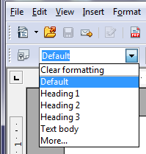
Figure 23: The Apply Style list on the Formatting toolbar

Using Keyboard Shortcuts
Some keyboard shortcuts for applying styles are predefined. For example, in Writer Ctrl+0 applies the Text body style, Ctrl+1 applies the Heading 1 style, and Ctrl+2 applies the Heading 2 style. You can modify these shortcuts and create your own; see Chapter 11 (Setting up and Customizing Apache OpenOffice) for instructions.

Modifying Styles
Apache OpenOffice provides several ways to modify styles (both the predefined styles and custom styles that you create):
- Change a style using the Style dialog
- Update a style from a selection
- Use AutoUpdate (paragraph and frame styles only)
- Load or copy styles from another document or template
Tip | Any changes you make to a style are effective only in the current document. To change styles in more than one document, you need to change the template or copy the styles into the other documents as described on page 36.

Changing a Style Using the Style Dialog
To change an existing style using the Style dialog, right-click on the required style in the Styles and Formatting deck and select Modify from the pop-up menu. In Writer, you can also right-click in a paragraph and choose Edit Paragraph Style from the context menu.
The Style dialog displayed depends on the type of style selected. Each style dialog has several tabs. For example, in Writer the Paragraph Style dialog includes tabs for Indents & Spacing, Font, Borders, Background, Outline & Numbering, and others.

Updating a Style from a Selection
To update a style from a selection:
- Open the Styles and Formatting deck in the Sidebar.
- In the document, select an item that has the format you want to adopt as a style.
Caution | Make sure that there are unique properties in this paragraph. For example, if there are two different font sizes or font styles, that particular property will remain the same as before.
- In the Styles and Formatting deck, select the style you want to update (single-click, not double-click), then click on the arrow next to the New Style from Selection icon and click on Update Style.

Figure 24: Updating a style from a selection

Using AutoUpdate (Writer)
AutoUpdate applies to paragraph and frame styles only. If the AutoUpdate option is selected on the Organizer page of the Paragraph Style or Frame Style dialog, applying direct formatting to a paragraph or frame using this style in your document automatically updates the style itself.
Tip | If you are in the habit of manually overriding styles in your document, be sure that AutoUpdate is not enabled.

Updating Styles from a Document or Template
You can update styles by copying or loading them from a template or another document. See “Copying and Moving Styles” on page 36.

Creating New (Custom) Styles
You may want to add some new styles. You can do this in two ways:
- Using the Style dialog
- From a selection

Creating a New Style Using the Style Dialog
To create a new style using the Style dialog, open the Sidebar Styles and Formatting deck and select the category of the style you wish to create by clicking one of the icons at the top of the deck. Then right-click and select New from the pop-up menu. If you want the new style to be linked with an existing style, first select that style and then right-click and select New.
If you link styles, the new style will inherit characteristics from the style that you selected. If you later change the base style (for example, by changing the font from Times to Helvetica), all the linked styles will change as well. Sometimes this is exactly what you want; other times you do not want the changes to apply to all the linked styles. It pays to plan ahead.
The dialog and choices are the same for defining new styles and for modifying existing styles.

Creating a New Style from a Selection
You can create a new style by copying an existing manual format. This new style applies only to this document; it will not be saved in the template.
- Open the Styles and Formatting window and choose the type of style you want to create.
- In the document, select the item you want to save as a style.
- In the Styles and Formatting window, click on the New Style from Selection icon.
- In the Create Style dialog, type a name for the new style. The list shows the names of existing custom styles of the selected type. Click OK to save the new style.

Figure 25: Naming a new style created from a selection

Dragging and Dropping to Create a Style (Writer and Calc)
You can drag and drop a text selection into the Styles and Formatting deck to create a new style.
Writer
Select some text and drag it to the Styles and Formatting window. If Paragraph Styles are active, the paragraph style will be added to the list. If Character Styles are active, the character style will be added to the list.
Calc
Drag a cell selection to the Styles and Formatting deck to create cell styles.

Copying and Moving Styles
You can copy or move styles from one template or document into another template or document, in two ways:
- Using the Template Management dialog
- Loading styles from a template or document

Using the Template Management Dialog
To copy or move styles using the Template Management dialog:
- Click File > Templates > Organize.
- In the Template Management dialog (Figure 26), set the lists at the bottom to either Templates or Documents, as needed. The default is Templates on the left and Documents on the right.
Tip | To copy styles from a file that is not open, click the File button. When you return to this dialog, both lists show the selected file and all the currently open documents.

Figure 26: Choosing to copy styles from a document, not a template
- Open the folders and find the templates from and to which you want to copy. Double-click on the name of the template or document, and then double-click the Styles icon to show the list of individual styles (Figure 27).
- To copy a style, hold down the Ctrl key and drag the name of the style from one list to the other.
Caution | If you do not hold down the Ctrl key when dragging, the style will be moved from one list to the other. The style will be deleted from the list you are dragging it from.
- Repeat for each style you want to copy. If the receiving template or document has many styles, you may not see any change unless you scroll down in the list. When you are finished, click Close.
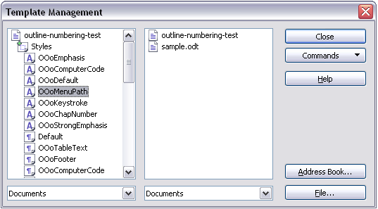
Figure 27: Copying a style from one document to another

Loading Styles from a Template or Document
You can copy styles by loading them from a template or another document:
- Open the document you want to copy styles into.
- In the Styles and Formatting deck, click on the arrow next to the New Style from Selection icon, and then click on Load Styles (see Figure 24).
- On the Load Styles dialog (Figure 28), find and select the template you want to copy styles from.

Figure 28. Copying styles from a template into the open document
- Select the categories of styles to be copied. Select Overwrite if you want the styles being copied to replace any styles of the same names in the document you are copying them into.
- Click OK to copy the styles. You will not see any change on screen.
Note | To copy the styles from another document, click the From File button to open a window from which you can select the required document.

Deleting Styles
You cannot remove (delete) any of Apache OpenOffice’s predefined styles from a document or template, even if they are not in use.
You can remove any user-defined (custom) styles; but before you do, you should make sure the styles are not in use. If an unwanted style is in use, you will want to replace it with a substitute style.
To delete unwanted styles, right-click on them (one at a time) in the Styles and Formatting window and click Delete on the pop-up menu.
If the style is in use, you receive a warning message.
If the style is not in use, you receive a confirmation message; click Yes.

Using a Template to Create a Document
To use a template to create a document:
- From the main menu, choose File > New > Templates and Documents. The Templates and Documents dialog (Figure 29) opens.
- In the box on the left, click the Templates icon if it is not already selected. A list of template folders appears in the center box.
- Double-click the folder that contains the template that you want to use. A list of all the templates contained in that folder appears in the center box.
- Select the template that you want to use. You can preview the selected template or view the template’s properties using the icons just below the title bar and slightly to the right of center:
  - To preview the template, click the Preview icon . A preview of the template appears in the box on the right.
  - To view the template’s properties, click the Document Properties icon . The template’s properties appear in the box on the right.
- Click Open. The Templates and Documents dialog closes and a new document based on the selected template opens in Apache OpenOffice.
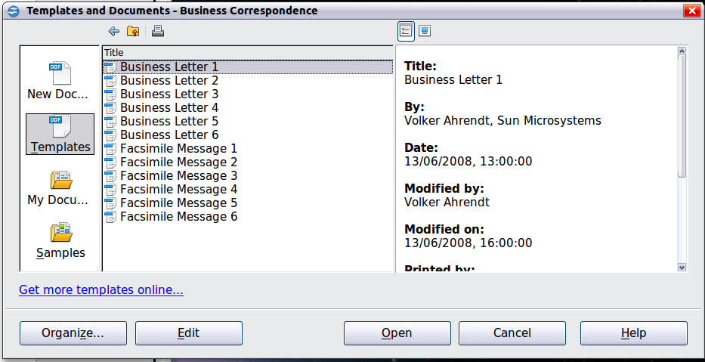
Figure 29: Templates and Documents window

Creating a Template
You can create your own templates in two ways: from a document or (in Writer) by using a wizard.

Creating a Template from a Document
In addition to formatting, any settings that can be added to or modified in a document can be saved in a template. For example, below are some settings (although not a full list) that can be included in a Writer document and then saved as a template for later use:
- Printer settings: which printer, single sided / double-sided, and paper size, and so on
- Styles to be used, including character, page, frame, numbering, and paragraph styles
- Format and settings regarding indexes, tables, bibliographies, table of contents
Templates can also contain predefined text, saving you from having to type it every time you create a new document. For example, a letter template may contain your name, address, and salutation.
You can also save menu and toolbar customizations in templates; see Chapter 11 (Setting Up and Customizing Apache OpenOffice) for more information.
To create a template from a document:
- Open a new or existing document of the type you want to make into a template (text document, spreadsheet, drawing, presentation).
- Add the content and styles that you want.
- From the main menu, choose File > Templates > Save. The Templates dialog opens (see Figure 30).
- In the New template field, type a name for the new template.
- In the Categories list, click the category to which you want to assign the template. The category you choose has no effect on the template itself; it is simply the folder in which you save the template.
- Selecting an appropriate category makes it easier to find the template when you want to use it. For example, you might save Impress templates under the Presentations category.
- To learn more about template folders, see “Organizing Templates” on page 44.
- Click OK to save the new template.
Figure 30: Saving a new template

Creating a Template Using a Wizard
In Writer, you can use wizards to create templates for letters, faxes, agendas, presentations, and Web pages.
For example, the Letter Wizard guides you through the following choices:
- Type of letter (business, formal personal or personal)
- Document elements like the return address, subject line (business letter), salutation, and complimentary close
- Options for sender and recipient information (business letter)
- Text to include in the footer (business letter)
To create a template using a wizard:
- From the main menu, choose File > Wizards > [type of template required] (see Figure 31).
- Follow the instructions on the pages of the wizard. This process is slightly different for each type of template, but the format is very similar.
- In the last section of the wizard, you can specify the name and location for saving the template. The default location is your user templates directory, but you can choose a different location if you prefer.
- Finally, you have the option of creating a new document from your template immediately, or manually changing the template. For future documents, you can re-use the template created by the wizard, just as you would use any other template.

Figure 31. Creating a template using a wizard

Adding Templates Using the Extension Manager
The Extension Manager provides an easy way to install collections of templates, graphics, macros, or other add-ins that have been “packaged” into files with a .OXT extension. See Chapter 11 (Setting up and Customizing Apache OpenOffice) for more about the Extension Manager.
This Web page lists many of the available extensions: https://extensions.openoffice.org/. Others may be available from third-party websites.
To install an extension, follow these steps:
- Download an extension package and save it anywhere on your computer.
- In Apache OpenOffice, select Tools > Extension Manager from the menu bar. In the Extension Manager dialog, click Add.
- A file browser window opens. Find and select the package of templates you want to install and click Open. The package begins installing. You may be asked to accept a license agreement.
- When the package installation is complete, the templates are available for use through File > New > Templates and Documents and the extension is listed in the Extension Manager.
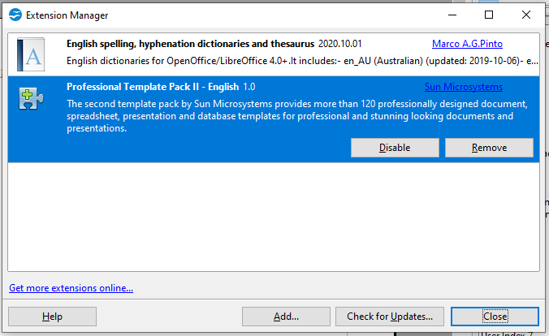
Figure 32: Newly-added package of templates

Editing a Template
You can edit a template’s styles and content, and then, if you wish, you can reapply the template’s styles to documents that were created from that template. You cannot reapply content.
To edit a template:
- From the main menu, choose File > Templates > Edit. A file browser window opens.
- Select the template that you want to edit and click Open.
- Edit the template as you would edit any other document. To save your changes, choose File > Save from the main menu.

Updating a Document from a Changed Template
The next time you open a document that was created from the changed template, a confirmation message appears.
Click Update Styles to apply the template’s changed styles to the document, or click Keep Old Styles if you do not want to apply the changed styles to the document.
Caution | If you choose Keep Old Styles, the document is no longer connected to the template, even though the template is still listed under File > Properties > General. To connect the document to the template again, use the procedure described in “Changing the Template Assigned to a Document” below.

Changing the Template Assigned to a Document
You can change the template assigned to a document, or reconnect a document to a template, in two ways: manually or using the Template Changer extension to OpenOffice.
To change or reassign a template manually, first create a new, blank document from the required template, as described on page 38. Then copy the contents of the old document into the new document.
To use the Template Changer extension, first you need to download and install it, then restart OpenOffice to activate it. After that, you can open the document and use File > Templates > Change Template (current document) from the main menu.
The Template Changer extension works with Writer, Calc, Draw, and Impress.

Setting a Default Template
If you create a document by choosing File > New > Text Document (or Spreadsheet, Presentation, or Drawing) from the main menu, Apache OpenOffice creates the document from the Default template for that type of document. You can, however, set a custom template to be the default. You can reset the default later if you decide.

Setting a Template as the Default
You can set any template to be the default, as long as it is in one of the folders displayed in the Template Management dialog.
To set a custom template as the default:
- From the main menu, choose File > Templates > Organize. The Template Management dialog opens.
- In the box on the left, select the folder containing the template that you want to set as the default, then select the template.
- Click the Commands button and choose Set As Default Template from the drop-down menu.
The next time that you create a document by choosing File > New, the document will be created from this template.
Although many important settings can be changed in the Options dialog (see Chapter 11), for example default fonts and page size, more advanced settings (such as page margins) can only be changed by replacing the default template with a new one.

Resetting the Default Template
To re-enable Apache OpenOffice’s Default template for a document type as the default:
- In the Template Management dialog, click any folder in the box on the left.
- Click the Commands button and choose Reset Default Template from the drop-down menu.
The next time that you create a document by choosing File > New, the document will be created from Apache OpenOffice’s Default template for that document type.

Organizing Templates
Apache OpenOffice can only use templates that are in Apache OpenOffice template folders. You can create new Apache OpenOffice template folders and use them to organize your templates. For example, you might have one template folder for report templates and another for letter templates. You can also import and export templates.
To begin, choose File > Templates > Organize from the main menu. The Template Management dialog opens.
Note | All the actions made by the Commands button in the Template Management dialogue can be made as well by right-clicking on the templates or the folders.

Creating a Template Folder
To create a template folder:
- In the Template Management dialog, click any folder.
- Click the Commands button and choose New from the drop-down menu. A new folder called Untitled appears.
- Type a name for the new folder, and then press Enter. Apache OpenOffice saves the folder with the name that you entered.

Deleting a Template Folder
You cannot delete template folders supplied with Apache OpenOffice or installed using the Extension Manager; you can only delete template folders that you have created.
To delete a template folder that you have created:
- In the Template Management dialog, select the folder that you want to delete.
- Click the Commands button and choose Delete from the drop-down menu. A message box appears and asks you to confirm the deletion. Click Yes.

Moving a Template
To move a template from one template folder to another template folder:
- In the Template Management dialog, double-click the folder that contains the template you want to move. A list of the templates contained in that folder appears underneath the folder name.
- Click the template that you want to move and drag it to the desired folder. If you do not have the authority to delete templates from the source folder, this action copies the template instead of moving it.

Deleting a Template
You cannot delete templates supplied with Apache OpenOffice or installed using the Extension Manager; you can only delete templates that you have created or imported.
To delete a template:
- In the Template Management dialog, double-click the folder that contains the template you want to delete. A list of the templates contained in that folder appears underneath the folder name.
- Click the template that you want to delete.
- Click the Commands button and choose Delete from the drop-down menu. A message box appears and asks you to confirm the deletion. Click Yes.

Importing a Template
If the template that you want to use is in a different location, you must import it into an Apache OpenOffice template folder.
To import a template into a template folder:
- In the Template Management dialog, select the folder into which you want to import the template.
- Click the Commands button and choose Import Template from the drop-down menu. A standard file browser window opens.
- Find and select the template that you want to import and click Open. The file browser window closes and the template appears in the selected folder.
- If you want, type a new name for the template, and then press Enter.

Exporting a Template
To export a template from a template folder to another location:
- In the Template Management dialog, double-click the folder that contains the template you want to export. A list of the templates contained in that folder appears underneath the folder name.
- Click the template that you want to export.
- Click the Commands button and choose Export Template from the drop-down menu. The Save As window opens.
- Find the folder into which you want to export the template and click Save.

Examples of Style Use
The following examples of common use of page and paragraph styles are taken from Writer. There are many other ways to use styles; see the guides for the various components for details.

Defining a Different First Page for a Document
Many documents, such as letters and reports, have a first page that is different from the other pages in the document. For example, the first page of a letter typically has a different header, or the first page of a report might have no header or footer, while the other pages do. With Apache OpenOffice, you can define the page style for the first page and specify the style for the following pages to be applied automatically.
As an example, we can use the First Page and Default page styles that come with Apache OpenOffice. Figure 33 shows what we want to happen: the first page is to be followed by the default page, and all the following pages are to be in the Default page style. Details are in Chapter 4 (Formatting Pages) in the Writer Guide.

Figure 33: Flow of page styles

Dividing a Document into Chapters
Similarly, you can divide a document into chapters. Each chapter might start with the First Page style, with the following pages using the Default page style, as above. At the end of the chapter, insert a manual page break and specify the next page to have the First Page style to start the next chapter, as shown in Figure 34.

Figure 34: Dividing a document into chapters using page styles

Changing Page Orientation Within a Document
A Writer document can contain pages in more than one orientation. A common scenario is to have a landscape page in the middle of a document, where the other pages are in a portrait orientation. This can be done with page breaks and page styles. Position the cursor at the point where you want to start the new (landscape) page. Click Insert > Manual Break on the main menu. In the Insert Break dialog, select Page Break under Type, and select a page style with landscape orientation in the Page Style list. Click OK to insert the page. To go back to the portrait page style, insert another page break and select the portrait page style you are using (which may be Default Page Style, if you haven’t selected or created a different one).

Different Headers on Right and Left Pages
Page styles can be set up to have the facing left and right pages mirrored or only right (first pages of chapters are often defined to be right-page only) or only left. When you insert a header on a page style set up for mirrored pages or right-and-left pages, you can have the contents of the header be the same on all pages or be different on the right and left pages. For example, you can put the page number on the left-hand edge of the left pages and on the right-hand edge of the right pages, put the document title on the right-hand page only, or make other changes.

Controlling Page Breaks Automatically
Writer automatically flows text from one page to the next. If you do not like the default settings, you can change them. For example, you can require a paragraph to start on a new page or column and specify the style of the new page. A typical use is for chapter titles to always start on a new right-hand (odd-numbered) page.

Compiling an Automatic Table of Contents
To compile an automatic table of contents, first apply styles to the headings you want to appear in the contents list, then use Tools > Outline Numbering to tell Writer which styles go with which level in the table of contents. See Chapter 3 for more information.

Defining a Sequence of Styles
You can set up one paragraph style so that when you press Enter at the end of that paragraph, the following paragraph automatically has the style you wish applied to it. For example, you could define a Heading 1 paragraph to be followed by a Text Body paragraph. A more complex example would be: Title followed by Author followed by Abstract followed by Heading 1 followed by Text Body. By setting up these sequences, you can often avoid manually applying styles.

Chapter 3
Getting Started with Writer

What Is Writer?
Writer is the word processor component of Apache OpenOffice. In addition to the usual features of a word processor (spelling check, thesaurus, hyphenation, autocorrect, find and replace, automatic generation of tables of contents and indexes, mail merge and others), Writer provides these important features:
- Templates and styles (see Chapter 2)
- Page layout methods, including frames, columns, and tables
- Embedding or linking of graphics, spreadsheets, and other objects
- Built-in drawing tools
- Master documents—to group a collection of documents into a single document
- Change tracking during revisions
- Database integration, including a bibliography database
- Export to PDF, including bookmarks (see Chapter 9)
- And many more
These features are covered in detail in the Writer Guide.

The Writer Interface
The main Writer workspace is shown in Figure 35. The menus and toolbars are described in Chapter 1 (Introducing Apache OpenOffice).
Some other features of the Writer interface are covered in this chapter.
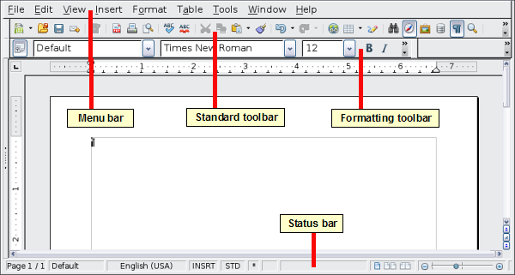
Figure 35: The main Writer workspace in Print Layout view

Status Bar
The Writer status bar provides information about the document and convenient ways to quickly change some document features.
Figure 36: Left end of status bar
Page number
Shows the current page number, the sequence number of the current page (if different), and the total number of pages in the document. For example, if you restarted page numbering at 1 on the third page, its page number is 1 and its sequence number is 3.
If any bookmarks have been defined in the document, a right-click on this field pops up a list of bookmarks; click on the required one.
To jump to a specific page in the document, double-click on this field. The Navigator opens. Click in the Page Number field and type the sequence number of the required page. After a brief delay, the display jumps to the selected page.
Page style
Shows the style of the current page. To change the page style, right-click on this field. A list of page styles pops up; choose a different style by clicking on it.
To edit the current page style, double-click on this field. The Page Style dialog opens.
Language
Shows the language for the selected text.
Click to open a menu where you can choose another language for the selected text or for the paragraph where the cursor is located. You can also select None (Do not check spelling) to exclude the text from a spelling check or select More… to open the Character dialog.
Insert mode
Click to toggle between Insert and Overwrite modes when typing.
Selection mode
Click to toggle between STD (Standard), EXT (Extend), ADD (Add) and BLK (Block) selection. EXT is an alternative to Shift+click when selecting text. See “Working with Text” on page 54 for more information about ADD and BLK.
Unsaved changes
An asterisk (*) appears here if changes to the document have not been saved.
Figure 37: Right end of status bar
Digital signature
If the document has been digitally signed, an icon shows here. You can double-click the icon to view the certificate.
Section or object information
When the cursor is on a section, heading, or list item, or when an object (such as a picture or table) is selected, information about that item appears in this field. Double-clicking in this area opens a relevant dialog. For details, consult the Help or the Writer Guide.
View layout
Click an icon to change between single page, side-by-side, and book layout views. The effect varies with the combination of window width and zoom factor in use. You can edit the document in any view.
Figure 38: View layouts: single, side-by-side, book.
Zoom
To change the view magnification, drag the Zoom slider, or click on the + and — signs, or right-click on the zoom level percent to pop up a list of magnification values from which to choose. Zoom interacts with the selected view layout to determine how many pages are visible in the document window.

Changing Document Views
Writer has several ways to view a document: Print Layout, Web Layout, and Full Screen. To access these and other choices, go to the View menu and click on the required view. (When in Full Screen view, press the Esc key to return to either Print or Web Layout view.)
When in Print Layout, you can use both the Zoom slider and the View Layout icons on the status bar. In Web Layout, you can use the Zoom slider.
You can also choose View > Zoom from the menu bar to display the Zoom & View Layout dialog, where you can set the same options as on the Status bar. In Web Layout view, most of the choices are not available.
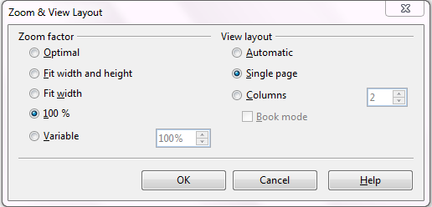
Figure 39: Choosing Zoom and View Layout options.

Moving Quickly through a Document
In addition to the navigation features of the Status bar (described above), you can use the Navigator deck in the Sidebar and the Navigation toolbar as described in Chapter 1 (Introducing Apache OpenOffice).
In Writer, you can also display the Navigation toolbar by clicking on the small Navigation icon near the lower right-hand corner of the window below the vertical scroll bar, as shown in Figure 40.

Figure 40: Navigation icons
The Navigation toolbar (Figure 41) shows icons for all the object types shown in the Navigator, plus some extras (for example, the results of a Find command).
Figure 41: Navigation toolbar
Click an icon to select that object type. Now all the Previous and Next icons (in the Navigator itself, in the Navigation Toolbar, and on the scroll bar) will jump to the next object of the selected type. This is particularly helpful for finding items like index entries, which can be difficult to see in the text. The names of the icons (shown in the tooltips) change to match the selected category; for example, Next Graphic, Next Bookmark, or Continue search forward.
For more uses of the Navigator in Writer, see the Writer Guide.

Working with Documents
Chapter 1 (Introducing Apache OpenOffice) includes instructions on starting new documents, opening existing documents, saving documents, and password-protecting documents. Chapter 2 (Using Styles and Templates) covers how to create a document from a template.

Saving as a Microsoft Word File
If you need to exchange files with users of Microsoft Word who are unwilling or unable to receive *.odt files, you can save a document as a Microsoft Word file.
- Important—First save your document in the file format used by Writer (.odt). If you do not, any changes you made since the last time you saved will appear only in the Microsoft Word version of the document.
- Then choose File > Save As. On the Save As dialog, in the File type (or Save as type) drop-down menu, select the type of Word format you need. Click Save.
Caution | Some formatting may be lost when you save in formats other than OpenDocument Formats. You may wish to test some typical files to see if yours save correctly in other formats.
Figure 42. Saving a file in Microsoft Word format
From this point on, all changes you make to the document will occur only in the Microsoft Word document. You have changed the name and file type of your document. If you want to go back to working with the .odt version of your document, you must open it again.
Tip | To have Apache OpenOffice save documents by default in the Microsoft Word file format, go to Tools > Options > Load/Save. See “Choosing options for loading and saving documents” in Chapter 11 (Setting Up and Customizing Apache OpenOffice).

Working with Text
Working with text (selecting, copying, pasting, moving) in Writer is similar to working with text in any other program. Apache OpenOffice also has some convenient ways to select items that are not next to each other, select a vertical block of text, and paste unformatted text.

Selecting Items That Are Not Consecutive
To select nonconsecutive items (as shown in Figure 43) using the mouse:
- Select the first piece of text.
- Hold down the Ctrl key and use the mouse to select the next piece of text.
- Repeat as often as needed.
Now you can work with the selected text (copy it, delete it, change the style, or whatever).
Note | Macintosh users: substitute the Command key when instructions in this chapter say to use the Ctrl key.

Figure 43: Selecting items that are not next to each other
To select nonconsecutive items using the keyboard:
- Select the first piece of text. (For more information about keyboard selection of text, see the topic “Navigating and selecting with the keyboard” in the Help.)
- Press Shift+F8. This puts Writer in “Add” mode. The word ADD appears on the status bar.
- Use the arrow keys to move to the start of the next piece of text to be selected. Hold down the Shift key and select the next piece of text.
- Repeat as often as needed.
Now you can work with the selected text. Press Esc to exit from this mode.

Selecting a Vertical Block of Text
You can select a vertical block or “column” of text that is separated by spaces or tabs (as you might see in text pasted from e-mails, program listings, or other sources), using Writer’s block selection mode. To change to block selection mode, use Edit > Selection Mode > Block Area, or click several times in the status bar on STD until it changes to BLK.
Now highlight the selection, using the mouse or keyboard, as shown below.

Figure 44: Selecting a vertical block of text

Cutting, Copying, and Pasting Text
Cutting and copying text in Writer is similar to cutting and copying text in other applications. You can use the mouse or the keyboard for these operations. You can copy or move text within a document, or between documents, by dragging or by using menu selections, icons, or keyboard shortcuts. Likewise, you can also copy text from other sources such as Web pages and paste it into a Writer document.
To move (cut and paste) selected text using the mouse, drag it to the new location and release it. To copy selected text, hold down the Ctrl key while dragging. The text retains the formatting it had before dragging.
When you paste text, the result depends on the source of the text and how you paste it. If you click on the Paste icon, any formatting the text has (such as bold or italics) is retained. Text pasted from Websites and other sources may also be placed into frames or tables. If you do not like the results, click the Undo icon or press Ctrl+Z.
To make the pasted text take on the formatting of the surrounding text where it is being pasted:
- Choose Edit > Paste Special, or
- Click the triangle to the right of the Paste icon, or
- Click the Paste icon without releasing the left mouse button.
Then select Unformatted text from the resulting menu.
The range of choices on the Paste Special menu varies depending on the origin and formatting of the text (or other object) to be pasted. See Figure 45 for an example with text on the clipboard.
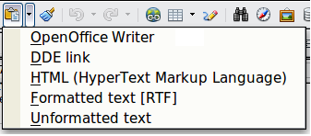Figure 45: Paste Special menu

Finding and Replacing Text and Formatting
Writer has two ways to find text within a document: the Find toolbar for fast searching and the Find & Replace dialog. In the dialog, you can:
- Find and replace words and phrases
- Use wildcards and regular expressions to fine-tune a search
- Find and replace specific formatting
- Find and replace paragraph styles


Using the Find Toolbar
If the Find toolbar is not visible, you can display it using View > Toolbars > Find.
To use the Find toolbar, click in the box and type your search text, then press Enter to find the next occurrence of that term. Click the Find Next or Find Previous buttons (up and down arrows) as needed.

Using the Find & Replace dialog
To display the Find & Replace dialog, use the keyboard shortcut Ctrl+F or choose Edit > Find & Replace from the menu bar. Optionally, click the More Options button to expand the dialog; the button changes to Fewer Options.

Figure 46: Expanded Find & Replace dialog
To use the Find & Replace dialog:
- Type the text you want to find in the Search for box.
- To replace the text with different text, type the new text in the Replace with box.
- You can select various options such as matching the case, matching whole words only, or doing a search for similar words.
- When you have set up your search, click Find. To replace text, click Replace instead.
Apache OpenOffice uses Regular Expression to perform wildcard searches. This is a powerful tool that can do complex text matching. See the Help for a brief introduction and there are many web resources that provide in depth tutorials.
For more information on using Find & Replace, see the Writer Guide.
Tip | If you click Find All, Writer selects all instances of the search text in the document. Similarly, if you click Replace All, Writer replaces all matches.
Caution | Use Replace All with caution; otherwise, you may end up with some hilarious (and highly embarrassing) mistakes. A mistake with Replace All might require a manual, word-by-word, search to fix.

Inserting Special Characters
A special character is one not found on a standard English keyboard. For example, © ¾ æ ç ñ ö ø ¢ are all special characters. To insert a special character:
- Place the cursor where you want the character to appear.
- Choose Insert > Special Character to open the Special Characters dialog.
- Select the characters (from any font or mixture of fonts) you wish to insert, in order, then click OK. The selected characters are shown in the lower left of the dialog. As you select a character, it is shown on the lower right, along with its numerical code.
Note | Different fonts include different special characters. If you do not find a particular special character, try changing the Font selection.

Figure 47: The Special Characters dialog, where you can insert special characters

Inserting Dashes and Non-breaking Spaces and Hyphens
To prevent two words from being separated at the end of a line, press Ctrl+Shift+space bar after the first word to insert a non-breaking space.
In cases where you do not want the hyphen to appear at the end of a line, for example in a number such as 123-4567, you can press Ctrl+Shift+minus sign to insert a non-breaking hyphen.
To enter en and em dashes, you can use the Replace dashes option on the Options tab under Tools > AutoCorrect Options. This option replaces two hyphens, under certain conditions, with the corresponding dash.
– is an en-dash; that is, a dash the width of the letter “n” in the font you are using. Type at least one character, a space, one or two hyphens, another space, and at least one more letter, then a space. The one or two hyphens will be replaced by an en-dash.
— is an em-dash; that is, a dash the width of the letter “m” in the font you are using. Type at least one character, two hyphens, and at least one more character, then a space. The two hyphens will be replaced by an em-dash.
The key difference is that an en-dash is written with spaces around it and an em-dash is not. See the Help for more details. For other methods of inserting dashes, see the Writer Guide.

Setting Tab Stops and Indents
The horizontal ruler shows both the default tab stops and any tab stops that you have defined. Tab settings affect indentation of full paragraphs (using the Increase Indent and Decrease Indent icons on the Formatting toolbar) as well as indentation of parts of a paragraph (by pressing the Tab key on the keyboard).
Using the default tab spacing can cause formatting problems if you share documents with other people. If you use the default tab spacing and then send the document to someone else who has chosen a different default tab spacing, tabbed material will change to use the other person’s settings. This may cause major formatting issues. Instead of using the defaults, define your own tab settings, as described in this section.
To define indents and tab settings for one or more selected paragraphs, double-click on a part of the ruler that is not between the left and right indent icons to open the Indents & Spacing page of the Paragraph dialog. Double-click anywhere between the left and right indent icons on the ruler to open the Tabs page of the Paragraph dialog.
A better strategy is to define tabs for the paragraph style. See Chapters 6 and 7 in the Writer Guide for more information.
Tip | Using tabs to space out material on a page is not recommended. Depending on what you are trying to accomplish, a table is usually a better choice.

Changing the Default Tab stop Interval
Note | Any changes to the default tab setting will affect the existing default tab stops in any document you open afterward, as well as tab stops you insert after making the change.
To set the measurement unit and the spacing of default tab stop intervals, go to Tools > Options > OpenOffice Writer > General.

Figure 48: Selecting a default tab stop interval
You can also set or change the measurement unit for rulers in the current document by right-clicking on the ruler to open a list of units. Click on one of them to change the ruler to that unit. The selected setting applies only to that ruler.
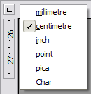
Figure 49: Changing the measurement unit for a ruler

Checking Spelling and Grammar
Writer provides a spelling checker, which can be used in two ways.
AutoSpellcheck checks each word as it is typed and displays a wavy red line under any misspelled words. When the word is corrected, the line disappears.
To perform a separate spelling check on the document (or a text selection) click the Spelling and Grammar button. This checks the document or selection and opens the Spelling and Grammar dialog if any misspelled words are found.
Here are some more features of the spelling checker:
- You can right-click on a word with a wavy underline to open a context menu. If you select from the suggested words on the menu, the selection will replace the misspelled word in your text. Other menu options are discussed below.
- You can change the dictionary language (for example, Spanish, French, or German) on the Spelling and Grammar dialog.
- You can add a word to the dictionary. Click Add in the Spelling and Grammar dialog and pick the dictionary to add it to.
- Click the Options button on the Spelling and Grammar dialog to open a dialog similar to the one in Tools > Options > Language Settings > Writing Aids described in Chapter 11. There you can choose whether to check uppercase words and words with numbers, and you can manage custom dictionaries, that is, add or delete dictionaries and add or delete words in a dictionary.
- On the Font tab of the Paragraph Styles dialog, you can set paragraphs to be checked in a specific language (different from the rest of the document). The font of a Character Style can also be set to its own language. See Chapter 7 (Working with Styles) in the Writer Guide for more information.
Writer does not include a grammar checker, but you can install an extension such as LanguageTool (from https://www.languagetool.org/) and access it from Tools > Spelling and Grammar. (See Chapter 11 for more about installing extensions.)
LanguageTool adds a new menu item and sub-menu to the Tools menu, from which you can configure the tool and check or recheck the document.

Using Built-in Language tools
Writer provides some tools that make your work easier if you mix multiple languages within the same document or if you write documents in various languages.
The main advantage of changing the language is that you can then use the correct dictionaries to check spelling and apply the localized versions of AutoCorrect replacement tables, thesaurus, and hyphenation rules.
You can also set the language for a paragraph or a group of characters as None. This option is especially useful when you insert text such as web addresses or programming language snippets that you do not want to check for spelling.
Specifying the language in character and paragraph styles is the preferred method, because styles allow a greater level of control and make changing the language much faster. On the Font tab of the Paragraph Styles dialog, you can specify that certain paragraphs be checked in a language that is different from the language of the rest of the document. See Chapter 7 (Working with Styles) in the Writer Guide for information on how to manage the language settings of a style.
You can set the language for the whole document, for individual paragraphs, or even for individual words and characters, all from Tools > Language on the menu bar.
Another way to change the language of a whole document is to use Tools > Options > Language Settings > Languages. In the Default languages for documents section of the Options dialog, you can choose a different language for all the text.
The spelling checker works only for those languages in the list that have the symbol next to them. If you do not see the symbol next to your preferred language, you can install the additional dictionary using Tools > Languages > More dictionaries online.
The language used for checking spelling is also shown in the status bar, next to the page style in use.

Using AutoCorrect
Writer’s AutoCorrect function has a long list of common misspellings and typing errors, which it corrects automatically. For example, “hte” will be changed to “the”.
Choose Tools > AutoCorrect Options to open the AutoCorrect dialog. There you can define on the Replace tab which strings of text are corrected and how. In most cases, the defaults are fine.
AutoCorrect is turned on when Writer is installed. To turn it off, uncheck Format > AutoCorrect > While Typing.
To stop Writer replacing a specific spelling, go to the Replace tab, highlight the word pair, and click Delete.
To add a new spelling to the list, type it into the Replace and With boxes on the Replace tab, and click New.
See the different tabs of the dialog for the wide variety of other options available to fine-tune AutoCorrect.
Tip | AutoCorrect can be used as a quick way to insert special characters. For example, (C) will be autocorrected to ©. You can add your own special characters.

Using Word Completion
If Word Completion is enabled, Writer tries to guess which word you are typing and offers to complete the word for you. To accept the suggestion, press Enter. Otherwise, continue typing.
To turn off Word Completion, select Tools > AutoCorrect Options > Word Completion and deselect Enable word completion.
You can customize word completion from the Word Completion page of the AutoCorrect dialog:
- Add (append) a space automatically after an accepted word
- Show the suggested word as a tip (hovering over the word) rather than completing the text as you type
- Change the maximum number of words remembered for word completion and the length of the smallest words to be remembered
- Delete specific entries from the word completion list
- Change the key that accepts a suggested entry—the options are Right arrow, End key, Return (Enter), Tab and Space bar
Note | Automatic word completion only occurs after you type a word for the second time in a document.

Using AutoText
Use AutoText to store text, tables, graphics, and other items for reuse and assign them to a key combination for easy retrieval. For example, rather than typing “Senior Management” every time you use that phrase, you can set up an AutoText entry to insert those words when you type “sm” and press F3.

Creating AutoText
To store some text as AutoText:
- Type the text into your document.
- Select the text.
- Choose Edit > AutoText (or press Ctrl+F3).
- In the AutoText dialog, type a name for the AutoText in the Name box. Writer will suggest a one-letter shortcut, which you can change.
- In the large box to the left, choose the category for the AutoText entry, for example My AutoText.
- Click the AutoText button on the right and select New (text only) from the menu.
- Click Close to return to your document.
Tip | If the only option under the AutoText button is Import, either you have not entered a name for your AutoText or there is no text selected in the document.
AutoText is especially powerful when assigned to fields. See Chapter 14 (Working with Fields) in the Writer Guide for more information.

Inserting AutoText
To insert AutoText, type the shortcut and press F3.

Formatting Text

Using Styles Is Recommended
Styles are central to using Writer. Styles enable you to easily format your document consistently, and to change the format with minimal effort. A style is a named set of formatting options. Writer defines several types of styles, for different types of elements: characters, paragraphs, pages, frames, and lists. See Chapter 2 (Using Styles and Templates) in this book and Chapters 6 and 7 in the Writer Guide.

Formatting Paragraphs
You can apply many formats to paragraphs using the buttons on the Formatting toolbar. Figure 50 Formatting toolbar, showing icons for paragraph formatting shows the Formatting toolbar as a floating toolbar, customized to show only the icons for paragraph formatting. The appearance of the icons may vary with your operating system and the selection of icon size and style in Tools > Options > OpenOffice > View.

1 | Open Styles and Formatting Window | 5 | Align Right | 10 | Numbering On/Off
 | Open Styles and Formatting Window | 6 | Justified | 11 | Bullets On/Off
2 | Apply Style | 7 | Line Spacing: 1 | 12 | Decrease Indent
3 | Align Left | 8 | Line Spacing: 1.5 | 13 | Increase Indent
4 | Centered | 9 | Line Spacing: 2 | 14 | Paragraph format dialog
Figure Formatting toolbar, showing icons for paragraph formatting

Formatting Characters
You can apply many formats to characters using the buttons on the Formatting toolbar. Figure 51 shows the Formatting toolbar, customized to include only the icon for character formatting.
The appearance of the icons may vary with your operating system and the selection of icon size and style in Tools > Options > OpenOffice > View.
1 | Open Styles and Formatting Window | 6 | Italic | 12 | Font Color
 | Open Styles and Formatting Window | 7 | Underline | 13 | Highlighting
2 | Apply Style | 8 | Superscript | 14 | Background Color
3 | Font Name | 9 | Subscript | 15 | Open Character Format Dialog
4 | Font Size | 10 | Increase Font |  | Open Character Format Dialog
5 | Bold | 11 | Reduce Font
Figure : Formatting toolbar, showing icons for character formatting
Tip | To remove manual formatting, select the text and choose Format > Default Formatting, or right-click and choose Default Formatting.

Auto-formatting
You can set Writer to automatically format parts of a document according to the choices made on the Options page of the AutoCorrect dialog (Tools > AutoCorrect Options).
Tip | If you notice unexpected formatting changes occurring in your document, this is the first place to look for the cause.
Some common unwanted or unexpected formatting changes include:
- Horizontal lines. If you type three or more hyphens (---), underscores (___) or equal signs (===) on a line and then press Enter, the paragraph is replaced by a horizontal line as wide as the page. The line is actually the lower border of the preceding paragraph.
- Bulleted and numbered lists. A bulleted list is created when you type a hyphen (-), star (*), or plus sign (+), followed by a space or tab at the beginning of a paragraph. A numbered list is created when you type a number followed by a period (.), followed by a space or tab at the beginning of a paragraph. Automatic numbering is only applied to paragraphs formatted with the Default, Text body or Text body indent paragraph styles.
To turn auto-formatting on or off, choose Format > AutoCorrect and select or deselect the items on the list.

Creating Numbered or Bulleted Lists
There are several ways to create numbered or bulleted lists:
- Use auto-formatting, as described above.
- Use list (numbering) styles, as described in Chapters 6 (Introduction to Styles) and 7 (Working with Styles) in the Writer Guide.
- Use the Numbering and Bullets icons on the paragraph formatting toolbar (see Figure 50): select the paragraphs in the list, and then click the appropriate icon on the toolbar.
Note | It is a matter of personal preference whether you type your information first, then apply Numbering/Bullets, or apply them as you type.

Using the Bullets and Numbering Toolbar
You can create nested lists (where one or more list items has a sub-list under it, as in an outline, by using the buttons on the Bullets and Numbering toolbar (Figure 52). You can move items up or down the list, or create sub-points, and even change the style of bullets. Use View > Toolbars > Bullets and Numbering to see the toolbar.
The appearance of the icons may vary with your operating system and the selection of icon size and style in Tools > Options > OpenOffice > View.

1 | Bullets On/Off | 6 | Promote One Level with Sub-points | 10 | Move Down
2 | Numbering On/Off | 6 | Promote One Level with Sub-points | 11 | Move Up with Subpoints
3 | Numbering Off | 7 | Demote One Level with Sub-points | 12 | Move Down with Subpoints
4 | Promote One Level | 8 | Insert Unnumbered Entry | 13 | Restart Numbering
5 | Demote One Level | 9 | Move Up | 14 | Bullets and Numbering
Figure : Bullets and Numbering toolbar
Note | If numbering or bullets are being applied automatically in a way that you find inappropriate, you can switch them off temporarily by unchecking Format > AutoCorrect > While Typing.

Hyphenating Words
You have several choices regarding hyphenation: let Writer do it automatically (using its hyphenation dictionaries), insert conditional hyphens manually where necessary, or don’t hyphenate at all.
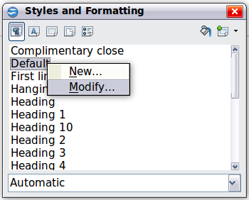Figure : Modifying a style

Automatic Hyphenation
To turn automatic hyphenation of words on or off:
- Press F11 (z+T on Mac) to open the Styles and Formatting window or go to the Styles deck of the Sidebar.
- On the Paragraph Styles page (Figure 53), right-click on Default and select Modify.
- On the Paragraph Style dialog (Figure 54), go to the Text Flow page.
- Under Hyphenation, select or deselect the Automatically option. Click OK to save.
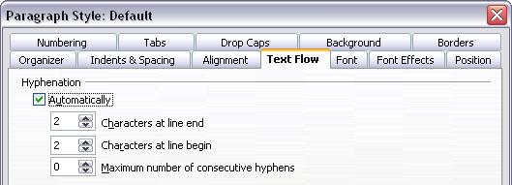
Figure : Turning on automatic hyphenation
Note | Turning on hyphenation for the Default paragraph style affects all other paragraph styles that are based on Default. You can individually change other styles so that hyphenation is not active; for example, you might not want headings to be hyphenated. Any styles that are not based on Default are not impacted. See Chapter 2 (Styles and Templates) for more about styles based on other styles)
You can also set hyphenation choices through Tools > Options > Language Settings > Writing Aids. In Options, near the bottom of the dialog, scroll down to find the hyphenation settings.

Figure : Setting hyphenation options
To change the minimum number of characters for hyphenation, the minimum number of characters before a line break, or the minimum number of characters after a line break, select the item, and then click the Edit button in the Options section.
Hyphenation options set on the Writing Aids dialog are effective only if hyphenation is turned on through paragraph styles.

Manual Hyphenation
To manually hyphenate words, do not use a normal hyphen, which will remain visible even if the word is no longer at the end of a line when you add or delete text or change margins or font size. Instead, use a conditional hyphen, which is visible only when required.
To insert a conditional hyphen inside a word, click where you want the hyphen to appear and press Ctrl+hyphen. The word will be hyphenated at this position when it is at the end of the line, even if automatic hyphenation for this paragraph is switched off.

Formatting Pages
Writer provides several ways for you to control page layouts: page styles, columns, frames, tables, and sections. For more information, see Chapter 4 (Formatting Pages) in the Writer Guide.
Tip | Page layout is usually easier if you show text, object, table, and section boundaries in Tools > Options > OpenOffice > Appearance, and paragraph ends, tabs, breaks, and other items in Tools > Options > OpenOffice Writer > Formatting Aids. These last items will appear when View > Nonprinting Characters is selected.

Which Layout Method to Choose?
The best layout method varies depending on what the final document should look like and what sort of information will be in the document. Here are some examples.
For a book similar to this user guide, with one column of text, some figures without text beside them, and some other figures with descriptive text, use page styles for basic layout, and tables to place figures beside descriptive text when necessary. | 
For an index or other document with two columns of text, where the text continues from the left-hand column to the right-hand column and then to the next page, all in sequence (also known as “snaking columns” of text), use page styles (with two columns). If the title of the document (on the first page) is full-page width, put it in a single-column section. | 
For a newsletter with complex layout, two or three columns on the page, and some articles that continue from one page to some place several pages later, use page styles for basic layout. Place articles in linked frames and anchor graphics to fixed positions on the page if necessary. | 
For a document with terms and translations to appear side-by-side in what appear to be columns, use a table to keep items lined up, and so you can type in both “columns”. | 

Creating Headers and Footers
A header is an area that appears at the top of a page. A footer appears at the bottom of the page. Information such as page numbers inserted into a header or footer displays on every page of the document with that page style.
To insert a header, choose Insert > Header > Default (or the page style, if not Default).
Other information, such as document titles and chapter titles, is often put into the header or footer. These items are best added as fields. That way, if something changes, the headers, and footers are updated automatically. Here is one common example.
To insert the document title into the header:
- Choose File > Properties > Description and type a title for your document.
- Add a header (Insert > Header > Default).
- Place the cursor in the header part of the page.
- Choose Insert > Fields > Title. The title should appear on a gray background (which does not show when printed and can be turned off).
- To change the title for the whole document, go back to File > Properties and select the Description tab.
Fields are covered in detail in Chapter 14 (Working with Fields) in the Writer Guide.
For more about headers and footers, see Chapter 4 (Formatting Pages) and Chapter 6 (Introduction to Styles) in the Writer Guide.

Numbering Pages
To automatically number pages:
- Insert a header or footer, as described in “Creating Headers and Footers” on page 68.
- Place the cursor in the header or footer where you want the page number to appear and choose Insert > Fields > Page Number.

Including the Total Number of Pages
To include the total number of pages (as in “page 1 of 12”):
- Type the word “page” and a space, then insert the page number as above.
- Press the space bar once, type the word “of” and a space, then choose Insert > Fields > Page Count.
Note | The Page Count field inserts the total number of pages in the document, as shown on the Statistics tab of the document’s Properties window (File > Properties). If you restart page numbering anywhere in the document, then the total page count may not be what you want. See Chapter 4 (Formatting Pages) in the Writer Guide for more information.

Restarting Page Numbering
Often you will want to restart the page numbering at 1, for example on the page following a title page or a table of contents. In addition, many documents have the “front matter” (such as the table of contents) numbered with Roman numerals and the main body of the document numbered in Arabic numerals, starting with 1.
You can restart page numbering in two ways.
Method 1:
- Place the cursor in the first paragraph of the new page.
- Choose Format > Paragraph.
- On the Text Flow tab of the Paragraph dialog, select Breaks.
- Select Insert and then With Page Style and specify the page style to use.
- Specify the page number to start from, and then click OK.
Tip | Method 1 is also useful for numbering the first page of a document with a page number greater than 1. For example, you may be writing a book, with each chapter in a separate file. Chapter 1 may start with page 1, but Chapter 2 could begin with page 25 and Chapter 3 with page 51.
Method 2:
- Insert > Manual Break.
- By default, Page break is selected on the Insert Break dialog (Figure 56).
- Choose the required page Style.
- Select Change page number.
- Specify the page number to start from, and then click OK.
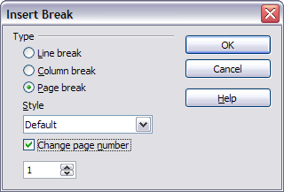
Figure : Restarting page numbering after a manual page break

Changing Page Margins
You can change page margins in two ways:
- Using the page rulers—quick and easy, but does not have fine control
- Using the Page Style dialog—can specify margins to two decimal places
Note | If you change the margins using the rulers, the new margins affect the page style and will be shown in the Page Style dialog the next time you open it.  Because the page style is affected, the changed margins apply to all pages using that style.
To change margins using the rulers:
- The gray sections of the rulers are the margins. Put the mouse cursor over the line between the gray and white sections. The pointer turns into a double-headed arrow.
- Hold down the left mouse button and drag the mouse to move the margin.

Figure : Moving the margins
Tip | The small arrows on the ruler are used for indenting paragraphs. They are often in the same place as the page margins, so you need to be careful to move the margin marker, not the arrows. Place the mouse pointer between the arrows and, when the pointer turns into a double-headed arrow, you can move the margin (the indent arrows will move with it).
To change margins using the Page Style dialog:
- Right-click anywhere on the page and select Page from the pop-up menu.
- On the Page tab of the dialog, type the required distances in the Margins boxes.

Adding Comments to a Document
Authors and reviewers often use comments (formerly called “notes”) to exchange ideas, ask for suggestions, or mark items needing attention.
To insert a comment in the text, place the cursor in the place the comment refers to and choose Insert > Comment or press Ctrl+Alt+C. The anchor point of the comment is connected by a dotted line to a box on the right-hand side of the page where you can type the text of the comment. Writer automatically adds at the bottom of the comment the author’s name and a time stamp indicating when the comment was created. Figure 58 shows an example of text with comments from two different authors.
Figure : Example of comments
Choose Tools > Options > OpenOffice > User Data to configure the name you want to appear in the Author field of the comment, or to change it.
If more than one person edits the document, each author is automatically allocated a different background color.
Right-clicking on a comment pops up a menu where you can delete the current comment, all the comments from the same author, or all the comments in the document. From this menu, you can also apply some basic formatting to the text of the comment. You can also change the font type, size, and alignment from the main menu.
To navigate from one comment to another, open the Navigator (F5) or go to the Navigator deck of the Sidebar, expand the Comments section, and click on the comment text to move the cursor to the anchor point of the comment in the document. Right-click on the comment to quickly edit or delete it.
You can also navigate through the comments using the keyboard. Use Ctrl+Alt+Page Down to move to the next comment and Ctrl+Alt+Page Up to move to the previous comment.

Creating a Table of Contents
Writer’s table of contents feature lets you build an automated table of contents from the headings in your document. Before you start, make sure that the headings are styled consistently. For example, you can use the Heading 1 style for chapter titles and the Heading 2 and Heading 3 styles for chapter subheadings.
Although tables of contents can be customized extensively in Writer, often the default settings are all you need. Creating a quick table of contents is simple:
- When you create your document, use the following paragraph styles for different heading levels (such as chapter and section headings): Heading 1, Heading 2, Heading 3, and so on. These are what will appear in your table of contents.
- Place the cursor where you want the table of contents to be inserted.
- Choose Insert > Indexes and Tables > Indexes and Tables.
- Change nothing in the Insert Index/Table dialog. Click OK.
If you add or delete text (so that headings move to different pages) or you add, delete, or change headings, you need to update the table of contents.
To do this:
- Place the cursor within the table of contents.
- Right-click and choose Update Index/Table from the pop-up menu.
Note | If you cannot place your cursor in the table of contents, choose Tools > Options > OpenOffice Writer > Formatting Aids, and then select Enable in the Cursor in protected areas section.
You can customize an existing table of contents at any time. Right-click anywhere in it and choose Edit Index/Table from the pop-up menu. Chapter 12 (Creating Tables of Contents, Indexes, and Bibliographies) of the Writer Guide describes in detail all the customizations you can select.

Creating Indexes and Bibliographies
Indexes and bibliographies work similarly to tables of contents. Chapter 12 (Creating Tables of Contents, Indexes, and Bibliographies) in the Writer Guide describes the process in detail.
In addition to alphabetical indexes, other types of indexes supplied with Writer include those for illustrations, tables, and objects, and you can even create a user-defined index. For example, you might want an index containing only the scientific names of species mentioned in the text, and a separate index containing only the common names of species. Before creating some types of indexes, you first need to create index entries embedded in your Writer document.

Adding Images and Other Graphics
Graphics in Writer are of three basic types:
- Image files, including photos, drawings, scanned images, and others
- Diagrams created using Apache OpenOffice’s drawing tools
- Charts created using Apache OpenOffice’s Chart facility
See Chapter 10 (Graphics, the Gallery, and Fontwork) in this book and Chapter 8 (Working with Graphics) in the Writer Guide.

Adding Tables, Spreadsheets, and Charts
Tables are a useful way to organize and present large amounts of information. They can often be used as an alternative to spreadsheets. Tables can also be used as a page layout tool to position text in areas of a document, as described in Chapter 4 (Formatting Pages) of the Writer Guide.
To insert a new table, position the cursor where you want the table to appear, then use any of the following methods to open the Insert Table dialog, where you can specify the properties for the new table:
- From the main menu, choose Insert > Table.
- From the main menu, choose Table > Insert > Table.
- Press Ctrl+F12 on the keyboard.
- From the Standard toolbar, click the Table icon 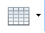
You can also click the small arrow to the right of the Table icon and select the number of cells to directly insert a table with the default table properties.
You can create a table from text, or convert a table to text, using Table > Convert from the menu bar.
You can edit the contents of these tables in the same way as you edit any other text.
A possible source of confusion is the Number Recognition feature of a table. If it is turned on, numbers and dates will be automatically formatted. If this is not desired, select the table cells you want to affect, then right click and deselect Number Recognition.
Chapter 9 (Working with Tables) in the Writer Guide describes how to format tables, add or delete columns and rows, merge and split tables and cells, add and sort data, and perform basic spreadsheet functions in a table of data.

Creating a Table from a Calc Spreadsheet
You can insert a table from a Calc spreadsheet into a Writer document:
- Open the Calc spreadsheet containing the cell range that you want to insert.
- In the spreadsheet, select the cells.
- Choose Edit > Copy or press Ctrl+C.
- In the Writer document, choose Edit > Paste or press Ctrl+V. The cell range is pasted as an object.
Alternatively, you can open both the Calc and Writer documents and drag and drop the cells from Calc to Writer:
- In the spreadsheet, select the cells.
- Click and hold the mouse button in the selected cells.
- Drag the selected cells into the text document.
To edit a table created from a Calc spreadsheet, double-click on it. The table opens in Calc.

Creating a Chart
You can create a chart in three ways:
- Insert a chart based on data from cells in Calc or Writer.
These charts update automatically when the source data changes.
- Insert a chart with a default data set, and then use the Data Table dialog to enter your own data for that chart.
These charts can be created in Writer, Impress, and Draw.
- Copy a chart from Calc or Writer into another document.
These charts are snapshots of the data at the time of copying. They do not change when the source data changes.
To create a chart based on the values in a Writer table:
- Click inside the Writer table.
- Choose Insert > Object > Chart. A chart preview and the Chart Wizard are displayed.
- Follow the instructions in the Chart Wizard to create the chart.
To create a chart based on values of its own:
- If you have not selected any cells, choose Insert > Object > Chart to insert a chart with default data.
- You can change the default data values by double-clicking on the chart and then choosing View > Chart Data Table.
For more about working with charts, see the Calc Guide.

Adding a Movie or Sound
To insert a movie or sound file into your document:
- Click where you want to insert the file.
- Choose Insert > Movie and Sound.
- In the File Open dialog, select the file that you want to insert.
The file types listed in this dialog are not supported by all operating systems.
- Click Open.
Alternatively, you can choose Tools > Media Player to open the Media Player. Use the Media Player to preview all supported media files. Click the Apply button in the Media Player window to insert the current media file into your document.
To play a movie or sound file:
- Click the object icon for the movie or sound file in your document.
If the icon is arranged on the background, hold down Ctrl while you click.
- The Media Playback toolbar is shown. Click Play.
You can also use the Media Playback toolbar to pause, stop, or loop, as well as to adjust the volume or mute the playback of the file. For movie files, the toolbar also provides a slider for selecting the zoom factor for the playback.

Printing
See Chapter 9 (Printing, Exporting, and E-mailing) in this book and Chapter 5 (Printing, Exporting, Faxing, and E-mailing) in the Writer Guide for details on previewing pages before printing, selecting print options, printing in black and white on a color printer, printing brochures, and other printing features.

Using Mail Merge
Writer provides very useful features to create and print:
- Multiple copies of a document to send to a list of different recipients (form letters)
- Mailing labels
- Envelopes
All these facilities use a registered data source (a spreadsheet or database containing the name and address records and other information).
Chapter 11 (Using Mail Merge) in the Writer Guide describes the process.

Tracking Changes to a Document
You can use several methods to keep track of changes made to a document.
- Make your changes to a copy of the document (stored in a different folder, or under a different name, or both), then use Writer to combine the two files and show the differences. Choose Edit > Compare Document. This technique is particularly useful if you are the only person working on the document, as it avoids the increase in file size and complexity caused by the other methods.
- Save versions that are stored as part of the original file. However, this method can cause problems with documents of non-trivial size or complexity, especially if you save a lot of versions. Avoid this method if you can.
- Use Writer’s change marks (often called “red lines” or “revision marks”) to show where you have added or deleted material, or changed formatting. Choose Edit > Changes > Record. Later, you or another person can review and accept or reject each change. Right-click on an individual change and decide Accept Change or Reject Change from the pop-up menu, or select Edit > Changes > Accept or Reject to view the list of changes and accept or reject them. Details are in the Writer Guide.
Tip | Not all changes are recorded. For example, changing a tab stop from align left to align right, and changes in formulas (equations) or linked graphics are not recorded.

Using Fields
Fields are extremely useful features of Writer. They are used for data that changes in a document (such as the current date or the total number of pages) and for inserting document properties such as name, author, and date of last update. Fields are the basis of cross-referencing (see below); automatic numbering of figures, tables, headings, and other elements; and a wide range of other functions—far too many to describe here. See Chapter 14 (Working with Fields) in the Writer Guide for details.

Linking to Another Part of a Document
If you type in cross-references to other parts of a document, those references can easily get out of date if you reorganize the order of topics, add or remove material, or reword a heading. Writer provides two ways to ensure that your references are up-to-date, by inserting links to other parts of the same document or to a different document:
- Hyperlinks
- Cross-references
The two methods have the same result if you Control+click the link when the document is open in Writer: you are taken directly to the cross-referenced item. However, they also have major differences:
- The text in a hyperlink does not automatically update if you change the text of the linked item (although you can change it manually), but changed text does automatically update in a cross-reference.
- When using a hyperlink, you do not have a choice of the content of the link (for example text or page number), but when using a cross-reference, you have several choices, including bookmarks.
- To hyperlink to an object such as a graphic, and have the hyperlink show useful text such as Figure 6, you need to either give such an object a useful name instead of leaving it as the default name (Graphics6), or you need to use the Hyperlink dialog to modify the visible text. In contrast, cross-references to figures with captions automatically show useful text, and you have a choice of several variations of the name.
- If you save a Writer document to HTML, hyperlinks remain active, but cross-references do not. (Both remain active when the document is exported to PDF.)

Using Hyperlinks
The easiest way to insert a hyperlink to another part of the same document is by using the Navigator:
- Open the document containing the items you want to cross-reference.
- Open the Navigator by clicking its icon, going to the Navigator deck in the Sidebar, choosing View > Navigator, or pressing F5.
- Click the arrow next to the Drag Mode icon, and choose Insert as Hyperlink.
- In the list at the bottom of the Navigator, select the document containing the item that you want to cross-reference.
- In the Navigator list, select the item that you want to insert as a hyperlink.
- Drag the item to where you want to insert the hyperlink in the document. The name of the item is inserted in the document as an active hyperlink.
You can also use the Hyperlink dialog to insert and modify hyperlinks within and between documents.
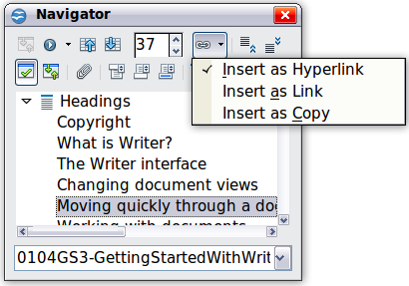
Figure : Inserting a hyperlink using the Navigator

Using Cross-References
If you type in references to other parts of the document, those references can easily get out of date if you reword a heading, add or remove figures, or reorganize topics. Replace any typed cross-references with automatic ones and, when you update fields, all the references will update automatically to show the current wording or page numbers. The Cross-references tab of the Fields dialog lists some items, such as headings, bookmarks, figures, tables, and numbered items such as steps in a procedure. You can also create your own reference items; see “Setting References” in Chapter 14 (Working with Fields) in the Writer Guide for instructions.
To insert a cross-reference to a heading, figure, bookmark, or other item:
- In your document, place the cursor where you want the cross-reference to appear.
- If the Fields dialog is not open, click Insert > Cross-reference. On the Cross-references tab, in the Type list, select the type of item to be referenced (for example, Heading or Figure). You can leave this page open while you insert many cross-references.
- Click on the required item in the Selection list, which shows all the items of the selected type. In the Format list, choose the format required. Usually this will be Reference (to insert the full text of the heading or caption), Category and Number (to insert the word “Figure” or “Table” and its number, but without the caption text), Numbering (to insert only the figure or table number, without the word “Figure” or “Table”), or Page (to insert the number of the page the referenced text is on). Click Insert.

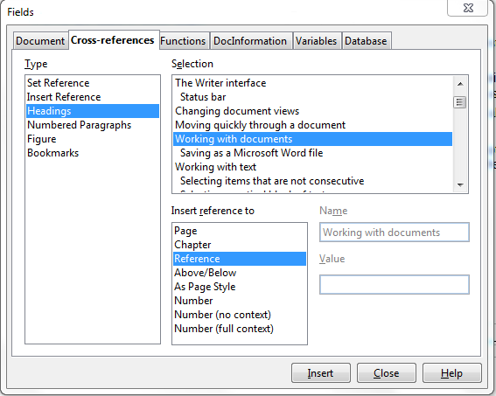Figure : The Cross-references tab of the Fields dialog

Using Bookmarks
Bookmarks are listed in the Navigator and can be accessed directly from there with a single mouse click. You can cross-reference to bookmarks and create hyperlinks to bookmarks, as described above.
- Select the text you want to bookmark. Click Insert > Bookmark.
- On the Insert Bookmark dialog, the larger box lists any previously defined bookmarks. Type a name for this bookmark in the top box, and then click OK.
Figure : Inserting a bookmark

Using Master Documents
Master documents are typically used for producing long documents such as a book, a thesis, or a long report; or when different people are writing different chapters or other parts of the full document, so you don’t need to share files. A master document joins separate text documents into one larger document, and unifies the formatting, table of contents (TOC), bibliography, index, and other tables or lists.
Yes, master documents do work in Writer. However, until you become familiar with them, you may think that master documents are unreliable or difficult to use. See Chapter 13 (Working with Master Documents) in the Writer Guide.

Creating Fill-in Forms
A standard text document displays information: a letter, report, or brochure, for example. Typically, the reader may edit everything or nothing in any way. A form has sections that are not to be edited, and other sections that are designed for the reader to make changes. For example, a questionnaire has an introduction and questions (which do not change) and spaces for the reader to enter answers.
Forms are used in three ways:
- To create a simple document for the recipient to complete, such as a questionnaire sent out to a group of people who fill it in and return it.
- To link into a database or data source and allow the user to enter information. Someone taking orders might enter the information for each order into a database using a form.
- To view information held in a database or data source. A librarian might call up information about books.
Writer offers several ways to fill information into a form, including check boxes, option buttons, text boxes, pull-down lists and spinners. See Chapter 15 (Using Forms in Writer) in the Writer Guide.

Chapter 4
Getting Started with Calc

What Is Calc?
Calc is the spreadsheet component of Apache OpenOffice. You can enter data (usually numerical) in a spreadsheet and then manipulate this data to produce certain results.
Alternatively you can enter data and then use Calc in a ‘What if…’ manner by changing some data and observing the results without having to retype the entire spreadsheet
Other features provided by Calc include:
- Functions, which can be used to create formulas to perform complex calculations on data
- Database functions, to arrange, store, and filter data
- Dynamic charts; a wide range of 2D and 3D charts
- Macros, for recording and executing repetitive tasks
- Ability to open, edit, and save Microsoft Excel spreadsheets
- Import and export of spreadsheets in multiple formats, including HTML, CSV, PDF, and PostScript

Spreadsheets, Sheets, and Cells
Calc works with documents called spreadsheets. Spreadsheets consist of a number of individual sheets, each sheet containing cells arranged in rows and columns. A particular cell is identified by its row number and column letter.
Cells hold the individual elements—text, numbers, formulas—that make up the data to display and manipulate.
Each spreadsheet can have many sheets, up to 256, and each sheet can have many individual cells. Each sheet can have a maximum of 1,048,576 rows and 1024 columns.

Parts of the Main Calc Window
When Calc is started, the main window looks similar to Figure 62.

Title Bar
The Title bar, located at the top, shows the name of the current spreadsheet. When the spreadsheet is newly created, its name is Untitled X, where X is a number. When you save a spreadsheet for the first time, you are prompted to enter a name of your choice.

Menu Bar
Under the Title bar is the Menu bar. (On a Mac, the Menu bar is at the top of the screen, above the Title bar, the same location as for other Mac applications.) When you choose one of the menus, a sub menu appears with other options. You can modify the Menu bar, as discussed in Chapter 11 (Setting up and Customizing Apache OpenOffice).
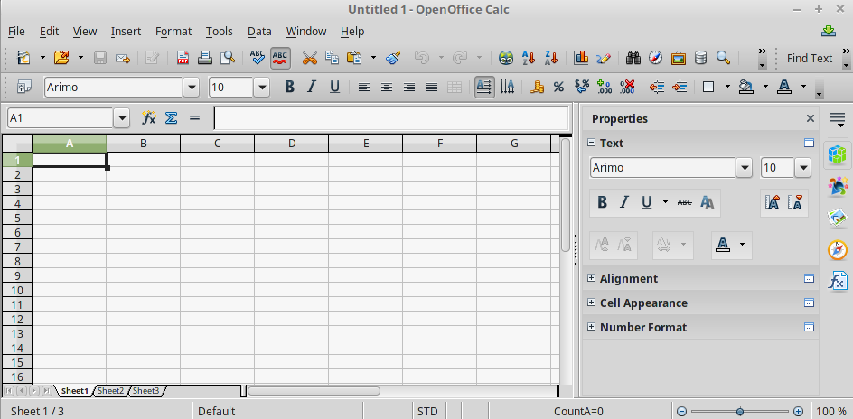

Figure : Parts of the Calc window
Title bar
Menu bar
Standard toolbar
Formatting toolbar
Sidebar
Name box
Row headers
Column headers
Active cell
Sheet tabs
Status bar
Formula bar

Toolbars
Three toolbars are located under the Menu bar by default: the Standard toolbar, the Formatting toolbar, and the Formula Bar.
The icons (buttons) on these toolbars provide a wide range of common commands and functions. You can also modify these toolbars, as discussed in Chapter 11 (Setting Up and Customizing Apache OpenOffice).
In the Formatting toolbar, the three boxes on the left are the Apply Style, Font Name, and Font Size lists. They show the current setting for the selected cell or area. (The Apply Style list may not be visible by default.) Click the down-arrow to the right of each box to open the list.
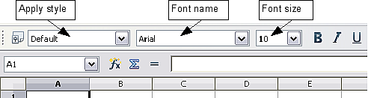
Figure . Apply Style, Font Name and Font Size lists

Formula Bar
On the left-hand side of the Formula bar is a small text box, called the Name Box, with a letter and number combination in it, such as D7. This combination, called the cell reference, is the column letter and row number of the selected cell.
To the right of the Name box are the Function Wizard, Sum, and Function buttons.
Clicking the Function Wizard button opens a dialog from which you can search through a list of available functions This can be very useful because it also shows how the functions are formatted.
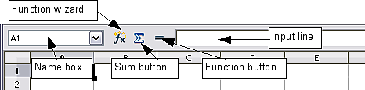
Figure . Formula Bar
In a spreadsheet the term function covers much more than just mathematical functions. See Chapter 7 in the Calc Guide for more details.
Clicking the Sum button inserts a formula into the current cell that totals the numbers in the cells above the current cell. If there are no numbers above the current cell, then the cells to the left are placed in the Sum formula.
Clicking the Function button inserts equals (=) sign into the selected cell and the Input line, thereby enabling the cell to accept a formula.
When you enter new data into a cell, the Sum and Equals buttons change to Cancel and Accept buttons .
The contents of the current cell (data, formula, or function) are displayed in the Input line, which forms the remainder of the Formula Bar. You can edit the contents of the current cell on the Input line or in the cell itself. To edit on the Input line, click in the line, then type your changes. To edit within the current cell, just double-click the cell.

Individual Cells
The main section of the screen displays the cells in the form of a grid, with each cell being at the intersection of a column and a row.
At the top of the columns and at the left end of the rows are a series of gray boxes containing letters and numbers. These are the column and row headers. The columns start at A and go on to the right, and the rows start at 1 and go down.
These column and row headers form the cell references that appear in the Name Box on the Formula Bar (Figure 64). You can turn these headers off by selecting View > Column & Row Headers.

Sheet Tabs
At the bottom of the grid of cells is the sheet tabs. These tabs enable access to each individual sheet, with the visible (active) sheet having a white tab. You can choose colors for the different sheet tabs by right-clicking the space, choosing Tab Color, and choosing a color from the palette.
Clicking on another sheet tab displays that sheet, and its tab turns white. You can also select multiple sheet tabs at once by holding down the Ctrl key while you click the names.
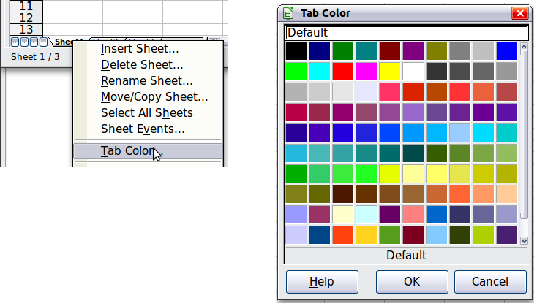
Figure : Choosing a tab color

Status Bar
At the very bottom of the Calc window is the status bar, which provides information about the spreadsheet and convenient ways to quickly change some of its features. Most of the fields are similar to those in other components of Apache OpenOffice; see Chapter 1 (Introducing Apache OpenOffice). Right-clicking on the Cell or object information field brings up a menu of functions that summarize the cells selected in the sheet. Among the options are Sum, Average, Minimum and Maximum. See Selecting Cells for information about selecting multiple cells.
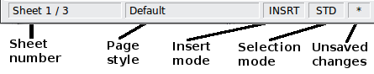
Figure : Left end of Calc status bar
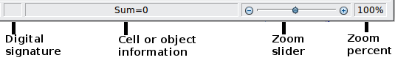
Figure : Right end of Calc status bar

Opening and Saving CSV files
Chapter 1 (Introducing Apache OpenOffice) includes instructions on starting new Calc documents, opening existing documents, and saving documents.
A special case for Calc is opening and saving comma-separated-values (CSV), which are text files that contain the cell contents of a single sheet. Each line in a CSV file represents a row in a spreadsheet. Commas, semicolons, or other characters are used to separate the cells. Text may be entered in quotation marks, numbers are entered without quotation marks.

Opening a CSV File
To open a CSV file in Calc:
- Choose File > Open.
- Locate the CSV file that you want to open.
- If the file has a *.csv extension, select the file and click Open.
- If the file has another extension (for example, *.txt), select the file, select Text CSV (*.csv;*.txt) in the File type box (scroll down into the spreadsheet section to find it) and then click Open.
- On the Text Import dialog (Figure 68), select the Separator options to divide the text in the file into columns.
You can preview the layout of the imported data at the bottom of the dialog. Right-click a column in the preview to set the format or to hide the column. Selecting Detect special numbers allows values with formatting such as currency symbols and some date formats to be read correctly. They will otherwise be read as text, which is a common source of difficulty with subsequent calculations.
If the CSV file uses a text delimiting character that is not in the Text delimiter list, click in the Other box and type the character.
- Click OK to open the file.
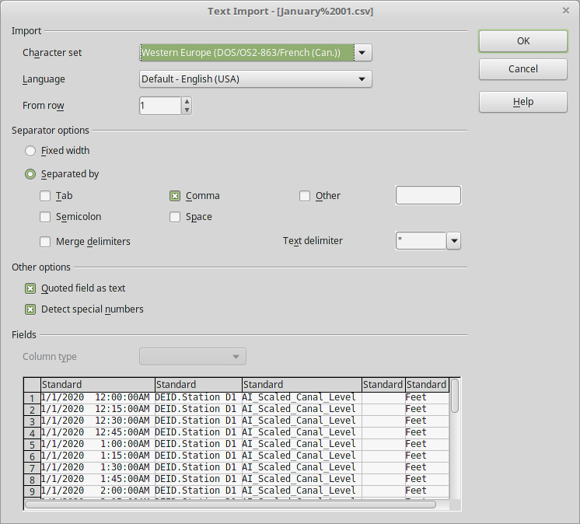

Figure : Text Import dialog, with Comma (,) selected as the separator and double quotation mark (“) as the text delimiter.

Saving as a CSV File
To save a spreadsheet as a comma separated value (CSV) file:
- Choose File > Save As.
- In the File name box, type a name for the file.
- In the File type list, select Text CSV (.csv) and click Save.
You may see the message box shown below. Click Keep Current Format.
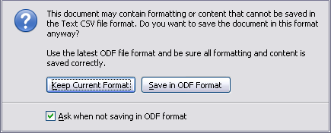
- In the Export of text files dialog, select the options you want and then click OK. You will get a warning that only the current sheet was saved. CSV files do not support multiple sheets.
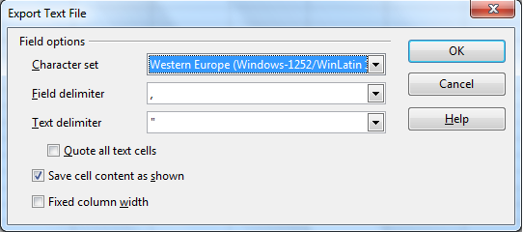
Figure : Choosing options when exporting to Text CSV

Navigating Within Spreadsheets
Calc provides many ways to navigate within a spreadsheet from cell to cell and sheet to sheet. You can generally use whatever method you prefer.

Going to a Particular Cell
Using the mouse
Place the mouse pointer over the cell and click.
Using a cell reference
Click on the little inverted black triangle just to the right of the Name Box (Figure 64). The existing cell reference will be highlighted. Type the cell reference of the cell you want to go to and press Enter. Or just click into the Name box, backspace over the existing cell reference and type in the cell reference you want and press Enter.
Using the Navigator
To open the Navigator, click its icon on the Standard toolbar, or go to the Navigator deck of the Sidebar, or press F5, or choose View > Navigator on the Menu bar, or double-click on the Sheet Sequence Number in the Status Bar. Type the cell reference into the top two fields, labeled Column and Row, and press Enter. In Figure 70 the Navigator would select cell A7.
You can dock the Navigator to either side of the main Calc window or leave it floating. (To dock or float the Navigator, hold down the Ctrl key and double-click in an empty area near the icons in the Navigator dialog.) If you want a docked Navigator, using the Sidebar is typically the easiest approach. The Sidebar is described in Chapter 1. Introducing Apache OpenOffice.
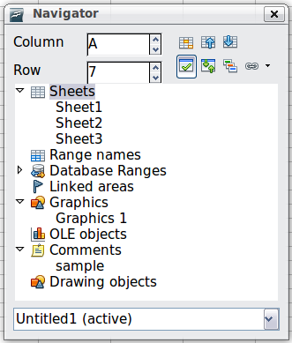
Figure : The Navigator in Calc
The Navigator displays lists of all the objects in a document, grouped into categories. If an indicator (plus sign or arrow) appears next to a category, at least one object of this kind exists. To open a category and see the list of items, click on the indicator.
To hide the list of categories and show only the icons at the top, click the Contents icon . Click this icon again to show the list.

Moving from Cell to Cell
In the spreadsheet, one cell normally has a darker black border. This black border indicates where the focus is (see Figure 71). If a group of cells is selected, they have a highlight color, with the focus cell having a dark border.
Using the mouse
To move the focus using the mouse, simply move the mouse pointer to the cell where you want the focus to be and click the left mouse button. This changes the focus to the new cell. This method is most useful when the two cells are a large distance apart.
Using the Tab and Enter keys
- Pressing Enter or Shift+Enter moves the focus down or up, respectively.
- Pressing Tab or Shift+Tab moves the focus to the right or to the left, respectively.
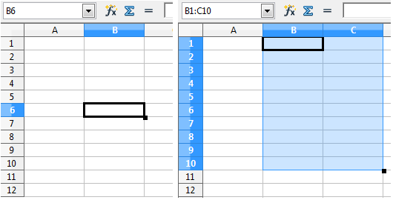
Figure . (Left) One selected cell and (right) a group of selected cells
Using the arrow keys
Pressing the arrow keys on the keyboard moves the focus in the direction of the arrows.
Using Home, End, Page Up and Page Down
- Home moves the focus to the start of a row.
- End moves the focus to the column furthest to the right that contains data.
- Page Down moves the display down one complete screen and Page Up moves the display up one complete screen.
- Combinations of Ctrl and Alt with Home, End, Page Down, Page Up, and the cursor keys move the focus of the current cell in other ways. See the Help or Appendix A (Keyboard Shortcuts) in the Calc Guide for details.
Tip | Use one of the four Alt+Arrow key combinations to resize a cell.

Customizing the Enter Key
You can customize the direction in which the Enter key moves the focus, by selecting Tools > Options > OpenOffice Calc > General.
The four choices for the direction of the Enter key are shown on the right-hand side of Figure 72. It can move the focus down, right, up, or left. Depending on the file being used or on the type of data being entered, setting a different direction can be useful.
The Enter key can also be used to switch into and out of editing mode. Use the first two options under Input settings in Figure 72 to change the Enter key settings.
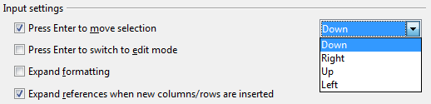
Figure : Customizing the effect of the Enter key

Moving from Sheet to Sheet
Each sheet in a spreadsheet is independent of the others, though they can be linked with references from one sheet to another. There are three ways to navigate between different sheets in a spreadsheet.
Using the Navigator
When the Navigator is open (Figure 70), double-clicking on any of the listed sheets selects the sheet.
Using the keyboard
Pressing Ctrl+Page Down moves one sheet to the right and pressing Ctrl+Page Up moves one sheet to the left.
Using the mouse
Clicking on one of the sheet tabs at the bottom of the spreadsheet selects that sheet.
If you have a lot of sheets, then some sheet tabs may be hidden behind the horizontal scroll bar at the bottom of the screen. If this is the case, then the four buttons at the left of the sheet tabs can move the tabs into view. Figure 73 shows how to do this.
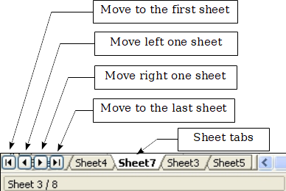Figure . Sheet tab arrows
Notice that the sheets here are not numbered in order. Sheet numbering is arbitrary; you can name a sheet as you wish.
Note | The sheet tab arrows that appear in Figure 73 only appear if you have some sheet tabs that are hidden by the horizontal scrollbar. Otherwise, they will appear faded as in Figure 62.

Selecting Items in a Sheet or Spreadsheet

Selecting Cells
Cells can be selected in a variety of combinations and quantities.
Single cell
Left-click in the cell. The result will look like the left side of Figure 71. You can verify your selection by looking in the Name box.
Range of contiguous cells
A range of cells can be selected using the keyboard or the mouse.
To select a range of cells by dragging the mouse:
- Click in a cell.
- Press and hold down the left mouse button.
- Move the mouse around the screen.
- Once the desired block of cells is highlighted, release the left mouse button.
To select a range of cells without dragging the mouse:
- Click in the cell which is to be one corner of the range of cells.
- Move the mouse to the opposite corner of the range of cells.
- Hold down the Shift key and click.
To select a range of cells without using the mouse:
- Select the cell that will be one of the corners in the range of cells.
- While holding down the Shift key, use the cursor arrows to select the rest of the range.
The result of these methods looks like the right side of Figure 71.
To select all the occupied cells in one direction:
- Click the first cell in the desired range.
- Hold the Ctrl + Shift keys and press the arrow to move in the desired direction. The cursor will jump to the last occupied cell.
Tip | You can also directly select a range of cells using the Name box. Click into the Name Box as described in “Using a cell reference” on page 86. To select a range of cells, enter the cell reference for the upper left-hand cell, followed by a colon (:), and then the lower right-hand cell reference. For example, to select the range that would go from A3 to C6, you would enter A3:C6.
Range of noncontiguous cells
- Select the cell or range of cells using one of the methods above.
- Move the mouse pointer to the start of the next range or single cell.
- Hold down the Ctrl key and click or click-and-drag to select a range.
- Repeat as necessary.

Selecting Columns and Rows
Entire columns and rows can be selected very quickly in Apache OpenOffice.
Single column or row
To select a single column, click on the column identifier letter (see Figure 62).
To select a single row, click on the row identifier number.
Multiple columns or rows
To select multiple columns or rows that are contiguous:
- Click on the first column or row in the group.
- Hold down the Shift key.
- Click the last column or row in the group.
To select multiple columns or rows that are not contiguous:
- Click on the first column or row in the group.
- Hold down the Ctrl key.
- Click on all the subsequent columns or rows while holding down the Ctrl key.
Entire sheet
To select the entire sheet, click on the small box between the A column header and the 1 row header. You can also press Ctrl+A to select the entire sheet.
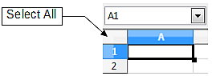
Figure . Select All box

Selecting Sheets
You can select either one or multiple sheets. It can be advantageous to select multiple sheets at times when you want to make changes to many sheets at once.
Single sheet
Click on the sheet tab for the sheet you want to select. The active sheet becomes white (see Figure 75).
Multiple contiguous sheets
To select multiple contiguous sheets:
- Click on the sheet tab for the first desired sheet.
- Move the mouse pointer over the sheet tab for the last desired sheet.
- Hold down the Shift key and click on the sheet tab.
All the tabs between these two sheets will turn white. Any actions that you perform will now affect all highlighted sheets.
Multiple noncontiguous sheets
To select multiple noncontiguous sheets:
- Click on the sheet tab for the first sheet.
- Move the mouse pointer over the second sheet tab.
- Hold down the Ctrl key and click on the sheet tab.
- Repeat as necessary.
The selected tabs will turn white. Any actions that you perform will now affect all highlighted sheets.
All sheets
Right-click any one of the sheet tabs and choose Select All Sheets from the pop-up menu.

Working with Columns and Rows

Inserting Columns and Rows
Columns and rows can be inserted individually or in groups.
Note | When you insert a single new column, it is inserted to the left of the highlighted column. When you insert a single new row, it is inserted above the highlighted row.  Cells in the new columns or rows are formatted like the corresponding cells in the column or row before (or to the left of) which the new column or row is inserted.
Single column or row
Using the Insert menu:
- Select the cell, column, or row where you want the new column or row inserted.
- Choose either Insert > Columns or Insert > Rows.
Using the mouse:
- Select the cell, column, or row where you want the new column or row inserted.
- Right-click the header of the column or row.
- Choose Insert Rows or Insert Columns.
Multiple columns or rows
Multiple columns or rows can be inserted at once rather than inserting them one at a time.
- Highlight the required number of columns or rows by holding down the left mouse button on the first one and then dragging across the required number of identifiers.
- Proceed as for inserting a single column or row above.

Deleting Columns and Rows
Columns and rows can be deleted individually or in groups.
Single column or row
A single column or row can only be deleted by using the mouse:
- Select the column or row to be deleted.
- Right-click on the column or row header.
- Select Delete Columns or Delete Rows from the pop-up menu.
Multiple columns or rows
Multiple columns or rows can be deleted at once rather than deleting them one at a time.
- Highlight the required number of columns or rows by holding down the left mouse button on the first one and then dragging across the required number of identifiers.
- Proceed as for deleting a single column or row above.

Working with Sheets
Like any other Calc element, sheets can be inserted, deleted, and renamed.

Inserting New Sheets
There are several ways to insert a new sheet. The first step for all the methods is to select the sheets that the new sheet will be inserted next to. Then any of the following options can be used.
- Choose Insert > Sheet from the menu bar.
- Right-click on the sheet tab and choose Insert Sheet.
- Click in an empty space at the end of the line of sheet tabs.
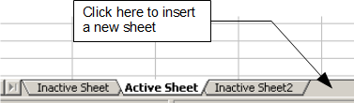Figure . Creating a new sheet
Each method will open the Insert Sheet dialog (Figure 76). Here you can select whether the new sheet is to go before or after the selected sheet and how many sheets you want to insert. If you are inserting only one sheet, there is the opportunity to give the sheet a name.
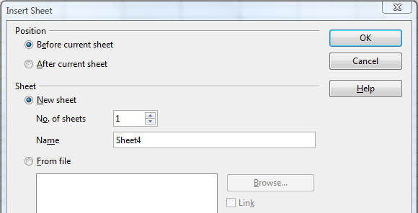
Figure . Insert Sheet dialog

Moving and Copying Sheets
You can move or copy sheets within the same spreadsheet by using either the mouse (drag and drop) or a dialog. Drag and drop does not work if you wish to move or copy a sheet to a different spreadsheet; instead, you need to use the dialog.

Using the Mouse
To move a sheet to a different position within the same spreadsheet, click on the sheet tab and drag it left or right. Two little triangles indicate where the sheet will be dropped (see Figure 77). The mouse pointer (not shown in the illustration) may change to include an indicator; the indicator symbol varies with your operating system.
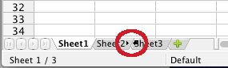Figure : Dragging a sheet to move it
To copy a sheet within the same spreadsheet, hold down the Ctrl key (Option key on Mac) while you click on the sheet tab and drag it. The mouse pointer may change to include a plus sign or other indicator; the symbol varies with your operating system.

Using a dialog
The Move/Copy dialog provides the opportunity to specify exactly where you want the sheet to go (in the same or a different document), at the same time as moving or copying occurs.
Note | When moving or copying sheets between different spreadsheets, be sure that both documents are open.
Follow these steps:
- In the current document, right-click on the sheet tab you wish to move or copy.
- Select Move/Copy Sheet from the context menu.
- On the Move/Copy Sheet dialog (Figure 78):
  - Select or deselect the Copy option at the bottom.
  - To document: select the document in which you want to place the sheet. By default, the field will show the current document. If you have another spreadsheet open, its name will appear in the drop-down list along with—new document.
Insert before: select the position within the target document.
- When you are done, click OK.
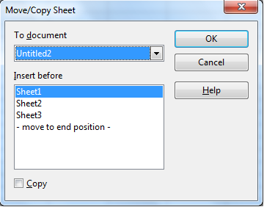
Figure : Move/Copy Sheet dialog
Caution | If you choose—new document—as the location, a new spreadsheet will be created. This may cause conflicts with formulas linked to other sheets in the previous location. If you accidentally move a sheet, you can fix it by moving or copying the sheet back to the original location.  This caution also applies to moving sheets to other existing documents.

Deleting Sheets can be Deleted Individually or in Groups.
Single sheet
Right-click on the tab of the sheet you want to delete and choose Delete Sheet from the pop-up menu, or choose Edit > Sheet > Delete from the menu bar.
Multiple sheets
To delete multiple sheets, select them as described earlier, then either right-click over one of the tabs and select Delete Sheet from the pop-up menu, or choose Edit > Sheet > Delete from the menu bar.

Renaming Sheets
The default name for a new sheet is SheetX, where X is a number. While this works for a small spreadsheet with only a few sheets, it becomes awkward when there are many sheets.
To give a sheet a more meaningful name, you can:
- Enter the name in the Name box when you create the sheet, or
- Right-click on a sheet tab and choose Rename Sheet from the pop-up menu; replace the existing name with a better one.
- Double-click on a sheet tab to pop up the Rename Sheet dialog.
Note | Sheet names must start with either a letter or a number. Apart from the first character of the sheet name, allowed characters are letters, numbers, spaces, and the underline character. Attempting to rename a sheet with an invalid name will produce an error message.

Viewing Calc

Using Zoom
Use the zoom function to change the view to show more or fewer cells in the window. For more about zoom, see Chapter 1 (Introducing Apache OpenOffice) in this book.

Freezing Rows and Columns
Freezing locks a number of rows at the top of a spreadsheet or a number of columns on the left of a spreadsheet or both. Then when scrolling around within the sheet, any frozen columns and rows remain in view.
Figure 79 shows some frozen rows and columns. The heavier horizontal line between rows 3 and 14 and the heavier vertical line between columns C and H denote the frozen areas. Rows 4 through 13 and columns D through G have been scrolled off the page. The first three rows and columns remained because they are frozen into place.
You can set the freeze point at a row, a column, or both a row and a column as in Figure 79.
Freezing single rows or columns
- Click on the header for the row below where you want the freeze or for the column to the right of where you want the freeze.
- Choose Window > Freeze.
- A dark line appears, indicating where the freeze is put.
Freezing a row and a column
- Click into the cell that is immediately below the row you want frozen and immediately to the right of the column you want frozen.
- Choose Window > Freeze.
- Two lines appear on the screen, a horizontal line above this cell and a vertical line to the left of this cell. Now as you scroll around the screen, everything above and to the left of these lines will remain in view.
Unfreezing
To unfreeze rows or columns, choose Window > Freeze. The check mark by Freeze will vanish.
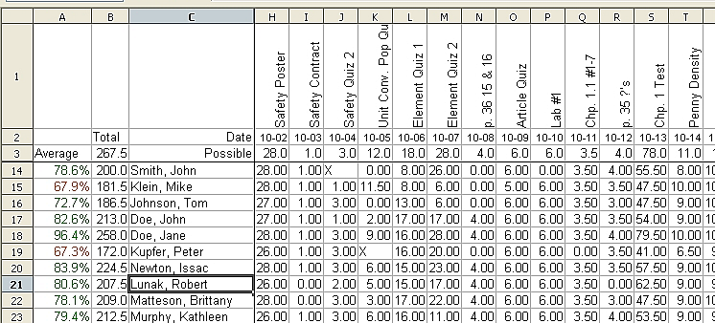
Figure . Frozen rows and columns

Splitting the Screen
Another way to change the view is by splitting the window, also known as splitting the screen. The screen can be split either horizontally or vertically or both. You can therefore have up to four portions of the spreadsheet in view at any one time.
Why would you want to do this? Imagine you have a large spreadsheet and one of the cells has a number in it which is used by three formulas in other cells. Using the split screen technique, you can position the cell containing the number in one section and each of the cells with formulas in the other sections. Then you can change the number in the cell and watch how it affects each of the formulas.
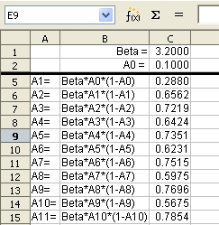
Figure . Split screen example

Splitting the Screen Horizontally
To split the screen horizontally:
- Move the mouse pointer into the vertical scroll bar, on the right-hand side of the screen, and place it over the small button at the top with the black triangle. Immediately above this button you will see a thick black line.
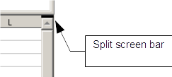
Figure . Split screen bar on vertical scroll bar
- Move the mouse pointer over this line, and it turns into a line with two arrows, as in Figure 82.

Figure . Split screen bar on vertical scroll bar with cursor
- Hold down the left mouse button. A gray line appears, running across the page. Drag the mouse downwards and this line follows.
- Release the mouse button and the screen splits into two views, each with its own vertical scroll bar. You can scroll the upper and lower parts independently.
Notice in Figure 80, the Beta and the A0 values are in the upper part of the window and other calculations are in the lower part. Thus, you can make changes to the Beta and A0 values and watch their effects on the calculations in the lower half of the window.
Tip | You can also split the screen using a menu command. Click in a cell immediately below and to the right of where you wish the screen to be split, and choose Window > Split.

Splitting the Screen Vertically
To split the screen vertically:
- Move the mouse pointer into the horizontal scroll bar at the bottom of the screen and place it over the small button on the right with the black triangle. Immediately to the right of this button is a thick black line.
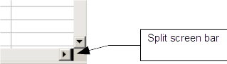Figure : Split bar on horizontal scroll bar
- Move the mouse pointer over this line, and it turns into a line with two arrows.
- Hold down the left mouse button, and a gray line appears, running up the page. Drag the mouse to the left and this line follows.
- Release the mouse button and the screen is split into two views, each with its own horizontal scroll bar. You can scroll the left and right parts of the window independently.

Removing Split Views
To remove a split view, do any of the following:
- Double-click on each split line.
- Click on and drag the split lines back to their places at the ends of the scroll bars.
- Choose Window > Split to remove all split lines at the same time.

Entering Data Using the Keyboard
Most data entry in Calc can be accomplished using the keyboard.

Entering Numbers
Click in the cell and type in the number using the number keys on either the main keyboard or the numeric keypad.
To enter a negative number, either type a minus (–) sign in front of it or enclose it in parentheses (brackets), like this: (1234).
By default, numbers are right-aligned and negative numbers have a leading minus symbol.
Note | If a number beginning with 0 is entered in to a cell, Calc will drop the 0 (for example 01234 becomes 1234).
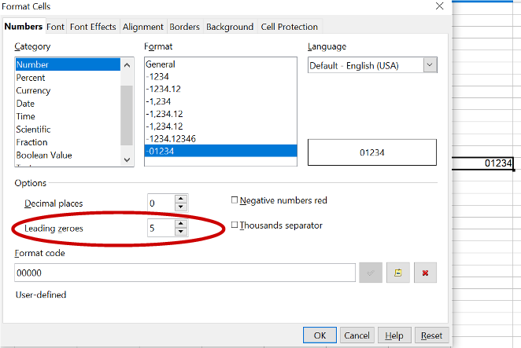Figure : Adjusting leading zeros
To enter a number and retain the leading 0, right-click on the cell and choose Format > Cells > Numbers. In the Format Cells dialog (Figure 84), under Options select the required number of Leading zeros.
The number selected for leading zeros needs to be one higher than the digits in a number. For example, if the number is 1234, the number entered for the leading zero will be 5.

Entering Text
Click in the cell and type the text. Text is left-aligned by default.

Entering Numbers as Text
A number can be entered as text to preserve a leading zero by entering an apostrophe before the number, like this: '01481.
The data is now regarded as text by Calc and displayed exactly as entered. Typically, formulas will treat the entry as a zero and functions will ignore it. Take care that the cell containing the number is not used in a formula.
Note | If “smart quotes” are used for apostrophes, the apostrophe remains visible in the cell.  To choose the type of apostrophe, use Tools > AutoCorrect Options > Localized Options. The selection of the apostrophe type affects both Calc and Writer.

Entering Dates and Times
Select the cell and type the date or time. You can separate the date elements with a slant (/) or a hyphen (–) or use text such as 10 Oct 20. Calc recognizes a variety of date formats. You can separate time elements with colons such as 10:43:45. Calc may change the appearance of the entered value to match the current cell format. You can adjust the cell appearance through the menu Format > Cells. See the section Formatting Numbers for more details.

Deactivating Automatic Changes
Calc automatically applies many changes during data input, unless you deactivate those changes. You can also immediately undo any automatic changes with Ctrl+Z.
AutoCorrect changes
Automatic correction of typing errors, replacement of straight quotation marks by curly (custom) quotes, and starting cell content with an uppercase (capital letter) are controlled by Tools > AutoCorrect Options. Go to the Localized Options, Options, or Replace tabs to deactivate any of the features that you do not want. On the Replace tab, you can also delete unwanted word pairs and add new ones as required.
AutoInput
When you are typing in a cell, Calc automatically suggests matching input found in the same column. To turn the AutoInput on and off, set or remove the check mark in front of Tools > Cell Contents > AutoInput.
Automatic date conversion
Calc automatically converts certain entries to dates. To ensure that an entry that looks like a date is interpreted as text, type an apostrophe at the beginning of the entry. The apostrophe is not displayed in the cell. You can also set the cell format to Text through the menu Format > Cells, using the Numbers tab.

Speeding Up Data Entry
Entering data into a spreadsheet can be very labor-intensive, but Calc provides several tools for removing some drudgery from input.
The most basic ability is to drop and drag the contents of one cell to another with a mouse. Calc also includes several other tools for automating input, especially of repetitive material. They include the Fill tool, selection lists, and the ability to input information into multiple sheets of the same document.

Using the Fill Tool on Cells
At its simplest, the Fill tool is a way to duplicate existing content. Start by selecting the cell to copy, then drag the mouse in any direction (or hold down the Shift key and click in the last cell you want to fill), and then choose Edit > Fill and the direction in which you want to copy: Up, Down, Left or Right.
Caution | Choices that are not available are grayed out, but you can still choose the opposite direction from what you intend, which could cause you to overwrite cells accidentally.
Tip | A shortcut way to fill cells is to grab the “handle” in the lower right-hand corner of the cell and drag it in the direction you want to fill. If the cell contains a number, the number will fill in series. If the cell contains text, the same text will fill in the direction you choose.

Figure : Using the Fill tool

Using a Fill Series
A more complex use of the Fill tool is to use a fill series. The default lists are for the full and abbreviated days of the week and the months of the year, but you can create your own lists as well.
To add a fill series to a spreadsheet, select the cells to fill, choose Edit > Fill > Series. In the Fill Series dialog (Figure 86), select AutoFill as the Series type, and enter as the Start value an item from any defined series. The selected cells then fill in the other items on the list sequentially, repeating from the top of the list when they reach the end of the list. The available lists can be seen at Tools > Options > OpenOffice Calc > Sort Lists.
You can also use Edit > Fill > Series to create a one-time fill series for numbers by entering the start and end values and the increment. For example, if you entered start and end values of 1 and 7 with an increment of 2, you would get the sequence of 1, 3, 5, 7. If you set a Start value but no End value, the series will fill all the selected cells. If you set both a Start and an End value the behavior depends on the number of selected cells, If there are at least enough cells selected to contain the series, the series will stop at the End value, possibly leaving some selected cells empty. If there are not enough cells selected, the series will stop at the last selected cell and not reach the End value.
In all these cases, the Fill tool creates only a momentary connection between the cells. Once they are filled, the cells have no further connection with one another.
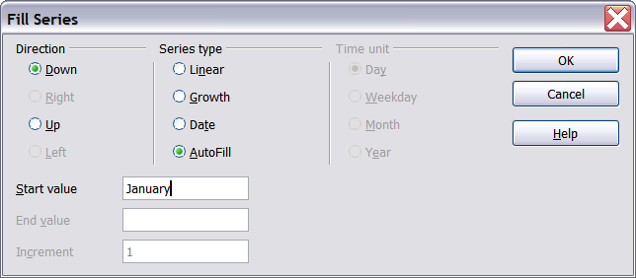
Figure : Specifying the start of a fill series (result is in Figure 87)
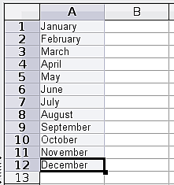
Figure : Result of fill series selection shown in Figure 86

Defining a Fill Series
To define your own fill series:
- Go to Tools > Options > OpenOffice Calc > Sort Lists. This dialog shows the previously-defined series in the Lists box on the left, and the contents of the highlighted list in the Entries box.
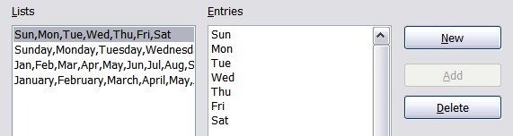
Figure : Predefined fill series
- Click New. The Entries box is cleared.
- Type the series for the new list in the Entries box (one entry per line). Click Add. The new list will now appear in the Lists box.
- Click OK at the bottom of the dialog to save the new list.
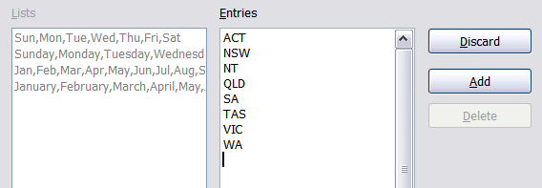
Figure : Defining a new fill series

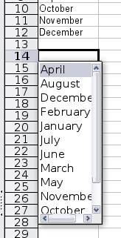
Using Selection Lists
Selection lists are available only for text, and are limited to using only text that has already been entered in the same column.
To use a selection list, select a blank cell and press Ctrl+D. A drop-down list appears of any cell in the same column that either has at least one text character or whose format is defined as Text. Click on the entry you require.

Validating Cell Contents
When creating spreadsheets for other people to use, you may want to make sure they enter data that is valid or appropriate for the cell. You can also use validation in your own work as a guide to entering data that is either complex or rarely used.
Fill series and selection lists can handle some types of data, but they are limited to predefined information. To validate new data entered by a user, select a cell and use Data > Validity to define the type of contents that can be entered in that cell. For example, a cell might require a date or a whole number, with no alphabetic characters or decimal points; or a cell may not be left empty. Valid values may also be defined by the contents of a cell range.
Depending on how validation is set up, the tool can also define the range of contents that can be entered and provide help messages that explain the content rules you have set up for the cell and what users should do when they enter invalid content. You can also set the cell to refuse invalid content, accept it with a warning, or start a macro when an error is entered.
See Chapter 2 (Entering, Editing, and Formatting Data) in the Calc Guide for more information.

Editing Data
Editing data is done in much the same way as entering data. The first step is to select the cell containing the data to be edited.

Removing Data from a Cell
Data can be removed (deleted) from a cell in several ways.
Removing data only
The data alone can be removed from a cell without removing any of the formatting of the cell. Click in the cell to select it, and then press the Backspace key.
Removing data and formatting
The data and the formatting can be removed from a cell at the same time. Press the Delete key (or right-click and choose Delete Contents, or use Edit > Delete Contents) to open the Delete Contents dialog. From this dialog, the different aspects of the cell can be deleted. To delete everything in a cell (contents and format), check Delete all.
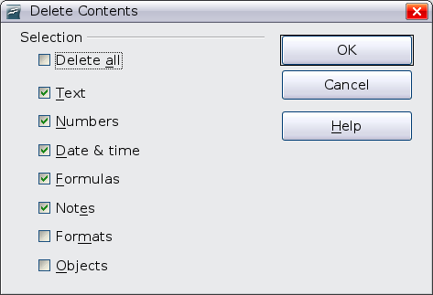
Figure : Delete Contents dialog

Replacing All the Data in a Cell
To remove data and insert new data, simply type over the old data. The new data will retain the original formatting.

Changing Part of the Data in a Cell
Sometimes it is necessary to change the contents of cell without removing all the contents, for example if the phrase “See Dick run” is in a cell, and it needs to be changed to “See Dick run fast.” It is often useful to do this without deleting the old cell contents first.
The process is the similar to the one described above, but you need to place the cursor inside the cell. You can do this in two ways.
Using the keyboard
After selecting the appropriate cell, press the F2 key and the cursor is placed at the end of the cell. Then use the keyboard arrow keys to move the cursor through the text in the cell.
Using the mouse
Using the mouse, either double-click on the appropriate cell (to select it and place the cursor in it for editing), or single-click to select the cell and then move the mouse pointer up to the input line and click into it to place the cursor for editing.

Formatting Data
The data in Calc can be formatted in several ways. It can either be edited as part of a cell style so that it is automatically applied, or it can be applied manually to the cell. Some manual formatting can be applied using toolbar icons. The Properties tab of the Sidebar also contains panels for Text properties, Alignment, Cell Appearance, and Number Format. For more control and extra options, click the More Options icon at the right edge of the Sidebar panel titles or select the appropriate cell or cells, right-click on it, and select Format Cells. All the format options are discussed below.
Note | All the settings discussed in this section can also be set as a part of the cell style. If several cells will be formatted identically, defining a cell style makes it easy to keep the format consistent. See Chapter 4 (Using Styles and Templates in Calc) in the Calc Guide for more information.

Formatting Multiple Lines of Text
Multiple lines of text can be entered into a single cell using automatic wrapping or manual line breaks. Each method is useful for different situations.

Using Automatic Wrapping
To set text to wrap at the end of the cell, right-click on the cell and select Format Cells (or choose Format > Cells from the menu bar, or press Ctrl+1). On the Alignment tab (Figure 91), under Properties, select Wrap text automatically and click OK. This setting is also available on the Alignment panel of the Properties deck of the Sidebar. The results are shown in Figure 92 alongside examples of text that overflows into neighboring empty cells or whose display is truncated because the cell does not have text wrapping turned on.
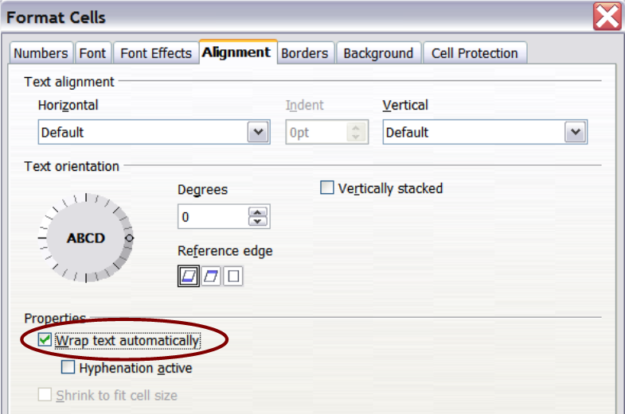Figure : Format Cells > Alignment dialog
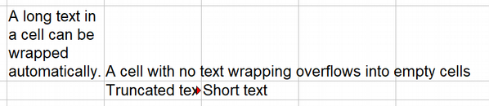Figure : Automatic text wrap

Using Manual Line Breaks
To insert a manual line break while typing in a cell, press Ctrl+Enter. This method does not work with the cursor in the input line. When editing text, first double-click the cell, then single-click at the position where you want the line break or move to the location using the arrow keys.
When a manual line break is entered, the cell width does not change. Figure 93 shows the results of using two manual line breaks after the first line of text.
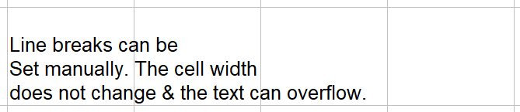Figure : Cell with manual line breaks

Shrinking Text to Fit the Cell
The font size of the data in a cell can automatically adjust to fit in a cell. To do this, select the Shrink to fit cell size option in the Format Cells dialog (Figure 91). Figure 94 shows the results in the top left cell along with other cells in the default font size demonstrating text overflow or truncation.
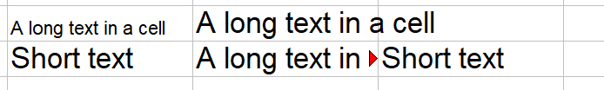Figure : Shrinking font size to fit cells

Formatting Numbers
Several number formats can be applied to cells by using icons on the Formatting toolbar. Select the cell, then click the relevant icon. Not all the icons in Figure 95 are visible by default. Icons can be added or removed from the toolbar as explained in the Customizing toolbars section of Chapter 1 (Introducing Apache OpenOffice).

Figure : Number format icons. Left to right: currency, percentage, date, exponential, standard, add decimal place, delete decimal place.
For more control or to select other number formats, use the Numbers tab (Figure 96) of the Format Cells dialog:
- Apply any of the data types in the Category list to the data.
- Control the number of decimal places and leading zeros.
- Enter a custom format code.
The Language setting controls the local settings for the different formats such as the date order and the currency marker.
Note | Changing the format of a cell never changes its value. This can cause confusion when a value that is intended to be a number, such as a date, is interpreted by Calc as text. This may happen, for example, when data is read in from a CSV file. Text has a value of zero and changing the format after Calc has set the value will not change that value. The cell format must be changed and then the data reentered.

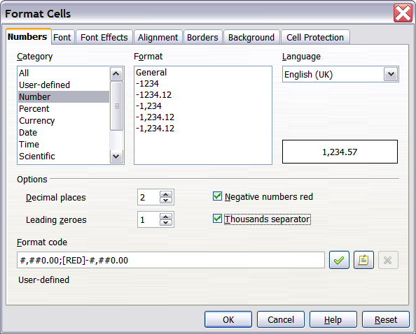Figure : Format Cells > Numbers

Formatting the Font
To quickly choose the font used in a cell, select the cell, then click the arrow next to the Font Name box on the Sidebar or on the Formatting toolbar and choose a font from the list.
Tip | To choose whether to show the font names in their font or in plain text, go to Tools > Options > OpenOffice > View and select or deselect the Show preview of fonts option in the Font Lists section. For more information, see Chapter 11 (Setting Up and Customizing Apache OpenOffice).
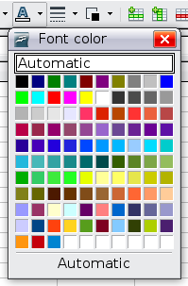
To choose the size of the font, click the arrow next to the Font Size box on the Formatting toolbar. For other formatting, you can use the Bold, Italic, or Underline icons.
To choose a font color, click the arrow next to the Font Color icon to display a color palette. Click on the required color.
(To define custom colors, use Tools > Options > OpenOffice > Colors. See Chapter 11.)
All the formatting options just discussed are also available in the Text panel of the Properties deck of the Sidebar.
To specify the language of the cell (useful because it allows different languages to exist in the same document and be spell-checked correctly), use the Font tab of the Format Cells dialog. Use the Font Effects tab to set other font characteristics. See Chapter 4 (Using Styles and Templates in Calc) of the Calc Guide for more information.

Formatting the Cell Borders
To add a border to a cell (or group of selected cells) click on the Borders icon on the formatting toolbar, and select one of the border options displayed in the palette.
To quickly choose a line style and color for the borders of a cell, click the small arrows next to the Line Style and Line Color icons on the Formatting toolbar. In each case, a palette of choices is displayed.
Icons for the border pattern options, line style and color are also available on the Cell Appearance panel of the Properties deck of the Sidebar.
For more controls, including the spacing between the cell borders and the text, use the Borders tab of the Format Cells dialog. The same dialog can be reached through the More Options button in the line style list in the Sidebar. There you can also define a shadow. See Chapter 4 (Using Styles and Templates in Calc) of the Calc Guide for details.
Note | The cell border properties apply to a cell, and can only be changed if you are editing that cell. For example, if cell C3 has a top border (which would be equivalent visually to a bottom border on C2), that border can only be removed by selecting C3. It cannot be removed in C2.

Formatting the Cell Background
To quickly choose a background color for a cell, click the small arrow next to the Background Color icon on the Formatting toolbar or on the Cell Appearance panel of the Properties deck of the Sidebar. A palette of color choices, similar to the Font Color palette, is displayed.
(To define custom colors, use Tools > Options > OpenOffice > Colors. See Chapter 11 for more information.)
You can also use the Background tab of the Format Cells dialog. See Chapter 4 (Using Styles and Templates in Calc) of the Calc Guide for details.

Auto-formatting Cells and Sheets
You can use the AutoFormat feature to quickly apply a set of cell formats to a sheet or a selected cell range.
- Select the cells, including the column and row headers, that you want to format.
- Choose Format > AutoFormat.
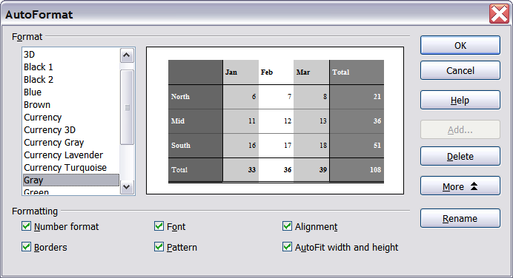
Figure : Choosing an AutoFormat
Note | The AutoFormat feature can only be applied if the selected set of cells consists of at least 3 columns and 3 rows and includes the column and row headers.
- To select which properties (number format, font, alignment, borders, pattern, autofit width and height) to include in an AutoFormat, click More. Select or deselect the required options.
- Click OK.
If you do not see any change in color of the cell contents, choose View > Value Highlighting from the menu bar.

Defining a New AutoFormat
You can define a new AutoFormat that is available to all spreadsheets.
- Format a sheet (in the style for the new AutoFormat).
- Choose Edit > Select All.
- Choose Format > AutoFormat. The Add button is now active.
- Click Add.
- In the Name box of the Add AutoFormat dialog, type a meaningful name for the new format.
- Click OK to save. The new format is now available in the Format list in the AutoFormat dialog.

Formatting Spreadsheets Using Themes
Calc comes with a predefined set of formatting themes that you can apply to your spreadsheets.
It is not possible to add themes to Calc, and they cannot be modified. However, you can modify their styles after you apply them to a spreadsheet.
To apply a theme to a spreadsheet:
- Click the Choose Themes icon in the Tools toolbar. If this toolbar is not visible, you can show it using View > Toolbars > Tools.
- The Theme Selection dialog appears. This dialog lists the available themes for the whole spreadsheet.
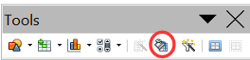Figure : Tools toolbar with the Choose Themes icon highlighted
- In the Theme Selection dialog, select the theme that you want to apply to the spreadsheet. As soon as you select a theme, some properties of the custom styles are applied to the open spreadsheet and are immediately visible.
- Click OK. If you wish, you can now go to the Styles and Formatting window to modify specific styles. These modifications do not change the theme; they only change the appearance of this specific spreadsheet document.

Using Conditional Formatting
You can set up cell formats to change depending on conditions that you specify. For example, in a table of numbers, you can show all the values above the average in green and all those below the average in red. The feature is reached through Format > Conditional Formatting.
Conditional formatting depends upon the use of styles, and the AutoCalculate feature (Tools > Cell Contents > AutoCalculate) must be enabled. See Chapter 2 (Entering, Editing, and Formatting Data) in the Calc Guide for details.

Hiding and Showing Data
When elements are hidden, they are not visible and may be hidden when printed, but can still be selected for copying if you select the surrounding elements. For example, if column B is hidden, it is copied when you select columns A and C. When you need a hidden element again, you can reverse the process, and show the element.
To hide or show sheets, rows, and columns, use the options on the Format menu or the right-click (context) menu. For example, to hide a row, first select the row, and then choose Format > Row > Hide (or right-click on the row header and choose Hide).
To hide or show selected cells, choose Format > Cells from the menu bar (or right-click and choose Format Cells). On the Format Cells dialog, go to the Cell Protection tab and select either Hide all or Hide a formula.
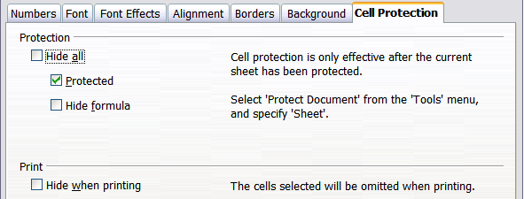
Figure : Hiding or showing cells

Outline Group Controls
If you are continually hiding and showing the same cells, you can simplify the process by creating outline groups, which add a set of controls for hiding and showing the cells in the group that are quick to use and always available.
If the contents of cells falls into a regular pattern, such as four cells followed by a total, then you can use Data > Group and Outline > AutoOutline to have Calc add outline controls based on the pattern. Otherwise, you can set outline groups manually by selecting the cells for grouping, then choosing Data > Group and Outline > Group. On the Group dialog, you can decide whether to group the selected cells by rows or columns.
When you close the dialog, the outline group controls are visible between either the row or column headers and the edges of the editing window. The controls resemble the tree-structure of a file-manager in appearance, and can be hidden by selecting Data > Outline > Hide Details. They are strictly for on screen use, and do not print.

Figure : Outline group controls
The basic outline controls have plus or minus signs at the start of the group to show or hide the hidden cells. However, if outline groups are nested, the controls have numbered buttons for hiding different levels.
If you no longer need a group, place the mouse cursor in any cell in it and select Data > Group and Outline > Ungroup. To remove all groups on a sheet, select Data > Group and Outline > Remove.

Filtering Which Cells Are Visible
A filter is a list of conditions that each entry has to meet in order to be displayed. You can set three types of filters from the Data > Filter sub-menu.
Automatic filters add a drop-down list to the top row of a column that contains commonly used filters. They are quick and convenient and are useful with text and with numbers, because the list includes every unique entry in the selected cells.
In addition to these unique entries, automatic filters include the option to display all entries, the ten highest numerical values, and all cells that are empty or not-empty, as well as a standard filter. The automatic filters are somewhat limited. In particular, they do not allow regular expressions, so you cannot use them to display cell contents that are similar, but not identical.
Standard filters are more complex than automatic filters. You can set as many as eight conditions as a filter, combining them with the operators AND, and OR. Standard filters are mostly useful for numbers, although a few of the conditional operators, such as = and < > can also be useful for text.
Other conditional operators for standard filters include options to display the largest or smallest values, or a percentage of them. Useful in themselves, standard filters take on added value when used to further refine automatic filters.
Advanced filters are structured similarly to standard filters. The differences are that advanced filters are not limited to eight conditions, and their criteria are not entered in a dialog. Instead, advanced filters are entered in a blank area of a sheet, then referenced by the advanced filter tool to apply them.

Sorting Records
Sorting arranges the visible cells on the sheet. In Calc, you can sort by up to three criteria, which are applied one after another. Sorts are handy when you are searching for a particular item, and become even more powerful after you have filtered data.
In addition, sorting is often useful when you add new information. When a list is long, it is usually easier to add new information at the bottom of the sheet, rather than adding rows in the proper places. After you have added information, you can then sort it to update the sheet.
Highlight the cells to be sorted, then select Data > Sort to open the Sort dialog (or click the Sort Ascending or Sort Descending toolbar buttons). Using the dialog, you can sort the selected cells using up to three columns, in either ascending (A-Z, 1-9) or descending (Z-A, 9-1) order.
On the Options tab of the Sort dialog, you can choose the following options:
Case-sensitive
If two entries are otherwise identical, one with an upper case letter is placed before one with a lower case letter in the same position.
Range contains column labels
Does not include the column heading in the sort.
Include formats
A cell's formatting is moved with its contents. If formatting is used to distinguish different types of cells, then use this option.
Copy sort results to
Sets a spreadsheet address to which to copy the sort results. If a range is specified that does not have the necessary number of cells, then cells are added. If a range contains cells that already have content, then the sort fails.
Custom sort order
Select the box, then choose one of the sort orders defined in Tools > Options > OpenOffice Calc > Sort Lists from the drop-down list.
Direction
Sets whether rows or columns are sorted. The default is to sort by rows.

Using Formulas and Functions
You may need more than numbers and text on your spreadsheet. Often the contents of one cell depend on the contents of other cells. Formulas are equations using numbers and variables to get a result. The variables are cell locations that hold the data you require for the equation.
A function is a predefined calculation entered into a cell to help you analyze or manipulate data. All you have to do is add the arguments, and the calculation is automatically made for you. Functions help you create the formulas needed to get the results that you are looking for.
Refer to Chapter 7 in the Calc Guide for more information.

Analyzing Data
Calc includes several tools to help you analyze the information in your spreadsheets, ranging from features for copying and reusing data, to creating subtotals automatically, to varying information to help you find the answers you need. These tools are divided between the Tools and Data menus.
One of the most useful of these tools is the Pivot Table. This is a tool for combining, comparing, and analyzing large amounts of data easily. Using the Pivot Table, you can view different summaries of the source data, display the details of areas of interest, and create reports, whether you are a beginner, an intermediate or advanced user. Refer to Chapter 8 in the Calc Guide for more information.
Other analysis options include:
Consolidation
Data > Consolidate provides a way to combine data from two or more ranges of cells into a new range while running one of several functions (such as Sum or Average) on the data.
Subtotals
Use Data > Subtotals to calculate subtotals for up to three columns.
Scenarios
Tools > Scenarios opens a dialog for testing “what-if” questions, such as different interest rates on a loan.
Goal seek
Use Tools > Goal Seek if you know the result you want, but need to discover what values will produce this result.
Solver
Tools > Solver is similar to Goal Seek, but you can use more than one variable. The Solver is designed to minimize or maximize the result according to a set of rules that you define.
All of these options are further discussed in Chapter 9 in the Calc Guide.

Printing
Printing from Calc is much the same as printing from other Apache OpenOffice components (see Chapter 9), but some details are different, especially regarding preparation for printing.

Using Print Ranges
Print ranges have several uses, including printing only a specific part of the data or printing selected rows or columns on every page. For more about using print ranges, see Chapter 6 (Printing, Exporting, and E-mailing) in the Calc Guide.

Defining a Print Range
To define a new print range or modify an existing print range:
- Highlight the range of cells that comprise the print range.
- Choose Format > Print Ranges > Define.
The page break lines display on the screen.
Tip | You can check the print range by using File > Page Preview. Calc will only display the cells in the print range.

Adding to the Print Range
After defining a print range, you can add more cells to it. This allows multiple, separate areas of the same sheet to be printed, while not printing the whole sheet. After you have defined a print range:
- Highlight the range of cells to be added to the print range.
- Choose Format > Print Ranges > Add. This adds the extra cells to the print range.
The page break lines no longer display on the screen.
Note | The additional print range will print as a separate page, even if both ranges are on the same sheet.

Removing a Print Range
It may become necessary to remove a defined print range, for example if the whole sheet needs to be printed later.
Choose Format > Print Ranges > Remove. This removes all defined print ranges on the sheet. After the print range is removed, the default page break lines will appear on the screen.

Editing a Print Range
At any time, you can directly edit the print range, for example to remove or resize part of the print range. Choose Format > Print Ranges > Edit.

Selecting the Page Order, Details, and Scale
To select the page order, details, and scale to be printed:
- Choose Format > Page from the main menu.
- Select the Sheet tab.
- Make your selections, and then click OK.
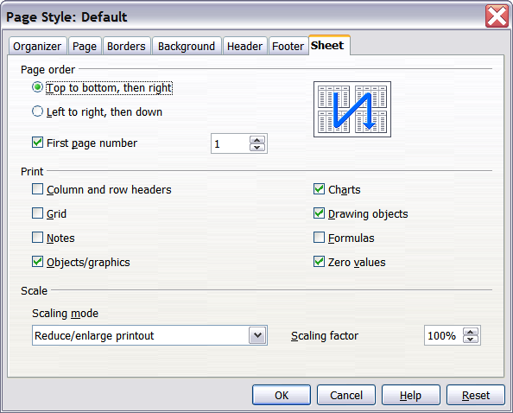
Figure . The Sheet tab of the Page Style dialog
Page Order
When a sheet will print on more than one page (of paper) you can set the order in which pages print. This is especially useful in a large document; for example, controlling the print order can save time if you have to collate the document a certain way. The two available options are shown below.
Top to bottom, then right | 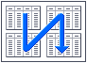 | Left to right, then down | 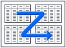
Details
You can specify which details to print. These details include:
- Row and column headers
- Sheet grid—prints the borders of the cells as a grid
- Comments—prints the comments defined in your spreadsheet on a separate page, along with the corresponding cell reference
- Objects and graphics
- Charts
- Drawing objects
- Formulas—prints the formulas contained in the cells, instead of the results
- Zero Values—prints cells with a zero value
Note | Remember that since the print detail options are a part of the page’s properties, they are also a part of the page style’s properties. Therefore, different page styles can be set up to quickly change the print properties of the sheets in the spreadsheet.
Scale
Use the scale features to control the number of pages the data will print on. This can be useful if a large amount of data needs to be printed compactly or if you want the text enlarged to make it easier to read.
- Reduce/Enlarge printout—scales the data in the printout either larger or smaller. For example if a sheet would normally print out as four pages (two high and two wide), a scaling of 50% would print as one page (both width and height are halved).
- Fit print range(s) on number of pages—defines exactly how many pages the printout will take up. This option will only reduce a printout, it will not enlarge it. To enlarge a printout, the reduce/enlarge option must be used.
- Fit print range(s) to width/height—defines how high and wide the printout will be, in pages.

Printing Rows or Columns on Every Page
If a sheet is printed on multiple pages, you can set up certain rows or columns to repeat on each printed page.
For example, if the top two rows of the sheet as well as column A need to be printed on all pages, do the following:
- Choose Format > Print Ranges > Edit. On the Edit Print Ranges dialog, type the rows in the text entry box under Rows to repeat. For example, to repeat rows 1 and 2, type $1:$2. This automatically changes Rows to repeat from, –none – to – user defined -.
- To repeat columns, type the columns in the text entry box under Columns to repeat. For example, to repeat column A, type $A. In the Columns to repeat list, – none – changes to – user defined -.
- Click OK.
Note | You do not need to select the entire range of the rows to be repeated; selecting one cell in each row works.
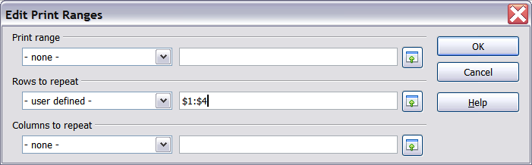
Figure : Specifying repeating rows

Page Breaks
While defining a print range can be a powerful tool, it may sometimes be necessary to manually adjust Calc’s printout. To do this, you can use a manual break. A manual break helps to ensure that your data prints properly. You can insert a horizontal page break above, or a vertical page break to the left of, the active cell.

Inserting a Page Break
To insert a page break:
- Navigate to the cell where the page break will begin.
- Select Insert > Manual Break.
- Select Row Break or Column Break depending on your need.
The break is now set.
Row break
Selecting Row Break creates a page break above the selected cell. For example, if the active cell is H15, then the break is created between rows 14 and 15.
Column break
Selecting Column Break creates a page break to the left of the selected cell. For example, if the active cell is H15, then the break is created between columns G and H.
Tip | To see page break lines more easily on screen, you can change their color. Choose Tools > Options > OpenOffice > Appearance and scroll down to the Spreadsheet section.

Deleting a Page Break
To remove a page break:
- Navigate to a cell that is next to the break you want to remove.
- Select Edit > Delete Manual Break.
- Select Row Break or Column Break depending on your need.
The break is now removed.
Note | Multiple manual row and column breaks can exist on the same page. When you want to remove them, you have to remove each one individually. This may be confusing at times, because although there may be a column break set on the page, when you go to Edit > Manual Break, Column break may be grayed out.  In order to remove the break, you have to be in the cell next to the break. For example, if you set the column break while you are in H15, you can not remove it if you are in cell D15. However, you can remove it from any cell in column H.

Headers and Footers
Headers and footers are predefined pieces of text that are printed at the top or bottom of a sheet, outside the sheet area. Headers are set in the same way as footers.
Headers and footers are assigned to a page style. You can define more than one-page style for a spreadsheet and assign different page styles to different sheets. For more about page styles, see Chapter 4 (Using Styles and Templates) in the Calc Guide.

Setting a Header or Footer
To set a header or footer:
- Navigate to the sheet that you want to set the header or footer for. Choose Format > Page.
- On the Page Style dialog, select the Header (or Footer) tab. See Figure 103.
- Select the Header on option.
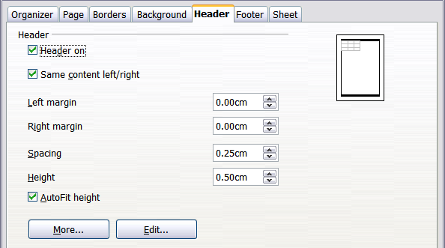
Figure : Header dialog
From here you can also set the margins, the spacing, and height for the header or footer. You can check the AutoFit height box to automatically adjust the height of the header or footer.
Margin
Changing the size of the left or right margin adjusts how far the header or footer is from the side of the page.
Spacing
Spacing affects how far above or below the sheet the header or footer will print. So, if spacing is set to 1.00", then there will be 1 inch (2.54 cm) between the header or footer and the sheet.
Height
Height affects how big the header or footer will be.

Header or Footer Appearance
To change the appearance of the header or footer, click the More button in the header dialog. This opens the Border/Background dialog (Figure 104).
From this dialog you can set the background and border of the header or footer. For more information see Chapter 4 (Using Styles and Templates) in the Calc Guide.
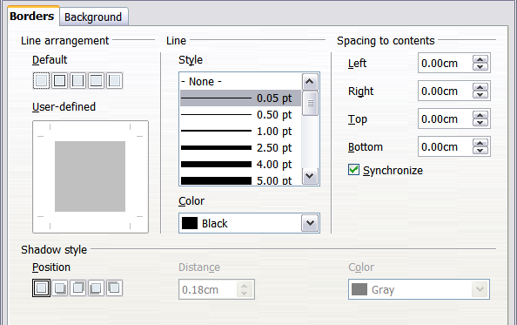
Figure : Header/Footer Border/Background

Setting the Contents of the Header or Footer
The header or footer of a Calc spreadsheet has three columns for text. Each column can have different contents.
To set the contents of the header or footer, click the Edit button in the header or footer dialog shown in Figure 103 to display the dialog shown in Figure 105.
Areas
Each area in the header or footer is independent and can have different information in it.
Header
You can select from several preset choices in the Header drop-down list, or specify a custom header using the buttons below the area boxes. (To format a footer, the choices are the same.)
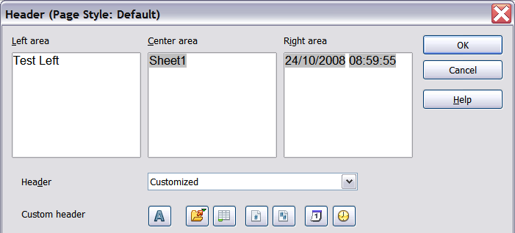
Figure : Edit contents of header or footer
Custom header
Click in the area (Left, Center, Right) that you want to customize, then use the buttons to add elements or change text attributes.
Opens the Text Attributes dialog.
Inserts the File Name field.
Inserts the Sheet Name field.
Inserts the current page number.
Inserts the total number of pages.
Inserts the Date field.
Inserts the Time field.

Chapter 5
Getting Started with Impress

What Is Impress?
Impress is the presentation (slide show) program included in Apache OpenOffice. You can create slides that contain many elements, including text, bulleted and numbered lists, tables, charts, and a wide range of graphic objects such as clip art, drawings, and photographs. Impress also includes a spelling checker, a thesaurus, text styles, and background styles.
This chapter includes instructions, screenshots, and hints to guide you through the Impress environment while designing your presentations. Although more difficult designs are mentioned throughout this chapter, explanations for creating them are in the Impress Guide. If you have a working knowledge of how to create slide shows, we recommend you use the Impress Guide for your source of information.
To use Impress for more than very simple slide shows requires some knowledge of the elements which the slides contain. Slides containing text use styles to determine the appearance of that text. Creating drawings in Impress is similar to the Draw program included in Apache OpenOffice. For this reason, we recommend that you also see Chapter 2 (Using Styles and Templates) and Chapter 6 (Getting Started with Draw) in this book. You may also wish to consult the Draw Guide for more details on how to use the drawing tools.

Starting Impress
You can start Impress in several ways:
- From the Apache OpenOffice Start Center, if no component is open, click on the Presentation icon.
- From the system menu, the standard menu from which most applications are started. On Windows, it is called the Start menu or use the Apache OpenOffice Quick-starter. On Gnome, it is called the Applications menu. For KDE it is identified by the KDE logo. With macOS, it is the Applications menu. Details vary with your operating system; see Chapter 1 (Introducing Apache OpenOffice).
- From any open component of AOO. Click the triangle to the right of the New icon on the main toolbar and select Presentation from the drop-down menu or choose File > New > Presentation from the menu bar.
Note | When AOO was installed on your computer, in most cases a menu entry for each component was added to your system menu. The exact name and location of these menu entries depend on the operating system and graphical user interface.
When you start Impress for the first time, the Presentation Wizard is shown. Here you can choose from the following options:
- Empty presentation, which gives you a blank document
- From template, which is a presentation designed with a template of your choice
- Open existing presentation
- Click Create to open the main Impress window.
For detailed instructions about how to use the Presentation Wizard, see “Creating a New Presentation” on page 134.
If you prefer not to use the Presentation Wizard in the future, you can select Do not show this wizard again. You can enable the wizard again later under Tools > Options > OpenOffice Impress > General > New document, and select the Start with wizard option.

The Main Impress Window
The main Impress window has three parts: the Slides pane, Workspace, and Sidebar. Additionally, several toolbars can be displayed or hidden during the creation of a presentation.
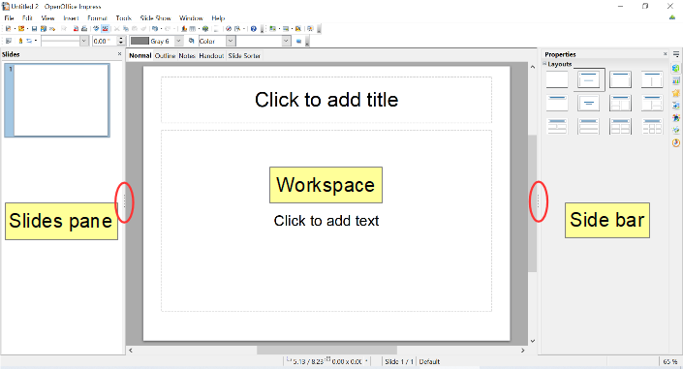Figure : The main Impress window
Tip | You can close the Slides pane or the Sidebar by clicking the X in the upper right corner of the pane or by choosing View > Slide Pane or View > Sidebar to deselect the pane. To reopen a pane, select View > Slide Pane or View > Sidebar again.  You can also maximize the Workspace area by clicking on the Hide/Show marker in the middle of the vertical separator line (indicated by ovals in Figure 106). Using the Hide/Show marker hides, but does not close, the Slides pane and Sidebar. To restore the pane, click again on its Hide/Show marker.

Slides Pane
The Slides' pane contains thumbnail pictures of the slides in your presentation, in the order they will be shown unless you change the slide show order. Clicking a slide in this pane selects it and places it in the Workspace. When a slide is in the Workspace, you can make changes any way you like.
Several additional operations can be performed on one or more slides simultaneously in the Slides pane:
- Add new slides to the presentation.
- Mark a slide as hidden so that it will not be shown as part of the presentation.
- Delete a slide from the presentation if it is no longer needed.
- Rename a slide.
- Duplicate a slide (copy and paste) or move it to a different position in the presentation (cut and paste).
It is also possible to perform the following operations, although there are more efficient methods than using the Slides pane:
- Change the slide transition following the selected slide or after each slide in a group of slides.
- Change the sequence of slides in the presentation.
- Change the slide design.
- Change slide layout for a group of slides simultaneously.

Sidebar
The Sidebar and the names of its components were introduced in Chapter 1. Introducing Apache Open Office. In Impress, it has seven decks, as shown in Figure 107. What is displayed to the left of the deck icons depends on the deck chosen and what is selected in the Workspace and may be entirely different from what is shown on your system.
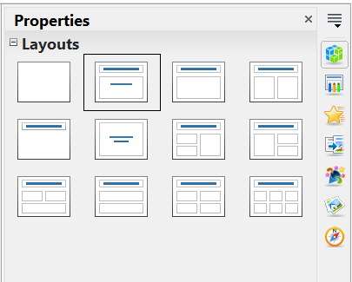

Figure : The Sidebar with its decks labeled
Properties
Master Pages
Custom Animation
Slide Transition
Styles and Formatting
Gallery
Navigator
Properties
This deck is very context dependent. Figure 107 shows the panel that is displayed when a slide is in the Workspace, but none of its components is selected. If a Text Box were selected, panels for setting the text and paragraph properties would be displayed and if a shape were selected, panels for setting area, line, and size and position would also be displayed.
Master Pages
Here you define the page (slide) style for your presentation. Impress includes several designs of Master Pages (slide masters). One of them—Default—is blank, and the rest have background and styled text. The deck has panels showing the Master Pages used in the current presentation, those used recently, and all of the available Master Pages.
Tip | The Styles and Formatting can be used to modify the styles used in any slide master to suit your purpose. This can be done at any time.
Custom Animation
A variety of animations can be used to emphasize or enhance different elements of each slide. The Custom Animation deck provides an easy way to add, change, or remove animations.
Slide Transition
The Slide Transition deck provides access to a number of slide transition options. The default is set to No Transition, in which the following slide simply replaces the existing one. However, many additional transitions are available. You can also specify the transition speed (slow, medium, fast), choose between an automatic or manual transition, and choose how long the selected slide should be shown (automatic transition only).
Styles and Formatting
This deck provides access to all the styles, which are grouped into the categories Presentation styles and Graphics styles. Styles and Formatting can also be accessed through the menu Format > Styles and Formatting or by pressing F11.
The Gallery and Navigator decks are very similar to the features available in all OpenOffice applications. Use of the Navigator is explained in Chapter 1. The Gallery provides several categories of clip art.

Workspace
The Workspace (normally in the center) has five tabs: Normal, Outline, Notes, Handout, and Slide Sorter. These five tabs are called View buttons. The Workspace below the View buttons changes depending on the chosen view. The workspace views are described in detail on page 129.
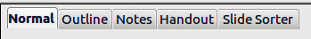
Figure : Workspace tabs

Toolbars
Many toolbars can be used during slide creation; they can be displayed or hidden by clicking View > Toolbars and selecting from the menu.
You can also select the icons that you wish to appear on each toolbar. For more information, refer to Chapter 1 (Introducing Apache OpenOffice) in this book.
Many of the toolbars in Impress are similar to the toolbars in Draw. Refer to the Draw Guide for details on the functions available and how to use them.

Status Bar
The Status bar, located at the bottom of the Impress window, contains information that you may find useful when working on a presentation. For details on the contents and use of these fields, see Chapter 1 (Introducing Apache OpenOffice).
Note | The sizes are given in the current measurement unit (not to be confused with the ruler units). This unit is defined in Tools > Options > OpenOffice Impress > General.
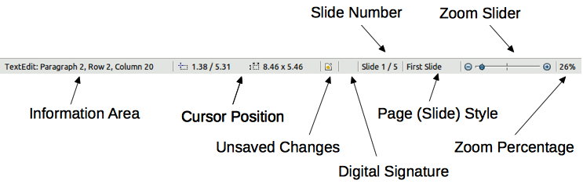
Figure : Status bar
From left to right, you will find:
- Information area, which changes depending on the selection.
For example:
Selection | Examples of information shown
Text area | TextEdit: Paragraph x, Row y, Column z
Charts, spreadsheets | Embedded object (OLE) “ObjectName” selected
Graphics | Bitmap with transparency selected
- Cursor position—the position of the cursor or of the top left corner of the selection measured from the top left corner of the slide, followed by the width and height of the selection or text box where the cursor is located.
- Unsaved changes—an asterisk or icon indicating that the file needs saving.
- Digital signature—an icon indicating whether the document is digitally signed. After the file has been saved, double-clicking on this flag opens the digital signatures dialog.
- Slide number—the slide number currently displayed in the Workspace and the total number of slides in the presentation.
- Page (slide) style—the style associated with the slide, handout, or notes page currently in the Workspace. Double-clicking on the style name opens the slide design dialog.
- Zoom slider—adjusts the zoom percentage of the Workspace displayed.
- Zoom percentage—indicates the zoom percentage of the Workspace displayed. Double-clicking on zoom percentage opens the zoom and layout dialog.
You can hide the information in the Status Bar by selecting View > Status Bar from the main menu.

Navigator
The Navigator displays all objects contained in a document. It provides another convenient way to move around a document and find items in it. To display the Navigator, click its icon among the Sidebar icons or on the Standard toolbar, choose View > Navigator on the menu bar, or press Ctrl + Shift + F5.
The Navigator is more useful if you give your slides and objects (pictures, shapes, and so on) meaningful names, instead of leaving them as the default “Slide 1” and “Shape 2”.
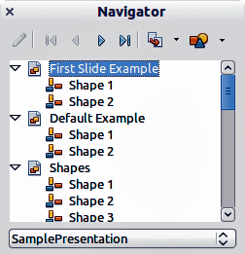
Figure : Navigator

Workspace Views
Each of the workspace views is designed to ease the completion of certain tasks; it is therefore useful to familiarize yourself with them in order to quickly accomplish those tasks.
Note | Each Workspace view displays a different set of toolbars when selected. These toolbar sets can be customized by going to View > Toolbars, then check or uncheck the toolbar you want to add or remove.

Normal View
Normal view is the main view for working with individual slides. Use this view to format and design and to add text, graphics, and animation effects.
To place a slide in the slide design area (Normal view), click the slide thumbnail in the Slides pane or double-click it in the Navigator (page 128).

Outline View
Outline view contains all the slides of the presentation in their numbered sequence. It shows topic titles, bulleted lists, and numbered lists for each slide in outline format. Only the text contained in the default text boxes in each slide is shown, so if your slide includes other text boxes or drawing objects, the text in these objects is not displayed. Slide names are also not included.

Figure : Outline view
Use Outline view for the following purposes.
- Making changes in the text of a slide:
  - Add and delete the text in a slide just as in the Normal view.
  - Move the paragraphs of text in the selected slide up or down by using the up and down arrow buttons (Move Up or Move Down) on the Text Formatting toolbar (highlighted in Figure 112).
  - Change the outline level for any of the paragraphs in a slide using the left and right arrow buttons (Promote or Demote) on the Text Formatting toolbar.
  - Both move a paragraph and change its outline level using a combination of these four arrow buttons.
- Compare slides with your outline (if you have prepared one in advance). If you notice from your outline that another slide is needed, you can create it directly in the Outline view, or you can return to the Normal view to create it.
Figure : Text Formatting toolbar

Notes View
Use the Notes view (Figure 113) to add notes to a slide. These notes are not seen when the presentation is shown.
- Click the Notes tab in the Workspace.
- Select the slide to which you want to add notes.
  - Click the slide in the Slides pane, or
  - Double-click the slide’s name in the Navigator.
- In the text box below the slide, click on the words Click to add notes and begin typing.
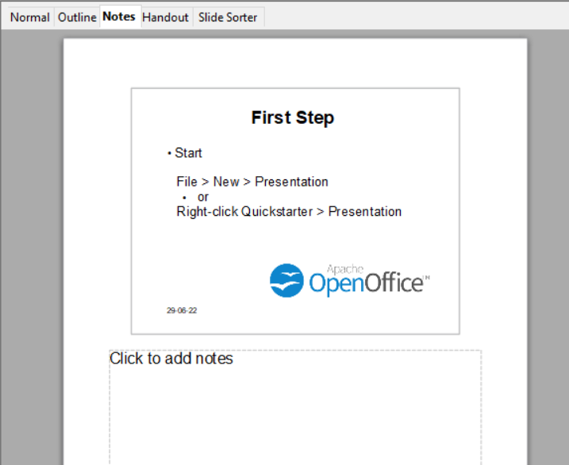Figure : Notes view
You can resize the Notes text box using the colored resizing handles which appear when you click on the edge of the box. You can also move the box by placing the pointer on the border, then clicking and dragging. To make changes in the text style, use the Styles and Formatting deck in the Sidebar or press the F11 key to open the Styles and Formatting window.

Handout View
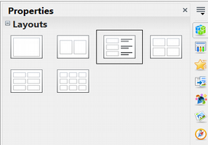Figure : Handout layouts
Handout view is for setting up the layout of your slide for a printed handout. Click the Handout tab in the workspace, then choose the Properties deck in the Sidebar. You can then select to print 1, 2, 3, 4, 6, or 9 slides per page.
Use this view also to customize the information printed on the handout. Refer to Chapter 10 of the Impress Guide for instructions on printing slides, handouts, and notes.
Select from the main menu Insert > Page Number or Insert > Date and Time and in the dialog box that opens, Figure 115, click on the Notes and Handouts tab. Use this dialog to select the elements you want to appear on each handout page and their contents. More details on how to use this dialog are provided in the Impress Guide.
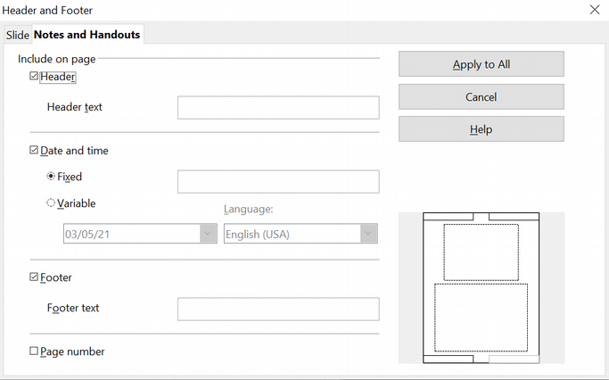Figure : Dialog to set the page information for handouts and notes

Slide Sorter View
Slide Sorter view contains all the slide thumbnails. Use this view to work with a group of slides or with only one slide.
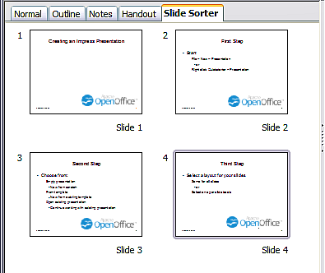Figure : Slide Sorter view

Customizing Slide Sorter View
To change the number of slides per row:
- Check View > Toolbars > Slide Sorter and Slide View to show or hide the slide sorter and view toolbars.
- Adjust the number of slides (up to a maximum of 15).
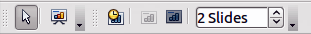
Figure : Slide Sorter and Slide View toolbars

Moving a Slide Using Slide Sorter
To move a slide in a presentation in the Slide Sorter:
- Click the slide and the slide is highlighted (see Figure 116).
- Drag and drop it to the location you want.

Selecting and Moving Groups of Slides
To select a group of slides, use one of these methods:
- Use the Control (Ctrl) key: Click on the first slide and, while pressing the Control key, select the other desired slides.
- Use the Shift key: Click on the first slide, and while pressing the Shift key, select the final slide in the group. This selects all the other slides between the first and the last.
- Use the mouse: Click slightly to one side (left or right) of the first slide to be selected. Hold down the left mouse button and drag the mouse pointer until all the slides you want selected are highlighted.
To move a group of slides:
- Select a group of slides.
- Drag and drop the group to their new location.

Working in Slide Sorter View
You can work with slides in the Slide Sorter view just as you can in the Slide pane.
To make changes, right-click a slide and choose any of the following from the pop-up menu:
- Add a new slide after the selected slide.
- Delete Slide: deletes the selected slide.
- Rename Slide: allows you to rename the selected slide.
- Slide Layout: allows you to change the layout of the selected slide in the Sidebar.
- Slide Transition: allows you to change the transition of the selected slide using the Sidebar.
  - For one slide, click the slide to select it and then add the desired transition.
  - For more than one slide, select the group of slides and add the desired transition.
- Hide Slide: hidden slides are not shown in the slide show.
- Cut: removes the selected slide and saves it to the clipboard.
- Copy: copies the selected slide to the clipboard without removing it.
- Paste: inserts a slide from the clipboard.

Creating a New Presentation
This section describes how to start a new presentation using the Presentation Wizard.
Tip | The first thing to do is decide on the purpose of the presentation and plan the presentation. Although you can make changes as you go, having an idea of whom the audience will be, the structure, the content, and how the presentation will be delivered, will save you a lot of time from the start.
When you start Impress, the Presentation Wizard appears.
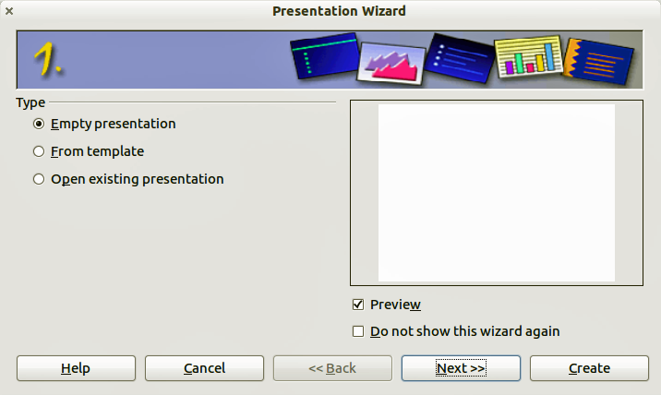
Figure . Choosing the type of presentation
- Under Type, choose one of the options. These options are covered in the Impress Guide.
  - Empty presentation creates a blank presentation.
  - From template uses a template design already created as the basis for a new presentation. The wizard changes to show a list of available templates. Choose the template you want.
  - Open existing presentation continues work on a previously created presentation. The wizard changes to show a list of existing presentations. Choose the presentation you want.
- Click Next. Figure 119 shows the Presentation Wizard step 2 as it appears if you selected Empty Presentation at step 1. If you selected From template, an example slide is shown in the Preview box.
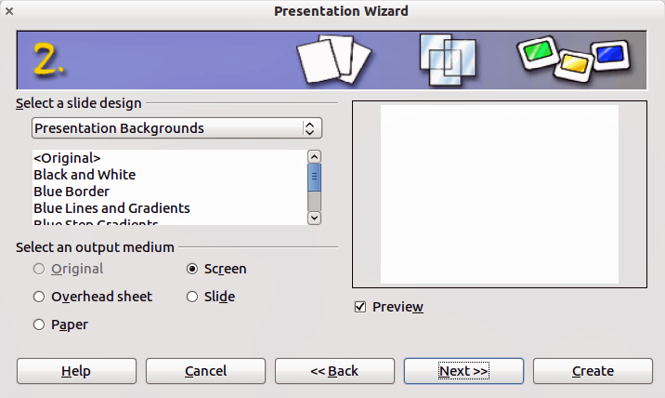
Figure . Selecting a slide design
- Choose a design under Select a slide design. The slide design section gives you two main choices: Presentation Backgrounds and Presentations. Each one has a list of choices for slide designs. If you want to use one of these other than <Original>, click it to select it.
  - The types of Presentation Backgrounds are shown in Figure 119. By clicking an item, you will see a preview of the slide design in the Preview window. Impress contains three choices under Presentations: <Original>, Introducing a New Product, and Recommendation of a Strategy.
  - <Original> is for a blank presentation slide design.
  - Both Introducing a New Product and Recommendation of a Strategy have their own prepackaged slide designs. Each design appears in the Preview window when its name is clicked.
Note | Introducing a New Product and Recommendation of a Strategy can also be used to create a presentation by choosing From template in the first step (Figure 118).
- Select how the presentation will be used under Select an output medium. Most often, presentations are created for computer screen display. Select Screen. You can change the page format at any time.
Note | The Screen page is optimized for a 4:3 display (28 cm x 21 cm) so it is not suitable for modern widescreen displays. You can change the slide size at any time switching to Normal view and selecting Format Page.
- Click Next. The Presentation Wizard step 3 appears (Figure 120).
  - Choose the desired slide transition from the Effect drop-down menu.
  - Select the desired speed for the transition between the different slides in the presentation from the Speed drop-down menu. Medium is a good choice for now.
- Click Create. A new presentation is created.
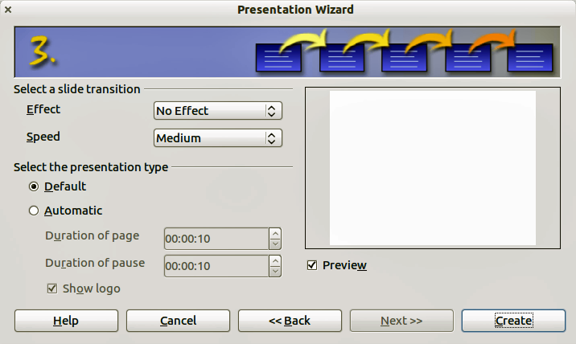
Figure : Selecting a slide transition effect
Tip | You can accept the default values for both Effect and Speed unless you are skilled at creating presentations. Both of these values can be changed later while working with Slide transitions and animations. These two features are explained in more detail in Chapter 9 of the Impress Guide.
Note | If you selected From template on step 1 of the Wizard, the Next button will be active on step 3 and other pages will be available. These pages are not described here.
Caution | Remember to save frequently while working on the presentation, to prevent any loss of information should something unexpected occur. You might also want to activate the AutoRecovery function (Tools > Options > Load/Save > General). Make sure Save AutoRecovery information every is selected and that you have entered a recovery frequency.

Formatting a Presentation
A new presentation contains only one empty slide. In this section we will start adding new slides and preparing them for the intended contents.

Inserting Slides
This can be done in a variety of ways; take your pick.
- Insert > Slide.
- Right-click on the present slide, and select Slide > New Slide from the pop-up menu.
- Click the Slide icon In the Presentation toolbar.
Sometimes, rather than starting from a new slide you want to duplicate a slide you have already inserted. To duplicate a slide, select the slide you want from the Slides pane and then choose Insert > Duplicate Slide.

Selecting a Layout
In the Sidebar, select the Properties deck. The Layouts panel will display the available layouts if no elements are selected in the slide. The Layouts differ in the number of elements a slide will contain, from a blank slide to a slide with six contents boxes and a title.
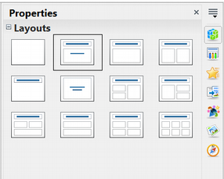Figure : Available slide layouts
The first slide in a presentation is normally a title slide. The Title Slide (which also contains a section for a subtitle) or Title Only are suitable layouts for the first slide, while for most of the slides you will probably use the Title, Contents layout.
To create the title, click on Click to add title (assuming the Blank Slide layout was not used) and then type the title text. To adjust the formatting of the title, modify the Title presentation style in the Styles and Formatting deck of the Sidebar; see Chapter 2 in the Impress Guide for instructions.
If you are using the Title Slide layout, click on Click to add text to add a subtitle. Proceed as above to make adjustments to the formatting if required, modifying the Subtitle presentation style instead.
Note | Text and graphic elements can be readjusted at any time during the preparation of the presentation, but changing the layout of a slide that already contains some contents can have a dramatic effect. It is therefore recommended that you pay particular attention to the layout you select. If you do need to change the layout after contents have been added, the contents are not lost though they may need to be reformatted.
Tip | To view the names for the included layouts, use the Tooltip feature: position the cursor on an icon in the Layout panel (or on any toolbar icon) and its name will be displayed in a small rectangle.  If tooltips are not enabled, choose Tools > Options > OpenOffice > General > Help and select the Tips option. If the Extended tips option is also selected, you will get more detailed tooltip information, but the tooltip names themselves will not be provided.
Several layouts contain one or more content boxes. Each of these boxes can be configured to contain one of the following elements: Text, Movie, Picture, Chart, or Table.
You can choose the type of contents by clicking on the corresponding icon that is displayed in the middle of the contents box as shown in Figure 122. If instead you intend to use the contents box for text, just click anywhere on the box to get a cursor.
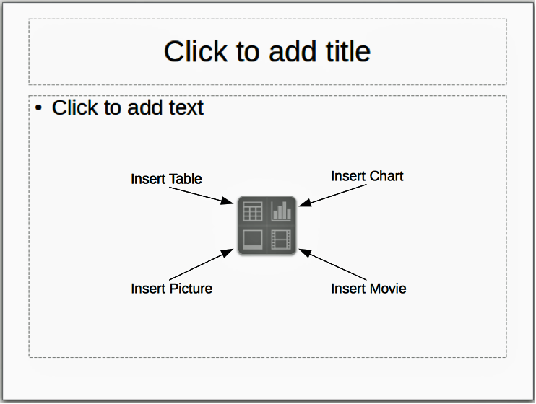
Figure : Selecting contents type
If you have selected a layout with one or more contents boxes, this is a good time to decide what type of contents you want to insert.

Modifying the Slide Elements
At this stage, the slide contains elements that were included in the slide master, as well as those elements included in the selected slide layout. It is however unlikely that the predefined layouts will suit all your needs. You may want to remove any elements that are not required or insert objects such as text and graphics.
Although Impress does not have the functionality to create new layouts, it allows you to resize and move the layout elements. It is also possible to add slide elements without being limited to the size and position of the layout boxes.
To resize a contents box, click on the outer frame so that the 8 resizing handles are displayed. To move it place the mouse cursor on the frame so that the cursor changes shape. You can now click the left mouse button and drag the contents box to its new position on the slide.
To remove any unwanted elements, do this:
- Click the element to highlight it. The colored resizing handles show it is highlighted.
- Press the Delete key to remove it.
Caution | Changes to any of the layouts included in Impress can only be made using View > Normal, which is the default. Attempting any changes by modifying a slide master, although possible, may result in unpredictable results and requires extra care as well as a certain amount of trial and error.

Adding Text to a Slide
To add text to a slide that contains a text frame, click on Click to add text in the text frame and then type your text. The Outline styles are automatically applied to the text as you insert it. You can change the outline level of each paragraph as well as its position within the text by using the arrow buttons on the Text Formatting toolbar (see “Outline View” on page 129).

Adding Pictures or Objects to a Slide
To add any pictures or objects to a slide, for example a picture, clip art, drawing, photograph, or spreadsheet, click on Insert then select from the drop-down menu what type of insert you require. For more information, see “Adding Pictures, Tables, Charts, Media Files, and Other Objects” on page 146.

Modifying the Appearance of All Slides
To change the background and other characteristics of all slides in the presentation, you need to modify the master page or choose a different master page as explained in “Working with Master Pages and Styles” on page 149.
A Slide Master is a slide with a specified set of characteristics that acts as a template and is used as the starting point for creating other slides. These characteristics include the background, objects in the background, formatting of any text used, and any background graphics.
Note | Apache OpenOffice uses three interchangeable terms for this one concept. Master slide, slide master, and master page. These terms all refer to a slide that is used to create other slides. This guide, however, uses only the term slide master, except when describing the user interface.
Impress includes a range of slide masters, found in the Master Pages deck of the Sidebar. You can also create and save additional slide masters or add more from other sources. See Chapter 2 in the Impress Guide for information on creating and modifying slide masters.
If all you need to do is to change the background, you can take a shortcut:
- Select Format > Page and go to the Background tab.
- Select the desired background between solid color, gradient, hatching, and bitmap.
- Click OK to apply it.
A dialog box will open asking if the background should be applied to all the slides. If you click yes, Impress will automatically modify the master page for you.
Note | Inserting and correctly formatting a background is beyond the scope of this chapter, but you can find all the information you need in Chapter 4 of the Draw Guide or in Chapter 6 of the Impress Guide.

Modifying the Slide Show
By default, the slide show will display all the slides in the same order as they appear in the slide sorter, without any transition between slides, and you need some keyboard or mouse interaction to move from one slide to the next.
You can use the Slide Show menu to change the order of the slides, choose which ones are shown, automate moving from one slide to the next, and other settings. To change the slide transition, animate slides, add a soundtrack to the presentation, and make other enhancements, you need to use functions in the Sidebar. See the Impress Guide for details on how to use all of these features.

Adding and Formatting Text
Many of your slides are likely to contain some text. This section gives you some guidelines on how to add text and how to change its appearance. Text in slides is contained in text boxes. For more information on adding and formatting text, see Chapter 3 in the Impress Guide.
There are two types of text boxes that you can add to a slide:
- Choose a predefined layout from the Layouts section of the Properties deck of the Sidebar and do not select any special contents type. These text boxes are called AutoLayout text boxes.
- Create a text box using the text tool in the Drawing toolbar or the Text toolbar.

Using Text Boxes Created from the Layout pane
Make sure Normal view is selected:
- Click in the text box that reads Click to add text.
- Type or paste your text in the text box.

Using Text Boxes Created from the Text Tool
Make sure Normal view is selected:
- Click on the Text icon on the Drawing toolbar or press F2. If the Drawing toolbar with the text icon is not visible, choose View > Toolbars > Drawing.
- Click and drag to draw a box for the text on the slide. Do not worry about the vertical size and position as the text box will expand if needed as you type.
- Release the mouse button when finished. The cursor appears in the text box, which is now in edit mode (gray hashed border shown in Figure 123).
- Type or paste your text in the text box.
- Click outside the text box to deselect it.
You can move, resize, and delete text boxes. For more information, see Chapter 3 in the Impress Guide.
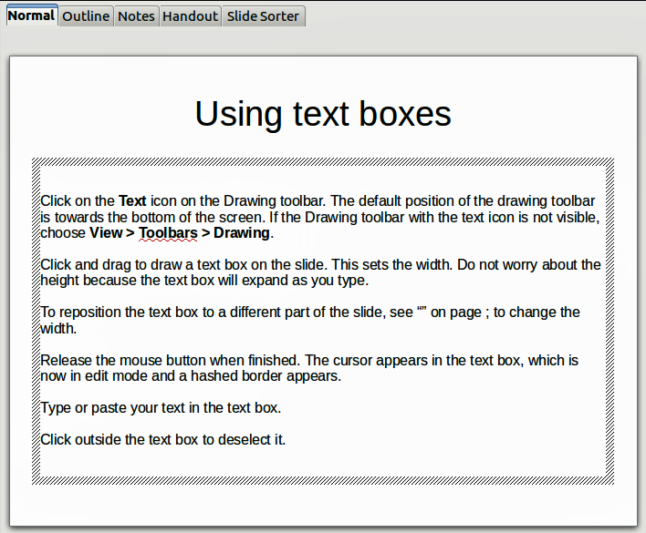
Figure : Creating and editing text boxes

Using Text Boxes Created from the Text Toolbar
Make sure Normal view is selected:
- Click on the Text icon on the Text toolbar (Figure 124). If the Text toolbar with the text icon is not visible, choose View > Toolbars > Text.
- Click and drag to draw a text box on the slide. This sets the width. Do not worry about the height because the text box will expand as you type.
- Release the mouse button when finished. The cursor appears in the text box, which is now in edit mode (a hashed border; see Figure 123).
- Type or paste your text into the text box.
- Click outside the text box to deselect it.
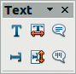
Figure : Text toolbar
Note | In addition to the normal text boxes where text is horizontally aligned, it is possible to insert text boxes where the text is aligned vertically. This choice is available only when Asian languages are enabled in Tools > Options > Language Settings > Languages. Click on the button in the drawing toolbar or text toolbar to create a vertical text box.

Quick Font Resizing
Impress has icons on the Text panel of the Properties deck of the Sidebar and on the Text Formatting toolbar to increase or decrease font size of selected text. The amount by which the font size changes depends on the standard sizes available for the font in use.

Pasting Text
Text may be inserted into the text box by copying it from another document and pasting it into Impress. However, the pasted text will probably not match the formatting of the surrounding text or that of the other slides in the presentation. This may be what you want on some occasions; however in most cases you want to make sure that the presentation style is consistent and does not become a patchwork of different paragraph styles, font types, bullet points and so on. There are several ways to ensure consistency; these methods are explained below.

Pasting Unformatted Text
It is normally good practice to paste text without formatting and apply the formatting later. To paste without formatting, either press Ctrl+Shift+V and then select Unformatted text from the dialog that appears, or click on the small black triangle next to the paste symbol in the standard toolbar and select Unformatted text. The unformatted text will be formatted with the outline style at the cursor position in an AutoLayout text box or with the default graphic style in a normal text box.

Formatting Pasted Text
If you are pasting the text into an AutoLayout area, you need to apply the appropriate outline style to the text to give it the same look and feel as the rest of the presentation.
- Paste the text in the desired position. Do not worry if it does not look right; it will in a minute.
- Select the text you have just pasted.
- Select Format > Default formatting from the menu bar.
- Use the four arrow buttons in the Text Formatting toolbar (highlighted in Figure 112) to move the text to the appropriate position and give it the appropriate outline level. The button with the arrow pointing left promotes the list entry by one level (for example from Outline 3 to Outline 2), the right arrow button demotes the list entry by one level, the up and down arrow buttons move the list entry.
- Apply manual formatting as required to sections of the text (to change font attributes, tabs, and so on).
If you are pasting text in a text box, you can still use styles to quickly format the text. Note that one and only one graphic style can be applied to the copied text. To do that:
- Paste the text in the desired position.
- Select the text you have just pasted.
- Select the desired graphic style.
- Apply manual formatting as required to sections of the text.

Creating Bulleted and Numbered Lists
The procedure to create a bulleted or numbered list is quite different depending on the type of text box used, although the tools to manage the list and customize the appearance are the same.
In text boxes created automatically by Impress (called AutoLayout), the outline styles available are by default bulleted lists, while for normal text boxes an additional step is required to create a bulleted list.

Creating Lists in AutoLayout Text Boxes
Every text box included in the available layouts is already formatted as a bulleted list, therefore to create a bulleted list the only necessary steps are:
- From the Layout panel, choose a slide design that contains a text box. Those are easily recognizable from the thumbnail.
- Click in the text box that reads Click to add text.
- Type the text, then press Enter to start a new bulleted line.
- The methods for switching between bulleted and numbered lists are explained in “Changing the Appearance of the List” on page 145.
Tip | Press Shift + Enter to start a new line without creating a new bullet or number. The new line will have the same indentation as the previous line. To switch off bullets altogether, click the bullets button on the text formatting toolbar. If the text formatting toolbar is not showing, enable it selecting View > Toolbar > Text Formatting on the menu bar.

Creating Lists in Other Text Boxes
To create a list in a text box, follow these steps:
- Place the cursor in the text box.
- Click the Bullets On/Off button in the Paragraph panel of the Properties deck of the Sidebar.
- Type the text and press Enter to start a new bulleted line.
- The default list type is a bulleted list. Methods for changing the appearance of the list are explained on page 145.

Creating a New Outline Level
- If necessary, press Enter to begin a new line.
- Press Tab or click the indentation arrows in the Paragraph panel of the Properties deck. Each time you press Tab or click the right arrow, the line indents to the next outline level. Pressing Enter creates a new line at the same level as the previous one. To return to the previous level, press Shift+Tab or click the left arrow.
In the AutoLayout text boxes, promoting or demoting an item in the list corresponds to applying a different outline style, so the second outline level corresponds to Outline 2 style, the third to Outline 3 style, and so on. As a consequence, a change in the level also produces other changes (for example, font size, bullet type, and so on).
Note | Do not try to change the outline level by selecting the text and then clicking the desired outline style as you would in Writer. Due to the way that presentation styles work, it is not possible to apply them in this way.

Changing the Appearance of the List
You can fully customize the appearance of a list, changing the bullet type or numbering for the entire list or for single entry. All changes can be made using the Bullets and Numbering dialog, which is accessed by selecting Format > Bullets and Numbering or by clicking on the Bullets and Numbering icon on the text formatting toolbar. A subset of the dialog's options are quickly accessible via the bullets or numbering icons in the Paragraph panel of the Sidebar's Properties deck and the full dialog can be reached by clicking More Options from the drop-down lists of those icons.
For the entire list:
- Select the entire list or click on the gray border of the text box so that the colored resizing handles are displayed.
- Access the Bullets and Numbering dialog using any of the methods described above or use the choices available from the drop-down lists of the Sidebar icons. In the latter case you can skip step 3.
- The Bullets and Numbering dialog contains five tabs: Bullets, Numbering type, Graphics, Position, and Customize.
  - If a bullet list is needed, select the desired bullet style from the default styles available on the Bullets page.
  - If a graphics style is needed, select one from those available on the Graphics page.
  - If a numbered list is needed, select one of the default numbering styles on the Numbering type page.
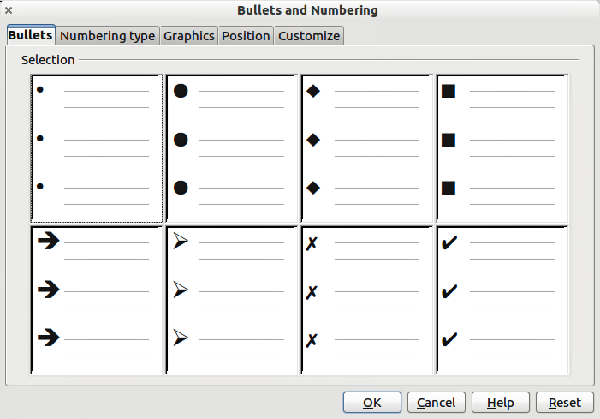
Figure : Bullets and Numbering dialog
For a single line in the list, click anywhere in the line to place the cursor in it and then follow steps 2 and 3 in the previous instruction set.
If the list was created in an AutoLayout text box, then an alternative way to change the entire list is to modify the Outline styles. Changes made to the outline style will apply to all the slides using them. Sometimes this is what you want; sometimes it is not, so some care must be taken.

Adding Pictures, Tables, Charts, Media Files, and Other Objects
As we have seen, in addition to text, a contents box can contain also pictures, tables, charts, and movies. This section provides a quick overview of how to work with these objects; for a more detailed description, you are invited to consult the Impress Guide.

Adding Pictures
To add a picture to a contents box:
- Go to Insert > Picture on the main menu bar and then select either From file or Scan.
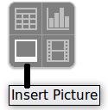
- Alternatively, and after inserting a new slide, click the Insert Picture icon and select the file from the Insert Picture dialog that opens. To see a preview of the picture, check Preview at the bottom of the Insert Picture dialog (Figure 126).
- Move the picture to the desired location.
The picture will resize itself to fill the area with the contents box. Follow the directions in the Caution note below when manually resizing a graphic.

Figure . Insert picture dialog
Caution | When resizing a graphic, right-click the picture. Select Position and Size from the context menu and make sure that Keep ratio is selected. Then adjust the height or width to the size you need. (As you adjust one dimension, both dimensions will change.) Failure to do so will cause the picture to become distorted. Remember also that resizing a bitmap image will reduce its quality; it is better to create an image of the desired size outside of Impress.

Adding Tables
For displaying tabular data, you can insert basic tables directly into your slides by choosing the Table contents type. It is also possible to add a table outside a contents box in a number of ways:
- Go to Insert > Table on the main menu bar.
- Click on the Table icon on the main toolbar or table toolbar.
- After inserting a new slide, click the Insert Table icon.
- Alternatively, click on the Table Design icon on the table toolbar to open the Table Design section of the Tasks pane and then select a style.
The first three methods above opens the Insert Table dialog, where you can select the required number of columns and rows. Alternatively, clicking on the black arrow next to the Table icon displays a graphic allowing you to drag and select the number of required rows and columns for your table.
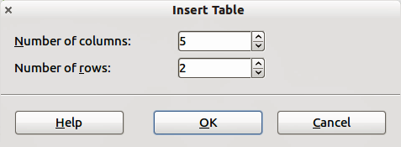
Figure . Creating a table with the Insert Table dialog
Note | Creating a table will cause the Properties deck of the Sidebar to display a Table Design panel where several table features can be set conveniently.
With the table selected, the Table toolbar should appear. If it does not, you can access it by selecting View > Toolbars > Table. The Table toolbar offers many of the same icons as the table toolbar in Writer, except for functions like Sort and Sum for performing calculations. For those functions, you need to use a spreadsheet inserted from Calc (discussed below).
After the table is created, you can modify it in much the same way as you would modify a table in Writer: adding and deleting rows and columns, adjusting width and spacing, adding borders, background colors and so on. Detailed information on working with tables and the Table Properties dialog can be found in Chapter 3 of the Impress Guide and Chapter 9 of the Writer Guide.
By modifying the style of the table from the Table Design section of the Sidebar, you can quickly change the appearance of the table or any newly created tables based on the Style options you select. You can choose to add emphasis to a header and total row as well as the first and last columns of the table, and apply a banded appearance to the rows and columns.
Having completed the table design, entering data into the cells is similar to working with text box objects. Click in the cell you wish to add data to, and begin typing. To move around cells quickly, use the following key options:
- The arrow keys move the cursor to the next table cell if the cell is empty, otherwise they move the cursor to the next character in the cell.
- The Tab key moves to the next cell, skipping over the contents of the cell; Shift+Tab move backwards from cell to cell.

Adding Charts
To insert a chart in a slide you can either use Insert > Chart from the main menu bar, clicking on the Chart icon in the main toolbar, or, after inserting a new slide, clicking on the Insert Chart icon. Impress will insert a default chart. To modify the chart type, insert your own data and change the formatting, right-click on the chart and select Chart Type or Chart Data Table. Refer to the Impress Guide for more details.

Adding Media Files
You can insert various types of media files, such as music and movie clips, into your slide by selecting the Insert Movie icon in an empty contents box. A media player will open at the bottom of the screen, and you can preview the media. When an audio file is inserted, the contents box will show a loudspeaker image.
Caution | In Linux-based systems such as Ubuntu, media files do not work straight out of the box. You need to download the Java Media Framework API (JMF) and add the path to jmf.jar to the Class Path in Tools > Options > OpenOffice > Java.

Adding Graphics, Spreadsheets, and Other Objects
Graphics, such as shapes, callouts, arrows, and so on, are often useful to complement the text on a slide. These objects are handled much the same way as graphics in Draw. For more information, see Chapter 6 (Getting Started with Draw) in this book, the Draw Guide, or Chapters 4, 5, and 6 in the Impress Guide.
Spreadsheets embedded in Impress include most of the functionality of spreadsheets in Calc and are therefore capable of performing extremely complex calculations and data analysis. If you need to analyze your data or apply formulas, these operations are best performed in a Calc spreadsheet and the results displayed in an embedded Impress spreadsheet or even better in a native Impress table.
Alternatively, choose Insert > Object > OLE Object > OpenOffice Spreadsheet from the menu bar. This opens a spreadsheet in the middle of the slide and the menus and toolbars change to those used in Calc so that you can start adding data, though you may first need to resize the visible area on the slide. You can also insert an already existing spreadsheet and use the viewport to select the data that you want to display on your slide.
Impress offers the capability of inserting in a slide various other types of objects such as Writer documents, Math formulas, or even another presentation. For details on using these objects, refer to Chapter 7 of the Impress Guide.

Working with Master Pages and Styles
A slide master is a slide that is used as the starting point for other slides. It is similar to a page style in Writer, and it controls the basic formatting of all slides based on it. A slide show can have more than one slide master.
Note | Apache OpenOffice uses three terms for a slide that is used to create other slides: master slide, slide master, and master page. This book uses the term slide master, except when describing the user interface.
A slide master has a defined set of characteristics, including the background color, graphic, or gradient; objects (such as logos, decorative lines, and other graphics) in the background; headers and footers; placement and size of text frames; and the formatting of text.

Styles
All characteristics of slide masters are controlled by styles. The styles of any new slide you create are inherited from the slide master from which it was created. In other words, the styles of the slide master are available and applied to all slides created from that slide master. Changing a style in a slide master results in changes to all the slides based on that slide master, but you can modify individual slides without affecting the slide master.
Note | Although it is highly recommended to use the slide masters whenever possible, there are occasions where manual changes are needed for a particular slide, for example to enlarge the chart area when the text and chart layout is used.
Slide masters have two types of styles associated with them: presentation styles and graphic styles. The prepackaged presentation styles can be modified, but new presentation styles cannot be created. In the case of graphic styles, you can modify the prepackaged ones and also create new ones.
Presentation styles affect three elements of a slide master: background, background objects (such as icons, decorative lines, and text frames), and text placed on the slide. Text styles are further divided into Notes, Outline 1 through Outline 9, Subtitle, and Title. The outline styles are used for the different levels of the outline to which they belong. For example, Outline 2 is used for the sub-points of Outline 1, and Outline 3 is used for the sub-points of Outline 2.
Graphic styles affect many of the elements of a slide. Notice that text styles exist in both the presentation and graphic style selections.

Slide Masters
Impress comes with a collection of slide masters. These slide masters are shown in the Master Pages deck of the Sidebar (Figure 128). This deck has three panels: Used in This Presentation, Recently Used, and Available for Use. Click the + sign next to the name of a panel to expand it to show thumbnails of the slides, or click the – sign to collapse the subsection to hide the thumbnails.
Each of the slide masters shown in the Available for Use list is from a template of the same name. If you have created your own templates, or added templates from other sources, slide masters from those templates will also appear in this list.
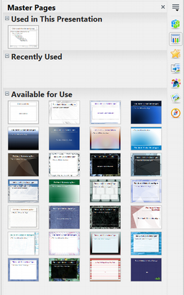Figure : Available master pages (slides masters)

Creating a Slide Master
You can create a new slide master with methods similar to modifying the default slide master.
To start, enable editing of slide masters by selecting View > Master > Slide Master and the Master View toolbar opens. You can also right-click on the slide master in the Master Pages deck of the Sidebar and select Edit Master to open the Master View toolbar. On the Master View toolbar, click the New Master icon (highlighted in Figure 129).
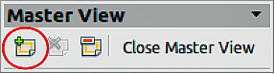
Figure : Master View toolbar
A second slide master appears in the Slides pane. Modify this slide master to suit your requirements. It is also recommended that you rename this new slide master: right-click on the slide in the Slides pane and select Rename master from the pop-up menu. When you are done, close the Master View toolbar to return to normal slide editing mode.

Applying a Slide Master
In the Sidebar, make sure the Master Pages deck is showing (Figure 128).
To apply one of the slide masters to all slides in your presentation, click on it in the list.
To apply a different slide master to one or more selected slides:
- In the Slide Pane, select the slides you want to change.
- In the Sidebar, right-click on the slide master you want to apply to the selected slides, and click Apply to Selected Slides on the pop-up menu.

Loading Additional Slide Masters
Sometimes, in the same set of slides, you may need to mix multiple slide masters that may belong to different templates. For example, you may need a completely different layout for the first slide of the presentation, or you may want to add to your presentation a slide from a different presentation (based on a template available on the hard disk).
The Slide Design dialog makes this possible. Access this dialog either from the menu bar (Format > Slide design) or from the pop-up menu that appears when right-clicking on a slide in the Slides pane.
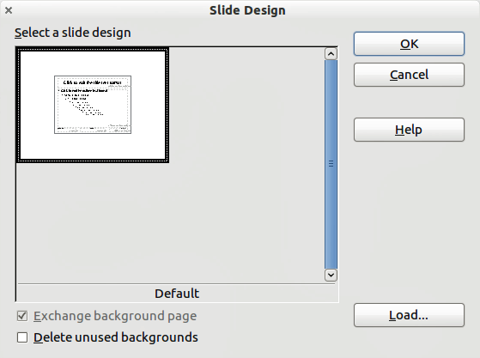
Figure : Slide Design
The main window in the dialog shows the slide masters already available for use. To add more:
- Click the Load button.
- Select in the Load Slide Design dialog (Figure 131) the template from which to load the slide master and click OK.
- Click OK again to close the slide design dialog.
The slide masters in the template you selected are now shown also in the Master Pages section of the Sidebar in the Available for Use subsection.
Note | The slide masters you have loaded will also be available the next time you load the presentation. If you want to delete the unused slide masters, click the corresponding checkbox in the Slide Design dialog. If the slide master was not used in the presentation, it is removed from the list of available slide masters anyway.
Tip | To limit the size of the presentation file, you may want to minimize the number of slide masters used.
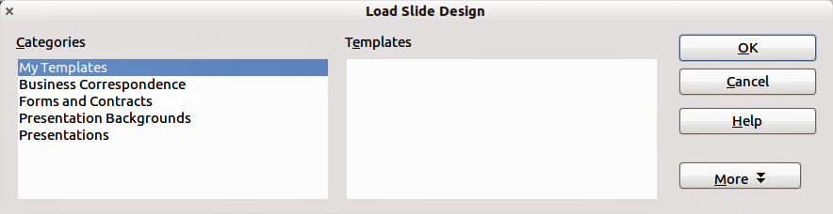
Figure : Load Slide Design dialog for selecting templates

Modifying a Slide Master
The following items can be changed on a slide master:
- Background (color, gradient, hatching, or bitmap)
- Background objects (for example, add a logo or decorative graphics)
- Size, placement, and contents of header and footer elements to appear on every slide
- Size and placement of default frames for slide titles and content
To select the slide master for modification:
- Select View > Master > Slide Master from the menu bar. This unlocks the properties of the slide master, so you can edit it.
- Click Master Pages in the Sidebar. This gives you access to the slide masters.
- Click on the slide master you want to modify among the ones available.
- Make changes as required, then click the Close Master View icon on the Master View toolbar. For details, see Chapter 2 of the Impress Guide.
- Save the file before continuing.
Caution | Any changes made to one slide when in Master View mode will appear on all slides using this slide master. Always make sure you close Master View and return to Normal view before working on any of the presentation slides. Select View > Normal from the menu bar, or clicking Close Master View in the Master View toolbar to return to the normal slide view.
The changes made to one of the slides in Normal view (for example, changes to the bullet point style, the color of the title area, and so on) will not be overridden by subsequent changes to the slide master. There are cases, however, where it is desirable to revert a manually modified element of the slide to the style defined in the slide master: to do that, select that element and choose Format > Default Formatting from the menu bar.

Using a Slide Master to Add Text to All slides
Some supplied slide masters have text objects in the footer. You can add other text objects to the master page for your slides to act as a header or a footer.
- Choose View > Master > Slide Master from the menu bar.
- On the Drawing toolbar, select the Text icon or press F2.
- Click once and drag in the master page to draw a text object, and then type or paste your text into the object or add fields as described below.
- Choose View > Normal when you are finished.
The Impress slide master comes with three pre-configured areas: for date, footer, and slide number.
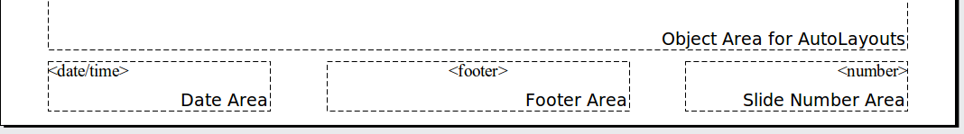
To add page (slide) numbers or date and time to the slide footers in your presentation, select Insert > Page Number or Insert > Date and Time to open the Header and Footer dialog (Figure 132) where you can select and configure these areas on the slide.
Tip | To change the number format (1,2,3 or a, b, c or i, ii, iii, etc.) for the page number field, choose Format > Page and then select a format from the list in the Layout Settings area.  To change the paragraph style, modify the Background Objects Presentation style.
To add other information, such as the author of the presentation or the name of the file, use Insert > Fields and select the required field from the submenu. If you want to edit this field in your slide, select it and choose Edit > Fields. See Chapter 2 (Adding and Formatting Text) in the Impress Guide for more information.
Tip | To change the author information, go to Tools > Options > OpenOffice > User Data.
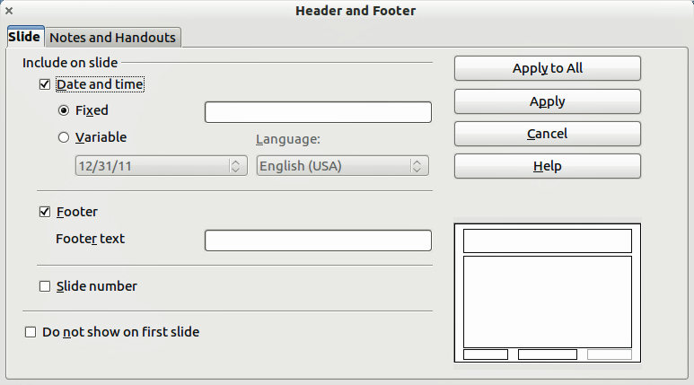
Figure : Configuring the slide footer areas
The fields you can use in Impress are:
- Date (fixed)
- Date (variable): updates automatically when you reload the file
- Time (fixed)
- Time (variable): updates automatically when you reload the file
- Author: first and last names listed in the OpenOffice user data
- Page Number (slide number)
- Page Count
- File Name

Adding Comments to a Presentation
Impress supports comments similar to those in Writer and Calc.
In Normal View, choose Insert > Comment from the menu bar. A small box containing your initials appears in the upper left-hand corner of the slide, with a larger text box beside it. Impress automatically adds your name and the current date at the bottom of the text box.
Type or paste your comment into the text box. You can optionally apply some basic formatting to the comment by selecting it, right-clicking, and choosing from the pop-up menu. From this menu, you can apply formatting to selected text, delete the current comment, delete all comments from the same author, or delete all comments in the presentation.
You can move the small comment markers to anywhere you wish on the slide. Typically, you might place it on or near an object you refer to in the comment.
To show or hide the comment markers, choose View > Comments.
Select Tools > Options > User Data to configure the name you want to appear in the Author field of the comment, or to change it.
If more than one person edits the document, each author is automatically allocated a different background color for their comments.
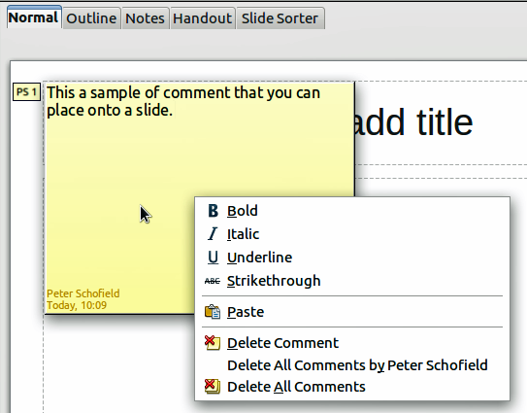
Figure : A comment

Setting Up the Slide Show
As mentioned in “Modifying the Slide Show” on page 141, Impress allocates reasonable default settings for slide shows, while at the same time allowing for customizing many aspects of the slide show experience. This section covers only some aspects; advanced techniques are explained in Chapter 9 (Slide Shows) in the Impress Guide.
Most of the tasks are best done in Slide Sorter view where you can see most of the slides simultaneously. Choose View > Slide Sorter from the menu bar or click the Slide Sorter tab at the top of the workspace.

One-slide Set — Multiple Presentations
In many situations, you may find that you have more slides than the time available to present them, or you may want to provide a rapid overview without dwelling on the details. Rather than having to create a new presentation, you can use two tools that Impress offers: hiding slides and custom slide shows.
To hide a slide, right-click on the slide thumbnail either in the Slide pane, in the Workspace area, or in the Slide Sorter view and choose Hide Slide from the pop-up menu. Hidden slides are marked by a slashed slide number.
If you want to reorder the presentation, choose Slide Show > Custom Slide Show. Click on the New button to create a new sequence of slides and save it.
You can have as many slide shows as you want from a single slide set.

Slide Transitions
Slide transition is the animation that is played when a slide is changed for the next slide in the presentation. You can configure the slide transition from the Slide Transition deck in the Sidebar. Select the desired transition, the speed of the animation, and whether the transition should happen when you click the mouse (preferred) or automatically after a certain number of seconds. Click Apply to all slides unless you prefer to have different transitions in the presentation.
Tip | The Slide transition panel has a very useful choice: Automatic preview. Select its checkbox and when you make any changes in a slide transition, the new slide is previewed in the Slide Design area, including its transition effect.

Automatic Slide Advance
You can set the presentation to automatically advance to the next slide after a set amount of time from the Slide Transition deck in the Sidebar. Go to Advance slide and select Automatically after, then choose the required amount of time in seconds that each slide will be displayed. Click on the Apply to All Slides button to apply the same display time to all slides.
To apply a different display time to each slide in your presentation, choose Slide Show > Rehearse Timings. Start the slide show and a small timer is displayed in the bottom left corner. When you are ready to advance to the next slide, click on the timer. If you mouse click on the display background or press the right arrow on your keyboard to advance the slide, Impress will keep the default time. Impress will memorize the timings for each slide and advance to the slide automatically after each timing ends when you run the slide show.
To automatically restart a slide show after the last slide has been displayed, go to Slide Show > Slide Show Settings on the menu bar. Select Auto and the timing of the pause between slide shows. Click OK when you have finished.

Running a Slide Show
To run a slide show, do one of the following:
- Click Slide Show > Slide Show on the menu bar.
- Click the Slide Show icon on the Presentation toolbar.
- Press F5 on the keyboard.
If the slide transition is Automatic after x seconds, let the slide show run by itself.
If the slide transition is On mouse click, do one of the following to move from one slide to the next:
- Use the arrow keys on the keyboard to go to the next slide or to go back to the previous one.
- Click the mouse to move to the next slide.
- Press the space bar on the keyboard to advance to the next slide.
Right-click anywhere on the screen to open a menu from which you can navigate the slides and set other options.
To exit the slide show at any time including at the end, press the Esc key.

Chapter 6
Getting Started with Draw

What Is Draw?
Draw is a vector graphics drawing program, although it can also perform some operations on raster graphics (pixels). Using Draw, you can quickly create a wide variety of graphical images.
Vector graphics store and display an image as simple geometric elements such as lines, circles, and polygons rather than a collection of pixels (points on the screen). Vector graphics allow for easier storage and scaling of the image.
Draw is fully integrated into the Apache OpenOffice suite, and this simplifies exchanging graphics with all components of the suite. For example, if you create an image in Draw, reusing it in a Writer document is as simple as copying and pasting the image. You can also work with drawings directly from within Writer or Impress, using a subset of the functions and tools from Draw.
Draw’s functionality is extensive; even though it was not designed to rival high-end graphics applications, it possesses more functions than most drawing tools that are integrated with office productivity suites.
A few examples of drawing functions are:
- Layer management
- Magnetic grid point system
- Dimensions and measurement display
- Connectors for making organization charts
- 3D functions that enable small three-dimensional drawings to be created (with texture and lighting effects)
- Drawing and page style integration
- Bézier curves
This chapter introduces some of Draw’s features, but it does not attempt to cover all of them. See the Draw Guide and the application Help for more information.

Parts of the Main Draw Window
The components of the main Draw window are shown in Figure 134.
You can surround the drawing area with toolbars and information areas. The number and position of the visible tools vary with the task in hand and user preferences. Therefore, your setup may look different. For example, many users put the main Drawing toolbar on the left-hand side of the workspace, not at the bottom as shown here. The figure shows the Sidebar with the Properties deck as it appears when a shape is selected. Many functions from various toolbars and menus are available in the Sidebar and displaying it with View > Sidebar may allow you to work with fewer toolbars visible. The Sidebar is introduced in Chapter 1.
You can split drawings in Draw over several pages. Multipage drawings are used mainly for presentations. The Pages pane, on the left side of the Draw window in Figure 134 gives an overview of the pages that you create. If the Pages pane is not visible on your setup, you can enable it from the View menu (View > Page Pane).
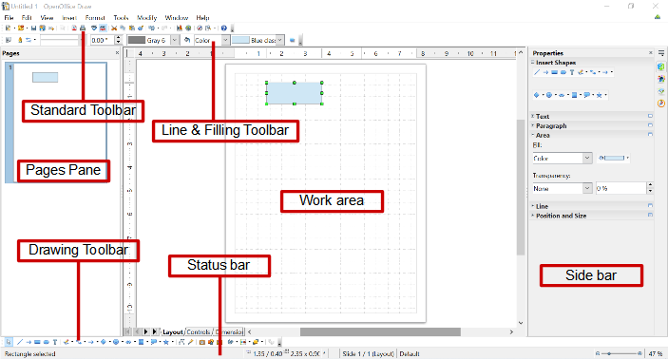Figure . Initial Draw window

Rulers
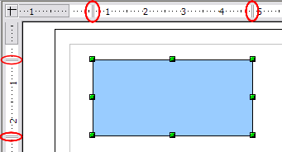
Figure : Rulers show the size of the selected object
You should see rulers (bars with numbers) on the upper and left-hand side of the workspace. The rulers show the size of a selected object on the page (see the gray double lines, highlighted in Figure 135). When no object is selected, they show the location of the mouse pointer, which helps to accurately position drawing objects.

You can also use the rulers to manage object handles and guidelines, making it easier to position objects. The page margins in the drawing area are also represented on the rulers. You can change the margins directly on the rulers by dragging them with the mouse.
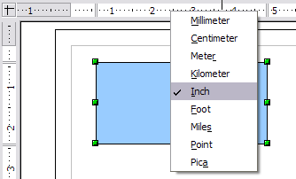
Figure . Ruler units
To modify the unit of measurement of a ruler, right-click on the ruler and select one of the measurement units. The two rulers can have different units.

Status Bar
The Status bar is located at the bottom of the screen (in all Apache OpenOffice components); it includes several Draw-specific fields.
For details on the contents and use of these fields, see Chapter 1 (Introducing Apache OpenOffice).
Note | The sizes are given in the current measurement unit (not to be confused with the ruler units). This unit is defined in Tools > Options > OpenOffice Draw > General, where you can also change the scale of the page. Another way to change the scale is to double-click on the number shown in the status bar.

Figure : Left end of the Draw status bar

Figure : Right end of Draw status bar

Toolbars
To display or hide the various Draw toolbars, choose View > Toolbars. On the menu that appears, select which toolbars you want to display. For more about working with toolbars, see Chapter 1 (Introducing Apache OpenOffice).
The tools available in the Draw toolbars are explained in the following sections. The appearance of the toolbar icons may vary depending on your operating system and the selection of icon size and style in Tools > Options > OpenOffice > View.
Standard toolbar
The Standard toolbar is the same for all Apache OpenOffice components and is not described in detail in this chapter.
Line and Filling toolbar
The Line and Filling toolbar lets you modify the main properties of a drawing object. See page 175 for details.
Text Formatting toolbar
If the selected object is text, the Line and Filling toolbar changes to the Text Formatting toolbar, which is similar to the Formatting toolbar in Writer. For more information, see Chapter 3 (Getting Started with Writer) in this book.
Drawing toolbar
The Drawing toolbar is the most important toolbar in Draw. It contains all the necessary functions for drawing various geometric and freehand shapes and for organizing them on the page.
Many of the functions of the Line and Filling, the Text Formatting, and the Drawing toolbars are available in the Properties deck of the Sidebar once an object is selected
Options toolbar
Use the Options toolbar to activate or deactivate various drawing aids. To display the Options toolbar, select View > Toolbars > Options.
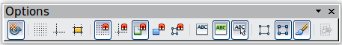
Figure : Options toolbar

Choosing and Defining Colors
Color Bar
To display the Color Bar, use View > Toolbars > Color Bar. The toolbar then appears at the bottom of the workspace.
This toolbar lets you rapidly choose the color of the objects in your drawing. The first box in the panel corresponds to transparency (no color).
You can access several specialized color palettes in Draw, as well as change individual colors to your own taste. To do this, choose Format > Area or the pouring can icon on the Line and Filling toolbar. This opens the Area dialog. Select the Colors tab.
To load another palette, click on the Load Color List button (circled in Figure 140). The file selector dialog asks you to choose one of the standard Apache OpenOffice palettes (files with the file extension *.soc). For example, web.soc is a color palette that is particularly adapted to creating drawings that are going to appear in Web pages. The colors will correctly display on workstations with screens displaying at least 256 colors.
The color selection box also lets you individually change any color by modifying the numerical values in the fields provided to the right of the color palette. You can use the color schemes known as CMYK (Cyan, Magenta, Yellow, Black), and RGB (Red, Green, Blue).
Click on the Edit button to open the Color Picker, where you can set individual colors. See “Color options” in Chapter 11 (Setting Up and Customizing Apache OpenOffice) in this book. Many more input possibilities are available in this dialog.
For a more detailed description of color palettes and their options, see Chapter 8 (Tips and Tricks), in the Draw Guide.
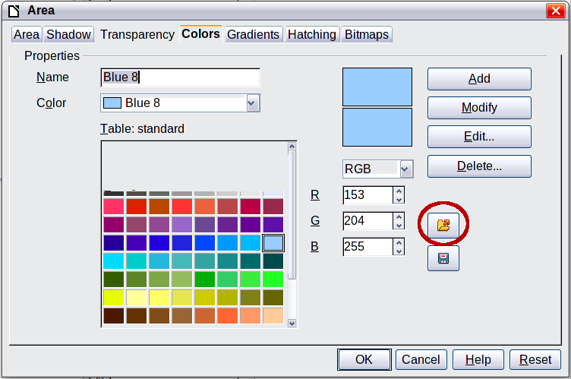
Figure . Changing the color palette

Positioning Objects with Snap Functions
In Draw, objects can be accurately and consistently positioned using grid points, special snap points and lines, object frames, individual points on objects, or page edges. This function is known as Snap.
The snap function is easier to work with at the highest practical zoom value. You can use two different snap functions at the same time, for example snapping to a guideline and to the page edge. It is best, however, to activate only those functions that you really need.
This section summarizes the snap-to-grid function. For more detailed information about the snap functions, see Chapter 8 (Tips and Tricks) and Chapter 10 (Advanced Draw Techniques) in the Draw Guide.

Snap to Grid
Use this function to move an object exactly to a grid point (see Figure 141). Switch this function on and off with View > Grid > Snap to Grid on the Options toolbar with the icon.
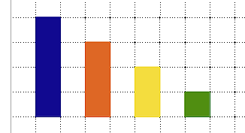
Figure : Exact positioning with snap to grid

Showing the Grid
To make the grid visible, choose View > Grid > Display Grid. Alternatively, turn the grid on (or off) with the icon on the Options toolbar.

Configuring the Grid
The spacing, and resolution of the grid points can be individually chosen for each axis. The spacing between the lines is defined in the Grid options dialog (Tools > Options > OpenOffice Draw > Grid).
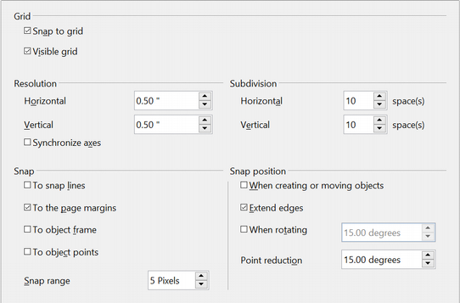Figure : Setting grid options
In the dialog shown in Figure 142, you can set the following parameters:
- Vertical and horizontal spacing of the dots in the grid. You can also change the unit of measurement used in the general Draw options (Tools > Options > OpenOffice Draw > General).
- The resolution is the size of the squares or rectangles in the grid. If the resolution is Horizontal 1 cm, Vertical 2 cm, the grid consists of rectangles 2 cm high and 1 cm wide.
- Subdivisions are additional points that appear along the sides of each rectangle or square in the grid. Objects snap to subdivisions as well as to the corners of the grid.
- The pixel size of the snap area defines how close you need to bring an object to a snap point or line before it will snap to it.

Changing the Color of the Grid Points
The default grid dots are light gray, which can be hard to see. To change the color of the grid points, choose Tools > Options > OpenOffice > Appearance.
In the Drawing / Presentation section, you can change the color of the grid points. On the Color Settings pull-down menu, select a more suitable/visible color, for example black.
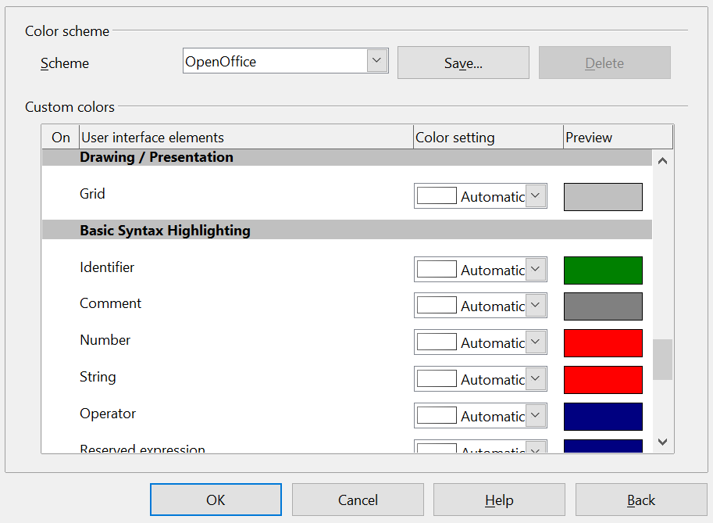

Figure : Changing the grid color

Positioning Objects with Guiding Lines
To simplify the positioning of objects it is possible to make visible guiding lines—extensions of the edges of the object—while it is being moved. These guiding lines have no snap function.
The guiding lines can be activated or deactivated under Tools > Options > OpenOffice Draw > View > Guides when moving, or by clicking on the icon on the Options toolbar.

The Basic Drawing Shapes
Draw provides a wide range of shapes, located in palettes accessed from the Properties deck of the Sidebar or the Drawing Toolbar. This section describes only a few of the basic shapes. These shapes include; rectangles and squares, circles, ellipses, and arcs, 3D objects, curves, lines and arrows, text, and connectors. All shapes in Draw are called objects. See the Draw Guide for a complete description of the shapes available.
Note | When you draw a basic shape or select one for editing, the Info field on the left side in the status bar changes to reflect the present action: Create Line , Text frame xxyy selected, and so on.
Figure 144 shows part of the Drawing toolbar with the icons needed in the following sections. The Text icon is also included. These same icons are displayed in the Sidebar.
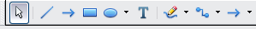
Figure : Part of the Drawing toolbar

Drawing a Straight Line
Click on the Line icon on the Drawing toolbar and position the mouse pointer where you want to start the line. Drag the mouse while keeping the button pressed. Release the mouse button at the point where you want to end the line.
A selection handle appears at each end of the line, showing that this is the currently selected object.
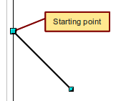
Figure : Drawing a straight line
To restrict the angle of the line to a multiple of 45 degrees (0, 45, 90, 135, and so on), hold down the Shift key while you draw the line.
To snap the end of the line to the nearest grid point, hold down the Control (Ctrl) key while drawing the line.
Note | The effect of the Ctrl key depends on the settings of the Snap to Grid option on the View > Grid menu:  Snap to Grid on: Ctrl deactivates the snap option for this activity.  Snap to Grid off: Ctrl activates the snap option for this activity.
To extend the line symmetrically in both directions from the starting point, hold down the Alt key while drawing the line.
To change line attributes (for example, the color or line type), select the line by clicking on it, then use the tools in the Line and Filling toolbar or the Line panel of the Sidebar Properties deck; or for more control, right-click on the line and choose Line to open the Line dialog.

Drawing an Arrow
Arrows are drawn like lines. Draw classifies arrows as a subgroup of lines: Lines with arrowheads. The information field on the status bar shows them only as lines. Click on the Line Ends with Arrow icon to draw an arrow.

Choosing Line Endings
Several types of line endings (arrows, circles, squares, and others) are available in Draw. Choose View > Toolbars > Arrows, or click on the small black triangle on the Lines and Arrows icon on the Sidebar or Drawing toolbar, to open a toolbar with ten tools for drawing lines and arrows. The last-used command is stored on the toolbar to make it quicker to call it up again.
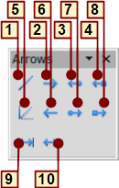
1 | Line | 5 | Line (45°) | 8 | Line with square/arrow
2 | Line Ends with Arrow | 6 | Line starts with arrow | 9 | Dimension line
3 | Line with arrow/circle | 7 | Line with circle/arrow | 10 | Line with arrows
4 | Line with arrow/square
Figure : Arrows toolbar

Drawing a Rectangle or Square
Drawing a rectangle is similar to drawing a straight line, except that you click on the Rectangle icon and the (imaginary) line drawn by the mouse corresponds to a diagonal of the rectangle. The rectangle changes shape as you drag the mouse around.
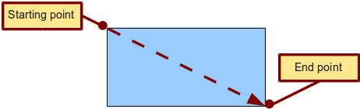
Figure : Drawing a rectangle
Hold down the Shift key to draw a square. Hold down the Alt key to draw a rectangle starting from its center. To combine the effects, hold down both the Shift and Alt keys simultaneously.

Drawing a Circle or Ellipse
To draw an ellipse (also called an oval) or a circle, use the Ellipse icon . (A circle is simply an ellipse with both axes the same length.) The ellipse drawn is the largest ellipse that fits inside the (imaginary) rectangle drawn with the mouse.
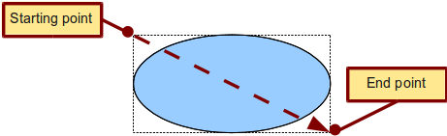
Figure : Drawing an ellipse
Here are some other ways to draw an ellipse or circle:
- To draw a circle, hold down the Shift key while dragging the mouse.
- To draw an ellipse with the starting point at the center (instead of the corner), hold down the Alt key while dragging the mouse.
- To draw a circle with the starting point at the center, hold down both the Alt and Shift keys while dragging the mouse.
- To draw an ellipse or circle that snaps to the nearest grid points, hold down the Ctrl key while dragging the mouse.
Note | If you first press and hold down the Ctrl key and then click on one of the icons for Line, Rectangle, Ellipse, or Text, a standard sized object is drawn automatically in the work area; the size, shape, and color are all standard values. These attributes can be changed later, if desired.

Drawing Curves
The tools for drawing curves or polygons are on the toolbar that appears when you click the arrow next to the Curve icon on the Sidebar or the Drawing toolbar. This toolbar contains eight tools (see Figure 149).
If you move the mouse cursor over one of the icons, a tooltip pops up with a description of the function.
Note | Hovering the mouse pointer over this icon gives a tooltip of Curve. If you convert the icon to a floating toolbar, however, the title is Lines, as shown in Figure 149.
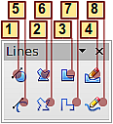
1 | Curve, filled | 4 | Free-form line, Filled | 7 | Polygon (45°)
2 | Polygon, filled | 5 | Curve | 8 | Free-form line
3 | Polygon (45°), filled | 6 | Polygon
Figure : Curves toolbar (incorrectly titled "Lines")
Polygons
Draw the first line from the start point with the left mouse button held down. As soon as you release the mouse button, a first corner point is drawn; move the mouse to see how the second line will look. Every mouse click sets another corner point. A double click ends the drawing. A filled polygon automatically joins the last point to the first point to close off the figure and fills it with the current standard fill color. A polygon without filling will not be closed at the end of the drawing.
Polygon 45°
Like ordinary polygons, these are formed from lines but with angles of 45 or 90 degrees between them.
Free-form line
With this tool you can draw just like with a pencil. Press and hold the left mouse button and drag the mouse. It is not necessary to end the drawing with a double click. Just release the mouse button and the drawing is completed. If you have selected Free-form Line, Filled, the end point is joined automatically to the start point and the object is filled with the appropriate color.
Curves and filled curves
For a description of the handling of curves and filled curves, see Chapter 10 (Advanced Draw Techniques) in the Draw Guide.

Writing Text
Use the Text tool to write text and select the font, color, size, and other attributes. Click at the location where you want to position the text or click and drag to create a larger text frame. Press Enter to move the cursor to the next line.
When you have finished typing text, click outside the text frame. Double-click on the text at any time to edit it.
When you use the Text tool, text formatting panels appear in the Sidebar and the Text formatting toolbar is visible; they include the usual paragraph attributes: indents, first line, and tab stops.
You can create Graphics styles that you can reuse for other text frames. Select the Styles and Formatting deck of the Sidebar, the menu Format > Styles and Formatting or press F11 to open the Styles and Formatting window. Graphics styles affect all the text within a text frame. To style parts of the text, use direct formatting with the Sidebar or toolbar.
Text frames can also have fill colors, shadows, and other attributes, just like any other Draw object. You can rotate the frame and write the text at any angle. These options are available by right-clicking on the object.
Use the Callout tool , located on the Sidebar or the Drawing toolbar, to create callouts (also known as captions or figure labels).
If you double-click on an object or press F2 or click the Text icon when an object is selected, text is written in the center of the object and remains within the object. Nearly any kind of object contains such an additional text element. These texts have slight differences to those in text frames concerning position and hyphenation.
For more about text, see Chapter 2 (Drawing Basic Shapes) and Chapter 10 (Advanced Draw Techniques) in the Draw Guide.

Gluepoints and Connectors
All Draw objects have associated invisible gluepoints, which become visible when you choose any of the connectors under the Connector icon on the Sidebar or Drawing toolbar and then move the mouse pointer over the object.
Most objects have four gluepoints, as shown in Figure 150. You can add more gluepoints, and customize gluepoints, using the toolbar under the Gluepoint icon on the Drawing toolbar. This icon is not available on the Sidebar but can be accessed with View > Toolbars > Gluepoints.
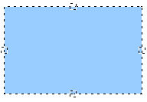
Figure : Four gluepoints
Gluepoints are different from handles (the small blue or green squares around an object). The handles are for moving or resizing an object. The gluepoints attach connectors to an object.
Connectors are lines or arrows whose ends automatically dock to gluepoints on an object. When you move the other object, the connector moves with it. Connectors are particularly useful for making organizational charts. You can reorganize the blocks of your chart and all the connected objects stay connected.
Figure 151 shows two Draw objects and a connector.

Figure : A connector between two objects
Draw offers a range of different connectors and connector functions. Open the floating Connector toolbar by clicking on the arrow next to the Connector icon . For more about connectors and gluepoints, see Chapter 9 (Organization Charts, Flow Diagrams, and More) in the Draw Guide.

Drawing Geometric Shapes
Geometric shapes include basic shapes, symbol shapes, block arrows, flowcharts, callouts, and stars. You can add text to all these shapes. See Chapter 2 (Drawing Basic Shapes) and Chapter 10 (Advanced Draw Techniques) in the Draw Guide for details.
Figure 152 shows part of the Drawing toolbar with the icons referred to in the following sections. The same icons are available on the Sidebar. Clicking on the arrow next to the icon opens a floating toolbar with the relevant work tools.
Tip | The use of all these tools is similar to that of the Rectangle tool, even though they produce different geometric shapes.
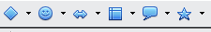
Figure : Part of the main Drawing toolbar
Basic shapes
The Basic Shapes icon makes available the range of tools for drawing basic shapes, including a rectangular tool identical to the one on the main toolbar. | 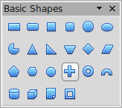
Symbol shapes
The Symbol Shapes icon provides an array of tools for drawing the various symbols. | 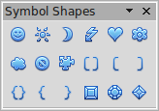
Block arrows
The Block Arrows icon opens the Block Arrows toolbar. | 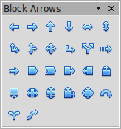
Flowcharts
The tools for drawing flowcharts are accessed by clicking on the Flowcharts icon .  The creation of flowcharts, organization charts, and similar planning tools are described in Chapter 9 (Organization Charts, Flow Diagrams, and More) in the Draw Guide. | 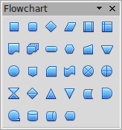
Callouts
Use the Callouts icon to open the Callouts toolbar. | 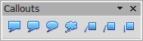
Stars and banners
These tools are associated with the Stars icon . | 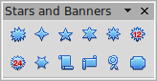

Selecting Objects

Direct Selection
The easiest way to select an object is to click directly on it. For objects that are not filled, click directly on the object's outline to select it.
Selection by Framing  You can select several objects at once by using the mouse to drag a large rectangle around the objects, as shown. For this to work, the Select icon on the Drawing toolbar must be active. Only objects that lie entirely within the rectangle are selected. | 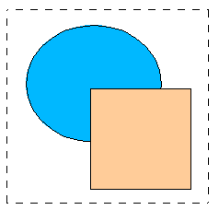

Selecting Hidden Objects
Even if objects are located behind others and not visible, they can still be selected. Hold down the Alt key and click where the object is located. If there are several overlapping objects, hold down the Alt key and click until you reach the object you want. To cycle through the objects in reverse order, hold down the Alt+Shift keys. The number and type of selected objects is shown at the left of the status bar to help you select the correct object.
Note | This method generally works in Windows, but on a Linux system it usually does not. If the Alt key on your system does not operate as described above, use the Tab key method described below.
To select an object that is covered by another object using the keyboard, press the Tab key to cycle through the objects, stopping at the object you wish to select. To cycle through the objects in reverse order, press Shift+Tab. This may not be practical if you have numerous objects in your drawing.
When you click on the selected object, its outline will appear briefly through the objects covering it.  In the illustration to the right, the square located beneath the circle was selected in this way (the circle was made transparent in order to see the square). | 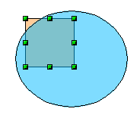

Arranging Objects
In a complex drawing, several objects may be stacked on top of one another. To rearrange the stacking order (move an object to the front or to the back of the stack), select the object, choose Modify > Arrange and choose Bring Forward or Send Backward. Or right-click the object, select Arrange from the context menu, then pick Bring Forward or Send Backward.
These options are also available from the Arrange tear-off toolbar from the button on the Drawing toolbar. A keyboard shortcut is Shift+Ctrl+plus sign to bring an object to the top, and Shift+Ctrl+minus to send an object to the bottom.
Draw also provides tools for aligning multiple objects; details are given in the Draw Guide.

Selecting Several Objects
To select or deselect several objects one by one, press the Shift key and click on the various objects to be selected or deselected. One click on an object selects it; a second click on the same object deselects it.

Moving and Dynamically Adjusting an Object’s Size
There are several ways of moving or changing the size of an object. The dynamic method described here uses the mouse.
When you dynamically change an object, remember to check the left-hand area of the status bar at the bottom of the Draw window. This area shows detailed information about the ongoing manipulation. This information changes when the mouse is moved.

Dynamic Movement of Objects
To move an object, select it and then click within the object’s border and hold down the left mouse button while dragging the mouse.  During movement, the shape of the object appears a faded version of the shape to help with repositioning.  To drop the object at its new location, release the mouse button. The new position appears immediately in the Status Bar. | 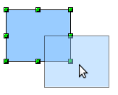

Dynamic Size Modification of Objects
To change the size of a selected object (or group of selected objects) with the mouse, move one of the handles located around the selection. As shown in the following illustration, a faded version of the new object shape is shown. | 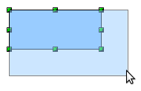
The results depend on which handle you use. To resize an object along one axis, use the appropriate side handle. To resize both axes, use a corner handle. The new size appears immediately in the status bar.
Note | If you press the Shift key while resizing an object, the change in size will be carried out symmetrically with respect to the two axes, so that the aspect (height/width) ratio of the object remains the same.

Rotation
Rotating an object lets you move the object around an axis. To do this dynamically (with the mouse), use the red handles, as you do when changing the size of the object. To get the red handles, click once on the object to select it and then click once on a green handle.
Note | Rotation works in a slightly different way for 3D objects because the rotation occurs in 3D space and not in one plane. See Chapter 7 (Working with 3D Objects) in the Draw Guide regarding rotation when Edit Points mode is active.
To rotate an object (or a group of objects), drag the red corner handle point of the selection with the mouse. The mouse cursor takes the shape of an arc of a circle with an arrow at each end. A faded version of the object being rotated appears and the current angle of rotation is dynamically shown in the status bar.
Rotations are made around an axis which is displayed as a small symbol, as shown in Figure 153. You can move the axis of rotation with the mouse.
If you hold down the Shift key during the rotation, the operation will be carried out in increments of 15°.
Figure : Rotating an object

Inclination and Perspective
To slant or shear objects, use the red handles located at the midpoint of an edge of the selected objects. The mouse pointer changes to a when the pointer hovers over one of these midpoint handles. Not every object can be slanted.
The slant axis is the point directly opposite the midpoint handle to be used for shearing the object. This point stays fixed in location; the other sides and edges move in relation to it as the mouse is dragged (make sure that the handle icon is showing before dragging).  As with rotation, you can set the inclination (slanting) to occur in steps of 15° by pressing the Shift key while moving the handle. | 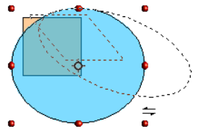

Editing Objects
To change an object’s attributes (such as color and border width) you can use the Area and Line panels of the Sidebar, the Line and Filling toolbar or the context menu.
If the Line and Filling toolbar (Figure 154) is not visible, you can display it using View > Toolbars > Line and Filling. From here you can edit the most common object attributes. You can also open the Line dialog by clicking on the Line icon and the Area dialog by clicking on the Area icon to see more options.
The same icons are available on the Sidebar, though the More Options icons are at the right edge of the title bar of the Line and Area panels.
1 Styles and Formatting  2 Line  3 Arrow Style | 4 Line Style  5 Line Width  6 Line Color | 7 Area  8–9 Area Style / Filling  10 Shadow
Figure : Line and Filling toolbar
When you select text, this toolbar changes to show text formatting options.

The Context Menu
When an object is selected, you can right-click on the object to bring up a context menu, which provides additional access to the options shown above and another way to change an object’s attributes. The entries with a small arrow on the right-hand side contain a submenu.

Editing Lines and Borders
Lines, arrows, and the borders of an object are managed through the Line dialog. An object’s border is just another type of line. | 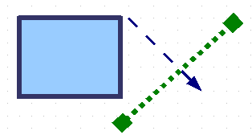
You can change some properties from the Line and Filling toolbar. To see more options, select the object and click on the Line icon or right-click on the object and choose Line from the context menu. This opens the Line dialog.

Common Line Properties
In most cases the property you want to change is the line’s style (solid, dashed, invisible, and so on), its color, or its width. These options are all available on the Sidebar or from the Line and Filling toolbar (Figure 154).
You can also edit these properties from the Line dialog, where you can also change the line’s transparency. Figure 155 illustrates different degrees of transparency.
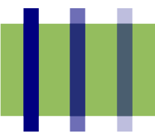Figure : The vertical lines have different levels of transparency (0%, 25%, and 50%).


Drawing Arrows
Arrowheads (and other line endings—usually referred to collectively as arrows) are a line property. Select a line and click on the Arrow Style 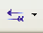 icon on the Sidebar or from the Line and Filling toolbar. This opens the Arrowheads menu.
Several types of arrowheads are available. Each end of the line can have a different arrowhead (or no arrowhead).
Arrowheads are only applicable to lines. They have no effect on an object’s border.

Customizing Line and Arrow Styles
You can modify the line and arrow styles and create your own. See Chapter 4 (Changing Object Attributes) in the Draw Guide for details.

Editing the Inside (Fill) of an Object
The Apache OpenOffice term for the inside of an object is Area fill. The area fill of an object can be a uniform color, a gradient, a hatching, or an image. It can be made partly or fully transparent and can throw a shadow.

In most cases, you will choose one of the standard fill options, which are all available from the Sidebar or the Line and Filling toolbar. You can also define your own area fills; see Chapter 4 in the Draw Guide for details.

Adding a Shadow
In Draw, shadows are considered as an area property. Click on the Shadow icon on the Line and Filling toolbar. This icon is not available directly on the Sidebar but the Shadow function is on the Area dialog reached through the More Options icon at the top right of the Area panel.  You can customize the position, distance, color, and transparency of shadows by using Format > Area > Shadow or by right-clicking on the selected object and choosing Area > Shadow. | 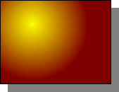

Adding Transparency
You can make objects partly or fully transparent, or even with a varying degree of transparency (as a gradient).

Using Styles
Suppose that you want to apply the same area fill, line thickness, and border to a set of objects. This repetitive process can be greatly simplified by the use of styles. Styles allow you to define a formatting template (a style) and then to apply that style to multiple objects. For more information about styles, see Chapter 2 (Using Styles and Templates) in this book.

Special Effects
With Draw, you can apply many special effects to objects and groups of objects. This section describes a few of these effects. The icons for these effects are available on the Drawing toolbar under the 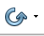 icon. More effects include distorting, shadows, and transparency can be found in Chapter 4 (Changing Object Attributes) in the Draw Guide.

Flip an Object
Select an object and click on the Flip icon . You will see a dashed line through the middle of the object. | 
This dashed line is the axis of symmetry. The object will be flipped around this line. Move one or both ends of the line with your mouse to set the orientation of the axis. | 
Then, grab any one of the eight green handles and move it across to the other side of the dashed line. The new position of the figure is shown dashed until the mouse is released. | 
Note | If you hold down the Shift key while moving the line, the line will rotate in 45-degree increments.

Mirror Copies
Move the axis of symmetry to the desired location of the mirror axis. Copy the object to the clipboard. Flip the object, then click on an empty area of the Draw screen in order to deselect the object. Paste from the clipboard to put a copy of the object in its original location, and now you have a mirror copy.
 | 

Distorting an Image
There are three tools through the Effects icon that let you drag the corners and edges of an object to distort the image.
The Distort tool distorts an object in perspective, the Set to Circle (slant) and Set in Circle (perspective) tools both create a pseudo three-dimensional effect. See Chapter 4 in the Draw Guide for details.

Dynamic Gradients
You can control transparency gradients in the same manner as color gradients. Both types of gradient can be used together. With a transparency gradient, the direction and degree of an object’s fill color changes from opaque to transparent (in a regular gradient, the fill changes from one color to another, but the degree of transparency remains the same). See Chapter 4 in the Draw Guide for details.

Duplication
Duplication makes copies of an object while applying a set of changes (such as color or rotation) to the duplicates. The result of a duplication is a new group of objects.
To start duplication, click on an object or group and choose Edit > Duplicate. The dialog shown in Figure 156 appears. When the options selected in that dialog are applied to a blue rectangle, they produce the result shown in Figure 157.
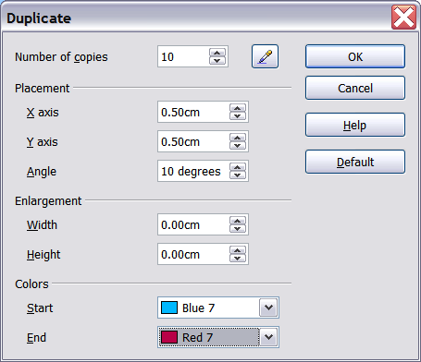
Figure : Duplicating an object
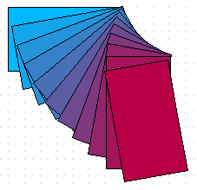Figure : Result of duplication

Cross-fading
Cross-fading transforms a shape from one form to another. The result is a new group of objects including the start and end points and the intermediate steps.
To carry out a cross-fade, first select two objects (hold the Shift key while selecting each object in turn) and then choose Edit > Cross-fading.
On the Cross-fading dialog, choose the number of increments (transition steps). You probably want to have Cross-fade attributes and Same orientation both checked. The end result is shown in Figure 159.
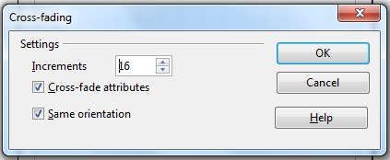
Figure : Choosing cross-fading settings
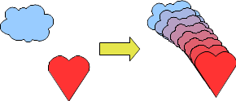Figure : Cross-fading example

Combining Multiple Objects
Using Draw, you can combine drawing objects together in two distinct ways: grouping and combining. These two methods allow you to treat multiple objects as one unit, or to merge objects to form a new shape.
Grouping is like putting objects in a container. You can move them as a group and apply global changes to them. A group can always be undone and the objects that make up the group can always be manipulated separately.
A combination is a permanent fusion of objects leading to a new object. The original objects are no longer available as individual entities and the operation is not reversible.

Grouping by Common Selection
When several objects are selected, any operations you carry out are applied to all the objects. For example, you can rotate a group of objects in its entirety. Groups obtained through common selection of many objects are undone as soon as you click outside the group. However, you can group objects and keep those selected objects grouped together.

Maintaining Groups and Undoing Groups
To group objects, first select the objects, then right-click and choose Group from the pop-up menu. You can also use the keyboard shortcut Ctrl+Shift+G or select Modify > Group from the menu bar.
When objects are grouped, any editing operations carried out on that group are applied to all members of the group. If you click on one member of the group, the whole group is selected.
The objects of a group retain their own individual properties. To undo a group, right-click and choose Ungroup from the pop-up menu, use the keyboard shortcut Ctrl+Alt+Shift+G or choose Modify > Ungroup from the menu bar.
You can edit a member of a group individually without breaking the group. To do this, right-click and choose Enter group or double-click on the group.

Combining Objects
In contrast to grouping functions, combinations create a new object; subsequent “un-combining” in the same manner as ungrouping is not possible. Select a collection of objects, then right-click and choose Combine from the pop-up menu.
After you have selected more than one object, the Merge, Subtract, and Intersect functions can be reached in the Modify > Shapes menu or though the group’s right-click menu under the heading Shapes.

Aids for Positioning Objects
Draw has various tools to help you arrange the objects with respect to each other:
- Moving an object to the front or to the back
- Aligning objects with respect to each other
- Distributing the distance and space between objects
See Chapter 5 (Combining Multiple Objects) in the Draw Guide for more information.

Inserting and Editing Pictures
Draw contains a number of functions for editing raster graphics (bitmaps)—for example, photos and scanned images—including import and export as well as conversion from one format to another. Draw can read in all the usual range of graphic file formats.
You can add pictures from several sources:
- The Gallery; see Chapter 10 (Graphics, the Gallery, and Fontwork) in this book
- Directly from a scanner (Insert > Picture > Scan)
- Images created by another program, including photographs from a camera (Insert > Picture > From File)
Draw provides tools for working with bitmap images: the Picture toolbar and the bitmap image management palette. However, it does not have the same capabilities as the specialized raster graphics programs like Adobe Photoshop or The Gimp. See Chapter 6 (Editing Pictures) in the Draw Guide for details and examples.

Working with 3D Objects
Although Draw does not match the functionality of the leading drawing or picture editing programs, it is capable of producing and editing very good 3D drawings.
Draw offers two types of 3D objects: 3D bodies, and 3D shapes. Depending on which type you choose, there are different possibilities for further editing of the object (rotation, illumination, perspective). 3D shapes are simpler to set up and edit than 3D bodies, but 3D bodies currently allow for more customization.
See Chapter 7 (Working with 3D Objects) in the Draw Guide for details.

Exporting Graphics
To save a Draw image in a format other than *.odg, use File > Export. Draw can save to many graphic file formats. You can export the entire file or selected objects.
You can also export Draw files to HTML or PDF. PDF export is the same as for any part of Apache OpenOffice, as described in Chapter 9 (Printing, Exporting, and E-mailing) in this book.
HTML export uses a conversion wizard that creates as many web pages as there are pages in your Draw document. You can optionally choose to display the pages in frames with a navigator and can set an index page. This process is similar to creating web pages from Impress presentations. For more information, see Chapter 10 (Printing, E-mailing, Exporting, and Saving Slide Shows) in the Impress Guide.

Adding Comments to a Drawing
Draw supports comments similar to those in Writer and Calc.
Choose Insert > Comment from the menu bar. A small box containing your initials appears in the upper left-hand corner of the Draw page, with a larger text box beside it. Draw has automatically added your name and the date at the bottom of this text box.
Type or paste your comment into the text box. You can optionally apply some basic formatting to parts of the text by selecting it, right-clicking, and choosing from the pop-up menu. From this menu, you can also delete the current comment, all the comments from the same author, or all the comments in the document.
You can move the small comment markers to anywhere you wish on the page. Typically, you might place it on or near an object you refer to in the comment.
To show or hide the comment markers, choose View > Comments.
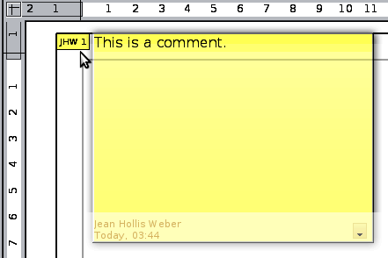
Choose Tools > Options > User Data to enter the name you want to appear in the Author field of the comment.
If more than one person edits the document, each author is automatically allocated a different background color.

Chapter 7
Getting Started with Base

What Is Base?
Base is the component of Apache OpenOffice that allows the office suite to interact with a wide variety of data sources. For example, a data source could be a list of names and addresses used for producing a mail merge letter. A shop stock list could be a data source managed through AOO.
Note | Apache OpenOffice uses the terms “Data Source” and “Database” to refer to the same thing, which could be a database such as MySQL or dBase or a spreadsheet or text document holding data.
This chapter covers creating a database, viewing and entering data, and loading the data into OpenOffice documents. It also covers using the Base component of AOO to register other data sources. A data source can be a database, spreadsheet, or text document.
Note | Base is not a database engine. OpenOffice includes the HSQL database engine in the installation files, which is used by default to manipulate data. All the files created by this engine in the default configuration, called an embedded database, are kept within the Base file. It is possible, and sometimes preferable, to connect Base to an external database engine.
Databases bear a superficial similarity to the more widely encountered spreadsheets, but there are important differences. A database consists of a number of columns or fields that contain the individual pieces of data. Groups of fields make up a table of the database. When creating a table, you also determine the characteristics of each field in the table. This is one key difference from spreadsheets. Each field or column may contain only one kind of data. Within the broad data types of text and numbers, there may be further restrictions. For example, the text might have to contain a certain number of characters or numbers might be restricted to be only integers. These restrictions are applied, if they are desired, when the table is defined. Forms are used to interact with the data tables, either for data entry or viewing. This is another difference from spreadsheets where you routinely directly view and manipulate the data tables. Forms format the data display and enable convenient navigation through the rows or records of a table. Database tables do not have the formatting or interactive tools to support convenient direct viewing, but they hold much more data and allow more flexible handling of lists. A query creates a new temporary table from the existing tables according to instructions you provide. The query may sort, order, filter, summarize and match data from many tables. A report organizes the information of the fields of a query in a document according to your requirements.
Caution | The database engine in AOO requires a Java Runtime Environment (JRE). If you do not have one on your computer, you can download it from www.java.com or adoptopenjdk.net and install it following the instructions on the site. In AOO, use Tools > Options > OpenOffice > Java to register Java.
Base creates relational databases. This makes it fairly easy to create a database in which the fields of the database have relationships with each other.
For example: Consider a database for a library. It will contain a field for the names of the authors and another field for the names of the books. There is an obvious relationship between the authors and the books they have written. The library may contain more than one book by the same author. This is what is known as a one-to-many relationship: one author and more than one book. Most if not all the relationships in such a database are one-to-many relationships.
Consider an employment database for the same library. One of the fields contains the names of the employees while others contain the social security numbers, and other personal data. The relationship between the names and social security numbers is one-to-one: only one social security number for each name.
If you are acquainted with mathematical sets, a relational database can easily be explained in terms of sets: elements, subsets, unions, and intersections. The fields of a database are the elements. The tables are subsets. Relationships are defined in terms of unions and intersections of the subsets (tables).
To explain how to use a database, we will create one for the sales and expenses of a small group of people. It is not intended to be realistic for any purpose; it will merely supply concrete but highly simplified examples of data. In the process, we will be explaining how a database works.

Planning a Database
Planning a database's structure is a very important step which should not be skipped or minimized. A well planned database can answer all the questions you know you will want to ask and can be adapted easily to changing needs. A poorly planned database will likely be hard to use and may have to be restructured for even a modest change in the data or in the questions to be answered.
The first planning step is to define the purpose and use of the database as carefully as possible. What information do you want to get out of the database and what information has to go in to achieve that? Be sure to consider not only the immediate questions you want to answer but how those questions might change with time.
The second step is to decide how to store the data in one or more tables to facilitate producing the results you want. Answering this question for a broad range of cases is far beyond the scope of this guide. We will work through a simple case of tracking the expenses and sales of a group of people to illustrate some concepts. It would also be very beneficial to understand database normalization, about which there are many tutorials on the internet. A key point is that there may be a clear difference between structuring the data to take advantage of how database engines work and how the data are best presented for humans to read. The former should govern the database table structure, the latter should be handled with Forms.

Creating a New Database
To begin the process of making the example database, we will make a new Base file with the default configuration of embedded HSQL tables. Choose File > New > Database from the menu bar, or click the arrow next to the New icon on the Standard toolbar and select Database from the drop-down menu. Both methods open the Database Wizard.
On the first page of the Database Wizard, select Create a new database and then click Next.
The second page has two questions. Make sure the choice for the first question is Yes, register the database for me and the choice for the second question is Open the database for editing. Click Finish.
Note | If the database is not registered, it will not be accessible to the other AOO components such as Writer and Calc. If the database is registered, other components can access it. Registering the database only informs your local OpenOffice program that this Base file exists. No information is sent to any other program or outside your computer.
Save the new database with the name Finance. This opens the Finance – OpenOffice Base window. Figure 160 shows part of this window.
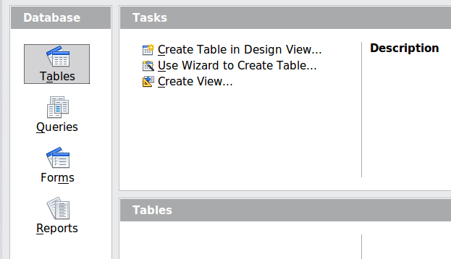Figure : Creating database tables
Tip | Every time the Finance Base file is opened, the Finance – OpenOffice Base window opens. Changes can then be made to the database. The title for this window is always <database name> – OpenOffice Base.
Caution | As you create a database, you should save your work regularly. This means more than just saving what you have just created. You must save the whole database as well. For some common tasks, Base opens a separate document window where you may, for example, design a Form to enter data. Saving the document in that window saves the Form inside the Base document, but you should then also save the Base document from its main window.

Creating Database Tables
In a database, a table stores information for a group of things we call fields or columns. For example, a table might hold an address book, a stock list, a phone book or a price list. A database can have from one to several tables.
To work with tables, click the Tables icon in the Database list, or press Alt+A. The three tasks that you can perform on a table are in the Tasks list (see Figure 160).

Using the Wizard to Create a Table
Wizards are designed to do the basic work. Sometimes this is not sufficient for what we want; in those cases we can use a wizard as a starting point and then build upon what it produces.
The Table Wizard in Base contains two categories of suggested tables: business and personal. Each category contains sample tables from which to choose. Each table has a list of available fields. We can delete some of these fields and add other fields.
A field in a table is one piece of information. For example, a price list table might have one field for the item name, one for the description, and a third for the price.
Caution | Every table requires a Primary key field. (What this field does will be explained later.) We will use this field to number our entries and want that number to automatically increase as we add each entry.
Click Use Wizard to Create Table. This opens the Table Wizard (Figure 161).
Step 1: Select fields
We will use the Expenses sample table in the Business category to select the fields we need for our first table.
- Category: Select Business. The Sample tables drop down list changes to a list of tables appropriate for a business.
- Sample tables : Select Expenses. The Available fields box changes to a list of available fields for this table.
- Selected fields : Using the > button, move the following fields from the Available fields window to the Selected fields window in this order: AmountSpent, DatePurchased, EmployeeID, ExpenseType. You can select multiple fields by pressing the Ctrl key while clicking and then move all the chosen fields at once.
At this point, you could select another sample table and move fields from it to the Selected fields list, but that is not necessary in this case.
- If you make a mistake in selecting fields, click on the field name in the Selected fields list and use the < button to move it from the Selected fields list back to the Available fields list.
- If you make a mistake in the order of the selected fields, click on the field name that is in the wrong order and use the Up or Down arrow on the right side of the Selected fields list to move the field name to the correct position.
- Click Next.
Notice that none of the field names include spaces. It is possible to have spaces in field names, but it is best to avoid them.
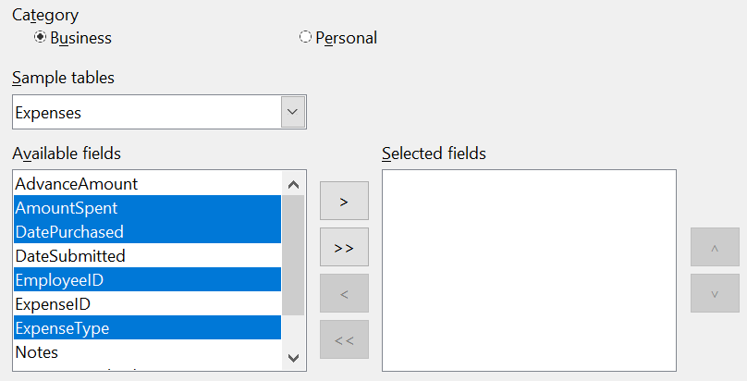Figure : Selecting fields for the table
Step 2: Set field types and formats
In this step you give the fields their properties. When you click a field, the information on the right changes. (See Figure 162) You can then make changes to meet your needs. Click each field, one at a time, and make the changes listed below. Some questions you might consider in a real application are included in the changes.
Note | If any of these fields requires an entry, set Entry required to Yes. An entry with that field blank will then not be allowed. In general, only set Entry required to Yes if something must always be put in that field. By default, Entry required is set to No.

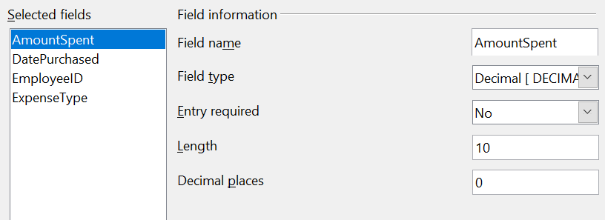Figure : Changing field types
- AmountSpent: Change Decimal places to 2. You should consider whether you want to allow an expense with no amount recorded. If not, change Entry required to Yes.
- DatePurchased: Notice the Field type is Date, which is correct. If you want to require a date, change Entry required to Yes.
- EmployeeID: If you want to require that every expense be assigned to an employee, change Entry required to Yes.
- ExpenseType: The Field type is Text [VARCHAR]. With Length set to 50, this field must be no more than 50 characters long. Is that enough?
Note | In Base the maximum length of each field must be specified on creation. It is not easy to change this later, so if in doubt specify a greater length. Base uses VARCHAR as the default field format for text fields. This format only uses the actual number of characters in a field up to the limit set. So, a field containing 20 characters will only use space for 20 characters even if the limit is set at 50.
- When you have finished, click Next.
Note | Each field has a Field Type, which must be specified. Types include text, integer, date, and decimal. If the field is going to have general information in it (for example, a name or a description), use text. If the field will always contain a number (for example, a price), the type should be decimal or another numerical field. The wizard picks the right field type, so to get an idea of how this works, see what the wizard has chosen for different fields.
Step 3: Set primary key
- Create a primary key should be checked.
- Select the option Automatically add a primary key and check Auto value.
- Click Next.
Note | A primary key uniquely identifies an item (or record) in the table. For example, you might know two people called “Randy Herring” or three people living at the same address and the database needs to distinguish between them.  The simplest method is to assign a unique number to each one: number the first person 1, the second 2, and so on. Each entry has one number and every number is different, so it is easy to say “record ID 172”. This is the option chosen here.
Step 4: Create the table
- If desired, rename the table at this point. If you rename it, make the name meaningful to you. For this example, make no changes.
- Leave the option Insert data immediately checked. We will view the table but not actually enter data.
- Click Finish to complete the table wizard.
A window will appear titled Expenses – Finance – OpenOffice Base: Table Data View. This displays the empty table with the fields (columns) you selected plus a column named ID that is labeled <AutoField> and it was created in Step 3 above. The ID column will be filled with integers automatically when data is added and those numbers will never repeat even if data is deleted. The ID column is the Primary Key of the table.
Close the window displaying the table, and you will be back to the main window of the database with the listing of the tables, queries, forms, and reports. Notice that a table named Expenses is now listed in the Tables portion of the window. Now is a good time to save the Base file.

Creating a Table by Copying an Existing Table
A situation may arise where you want to have two or more tables with the same structure but different data. Rather than creating each table from the wizard, you can make copies of the original table, naming each differently.
- Click on the Tables icon in the Database pane to see the existing tables.
- Right-click on the icon of the table you want to copy. Choose Copy from the pop-up menu.
- Move the mouse pointer below this table, right-click, and select Paste. The Copy table dialog opens.
- Change the table name and click Next.
- Click the >> button to move all the fields from the left box to the right box and click Next.
- Since all the fields already have the proper Field type, no changes should be needed. However, this is the time and place to make any changes if they are needed. (See Caution below for the reason.) Click Create. The new table is created.
Caution | Once tables have been created using the wizard and data has been entered, editing them should be very limited. Fields can be added or deleted, but adding a field requires taking the time to enter the data for that one field for every record having an entry for that field.  Deleting a field deletes all the data once contained in that field. Changing the field type of field can lead to data being lost, either partially or completely, if the two data types are not compatible. When creating a new table, it pays to create the fields with the correct names, length, and format before you add any data.  Deleting a table removes all the data contained in every field of the table. Unless you are sure, do not delete a table.

Creating Tables in Design View
Design View is a more flexible method for creating a new table, in which you directly enter information about each field in the table. We will use this method for the rest of the tables of our database.
Note | While the Field type and formatting are different in Design View, the concepts are the same as in the Wizard.
The first table to be created is People. Its fields are PeopleID, FirstName, and LastName.
- Click Create Table in Design View. A table similar to Figure 163 will appear but with no entries.
- PeopleID field:
  - Type PeopleID as the first Field Name. Press the Tab key to move to the Field Type column.
  - Select Integer [INTEGER] as the Field Type from the dropdown list. (The default setting is Text [VARCHAR].)
Tip | A shortcut for selecting from the Field Type dropdown list: press the key for the first letter of the choice. You can cycle through the choices for a given letter by repeatedly pressing that key.
  - Change the Field Properties in the bottom section.
Change AutoValue from No to Yes.
  - As a result of choosing AutoValue, when you move the cursor to the next row, PeopleID will be set as the Primary key and a small key icon will appear next to the field name. To set the primary key manually, right-click on the green triangle to the left of the field name (Figure 163) and select Primary Key from the menu. This places a key icon in front of the field name. However, if AutoValue has not been set, you will need a method to track what values have been used and to create values for new entries.
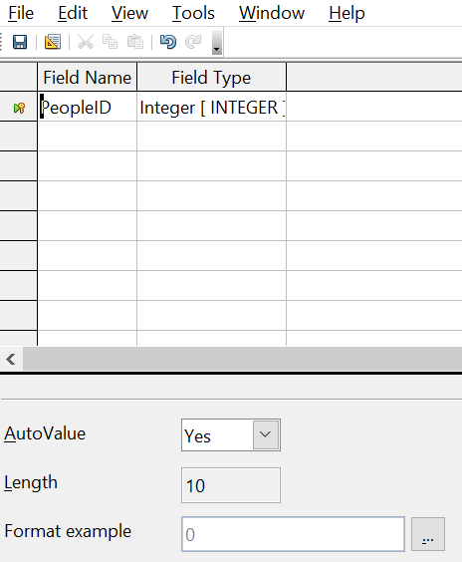Figure : Table definition after the first row is defined
- FirstName and LastName fields:
  - Type the next field name in the Field Name column.
  - Select the Field Type TEXT [VARCHAR] for each field.
- To save and close the table, choose File > Save. Name the table People. Close the table.
Follow the same steps to create a table named Sales. The fields and their field types are listed in Figure 164. Make sure you make the SaleID field the primary key before closing. This should be true if you define the field with AutoValue = Yes. Be sure to set the Decimal places of the Amount field to 2 as shown in the figure.
You can set the display format of either the Date field or the Amount field. To do this, click the button at the right end of the Format example box to bring up the Field Format dialog. This dialog is shown in Figure 165 with a currency format chosen, which might be appropriate for the Amount field.
Once all the fields are defined, save the table and name it Sales. Close the Sales table and save the Base document.
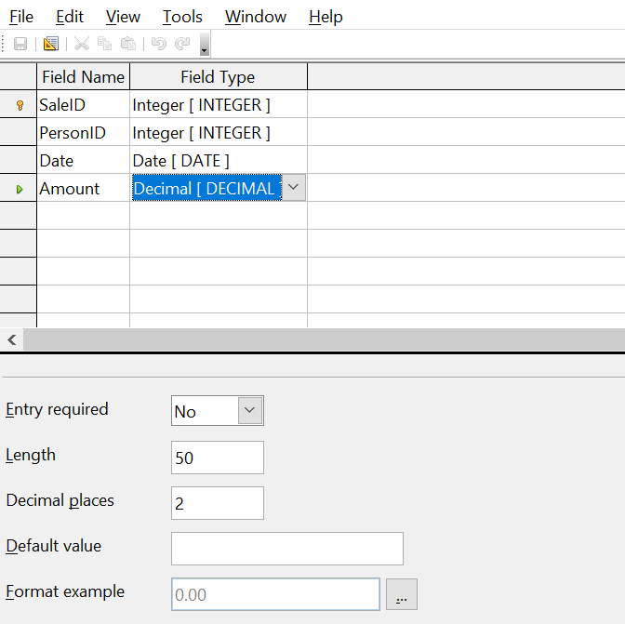Figure : Fields in Sales table
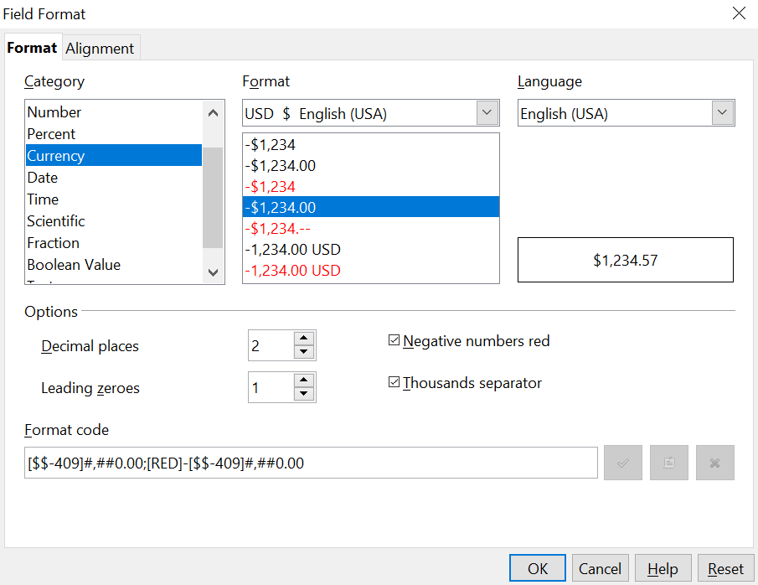Figure : Field Format dialog

Creating Auxiliary Tables for Data Entry
It is often useful to have tables that provide a list of the possible values that a field in another table may have. For example, the Expenses table defined above has a field named ExpenseType. If people are allowed to enter anything in that field, a variety of words may be entered for one item. Buying gasoline might be entered as gasoline, gas, Gas, fuel, or several other possibilities. The entries might also have leading or trailing spaces that are hard to notice. All of that can be dealt with when the table is queried but limiting the entries, even if only you will use the database, leads to a cleaner data set.
For the present case of the ExpenseType field, we will make the simplest possible table with just one column that will serve as both the primary key and the useful data.
Click the Tables icon in the Database region of the main window and choose Create Table in Design View in the Tasks pane. Give the field the name ExpType and leave the field type as TEXT [VARCHAR]. Before leaving that row of the design table, right-click on the small green arrow at the left edge of the row and select Primary Key Save the table using File > Save with the name Expense_Categories and close it.

Adding Data to the List Table
You should now be back at the main Base window. In the Tables pane, right-click on the icon for Expense_Categories and select Open. Enter the values Supplies, Equipment, Travel, Meals as the first four values of the ExpType column. You can close the table without saving it, because the values were saved automatically as you entered them. Do be sure to complete the entry of the last value by pressing Enter or the down arrow to move to a new row before closing the window.
An alternative to this very simple table structure is to define a primary key column that is separate from the values you want to display in the Form when entering data. This is discussed further in the next section.

Defining Relationships
The structure that we have defined for the database tables assumes some relationships that have not yet been made explicit. The following table shows each database table and its fields.
Expense_Categories | Expenses | People | Sales
ExpType | ID | PeopleID | SaleID
 | AmountSpent | FirstName | PersonID
 | DatePurchased | LastName | Date
 | EmployeeID |  | Amount
 | ExpenseType

Both the Expenses table and the Sales table have fields to identify people: EmployeeID and PersonID. When data is being entered into these tables, the PeopleID values are imported from the People table. This is known as a Foreign Key. The advantage of this relationship is that the FirstName and LastName values associated with the ID appear in only one place, a single row in the People table. If a person's name should change for some reason, only one row in one table needs to be edited. In this very simple example, that is not a very daunting task but in a real situation where there might be tables for salary, medical benefits, vacation, leaves, emergency contacts and much more, updating every entry in all the tables would be prone to error and quickly result in very unreliable data.
A similar relationship exists between the Expenses_Categories and the Expenses table, though the purpose is different. In that case, the values of ExpType serve to control the values that can be entered as an ExpenseType in the Expenses table. This is another form of a Foreign Key.
Tip | As you create your own databases, you need to also determine where tables are related and how.
- To begin defining relationships in the database, choose Tools > Relationships. The Finance – OpenOffice Base: Relation Design window opens and the Add Tables dialog pops up. (You can also open it by clicking the Add Tables icon, highlighted in red in Figure 166, on the Relation Design window.)
- In this database, all the tables have a relationship to another table and must be added to the Relation Design Window. On the Add Tables dialog, use either of these ways to add a table to the Relation Design window:
  - Double-click the name of the table.
  - Or, click the name of the table and then click Add for each table.
- Click Close to close the Add Tables dialog when you have added the tables you want.
Figure 166 shows the Relation Design window in its final state after the relations have been created. At the current state of the process you will not see the lines connecting the tables. The tables may also be closer together and not display all of their fields. Feel free to drag the tables farther apart and resize them by clicking on their edge and dragging.
You can define the relationship between pairs of tables in two ways:
- Click and drag the primary key field in one table to the foreign key field in the other table. When you release the mouse button, a connecting line forms between the two data fields. For example, drag from ExpType in Expense_Categories to ExpenseType in the Expenses table.
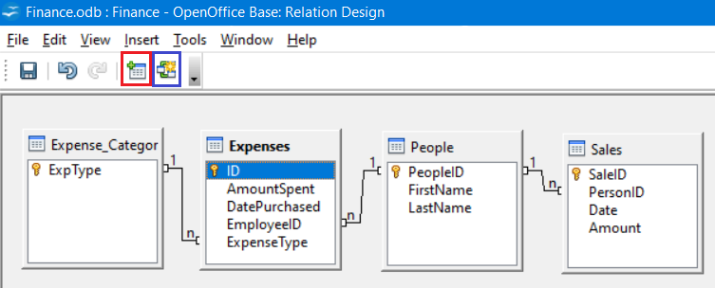Figure : Designation for a 1:n relationships
  - Or, click the New Relation icon, highlighted in blue in Figure 166. This opens the Relations window (Figure 167). The available tables are listed in the drop-down lists in the Tables involved section.
    - Select a table that holds the primary key from the left-hand drop-down list and the corresponding table holding the foreign key from the right-hand drop-down list. Figure 167 shows the tables Expense_Categories and Expenses selected.
    - In the Fields involved section, click the drop-down list under the Expense_Categories label.
    - Select ExpType from the list.
    - Click in the cell to the right of this drop-down list. This opens a dropdown list for the Expenses table.
    - Select ExpenseType from the Expenses table list. The dialog should now look like the top half of Figure 167.
    - Under Update options select Update cascade and under Delete options select Delete cascade.
    - Click OK.
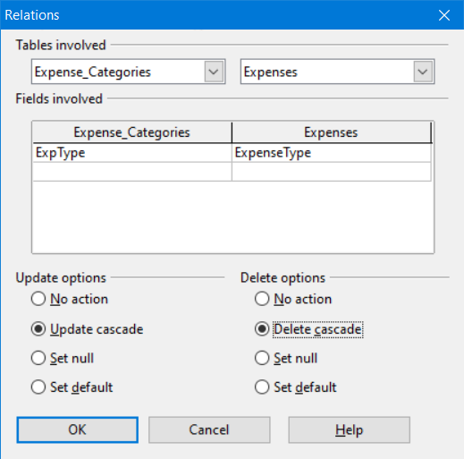Figure : Selected fields in a relationship
The Update cascade and Delete cascade options control what happens when one of the primary key options is updated (changed) or deleted. The cascade option means that any rows in the Expenses table using the modified or deleted value will likewise be modified or deleted. While these options are not strictly necessary, they do help. Having them selected permits you to update a table that has a relationship defined with another table. It also permits you to delete a field from the table.
You can now repeat the process of step 4 to make the relationships between the People table and the Expense and Sales tables. At this point the Relation Design window should look like Figure 166. After closing the Relation Design window, it is a good idea to save the Base document.

Creating a Database Form
Databases are used to store data. But how is the data put into the database? Forms are used to do this. In the language of databases, a form is a front end for data entry and editing.
A simple form consists of the fields from a table. More complex forms can contain much more, including additional text, graphics, selection boxes, and many other elements. We will make three simple forms to demonstrate the basics of tying form controls to database tables, viewing and entering data, and modifying the function and appearance of form controls. The data tables are so simple that they are not realistic, but they serve the purpose of showing how forms work. The examples do not use all the available types of form controls, but the principles are much the same for all controls.

Using the Wizard to Create a Simple Form

Making the Form
We will first use the Form Wizard to create a very simple People form for entering data in the People table.
In the main database window (Figure 160), click the Forms icon in the left column. In the Tasks list, click Use Wizard to Create Form to open the Form Wizard (Figure 168). On the left, you can see the possible steps to create a form. Simple forms require only some of these steps, while more complex forms may use all of them. Towards the center, there is a drop-down list titled Tables or queries where you can see that the People table has been chosen.
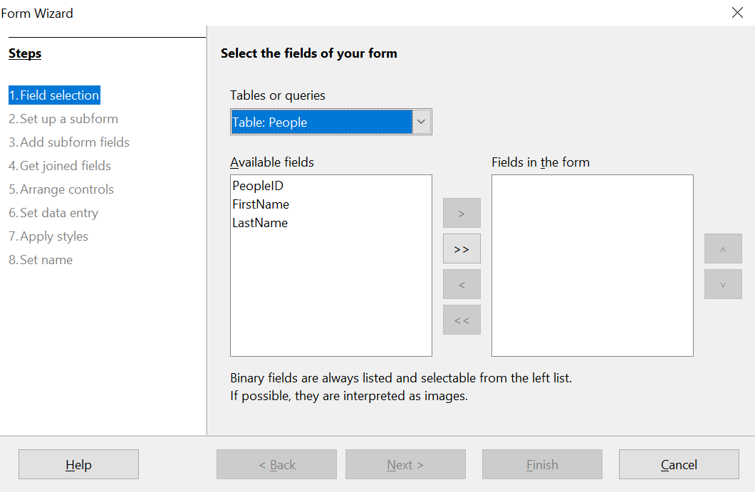Figure : Form Wizard steps
Step 1: Select fields
- Under Tables or queries, select Table: People. Available fields lists the fields for the People table.
- Click the field FirstName and then on the right single arrow to move it to the Fields in the form list. Do the same with LastName. Click Next. We do not put the PeopleID field on the form because it was defined as an AutoValue field, and it will be populated automatically.
Step 2: Set up a subform
This form will not have a subform. Click Next and the dialog will jump to Step 5.

Step 5: Arrange controls
Each control in a form consists of two parts: a label and a field. This step in creating the form determines where a control’s label and field are placed in relationship with each other. The four choices from left to right are Columnar - Labels Left, Columnar – Labels on Top, As Data Sheet, and In Blocks – Labels Above. Click the third icon from the left in the Arrangement of the main form section, the As Data Sheet icon, then click Next.
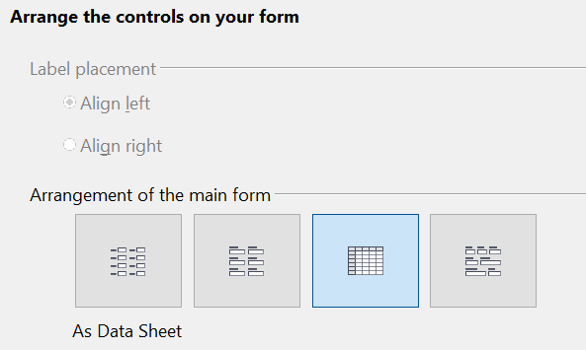Figure : Form Wizard Step 5 - Detail
Step 6: Set data entry
This step allows limiting what can be done with the form, such as preventing data deletion or viewing existing data. We will leave the defaults in place, but this could be an important step in securing data. Click Next.
Step 7: Apply styles
You can adjust the appearance of the form at this step with different colors and borders. We will leave the default in place, but you might want to try different settings. Click Next.
Step 8: Set name
You can give the form any name; there is no need to match the name of the table to which it is connected. We will keep the default name of People and also accept the option Work with the form. Click Finish and the form will be ready for data entry. It is a good idea to close the form now and save the main Base document.

Entering Data With the New Form
If you have closed the form, you can open it by clicking on the Forms icon in the main Base window (Figure 160) and then double-clicking on the People icon in the list of Forms.
Data can be entered into the People table by typing into the FirstName and LastName fields. You can navigate from field to field by selecting them with the mouse, using the Tab key or using the buttons of the navigation bar along the bottom of the form's data sheet. The navigation bar shows the current record number, the total number of records and buttons which move the selection to the first record, the previous record, the next record, the last record, and a new record. As you enter data, moving out of a record automatically saves it to the database table. Be sure to exit the last row into which you enter data so that it gets written to the database table.
In later sections, we will add controls to forms that include dropdown lists and there are other methods of automating data input such as buttons to increment numeric values. The basic steps are always same. You navigate from field to field by clicking or with the Tab key and moving to another record automatically saves the entered data. If a record does not meet a requirement placed on the table, for example, not entering data in a field for which input is required, the form will not move to a new record and an error message may appear.

Modifying the Form
The Form Wizard's choices for the size and layout of controls will probably not be ideal. Adjustments can easily be made by opening the form in edit mode. When the form is closed, right click on its icon and select Edit. The form should open ready to be edited, but we will explain how to toggle in and out of Design Mode. If the Form Controls toolbar is not visible, open it with View > Toolbars > Form Controls. The toolbar is shown in Figure 170 with Design Mode on and off and with the button that does the toggling highlighted with red. When Design Mode is off, most of the toolbar's icons are gray.
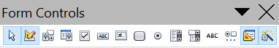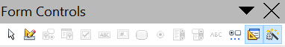

Figure : Form Controls toolbar with Design Mode on and off
Design Mode On
Design Mode Off
With Design Mode on, you can click on the form's data sheet to select it. Eight green handles will appear at the edges of the data sheet. You can click and drag with these to resize it. You can also resize the data sheet's columns by dragging the boundary between them. When resizing the sheet, pay attention to the navigation bar at the bottom so that you do not obscure some controls. You can control more details of the appearance of the data sheet using the Table Control dialog. To access this, right-click on the data sheet and select Control or select it with a left click and then click on the Control icon on the Form Controls toolbar. The Control button is highlighted in blue in Figure 170. In the dialog, you can adjust the size and position, font, background color, border style, and turn off the navigation bar.

Using the Wizard to Make a Form With a Subform

Making the Form
Forms can be arranged in a hierarchy so that the data selected in one form influences the data shown on the second form. The objects referred to as forms here are different from what we have previously called a form. If you click on the Forms icon on the main Base page, you will see a pane labeled Forms that displays forms previously saved in the Base file. In the file we have been working with there is now one form called People. A more precise descriptor for People would be Form Document. A Form Document contains one or more groups of Form Controls that interact with a database table or query. In the People Form Document, there is only one control, a data sheet, and it reads data from and writes to the People table. We could have had multiple controls, one dealing with each field in the table, but they all would have interacted with one table. Such a group of controls is also called a form, though a more precise name would be a Data Form. It is possible, even common, to have a Form Document that contains two or more Data Forms, each Data Form interacting with a different table but also some Data Forms influencing other Data Forms. We will now use the Form Wizard to make a Form Document that contains two Data Forms arranged as Form – Subform. The main Form will use the People table and the Subform will use the Expenses table. The two Data Forms will allow us to view and record the expenses of a chosen person.
In the main database window (Figure 160), click the Forms icon in the left column. In the Tasks list, click Use Wizard to Create Form to open the Form Wizard (Figure 168).
Step 1: Select fields
- Under Tables or queries, select Table: People. The box Available fields lists the fields for the People table.
- Click the field FirstName and then on the right single arrow to move it to the Fields in the form list. Do the same with LastName. Click Next.
Step 2: Set up a subform
Since we have already created a relationship between the People and Expenses tables, we will use that relationship. If no relationship had been defined, this would be done in step 4.
- Click the box labeled Add Subform.
- Click Subform based upon existing relation.
- Both the Expenses and Sales tables have a relation with People, so both are listed as possible choices. Click Expenses to highlight it, as in Figure 171. Click Next. Even if only one table were listed, it would still be necessary to click on it to select it for the subform.
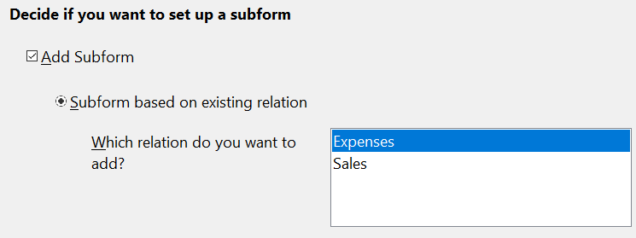Figure : Adding a subform and choose the relation.
Step 3: Add subform fields
This step is much like step 1.
- Expenses is preselected under Tables or queries.
- Use the >> button to move all the fields to the right.
- Click the ID field to highlight it.
- Use the < button to move the ID to the left (Figure 172). We are excluding the ID field because its value is set automatically. There can be circumstances where you would want to be able to view the ID and displaying it in the form is a valid choice. Click Next.

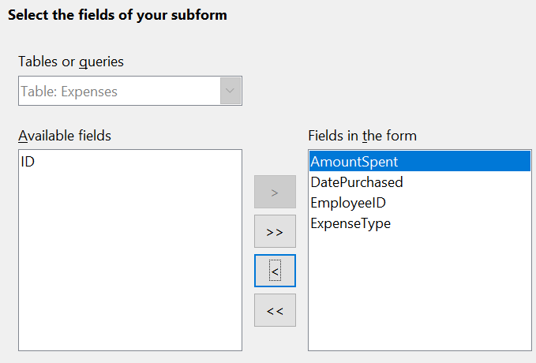Figure : Selecting fields of a subform
Step 4: Get Joined Fields
This step is for tables or queries for which no relationship has been defined. Because we have already defined the relationship, the wizard skips this step.
Note | It is possible to create a relationship between two tables that is based upon more than one pair of fields.
Caution | When selecting a pair of fields from two tables to use as a relationship, they have to have the same field type. The chosen columns in our example are both INTEGER.  Whether a single pair of fields from two tables are chosen as the relationship or two or more pairs are chosen, certain requirements must be met for the form to work.  - No field from the subform can be the Primary key for its table. (ID cannot be used.)  - Each pair of joined fields must have the same field type.  - One of the fields from the main form must be the Primary key for its table.
Step 5: Arrange controls
Set the arrangement of both the main form and the subform to be As Data Sheet, which is the third icon from the left. Click Next.
Step 6: Set data entry
Accept the default settings. Click Next.
Step 7: Apply styles
- Select the color you want in the Apply Styles list.
- Select the Field border you want.
- Click Next.
Step 8 : Set name
- Enter the name for the form. In this case, it is Expenses.
- Click Work with the form.
- Click Finish. The form opens ready for use. Though you can use the form immediately, it is a good time to close the form and save the main Base document.

Entering Data in the Subform
Reopen the Expenses form document if you closed it. If you have already entered data in the People table as described in Entering Data With the New Form, you will see that data in the main form. Figure 173 shows three people entered into the People table and the subform ready for data.
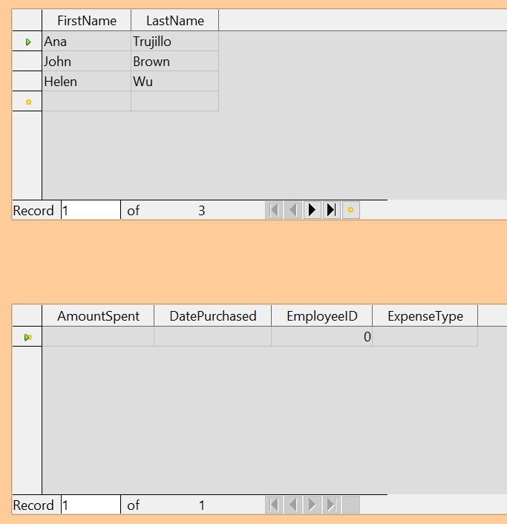Figure : Main and subform of Expenses
Notice that the EmployeeID of the subform is already populated. The 0 is the PeopleID of Ana Trujillo in the People table, which is the record that is currently selected as can be seen by the green triangle at the left edge of the row. Remember that PeopleID and EmployeeID have a foreign key relationship as seen in Figure 166. If you select another person by clicking on the record or using the navigation bar, the EmployeeID in the subform will automatically change.
We could enter data for each employee now. The AmountSpent can be any number, the DatePurchased should be in the format appropriate for your locale, though YYYY-MM-DD should work anywhere, and the ExpenseType must be one of the values in the Expense_Categories table. If you try to enter some other value, say, Fish, the database will refuse to accept it. No error message appears, but you cannot move down to the next row with an invalid value in ExpenseType. Similarly, you can enter a number in EmployeeID, but if it is not a value that exists in the People table, it will not be accepted. This is a result of the foreign key relationships set up earlier and is an important tool for maintaining data integrity. Rather than struggling to remember valid ExpenseTypes, we can modify the form to improve the ease of data entry.

Modifying the Subform
In addition to making it easier to enter the ExpenseType, there are a few other changes that would improve the usability or appearance of the form. The column headers currently show the field names and could be replaced with labels closer to nontechnical language. Also, the DatePurchased column would benefit from a calendar widget to decrease the amount of typing.
Open the form document by right-clicking on its icon and selecting Edit. The first step is to put the two Data Sheets into Design Mode. If the Form Controls toolbar is not visible, open it with the menu View > Toolbars > Form Controls. As shown in Figure 170, use the Design Mode button, which is highlighted in red, to toggle Design Mode to On.
Right-click the ExpenseType header and select Replace with > Combo Box. The column had been a set of Text Boxes. These are controls which accept text entries. A Combo Box is very similar except that it provides a drop-down list of entries. To set the properties of the Combo Box, right click again on the ExpenseType header and select Column. A dialog titled Properties: Combo Box will appear.
- On the General tab, change the Label to Expense Type, with a space between the words.
- On the Data tab, make sure Type of list contents is Sql and List content is
SELECT "ExpType" FROM "Expense_Categories".
The code SELECT "ExpType" FROM "Expense_Categories" is in the SQL language that is used to interact with databases. We will not cover SQL in any detail but understanding simple statements like this is useful for setting up Combo Boxes and List Boxes that can display values stored in database tables. The SELECT keyword means “Show the following columns” and the FROM keyword means "Use the following tables to find the data". So, the entire statement means "Show the ExpType column from the Expense_Categories table”. The only other detail is that the column and table names are in double quotes.
To make the other changes in the Data Sheet, click on each column header and select Column.
- For the AmountSpent field, change the Label to Amount Spent. You may also adjust the Formatting property by clicking the small button with three dots at its right edge and using the dialog to set the Category to Currency and the Format to whichever setting you prefer.
- For the DatePurchased field, select the General tab and set the Label to Date Purchased then scroll down to find the Drop-down listing and change it to Yes.
It would also make sense to delete the EmployeeID column. Its value is set through the foreign key relation. It was displayed only to show the effect of the relation. We will not do that, but a column is deleted by clicking on the header and selecting Delete Column.
Take the forms out of Design Mode and try entering some data. You should be able to use dropdown lists in the Date Purchased and Expense Type columns and the Amount Spent column will be displayed with a currency format if you chose to set that up.

Laying Out a Form With Multiple Controls
A form with multiple controls will likely need some adjustments to their layout and appearance. We will make a form for the Sales table as a tool to demonstrate how to do this. The form could be made with a Form – Subform arrangement as was done for the Expenses form document.

Making the Form
In the main database window (Figure 160), click the Forms icon in the left column. In the Tasks list, click Use Wizard to Create Form to open the Form Wizard (Figure 168).
Step 1: Select fields
- Under Tables or queries, select Table: Sales.
- Move all the fields to the list on the right using the >> button then click Next. Since SaleID is an AutoValue field, you might normally choose to not display it in the form.
Step 2: Set up a subform
This form will not have a subform. Click Next and the dialog will jump to Step 5.

Step 5: Arrange controls
In the Arrangement of the main form section, choose the second icon from the left which sets the layout to Columnar – Labels on top. Click Next.
Step 6: Set data entry
Accept the defaults by clicking Next.
Step 7: Apply styles
Accept the defaults by clicking Next.
Step 8: Set name
Choose the name Sales and the option Modify the form and then click Finish.
You will now have a data form with four controls in a single column as shown in Figure 174. This is a perfectly serviceable arrangement, but we will change it to have the controls horizontally arranged towards the middle of the form. If the Form Controls toolbar is not visible, open it with the menu View > Toolbars > Form Controls. Use the Design Mode button, which is highlighted in red, to toggle Design Mode to On as shown in Figure 170.

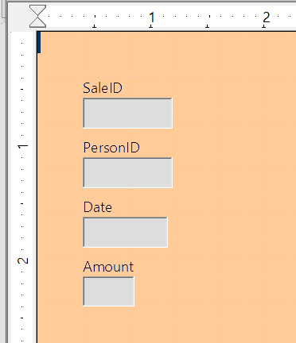Figure : Initial control arrangement of the Sales form
The entire group of controls can be moved by selecting them with click and drag. Make sure the cursor is in select mode by clicking the Select icon on the Form Controls toolbar. It is the first icon on the toolbar. Click and hold above and to the left of the SaleID label and drag down and to the right to form a rectangle around all the controls. When you release the mouse button, green handles will define a rectangle encompassing all the controls. Click and hold within this rectangle and drag the group to the right. Click anywhere outside the rectangle to release the grouping of the controls. To arrange the controls horizontally, we will first drag them into their approximate positions and then fine tune them with Position and Size dialogs. Each control consists of a label and a field and if you click on one of the controls, both the label and the field are selected. After placing the label/field pairs close to their desired final positions, we can examine and adjust their precise positions. Figure 175 shows the controls after clicking and dragging.
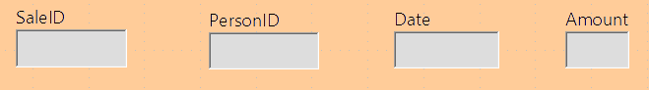Figure : Controls approximately horizontally arranged
Since we are dealing with an artificial set of data, we do not have strong reasons to arrange the controls in any particular way. We will make the rather arbitrary decision to make each field box one inch long and put a half inch between them. We also want them all at the same vertical position.
The label and the field are actually two objects that can be edited independently. To access one of them, use Ctrl + Click. Figure 176 shows the difference between clicking on the field of the SaleID control using just the left mouse button or using Ctrl + Click.
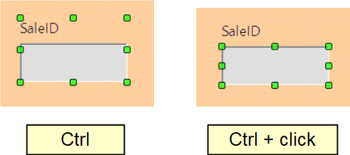Figure : Click vs. Ctrl + click
After using Ctrl + Click, you can move from the field to the label and vice versa with the Tab key. If you want to move both the label and the field, you should be careful that you have selected both with a plain click, so you do not undo their alignment accidentally.
To examine and adjust a control's position, click on it, then right click and select Position and Size. The resulting dialog is shown in Figure 177.
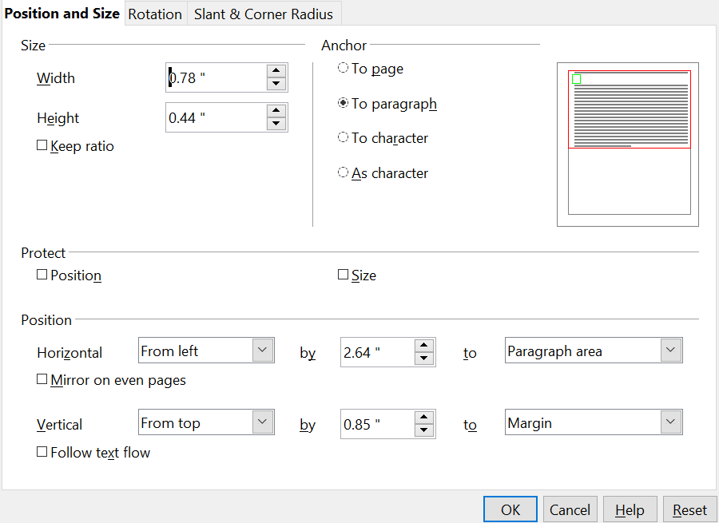Figure : Position and Size dialog of a control
The width and size of the label/field pair is shown at the top left while the position on the page is shown at the bottom. We will set the horizontal position to 2.50 and note that the vertical position is 0.85. We will leave the width unchanged because we want to change the width of only the field and not the label. Likewise, we then exit the dialog and use Ctrl + Click to select only the data field of the SaleID control. Furthermore, we can as well right-click on the field, choose Position and Size and adjust its width to one inch. We can also use Ctrl + Click to select the label, right click on it, select Control, and change the label text, font color, or any other property. We can then proceed to the other controls, setting them to be on a 1.5 inch (3.81 cm) pitch with each data field having a width of one inch and placing them all at the 0.85 inch (2.16 cm) vertical position. Furthermore, we should also set the Date field to have a dropdown list by using Ctrl + Click to select only the date field, then right-clicking and selecting Control.
The controls are now evenly positioned, but there are three remaining adjustments to make the form easily usable.

Navigation Bar
The first adjustment is to add a Navigator Bar to move from record to record and add new records. There is a Navigation Bar icon available in the More Controls auxiliary toolbar of the Form Controls toolbar. Figure 178 shows the location of the More Controls icon and the Navigation Bar icon.
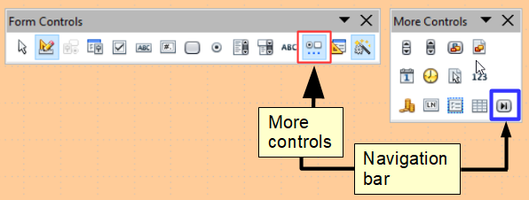Figure : More Controls toolbar and Navigation Bar icon
Click the Navigation Bar icon and use click and drag to place the bar. You can select it and lengthen it manually until all of its buttons are visible and use the methods just discussed for positioning it precisely. It has buttons which move the selection to the first record, the previous record, the next record, the last record, and a new record.

Adding a List Box
Another change needed to improve the usability of the form is to change the PersonID field into a List Box. The Form Wizard chose a Formatted Field for this control, which is basically a numeric field. You can see this by selecting only the PersonID data field, right-clicking and selecting Control. The title bar shows that the control is a Formatted Field. The PersonID field is indeed numeric, it stores the PeopleID value from the People table as shown in Figure 166. To input data easily, we would want to know which FirstName and LastName correspond to a PeopleID value. A List Box is like a Combo Box in that it displays values, but it displays one value and stores another. We will use a List Box to display the combined FirstName and LastName values of a row from the People table and store the corresponding PeopleID value in the Sales table PersonID field.
Use Ctrl + Click to select the field of the PersonID field then right click and choose Replace with > List Box. Right click again on the field and select Control. On the Data tab set Type of list contents to Sql and set List content to
SELECT "FirstName" || ' ' || "LastName", "PeopleID" FROM "People"
The Bound field should be set to 1 and on the General tab, the Drop-down list should be set to Yes.
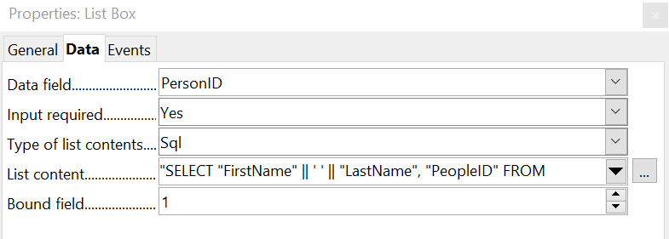Figure : List Box set up
The meaning of a very similar SQL statement was explained in the section Modifying the Subform. The fields named after the SELECT keyword are a little more complicated here. The || symbol acts to concatenate or glue together the text on each side of it. "FirstName" || ' ' || "LastName" means "The value of the FirstName field followed by a space followed by the value of the LastName field". We will call this the Full Name of the record. The full SELECT clause returns the Full Name followed by the PeopleID of the record in the People table. The Bound Field value tells the control to store the second returned item (the control counts from zero) in the target table. This means PeopleID will be sent to the PersonID field of the Sales table. Figure 180 shows the result of setting up the List Box. The Person ID dropdown list shows the full name of the person, but the value stored in the Sales table is the integer PeopleID. This can be confirmed after some data are entered by going to the main window of the Base file, selecting the Tables icon and double-clicking on the Sales table.
The advantage of this arrangement is that if a person's name should change, the information only needs to be updated in one table. A database might have many tables that need to tie records with a particular person. If the name were input into each of these, a name change would require updating many tables, which is likely to lead to errors. It is a common practice to give people employee or customer identification numbers which look more elaborate than our simple integers but serve the same purpose in the database.
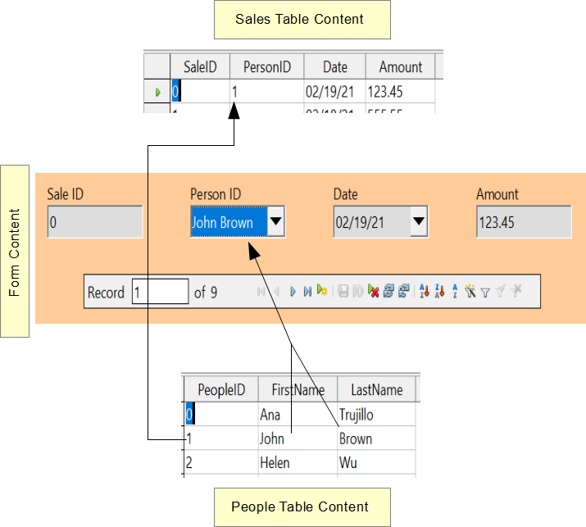Figure : A List Box displays one value from the source table but sends another value to the target table.

Changing the Tab Order
The last change for usability is to adjust the tab order of the controls. In the very simple form we have made, this is not needed but in forms with many controls, it is much more convenient to jump from one control to the next with the tab key than to repeatedly click on the form. To adjust the tab order, open the Form Design toolbar with View > Toolbars > Form Design. The toolbar is shown in Figure 181 with the Activation Order icon highlighted in red. Click that icon to open a dialog showing all the controls in the order in which they will be chosen by the Tab key.
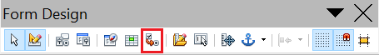Figure : Form Design toolbar with Activation Order highlighted
The dialog, shown in Figure 182, has buttons to move controls up and down the list. The control names are the automatically assigned ones unless you have changed them while editing other control properties. The easiest way to make these names meaningful is to give the database table fields meaningful names, which is good practice in any case. The list has the controls in a reasonable order but in a form with more fields, it is likely that the order of the fields in the database will not be convenient for data entry.
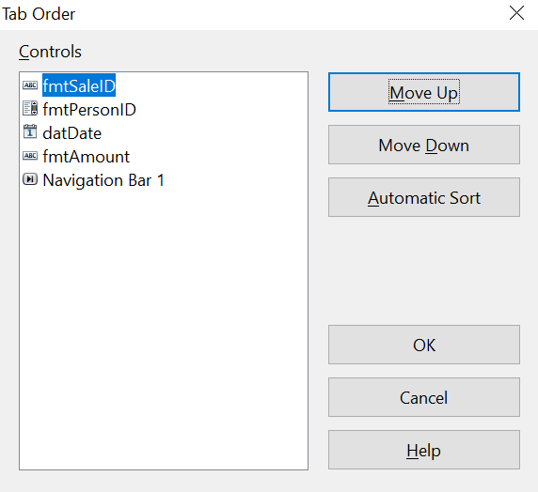Figure : Tab order dialog

Creating Forms and Subforms in Design View
This method requires using the Form Controls and Form Design toolbars extensively. These techniques are beyond the scope of this document.

Accessing Other Data Sources
OpenOffice allows data sources to be accessed and then linked into AOO documents. For example, a mail merge links an external document containing a list of names and addresses into a letter, with one copy of the letter being generated for each entry.
To access an external data source:
- File > New > Database opens the Database Wizard window.
- Select Connect to an existing database. Click the arrow next to the Database type field and select the database type from the drop-down list. Click Next.
- Click Browse and select the database. Click Next.
- Accept the default settings: Register the database for me, and Open the database for editing. Click Finish. Name and save the Base file in the location of your choice.

Accessing a Spreadsheet as a Data Source
Accessing a spreadsheet is similar to accessing other databases:
- Choose File > New > Database.
- Select Connect to an existing database. Select Spreadsheet as the Database type. Click Next.
- Click Browse to locate the spreadsheet you want to access. If the spreadsheet is password protected, check the Password required box. Click Next.
- You can now choose to register the database, so that it is available to other OpenOffice documents, and to open it for editing. Click Next.
- Name and save the database file as you would any other document. If you have chosen to open it and it requires a password, you will see a prompt for the password.
Note | Using this method of accessing a spreadsheet, you cannot change anything in the spreadsheet. You can only view the contents of the spreadsheet, run queries, and create reports based upon the data already entered into the spreadsheet.  All changes in a spreadsheet must be made in the spreadsheet itself, using Calc. After modifying the spreadsheet and saving it, you will see the changes in the database. If you create and save an additional sheet in your spreadsheet, the database will have a new table the next time you access it.

Registering *.odb Databases
Registering a *.odb database is simple:
- Choose Tools > Options > OpenOffice Base > Databases.
- Under Registered databases, click New.
- Browse to where the database is located.
- Make sure the registered name is correct.
- Click OK.

Using Data Sources in Apache OpenOffice
Having registered the data source, whether a spreadsheet, text document, external database or other accepted data source, you can use it in other AOO components including Writer and Calc.

Viewing Data Sources
Open a document in Writer or Calc. To view the data sources available, press F4 or select View > Data Sources from the pull-down menu. This brings up a list of registered databases, which will include Bibliography and any other database registered, such as the database created earlier in this chapter.
To view each database, click on the + to the left of the database’s name (see Figure 183). This brings up Tables and Queries. Click on the + next to Tables to view the individual tables created. Now click on a table to see all the records held in it.
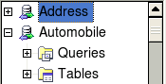Figure : Databases

Editing Data Sources
Some data sources can be edited in the View Data Sources dialog. A spreadsheet can not. In other cases, a record can be edited, added, or deleted.
The data is displayed on the right side of the screen. Click in a field to edit the value.
Figure : View Data Sources navigation buttons
Beneath the records are five tiny buttons. The first four move backwards or forwards through the records, or to the beginning or end. The fifth button, with a small star, inserts a new record.
To delete a record, right-click on the gray box to the left of a row to highlight the entire row, and select Delete Rows to remove the selected row.
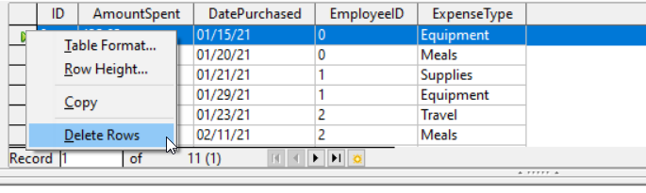Figure : Deleting a row in the Data View window

Launching Base to Work on Data Sources
You can launch Base at any time from the View Data Source pane. Just right-click on a database or the Tables or Queries icons and select Edit Database File. Once in Base, you can edit, add, and delete tables, queries, forms, and reports.

Using Data Sources in Writer and Calc
Data can be placed into Writer and Calc documents from the tables in the data source window. In Writer, values from individual fields can be inserted. Or, a complete table can be created in the Writer document. One common way to use a data source is to perform a mail merge.
Tip | Choosing Tools > Mail Merge Wizard or clicking on the Mail Merge icon on the View Data Source pane launches the Mail Merge wizard which steps you through creating a mail merge document. See Chapter 11 in the Writer Guide.

Writer Documents
To insert a field from a table opened in the data source window into a Writer document, click on the field name (the gray square at the top of the field list) and, with the left mouse button held down, drag the field onto the document. In a Writer document, it will appear as <FIELD> (where FIELD is the name of the field you dragged).
For example, to enter the information about an expense you can follow these steps.
- Open the list of data sources by pressing F4 and select the Finance database and its Expenses table.
- Type the sentence in the Writer document to contain the information from the table, but do not write anything in the locations where database information will go. See Figure 186.
- Click and hold on the column header of one of the desired fields, for example DatePurchased, and drag it to the desired location. Do this for each field. The text in the document will now look like
On <DatePurchased>, an expense of <AmountSpent> was submitted for <ExpenseType>.
- Click on the gray box at the left end of the row holding the desired information.
- Click on the Data to Fields icon, which is highlighted in red in Figure 186.
The values from the selected row will appear in the document. If View > Field Shadings is selected, the values will appear with gray shading. This shading does not print. If the record with ID = 9 was selected, the text in the Writer document will say:
On 02/02/21, an expense of 213.56 was submitted for Travel.
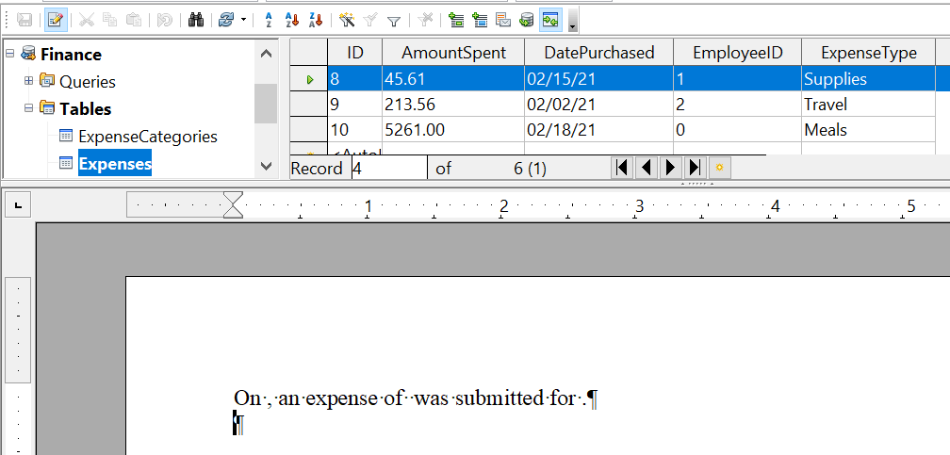

Figure : Sending data from Base to Writer with fields
Adding data in table format is a little easier and takes perhaps fewer steps. Some steps will be quite similar.
- Navigate to the place you want to place the table and click the location.
- Ctrl+Click the gray box to the left of each row of the data source that you want to be a row in your table when the rows are not consecutive. To select consecutive rows, click the gray box to the left of the top desired row and Shift+Click the bottom desired row.
- Click the Data to Text icon to open the Insert Database Columns dialog. (The Data to text icon is to the left of the Data to Fields icon in Figure 186.

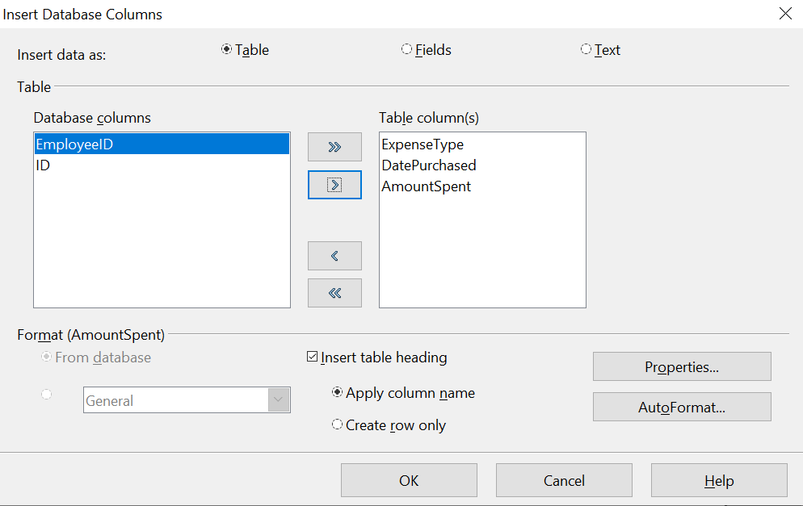 Figure : Insert Database Columns dialog
- Move the fields you want in your table from the Database columns list to the Table column(s) list.

  - To place the fields in the order you select, click the field and use the single arrow to move the fields in the order you desire. You can also limit the fields you use to less than all the fields available.
  - If you want to use all the fields, use the double arrow pointing to the right to move all of them at one time. The order of the fields in the table you create will be the same as in the data source table.
  - To remove a single field from the Table Column(s) list, click the field and use the single arrow pointing to the left.
- To start over, click the double arrow pointing to the left.
- Select the settings for your table. Use the default settings as in Figure 187.
- Click OK. Save the document.

Calc Spreadsheets
There are two ways to enter data in a Calc spreadsheet. One enters the data into the spreadsheet cells. The other creates controls to display the data in the spreadsheet just as is done in creating a form document in a Base file. While you can directly access the data in the spreadsheet cells, you can only see the data in the controls created in the spreadsheet.
Entering data directly to the spreadsheet cells uses the Data to Text icon as we did to make a table in a Writer document. But differences exist in these two situations.
The steps are straightforward:
- Click the cell of the spreadsheet which you want to be the top left of your data including the column names.
- Use F4 to open the database source window and select the table whose data you want to use.
- Select the rows of data you want to add to the spreadsheet:
  - Click the gray box to the left of the row you want to select if only selecting one row. That row is highlighted.
  - To select multiple rows, hold down the Control key while clicking the gray box of the rows you need. Those rows are highlighted.
  - To select all the rows, click the gray box in the upper left corner. All rows are highlighted.
- Click the Data to Text icon to insert the data into the spreadsheet cells.
- Save the spreadsheet.
Adding records displayed in form controls to a spreadsheet is fairly easy. You need to have the Data Source window open, your spreadsheet open, and the table you want to use selected.
- Click the gray box above a field name.
- Drag and drop the gray box for the field to where you want the record to appear in the spreadsheet.
- Repeat until you have moved all the fields you need to where you want them.
- Name and save the spreadsheet.
- Click a row of the table in the Data Source window.
- Drag the data, not the header, in the first field in the selected row onto its corresponding control in the spreadsheet. The Save icon should activate.
- Click the Edit File button to make the spreadsheet read only. Click Save when asked if you want to save the file.
- The Data Source window goes blank, the fields in the spreadsheet are populated with data from the row you selected, and the Form Navigation toolbar appears at the bottom of the spreadsheet.
Figure : Navigation arrows of a form
Click the arrows on the Form Navigation toolbar to view the different records of the table. (The arrows are circled in red.) The number in the box changes when you change the record number by clicking an arrow. The data in the fields changes correspondingly to the data for that particular record number.

Creating Queries
Queries are used to get specific information from a database. Query results are special tables within the database, but the results are not permanently stored; only the code to produce the results is stored.
To demonstrate the use of queries, we will use both the query Wizard and query Design View to look at the Sales data from the Finance database we made in previous sections.

Using the Wizard to Create a Query
Queries created by the wizard provide a list or lists of information based upon what one wants to know. It is possible to obtain all the records meeting the desired conditions or aggregated results such as the sum of data from multiple records.
In the main database window (Figure 160), click the Queries icon in the Databases section, then in the Tasks section, click Use Wizard to Create Query. The Query Wizard window opens (Figure 189). We want to display the PersonID, the date and the amount of each sale, sorted by the date and including only sales with an Amount greater than or equal to 100.
Note | When working with a query, more than one table can be used. Since different tables may contain the same field names, the format for naming fields in a query is Table name.field name, with a period (.) between the table name and the field name. For example, the Date field of the Sales table used in a query has the name Sales.Date.
Step 1: Select the fields
- Select the Sales table from the dropdown list of tables.
- Select fields in the Available fields list. This step has already been done in the figure.
  - Click PersonID, and use the > button to move it to the Fields in the Query list.
  - Move the Date and Amount fields in the same manner.
  - Click Next.
Tip | To change the order of the fields, select the field you want to move and click the up or down arrow.
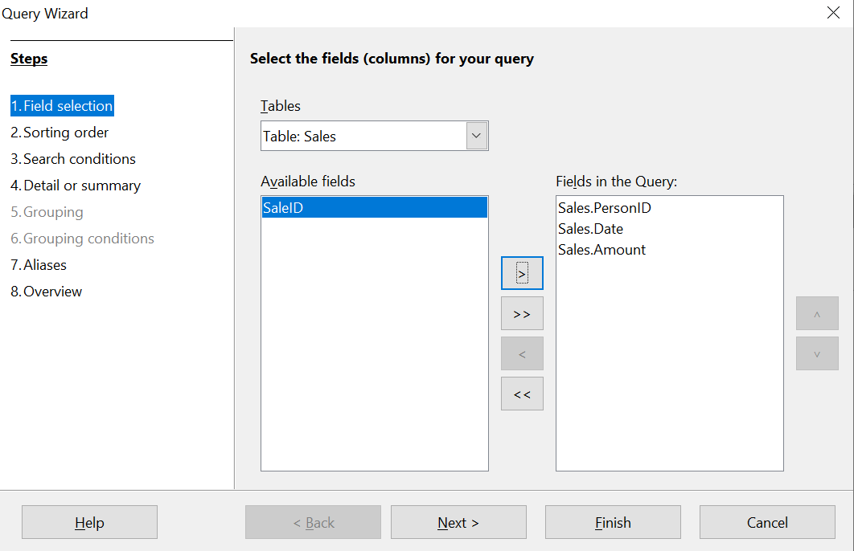Figure : First page of the Query Wizard

Step 2: Select the sorting order
The Wizard allows up to four fields to be used to sort the information of our query. The query language, SQL, does not have a limit on the number of fields that can be used for sorting. In our case, we only want to sort by the date. Set the Sort by list to Sales.Date, leave the Ascending button selected and click Next. Figure 190 shows the dialog just before clicking Next.
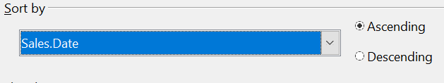Figure : Sorting order page
Step 3: Select the search conditions
The search conditions allow us to compare the field values with desired values and decide whether to include a particular record in our query result or not. Among the choices are:
- is equal to
- is not equal to
- is smaller than
- is greater than
- is equal or less than
- is equal or greater than
- like (used for wildcard matching of text)
Note | These conditions apply to numbers, letters (using the alphabetical order), and dates.
The conditions can be related to each other with AND, so that all the conditions have to be met, or with OR, so that only one condition need be met. We want to limit the records to amounts greater than or equal to 100.
- Since we are only setting one condition, we will use the default setting of Match all of the following.
- We are looking for data beyond a certain value. Select Sales.Amount in the Fields list and is equal or greater than as the Condition.
- Set the Value box to 100. Click Next.
Step 4: Select type of query
We want all the records that meet the criterion returned, so the default setting: Detailed query is what we want. Click Next at the bottom of the window.
Note | Since we have a simple query, the Grouping and Grouping conditions are not needed. Steps 5 and 6 of the wizard are skipped in our query.
Step 7: Assign aliases if desired
We use the default settings, but it is often useful to give descriptive names at this point. Click Next.
Step 8: Overview
Name the query (suggestion: SalesAbove100). To the right of this are two choices. Select Display Query. Click Finish. You will now see a display of the selected rows in the same style that database tables are displayed.

Using the Design View to Create a Query

Make a Basic Query
Creating a query using Design View is not difficult but does require learning the conventions of the tool. We will start with a duplicate of the query from the last section and then make some more complicated queries.
Our first query will display all the sales with an amount greater than or equal to 100, sorted by date.
Step 1: Open the query in Design View
Click Create Query in Design View in the Query's pane of the main Base window.
Step 2: Add tables
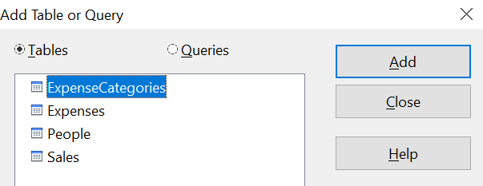Figure : Add Tables or Query window
- Click Sales to highlight it.
- Click Add. Click Close.
Tip | Move the cursor over the bottom edge of the Sales table (Figure 192) and drag it to make it longer and easier to see all the fields in the table.
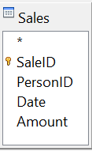Figure : Sales table in query
Step 3: Add fields to the query definition table at the bottom
Double-click the PersonID, Date, and Amount fields to add them to the query definition table.
The table at the bottom of the query window should now have three columns populated. The row labeled Visible is used to toggle the visibility of the field in the final query result. The default is to show all the fields.
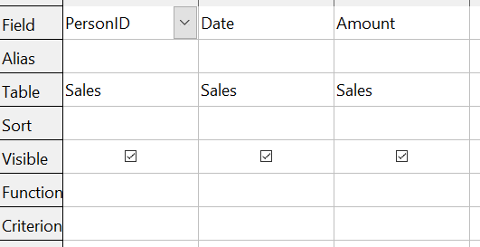Figure : Query definition table
Step 4: Set the criterion for the query
We want the query results to have an Amount greater than or equal to 100 and the dates to be sorted in ascending order.
- Type >= 100 in the Criterion cell under Amount in the query definition table.
- Choose ascending from the dropdown list in the Sort row of the Date column.
- Click the Run Query icon in the Query Design toolbar, which is highlighted in red in Figure 194.
Figure : Query Design toolbar
Step 5: Save and close the query
Save the query and also save the main Base document.

Make a Query With a Calculated Field
Imagine you would like to calculate a commission for each sale that is 7% of the sale amount. The process is just like the last query except that at step 3 an additional column is added manually to the query description, as shown in Figure 195. Notice the fourth column where the Field is defined as "Amount" * 0.07. The name of the column upon which the calculation is based should be enclosed in double quotes. Besides the usual arithmetical operators of +, -, *, and /, many other functions such as square root (sqrt) and the trigonometric functions are available. The calculations may also use more than one column, so you could, for example, calculate the difference or ratio of two columns.
Some other details to note in the calculated column are that it has the text Commission written in its Alias row, and that the Table row is blank. These changes should make sense. The column is not stored in a table, and therefore it does not have a good default name. If the alias is not supplied, the text of the calculation is used, which is not often a helpful column header. Note also that the criterion in the Amount column has been removed. This was not required; it is perfectly possible to do the calculation only on rows that meet any number of criteria.
An important point in database design is that calculations based on field values should be done in queries and not stored in the regular database tables. The main reason for this is that if the underlying values are updated, the calculated values in a regular table will not be automatically updated. You have to explicitly recalculate them. In a query, on the other hand, only the code to run the query is stored, so any calculated values are updated every time the query is run.
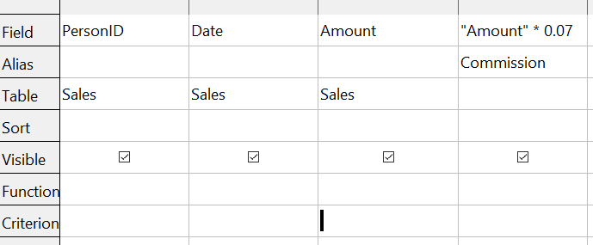Figure : A query with a calculated field

Query with Two Related Tables
An obvious deficiency in the previous queries is that the people associated with an expense or a sale are only identified by the value of the PeopleID field in the People table. Adding their names to the query output is simple because we have established relations between the People table and the Expenses and Sales tables. We will make a new query that displays sales information along with the name of the associated person.
Step 1: Start the query in Design View
From the main Base window, click Queries in the left pane and then Create Query in Design View from the Tasks pane.
Step 2: Add tables to the query
In the Add Query or Table dialog, click on People and then the Add button and do the same for the Sales table. Click Close. You will now have small representations of the two tables with a line running from the PeopleID field of one to the PersonID field of the other, as shown in Figure 196. You may want to resize the tables by dragging down their lower edges.

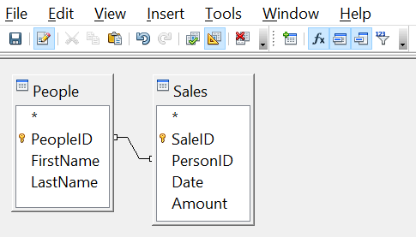Figure : The People and Sales tables in a query
Step 3: Add fields to the query
Double-click on the FirstName and LastName from the People table and Date and Amount from the Sales table to add them to the query definition table.
We now have a query that will display the names along with the information from the Sales table. Save both the query and the main Base document. The query can be enhanced with criteria in any column or with calculated columns as shown in the previous sections.

Query That Summarizes Data
All the queries we have written so far display all the rows that meet the query criteria. It is very common to want a summary of the data that displays quantities like the sum or the average of a field calculated over some group of rows. For example, we might want the sum of sales for each person. Writing such a query can be done using the Function row of the query definition table in Design View.
Step 1: Start the query in Design View
From the main Base window, click Queries in the left pane and then Create Query in Design View from the Tasks pane.
Step 2: Add tables to the query
In the Add Query or Table dialog, click on People and then the Add button and do the same for the Sales table. Click Close.
Step 3: Add fields to the query
Double-click on the FirstName and LastName from the People table and Amount from the Sales table to add them to the query definition table.
Step 4: Set the grouping and the sum function
In the Function row of the query definition table, use the drop-down list to set FirstName and LastName to Group and set Amount to Sum. Also set the Alias of the Amount column to Sales_Sum. The final settings of the query definition table are shown in Figure 197.

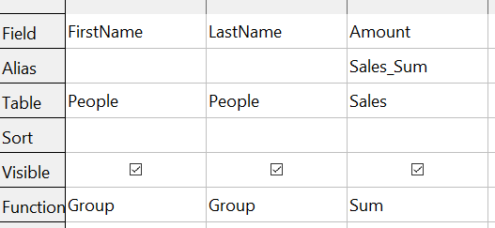Figure : Query summing Amount for each person
Note | In a query that uses one or more summarizing functions, also known as aggregating functions, every column must have an entry in the Function row, either as Group or one of the other functions.

Query Summarizing Over a Calculated Field
As a final example of a query, we will calculate the total sales of each person for each month and year. We will need to use the Date column from the Sales table twice, one to calculate the year and again to calculate the month, and we will also use the fields FirstName, LastName from the People table and Amount from the Sales table.
Step 1: Start the query in Design View
From the main Base window, click Queries in the left pane and then Create Query in Design View from the Tasks pane.
Step 2: Add tables to the query
In the Add Query or Table dialog, click on People and then the Add button and do the same for the Sales table. Click Close.
Step 3: Add fields to the query
Double-click on the Date field from the Sales table twice, then double-click on FirstName and LastName from the People table and Amount from the Sales table to add them to the query definition table.
Step 4: Set the calculation of the year and the month
Change the Field row of the first Date column to read YEAR("Date") and change the Field row of the second Date column to read MONTH("Date"). Set the Alias row to read Sale_Year and Sale_Month for these two columns. The YEAR and MONTH functions are among the many functions provided by the HSQL database engine. A complete list is available in the documentation at https://www.hsqldb.org/doc/1.8/guide/guide.html#N1251E.
Step 5: Set the grouping and the sum function
Set the Function row of every field except Amount to read Group. Set the Function row of the Amount column to read Sum and set its alias to Sales_Sum.
Step 6: Set the sorting
For a more logical presentation of the data, set the Sort column of the year, month and LastName columns to read ascending.
Be sure to save the query and the main Base document. We saved the query with the name GrpCalcColumn, and we will use it in the reports in the next section.
The final configuration of the query definition table and the query results are shown in Figure 198.

Creating Reports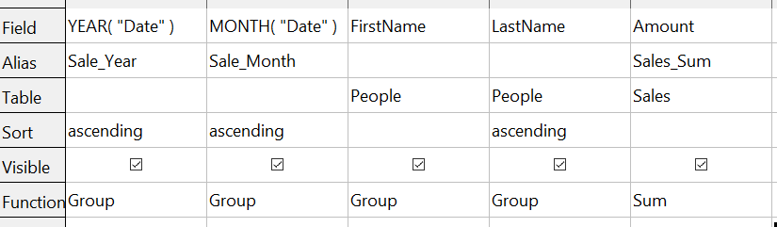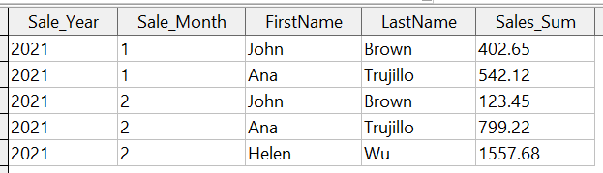

Figure : Definition and result of a query that groups on a calculated column
Reports provide information found in the database in a useful way. In this, they are similar to queries. Reports are generated from the database’s tables or queries. They can contain all the fields of the table or query, or just a selected group of fields. Reports can be static or dynamic. Static reports contain the data in the selected fields at the time the report was created. Dynamic reports can be updated to show the latest data.
For example, a report on expenses in the past should probably be a static report because it is based upon specific data that does not change. However, a report on year-to-date expenses should probably be a dynamic report because this report depends upon data that does change.
All reports are based upon a single table or query, and you need first to decide what fields you want to use in the report. If you intend to use fields from different tables, you must first combine these fields in a single query. Then you can create a report on this query.
The most flexible method for making a report is to write a query that returns the desired columns and sorts the rows, and then save this query as a View in the database. A View is simply a query whose code has been stored alongside the database tables, and it can be treated just like a table. To make a View from a query, click on the Queries icon in the main Base window, then right-click on the name of the specific query and select Create as View. You will be prompted for a name to give the View. A good practice is to give the View the same name as the query, with View as either a prefix or suffix. For the View made from the GrpCalcColumn query that we will use in the reports, we used the name GrpCalcColumn_View. This makes it easy to see the code saved in the View. Keep in mind that editing the query after saving the View does not change the View. You would have to make a new View to embody the new query. Once the View is saved, it will be listed along with the tables in the database.
Once a View is ready for the report, making the report is very simple.

Simple Static Report
Step 1: Start the Report Wizard
On the main Base window, click the Reports icon and then click Use Wizard to Create Report.
Step 2: Choose the fields from the View
Choose the View you want to use from the Tables or queries dropdown list. The available fields will be listed. Use the >> button to move all of them to the Fields in report list. You can just move a subset of the fields by selecting them individually and using the > button. The fields can also be reordered with the up and down arrow buttons. Click Next.
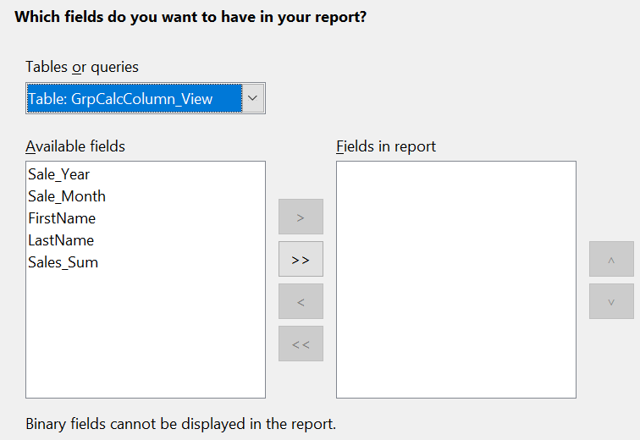Figure : Dialog for choose the fields in a report.
Step 3: Labeling the fields
Here you can modify the field labels from their default values. We will remove the underscores from the field names and add spaces so that Sale_Year becomes Sale Year and LastName becomes Last Name. Click Next.
Step 4: Grouping levels
In this first report we will not add grouping levels. In the next iteration of the report, we will do that. Click Next.
Step 5: Sort options
It is better to sort in the View rather than using the Report Wizard's sort. Click Next.
Step 6: Choose layout
There are many layout options. We will leave the defaults in place, but you can explore alternatives. A mock version of the report is visible behind the Report Wizard dialog and if you drag the dialog low in the screen, you can see the effect of different layouts. Click Next.
Step 7: Create report
In this step, you give the report file a name, rather misleadingly called Title of report and choose whether the report is static or dynamic. We will select static for this version. Click Finish.
We now have a Writer file that looks like Figure 200.
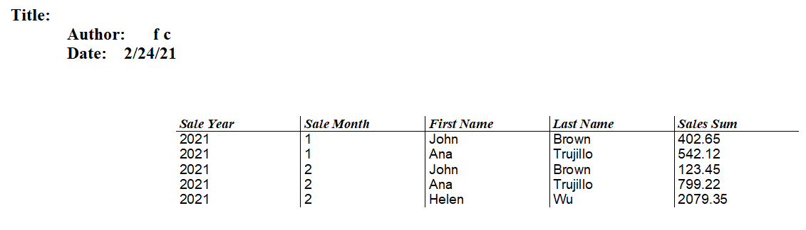Figure : Static report
The Author field is taken from Tools > Options > OpenOffice > User Data > First/Last name. All the information is locked and not easily edited. It can be copied to a new document and edited there. If you do that, the Title field can be filled out in the new document by selecting the menu File > Properties and filling out the Title on the Description tab.

Grouped Dynamic Report
We will now change the report in two ways. We will make it dynamic, and we will add some Grouping Levels. Keep in mind that these two are independent. The Grouping Levels could have been added to the static report in the last section.
Step 1: Start the Report Wizard
On the main Base window, click the Reports icon and then click Use Wizard to Create Report.
Step 2: Choose the fields from the View
Choose the View you want to use from the Tables or queries dropdown list. The available fields will be listed. Use the >> button to move all of them to the Fields in report list. Click Next.
Step 3: Labeling the fields
Here you can modify the field labels from their default values. We will remove the underscores from the field names and add spaces so that Sale_Year becomes Sale Year and LastName becomes Last Name. Click Next.
Step 4: Grouping levels
Use the > button to move the Sale_Year and Sale_Month, in that order, from the Fields to the Groupings column. Click Next.
Step 5: Sort options
Note that Sale_Year and Sale_Month are now listed as sort fields. Click Next.
Step 6: Choose layout
We will keep the defaults but, as mentioned in the previous section, you can try many alternatives. Click Next.
Step 7: Create report
Set the name of the report file, choose Dynamic report and Create report now. Click Finish.
The top part of the report looks much like Figure 200, but the data table now has a hierarchical structure with the year being the outermost category, then the month and then the data for each person's monthly sales in a table.
The report layout can be edited by closing the report then right-clicking on its icon and selecting Edit. The report will appear filled with dummy data. The Title field can be populated by selecting the menu File > Properties and filling out the Title on the Description tab. The Author field is taken from Tools > Options > OpenOffice > User Data > First/Last name. The date format in the header area can be adjusted by right-clicking on it and selecting Fields. A dialog with a long list of formats will appear. Choose one then click OK. In the data table, the column widths can be adjusted by hovering the cursor over a border until it becomes a double-headed arrow then clicking and dragging it left or right.
When you are done changing the format, save the document and also save the main Base document. If you double-click on the report now, you will see the format changes along with the actual data from the View. Compare Figure 201 to Figure 200 to see the effect of the groupings by the Sale Year and Sale Month. Remember that the grouping could have been done in the static report. Since this report is dynamic, if data is added or deleted from the People and Sales tables, the report will reflect the changes.
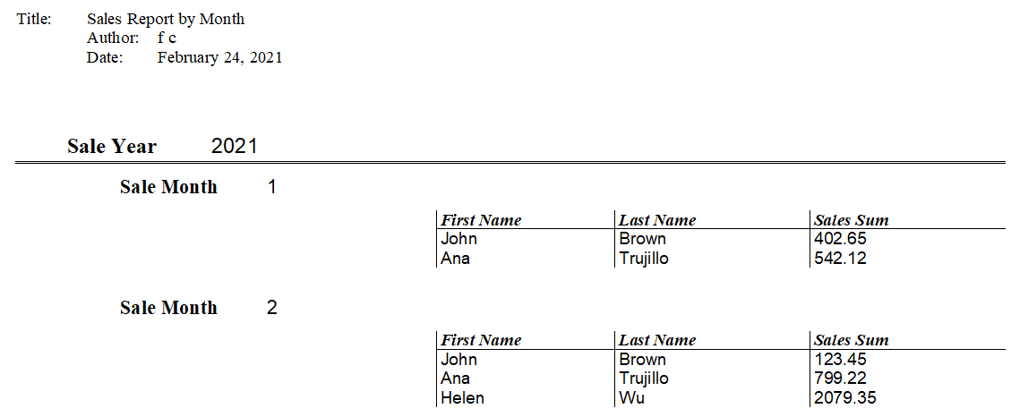Figure : Dynamic report with grouped data

Chapter 8
Getting Started with Math

What is Math?
Math is Apache OpenOffice’s component for writing mathematical equations. It is most commonly used as an equation editor for text documents, but it can also be used with other types of documents or stand-alone. When used inside Writer, the equation is treated as an object inside the text document.
Note | The equation editor is for writing equations in symbolic form, as in the equation below. If you want to evaluate a numeric value, see the Calc Guide.

Getting Started
To insert an equation, choose Insert > Object > Formula.
The equation editor opens at the bottom of the screen, and the floating Elements window may appear. You will also see a small box with a gray border in your document, where the formula will be displayed. (See Figure 202.)

Entering a Formula
The equation editor uses a markup language to represent formulas. For example, %beta creates the Greek character beta (). This markup is designed to read similar to English whenever possible. For example, a over b produces a fraction: .
You can enter a formula in three ways:
- Select a symbol from the Elements window.
- Right-click on the equation editor and select the symbol from the context menu.
- Type markup in the equation editor.
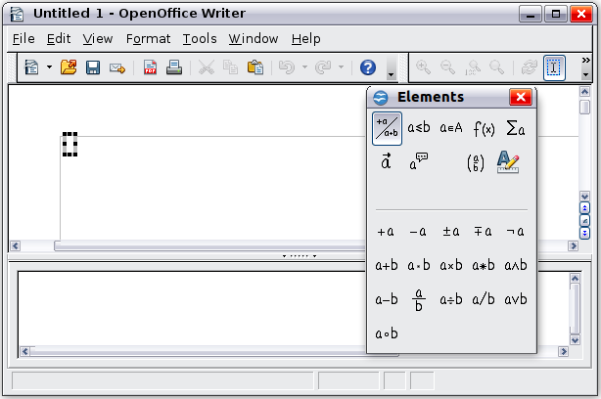Figure . Equation Editor, Elements window, and location of resulting equation.
The context menu and the Elements window insert the markup corresponding to a symbol. This provides a convenient way to learn the Math markup.
Note | Click on the document body to exit the formula editor.  Double-click on a formula to enter the formula editor again.

The Elements Window
The simplest method for entering a formula is to use the Elements window.
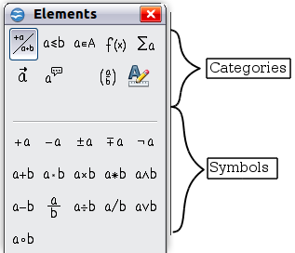
Figure . Symbols are divided into categories
The Elements window is divided into two main parts.
- The top shows the symbol categories. Click on these to change the list of symbols.
- The bottom shows the symbols available in the current category.
Tip | You can hide or show the Elements window with View > Elements.

Example 1:
For this example we will enter a simple formula:. On the Elements window:
- Select the top-left button of the categories (top) section.
- Click on the multiplication symbol.
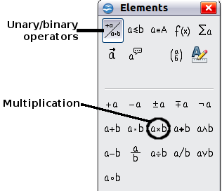
Figure . Selecting the multiplication symbol
When you select the multiplication symbol on the Elements window, two things happen:
- The equation editor shows the markup:
- The body of the document shows a gray box like this:
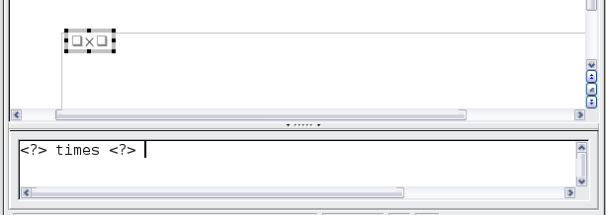
Figure . Result of selecting the multiplication symbol
The <?> symbols shown in Figure 205 are placeholders that you can replace by other text, for example 5 and 4. The equation will update automatically, and the result should resemble Figure 206.
Tip | To keep the equation from updating automatically, choose View > AutoUpdate Display from the menu bar. To update a formula manually, press F9 or pick View > Update.
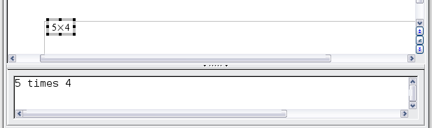
Figure . Result of entering 5 and 4 next to the times operator

Right-click (Context) Menu
Another way to access mathematical symbols is to right-click on the equation editor. This pops up the menu shown in Figure 207. The items in this menu correspond exactly to those in the Elements window.
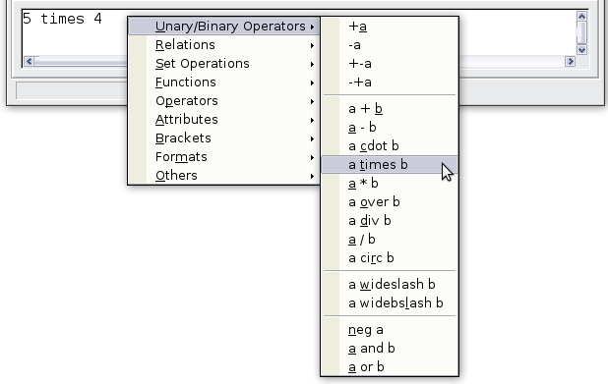
Figure . Right-click (Context) Menu

Markup
You can type the markup directly in the equation editor. For example, you can type 5 times 4 to obtain . If you know the markup, this can be the fastest way to enter a formula.
Tip | The formula markup resembles the way the formula reads in English.
Below is a short list of common equations and their corresponding markup.
Display | Command | Display | Command
 | a = b |  | sqrt {a}
 | a^2 |  | a_n
 | int f(x) dx |  | sum a_n
 | a <= b |  | infinity
 | a times b |  | x cdot y

Greek Characters
Greek characters (, and so on) are common in mathematical formulas. These characters are not available in the Elements window or on the right-click menu. Fortunately, the markup for Greek characters is simple: Type a % sign followed by the name of the character, in English. (In localized versions of OpenOffice, these names are localized.)
- To write a lowercase character, type the name of the character in lowercase.
- To write an uppercase character, type the name of the character in uppercase.
A complete table of Greek characters is provided in the Math Guide. See the table below for some examples.
Lowercase | Uppercase
%alpha | %ALPHA
%beta | %BETA
%gamma | %GAMMA
%psi | %PSI
%phi | %PHI
%theta | %THETA
Another way to enter Greek characters is by using the Symbols catalog window. Choose Tools > Catalog. Under Symbol set, select Greek and double-click on a Greek letter from the list. The markup name of the character is shown below the list window.
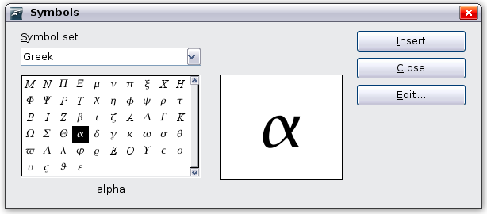
Figure . Symbols catalog—used for entering Greek characters and some special symbols.

Example 2:
For this example we will suppose that:
- We want to enter the above formula (the value of pi rounded to 5 decimal places).
- We know the name of the Greek character (pi).
- But we do not know the markup associated with the symbol.
Step 1: Type % followed by the text pi. This displays the Greek character .
Step 2: Open the Elements window (View > Elements).
Step 3: The symbol is a relation, so we click on the Relations button. If you hover the mouse over this button you see the tooltip Relations (Figure 209).
Figure 210 shows the Elements window after clicking the Relations button. The symbol we want is circled.
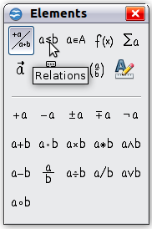  Figure . Tool-tip indicates the  Relations button. | 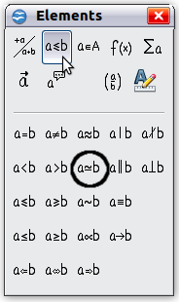  Figure . After selecting Relations.
Step 4: Click on the ab symbol. The equation editor now shows the markup
%pi<?> simeq <?>.
Step 5: Delete the <?> text and add 3.14159 at the end of the equation. We end up with the markup %pi simeq 3.14159. The result is shown in Figure 211.
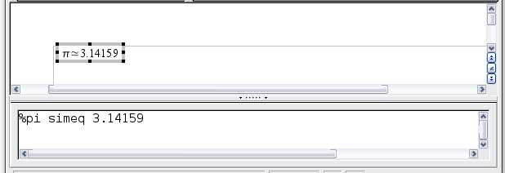
Figure . Final result

Customization

Formula Editor as a Floating Window
The formula editor can cover a large part of the Writer window. To turn the formula editor into a floating window, do this:
- Hover the mouse over the editor frame, as shown in Figure 212.
- Hold down the Ctrl key and double-click.
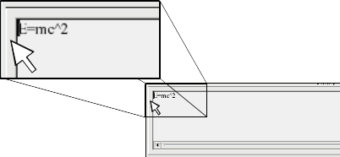Figure . Hold down the Ctrl key and double-click on the border of the formula editor to turn it into a floating window.
Figure 213 shows the result. You can dock the floating window again by using the same steps. Hold down the Ctrl key and double-click the window frame.
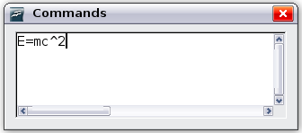
Figure . Formula editor as a floating window

How Can I Make a Formula Bigger?
This is one of the most common questions people ask about Math. The answer is simple, but not intuitive:
- Start the formula editor and choose Format > Font size.
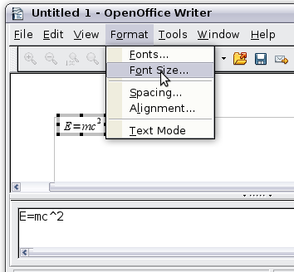
Figure . Changing the font size for a formula
- Select a larger font size under Base size (top-most entry).
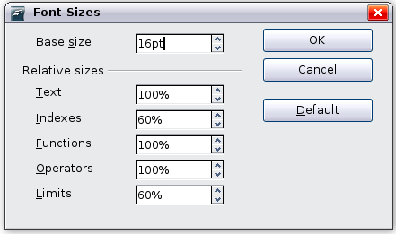
Figure . Edit Base size (top) to make a formula bigger
The result of this change is illustrated in Figure 216.
Figure . Result of changing the base font size

Formula Layout
The most difficult part of using Math comes when writing complicated formulas. This section provides some advice.

Brackets Are Your Friends
Math knows nothing about order of operation. You must use brackets to state the order of operations explicitly. Consider the following example.
Markup | Result
2 over x + 1
2 over {x + 1}

Equations Over More Than One Line
Suppose you want to type an equation covering more than one line. For example:
Your first reaction would be to simply press the Enter key. However, if you press the Enter key, though the markup goes to a new line, the resulting equation does not. You must type the newline command explicitly. This is illustrated in the table below.
Markup | Result
x = 3
y = 1
x = 3 newline
y = 1

How do I Add Limits to My Sum/Integral?
The sum and int commands can (optionally) take the parameters from and to. These are used for lower and upper limits respectively. These parameters can be used singly or together. Limits for integrals are usually treated as subscripts and superscripts. Remember that subscripts are indicated with _ and superscripts are indicated with ^.
Markup | Result
sum from k = 1 to n a_k
int from 0 to x f(t) dt  or  int_0^x f(t) dt | or
int from Re f
sum to infinity 2^{-n}
Note | For more details on integrals and sums, see the Math Guide.

Brackets with Matrices Look Ugly!
For background, we start with an overview of the matrix command.
Markup | Result
matrix { a # b ## c # d }
Note | Rows are separated by two #’s and entries within each row are separated by one #.
The first problem people have with matrices is that brackets do not scale with the matrix.
Markup | Result
( matrix { a # b ## c # d } )
Math provides scalable brackets. That is, the brackets grow in size to match the size of their contents. Use the commands left (and right) to make scalable brackets.
Markup | Result
left( matrix { a # b ## c # d } right)
Tip | Use left[ and right] to obtain square brackets.

How do I Make a Derivative?
Making derivatives essentially comes down to one trick: Tell Math it’s a fraction.
In other words, you have to use the over command. Combine this with either the letter d (for a total derivative) or the partial command (for a partial derivative) to achieve the effect of a derivative.
Note | Notice that we have to use braces (squiggly brackets) to make the derivative.
Markup | Result
{df} over {dx}
{partial f} over {partial y}
{partial^2 f} over {partial t^2}

How do I Align My Equations at the Equals Sign?
Math does not have a command for aligning equations on a particular character, but you can use a matrix to do this, as shown below.
Markup | Result
matrix{
alignr x+y # {}={} # alignl 2 ##
alignr x # {}={} # alignl 2-y
}
The empty braces around = are necessary because = is a binary operator and thus needs an expression on each side.
You can reduce the spacing around = if you change the inter-column spacing of the matrix:
- With the equation editor open, choose Format > Spacing from the menu bar.
- In the Spacing dialog (Figure 217), click the Category button and select Matrices in the drop-down menu.
- Enter 0% for Column spacing and click OK.
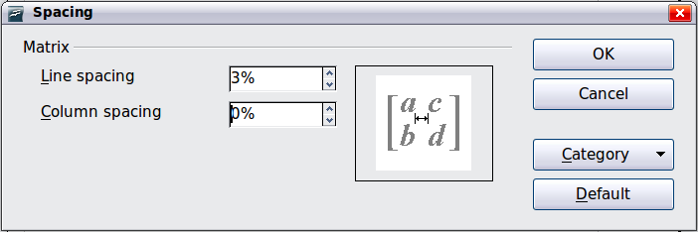Figure : Changing spacing in a matrix formula

Numbering Equations
Equation numbering is one of Math’s best hidden features. The steps are simple, but obscure:
- Start a new line in the Writer document.
- Type fn and then press F3.
The fn is replaced by a numbered formula:
()
Now you can double-click on the formula to edit it. For example, here is the Riemann Zeta function:
()
You can reference an equation (“as shown in Equation (1)”) with these steps:
- Choose Insert > Cross-reference from the menu bar.
- On the Cross-references tab (Figure 218), under Type, select Text.
- Under Selection, select the equation number.
- Under Format, select Reference.
- Click Insert.
Done! If you later add more equations to the paper before the referenced equation, all the equations will automatically renumber and the cross-references will update.
Tip | To insert the equation number without parenthesis around it, choose Numbering instead of Reference under Format.
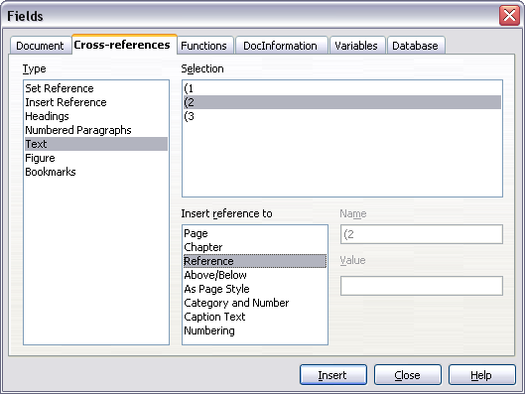
Figure . Inserting a cross-reference to an equation number

Chapter 9
Printing, Exporting, and E-mailing

Introduction
This chapter provides general information about printing, exporting, and e-mailing documents from Apache OpenOffice.

Quick Printing
Click the Print File Directly icon to send the entire document to the default printer defined for your computer.
Note | You can change the action of the Print File Directly icon to send the document to the printer defined for the document instead of the default printer for the computer. Go to Tools > Options > Load/Save > General and select the Load printer settings with the document option.

Controlling Printing
For more control over printing, use the Print dialog (File > Print or Ctrl+P). (See Figure 219)
The Print dialog has four tabs, from which you can choose a range of options, as described in the following sections.
Note | The options selected on the Print dialog apply to this printing of this document only.  To specify default printing settings for Apache OpenOffice, go to Tools > Options > OpenOffice > Print and Tools > Options > OpenOffice Writer > Print. See Chapter 11 (Setting Up and Customizing Apache OpenOffice) for more details.
The different components of Apache OpenOffice have different available print settings, as summarized in Table 2.
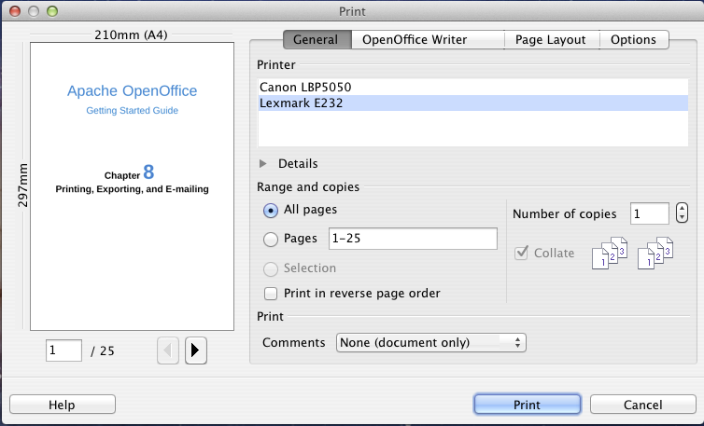
Figure . The Print dialog
Table : Print options in Apache OpenOffice components
Feature | Writer | Calc | Impress | Draw
Select pages/sheets/slides to print | Yes | Yes | Yes | Yes
Print multiple pages/sheets/slides on one page | Yes | Yes | Yes | Yes
Print a brochure | Yes | No | Yes | Yes
Print envelopes | Yes | No | No | No
Print labels or business cards | Yes | No | No | No
Preview pages/sheets before printing | Yes | Yes | No | No

Selecting General Printing Options
On the General tab of the Print dialog, you can choose:
- The printer (from the printers available)
- Which pages to print, the number of copies to print, and whether to collate multiple copies (Range and copies section)
- Whether to print a multiple-page document in reverse page order, to accommodate the output feed of the printer
- Whether to print any comments that are in the document, and where to print the comments.
Figure : Choosing whether and where to print comments
Select the Properties button to display a dialog where you can choose portrait or landscape orientation, which paper tray to use, and the paper size to print on. Setting some of these properties requires clicking the Advanced button in the Properties dialog.
On the Options tab of the Print dialog (Figure 221), the last item, Use only paper tray from printer preference, is not available in Calc.
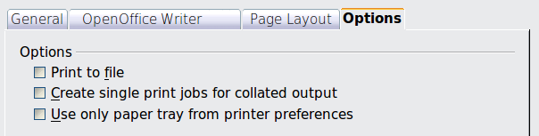
Figure : General print options

Printing Multiple Pages on a Single Sheet of Paper
You can print multiple pages of a document on one sheet of paper. To do this:
- In the Print dialog, select the Page Layout tab (Figure 222).
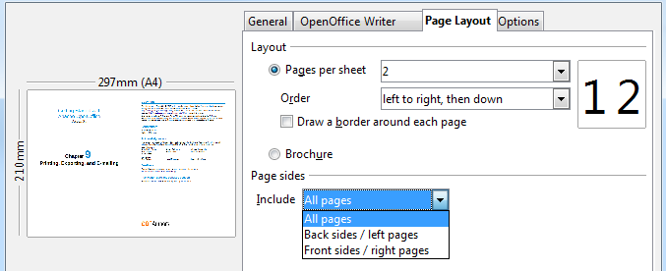
Figure : Printing multiple pages per sheet of paper
- In the Layout section, select from the drop-down list the number of pages to print per sheet. The preview panel on the left of the Print dialog shows how the printed document will look.
When printing more than 2 pages per sheet, you can choose the order in which they are printing across and down the paper. The two pictures below show the difference.
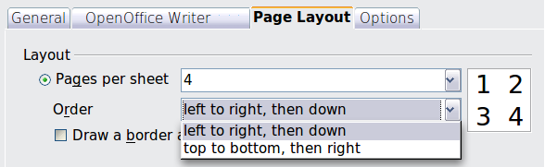
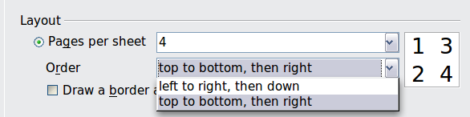
- In the Page sides section, select whether to print all pages or only some pages.
- Click the Print button.
Tip | In Writer, to print two pages per sheet in “facing pages” (book layout) style, print from Print Preview instead. See page 250.

Selecting Pages/Sheets/Slides to Print
In addition to printing a full document, you can choose to print individual pages/ sheets/slides, ranges of pages/sheets/slides, or a selection of a document. The details vary slightly in Writer, Calc, Draw and Impress, as described in this section.

Writer
Printing an individual page:
- Choose File > Print from the menu bar.
- On the Print dialog, select the page to print.
  - In the Ranges and copies section of the General page, select the Pages option.
  - Enter the sequence number of the page you want to print. The preview box changes to show the selected page.
If you have restarted page numbering within the document, the sequence number is not the same as the page number.
- Click the Print button.
Printing a range of pages:
- Choose File > Print from the menu bar.
- On the Print dialog, select the range of pages to print.
  - In the Ranges and copies section of the General page, select the Pages option.
  - Enter the sequence numbers of the pages to print (for example, 1–4 or 1,3,7,11).
- Click the Print button.
Printing a selection of text:
- In the document, select the material (text and graphics) to print.
- Choose File > Print from the menu bar.
- The Ranges and copies section of the Print dialog now includes a Selection option and the preview box shows the selected material. See Figure 223.
- Click the Print button.
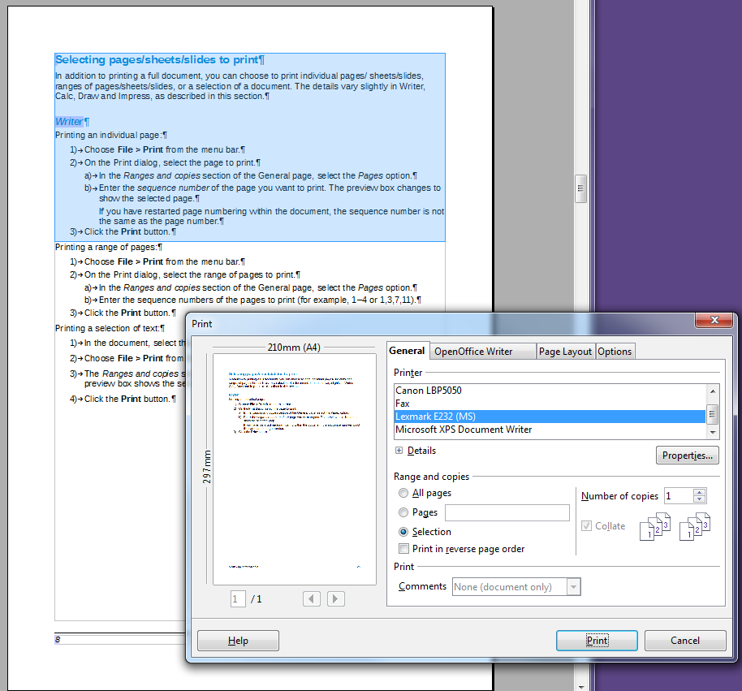
Figure : Printing a selection of text

Calc
You can choose single sheets, multiple sheets, and selections of cells for printing.
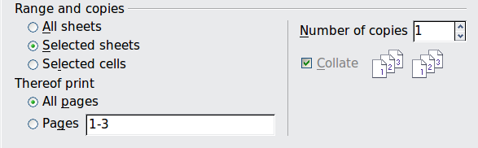
Figure : Choosing what to print in Calc
Printing an individual sheet:
- In the spreadsheet, click on the sheet tab to select the sheet you want to print.
- Choose File > Print from the menu bar.
  - In the Ranges and copies section of the Print dialog, choose the Selected sheets option.
- Click the Print button.
Printing a range of sheets:
- In the spreadsheet, select the sheets to print.
  - Select the first sheet.
  - Hold down the Ctrl key.
  - Click on the additional sheet tabs.
  - Release the Ctrl key when all required sheets are selected.
- Choose File > Print from the menu bar.
- In the Ranges and copies section of the Print dialog, choose the Selected sheets option.
- Click the Print button.
Printing a selection of cells:
- In the document, select the section of cells to print.
- Choose File > Print from the menu.
- In the Ranges and copies section of the Print dialog, select the Selected cells option.
- Click the Print button.
Caution | After printing, be sure to deselect the extra sheets. If you keep them selected, the next time you enter data on one sheet, you enter data on all the selected sheets. This might not be what you want.

Impress and Draw
You can choose individual slides, ranges of slides, or selections of slides for printing.

Printing an individual slide:
- Choose File > Print from the menu bar.
- Select the slide to print.
  - In the Ranges and copies section of the Print dialog, select the Slides option.
  - Enter the number of the slide to print.
- Click the Print button.
Printing a range of pages:
- Choose File > Print from the menu bar.
- Select the slides to print.
  - In the Ranges and copies section of the Print dialog, select the Slides option.
  - Enter the number of the slides to print (for example 1-4 or 1,3,7,11).
- Click the Print button.
Printing a selection of a slide, or a selection from multiple slides:
- In the document, select the section of the slide to print.
- Choose File > Print from the menu bar.
- Select the Selection option in the Ranges and copies section of the Print dialog.
- Click the Print button.

Printing Handouts, Notes, or Outlines in Impress
Handouts print the slides in reduced size on the page, from one to nine slides per page. The slides can be printed horizontally (landscape orientation) or vertically (portrait orientation) on the page.
Notes print a single slide per page with any notes entered for that slide in Notes View.
Outline prints the title and headings of each slide in outline format.
To print handouts, notes, or outlines:
- Choose File > Print from the menu bar.
- In the Print section of the Print dialog, select the required option.
- For Handouts, you can then choose how many slides to print per page, and the order in which they are printed.
- Click the Print button.
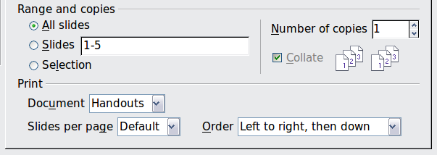

Printing A Brochure
In Writer, Impress, and Draw, you can print a document with two pages on each side of a sheet of paper, arranged so that when the printed pages are folded in half, the pages are in the correct order to form a booklet or brochure.
Tip | Plan your document, so it will look good when printed half size; choose appropriate margins, font sizes, and so on. You may need to experiment.
To print a brochure on a single-sided printer:
- Choose File > Print.
- In the Print dialog, click Properties.
- Check the printer is set to the same orientation (portrait or landscape) as specified in the page setup for your document. Usually the orientation does not matter, but it does for brochures. Click OK to return to the Print dialog.
- Select the Page layout tab in the Print dialog.
- Select the Brochure option.
- In the Page sides section, select Back sides / left pages option from the Include drop-down list.
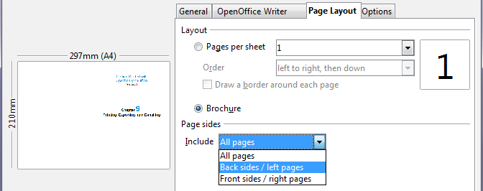
- Click the Print button.
- Take the printed pages out of the printer, turn the pages over, and put them back into the printer in the correct orientation to print on the blank side. You may need to experiment a bit to find out what the correct arrangement is for your printer.
- On the Print dialog, in the Page sides section, select Front sides / right pages option from the Include drop down box.
- Click the Print button.
Tip | If your printer can print double-sided automatically, choose All pages.

Printing Envelopes, Labels, Business Cards
Printing envelopes, labels, or business cards using Writer involves two steps: setup and printing.
For details of how to set these up, see Chapter 11 (Using Mail Merge) in the Writer Guide. To print:
- Choose File > Print from the menu bar.
- On the Print dialog, under Ranges and copies, choose Pages and type 1 in the box. Click the Print button.

Printing in Black and White (on a Color Printer)
You may wish to print documents in black and white on a color printer. Several choices are available. Please note that some color printers may print in color regardless of the settings you choose.
Change the printer settings to print in black and white or gray scale:
- Choose File > Print to open the Print dialog.
- Click Properties to open the Properties dialog for the printer. The available choices vary from one printer to another, but you should find options for the Color settings. See your printer’s help or user manual for more information.
- The choices for color might include black and white or grayscale. Choose the required setting.
- Click OK to confirm your choice and return to the Print dialog,
Click the Print button to print the document.
Tip | Gray scale is best if you have any graphics in the document.
Change the Apache OpenOffice settings to print all color text and graphics as gray scale:
- Choose Tools > Options > OpenOffice > Print.
- Select the Convert colors to grayscale option. Click OK to save the change.
- Open the Print dialog (File > Print).
- Click the Print button to print the document.
Change the Writer (or Calc, Impress, Draw) settings to print all color text as black, and all graphics as gray scale:
- Choose Tools > Options > OpenOffice Writer > Print.
- Under Contents, select the Print text in black option. Click OK to save the change.
- Open the Print dialog (File > Print).
- Click the Print button to print the document.

Previewing Pages/Sheets Before Printing
You can use the previewing options in Writer and Calc to view the document as it will be printed. Different viewing options are available.

Writer
The normal page view in Writer shows you what each page will look like when printed, and you can edit the pages in that view. If you are designing a document to be printed double-sided, you may want to see what facing pages look like. Writer provides two ways to do this:
- View Layout (editable view): use the Facing Pages (Book Preview) button on the status bar.
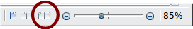
- Page Preview (read-only view).
To use Page Preview:
- Choose File > Page Preview (or click the Page Preview button on the Standard toolbar).
Writer now displays the Page Preview toolbar instead of the Formatting toolbar.
Figure . Page Preview toolbar (Writer)
- Select the required preview icon: Two Pages (), Multiple Pages () or Book Preview ().
- To print the document from this view, click the Print document icon() to open the Print dialog.
- Choose the print options and click the Print button.

Calc
To preview the sheets in Calc before printing:
- Choose File > Page Preview.
The Calc window now displays the Page Preview toolbar instead of the Formatting toolbar.
Figure . Page Preview toolbar (Calc)
- To print the document from this view, click the Print document icon() to open the Print dialog.
- Choose the print options and click the Print button.

Exporting to PDF
OpenOffice can export documents to PDF (Portable Document Format). This industry-standard file format is ideal for sending the file to someone else to view using any of the many PDF viewers.
The process and dialogs are the same for Writer, Calc, Impress, and Draw, with a few minor differences mentioned in this section.

Quick Export to PDF
Click the Export Directly as PDF icon to export the entire document using your default PDF settings. You are asked to enter the file name and location for the PDF file, but you do not get a chance to choose a page range, the image compression, or other options.

Controlling PDF Content and Quality
For more control over the content and quality of the resulting PDF, use File > Export as PDF. The PDF Options dialog opens. This dialog has five pages (General, Initial View, User Interface, Links, and Security). Select the appropriate settings, and then click Export. Then you are asked to enter the location and file name of the PDF to be created, and click Export to export the file.

General Page of PDF Options Dialog
On the General page, you can choose which pages to include in the PDF, the type of compression to use for images (which affects the quality of images in the PDF), and other options.
Range section
- All: Exports the entire document to PDF.
- Pages: To export a range of pages, use the format 3-6 (pages 3 to 6). To export single pages, use the format 7;9;11 (pages 7, 9, and 11). You can also export a combination of page ranges and single pages, by using a format like 3-6;8;10;12.
- Selection: Exports all the selected material.
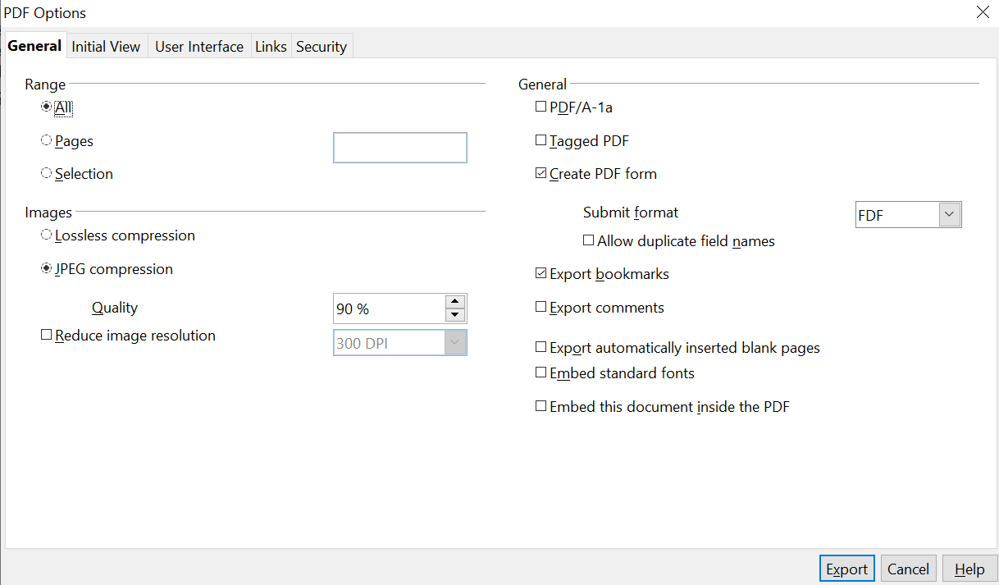

Figure : General page of PDF Options dialog
Images section
- Lossless compression: Images are stored without any loss of quality. Tends to make large files when used with photographs. Recommended for other kinds of images or graphics.
- JPEG compression: Allows for varying degrees of quality. A setting of 90% works well with photographs (small file size, little perceptible loss of quality).
- Reduce image resolution: Lower-DPI (dots per inch) images have lower quality. For viewing on a computer screen generally a resolution of 72dpi (for Windows) or 96dpi (GNU/Linux) is sufficient, while for printing it is generally preferable to use at least 300 or 600 dpi, depending on the capability of the printer. Higher dpi settings greatly increase the size of the exported file.
Note | EPS (Encapsulated PostScript) images with embedded previews are exported only as previews. EPS images without embedded previews are exported as empty placeholders.
General section
- PDF/A-1a: PDF/A is an ISO standard for long-term preservation of documents, by embedding all the information necessary for faithful reproduction (such as fonts) while forbidding other elements (including forms, security, and encryption). PDF tags are written. If you select PDF/A-1a, the forbidden elements are grayed-out (not available).
- Tagged PDF: Tagged PDF contains information about the structure of the document’s contents. This can help to display the document on devices with different screens, and when using screen reader software. Some tags that are exported are table of contents, hyperlinks, and controls. This option can increase file sizes significantly.
- Create PDF Form – Submit format: Choose the format of submitting forms from within the PDF file. This setting overrides the control’s URL property that you set in the document. There is only one common setting valid for the whole PDF document: PDF (sends the whole document), FDF (sends the control contents), HTML, and XML. Most often you will choose the PDF format.
- Export bookmarks: Exports headings in Writer documents, and page names in Impress and Draw documents, as “bookmarks” (a table of contents list displayed by most PDF viewers).
- Export comments: Exports comments as PDF notes. You may not want this!
- Export automatically inserted blank pages: If selected, automatically inserted blank pages are exported to the PDF. This is best if you are printing the PDF double-sided. For example, books usually have chapters set to always start on an odd-numbered (right-hand) page. When the previous chapter ends on an odd page, Apache OpenOffice inserts a blank page between the two odd pages. This option controls whether to export that blank page.
- Embed standard fonts: You can choose to embed the standard fonts (Times, Helvetica, Courier, Symbol, and ZapfDingbats) in all PDF documents created by Apache OpenOffice to enhance display accuracy in PDF viewers.
- Embed this document inside the PDF: This will allow some OpenOffice extensions or other software to extract the original document so it can be edited and an updated PDF created without a PDF editing program.

Initial View Page of PDF Options Dialog
On the Initial View page (Figure 228), you can choose how the PDF opens by default in a PDF viewer. The selections should be self-explanatory.

User Interface Page of PDF Options Dialog
On the User Interface page (Figure 229), you can choose more settings to control how a PDF viewer displays the file. Some of these choices are particularly useful when you are creating a PDF to be used as a presentation or a kiosk-type display.
Window options section
- Resize window to initial page. Causes the PDF viewer window to resize to fit the first page of the PDF.
- Center window on screen. Causes the PDF viewer window to be centered on the computer screen.
- Open in full screen mode. Causes the PDF viewer to open full-screen instead of in a smaller window.
- Display document title. Causes the PDF viewer to display the document’s title in the title bar.

Figure : Initial View page of PDF Options dialog

Figure : User Interface page of PDF Options dialog
User interface options section
- Hide menubar. Causes the PDF viewer to hide the menu bar.
- Hide toolbar. Causes the PDF viewer to hide the toolbar.
- Hide window controls. Causes the PDF viewer to hide other window controls.
Transitions
In Impress, displays slide transition effects as their respective PDF effects.
Bookmarks
Select how many heading levels are displayed as bookmarks, if Export bookmarks is selected on the General page.

Links Page of PDF Options Dialog
On the Links page, you can choose how links are exported to PDF.
Figure : Links page of PDF Options dialog
Export bookmarks as named destinations
If you have defined Writer bookmarks, Impress or Draw slide names, or Calc sheet names, this option exports them as “named destinations” to which Web pages and PDF documents can link.
Convert document references to PDF targets
If you have defined links to other documents with OpenDocument extensions (such as .ODT, .ODS, and .ODP), this option converts the files names to .PDF in the exported PDF document.
Export URLs relative to file system
If you have defined relative links in a document, this option exports those links to the PDF.
Cross-document links
Defines the behavior of links clicked in PDF files.

Security Page of PDF Options Dialog
PDF export includes options to encrypt the PDF (so it cannot be opened without a password) and apply some digital rights management (DRM) features.
- With an open password set, the PDF can only be opened with the password. Once opened, there are no restrictions on what the user can do with the document (for example, print, copy, or change it).
- With a permissions password set, the PDF can be opened by anyone, but its permissions can be restricted. See Figure 231. After you set a password for permissions, the other choices on the Security page become available.
- With both the open password and permission password set, the PDF can only be opened with the correct password, and its permissions can be restricted.
Note | Permissions settings are effective only if the user’s PDF viewer respects the settings.
Figure 232 shows the pop-up dialog displayed when you click the Set open password button on the Security page of the PDF Options dialog.
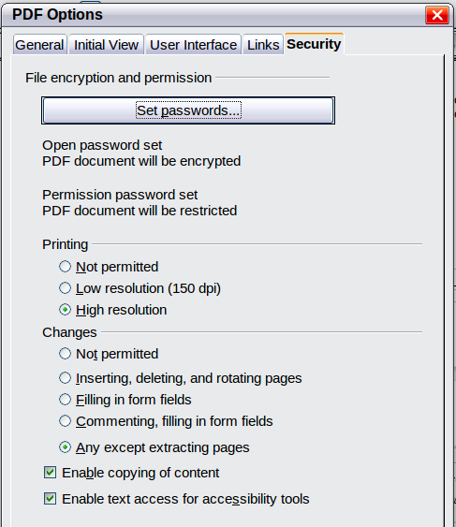
Figure : Security page of PDF Options dialog
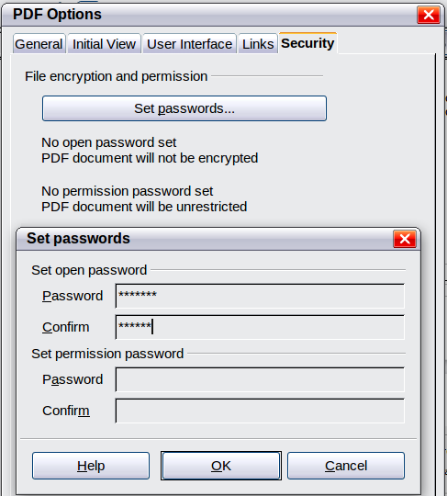
Figure : Setting a password to encrypt a PDF

Exporting to Other Formats
Apache OpenOffice uses the term “export” for some file operations involving a change of file type. If you cannot find what you want under File > Save As, look under File > Export as well.
Apache OpenOffice can export files to XHTML. In addition, Draw and Impress can export to a range of image formats.
To export to one of these formats, choose File > Export. On the Export dialog, specify a file name for the exported document, then select the required format in the File format list and click the Export button.

E-mailing Documents
Apache OpenOffice provides several ways to quickly and easily send documents as an e-mail attachment in one of three formats: OpenDocument (Apache OpenOffice’s default format), Microsoft Office formats, or PDF.
Note | Documents can only be sent from the Apache OpenOffice menu if you have an e-mail program such as Thunderbird installed on your computer. Sending e-mail via a web service accessed through a web browser requires saving the document and attaching it to the e-mail message from the service's software.
To send the current document in OpenDocument format:
- Choose File > Send > Document as E-mail. OpenOffice opens your default e-mail program. The document is attached.
- In your e-mail program, enter the recipient, subject, and any text you want to add, then send the e-mail.
File > Send > E-mail as OpenDocument Text (or Spreadsheet or Presentation) has the same effect.
If you choose E-mail as Microsoft [Word, Excel, or PowerPoint], Apache OpenOffice first creates a file in one of those formats and then opens your e-mail program with the file attached. Remember that using a non-native format may cause changes in formatting.
Similarly, if you choose E-mail as PDF, Apache OpenOffice first creates a PDF using your default PDF settings (as when using the Export Directly as PDF toolbar button) and then opens your email program with the .PDF file attached.

E-mailing a Document to Several Recipients
To e-mail a document to several recipients, you can use the features in your e-mail program, or you can use Apache OpenOffice’s mail merge facilities to extract email addresses from an address book.
You can use Apache OpenOffice’s mail merge to send e-mail in two ways:
- Use the Mail Merge Wizard to create the document and send it. See Chapter 11 (Using Mail Merge) of the Writer Guide for details.
- Create the document in Writer without using the Wizard, then use the Wizard to send it. This method is described here.
To use the Mail Merge Wizard to send a previously-created Writer document:
- Click Tools > Mail Merge Wizard. On the first page of the wizard, select Use the current document and click Next.
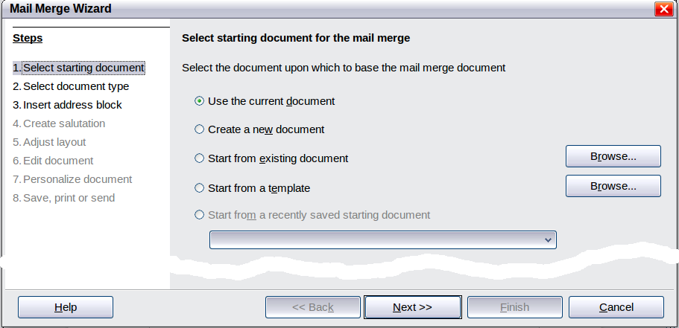
Figure : Select starting document
- On the second page, select E-mail message and click Next.
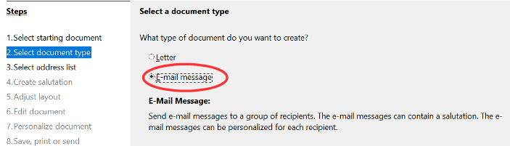
Figure : Select document type
- On the third page, click the Select Address List button. Select the required address list (even if only one is shown) and then click OK. (If the address list you need is not shown here, you can click Add to find it and add it to the list.)

Figure : Selecting an address list
- Back on the Select address list page, click Next. On the Create salutation page, deselect This document should contain a salutation.
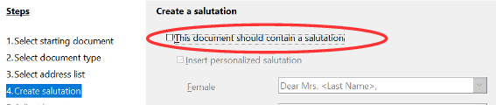Figure : Deselecting a salutation
- In the left-hand list, click 8. Save, print or send. Apache OpenOffice displays a “Creating documents” message and then displays the Save, print or send page of the Wizard.
- Select Send merged document as E-Mail. The lower part of the page changes to show e-mail settings choices. (See Figure 237.)
- Type a subject for your email and click Send documents. Apache OpenOffice sends the e-mails.
Figure : Sending a document as an email message

Digital Signing of Documents
To sign a document digitally, you need a personal key, also known as a certificate. A personal key is stored on your computer as a combination of a private key, which must be kept secret, and a public key, which you add to your documents when you sign them. You can get a certificate from a certification authority, which may be a private company or a governmental institution.
When you apply a digital signature to a document, a kind of checksum is computed from the document’s content plus your personal key. The checksum and your public key are stored together with the document.
When someone later opens the document on any computer with OpenOffice, the program will compute the checksum again and compare it with the stored checksum. If both are the same, the program will signal that you see the original, unchanged document. In addition, the program can show you the public key information from the certificate. You can compare the public key with the public key that is published on the website of the certificate authority. Whenever someone changes something in the document, this change breaks the digital signature.
On Windows operating systems, the Windows features of validating a signature are used. On Linux systems, files that are supplied by Thunderbird, Mozilla, or Firefox are used. For a more detailed description of how to get and manage a certificate, and signature validation, see “About Digital Signatures” in the Apache OpenOffice Help.
To sign a document:
- Choose File > Digital Signatures.
- If you have not saved the document since the last change, a message box appears. Click Yes to save the file.
- After saving, you see the Digital Signatures dialog. Click Sign Document to add a public key to the document.
- In the Select Certificate dialog, select your certificate and click OK.
- You see again the Digital Signatures dialog, where you can add more certificates if you want. Click OK to add the public key to the saved file.
A signed document shows an icon in the status bar. You can double-click the icon to view the certificate.

Removing Personal Data
You may wish to ensure that personal data, versions, notes, hidden information, or recorded changes are removed from files before you send them to other people or create PDFs from them.
In Tools > Options > OpenOffice > Security > Options, you can set Apache OpenOffice to remind (warn) you when files contain certain information and remove personal information automatically on saving.
To remove personal and some other data from a file, go to File > Properties. On the General tab, uncheck Apply user data and then click the Reset button. This removes any names in the created and modified fields, deletes the modification and printing dates, and resets the editing time to zero, the creation date to the current date and time, and the version number to 1.
To remove version information, either go to File > Versions, select the versions from the list and click Delete, or use Save As and save the file with a different name.

Chapter 10
Graphics, the Gallery, and Fontwork

Introduction
You can add graphic and image files, including photos, drawings, scanned images, and others, to Apache OpenOffice (AOO) documents. AOO can import various vector (line drawing) and raster (bitmap) file formats. The most commonly used graphic formats are GIF, JPG, PNG, and BMP.
Graphics in Apache OpenOffice are of three basic types:
- Image files, such as photos, drawings, and scanned images
- Diagrams created using AOO’s drawing tools
- Charts created using AOO’s Chart facility
This chapter covers images and diagrams.
More detailed descriptions on working with drawing tools can be found in the Draw Guide and Impress Guide. Instructions on how to create charts are given in the Calc Guide.

Adding Images to a Document
Images can be added to a document in several ways: by inserting an image file, directly from a graphics program or a scanner, or from the Apache OpenOffice Gallery.

Inserting an Image file
When the image is in a file stored on the computer, you can insert it into an AOO document using either of the following methods.

Drag and Drop
- Open a file browser window and locate the image you want to insert.
- Drag the image into the AOO document and drop it where you want it to appear. A faint vertical line marks where the image will be dropped.
This method embeds (saves a copy of) the image file in the Writer document. To link the file instead of embedding it, hold down the Ctrl+Shift keys while dragging the image.

Insert Picture Dialog
- Click in the AOO document where you want the image to appear.
- Choose Insert > Picture > From File from the menu bar.
- On the Insert Picture dialog (Figure 238), notice the two options at the bottom left: Preview and Link. Choose Preview to view a thumbnail of the selected image on the right, so you can verify that you have the correct file. See page 265 for the use of Link.
- Navigate to the file to be inserted, select it, and click Open.
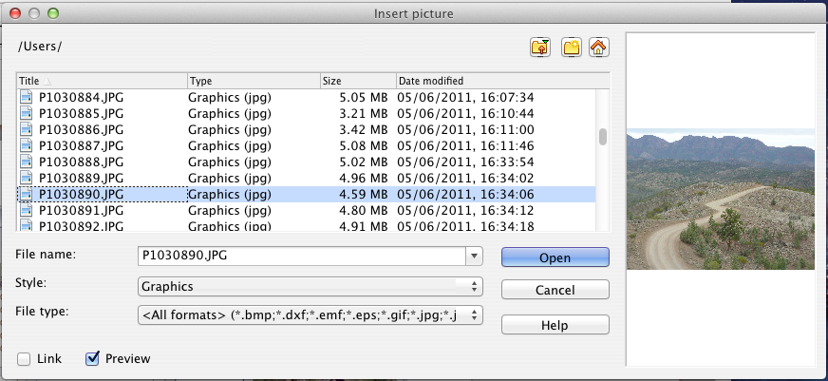
Figure . Insert picture dialog

Linking an Image File
If the Link option in the Insert picture dialog is selected, Apache OpenOffice creates a link to the file containing the image instead of saving a copy of the image in the document. The result is that the image is displayed in the document, but when the document is saved, it contains only a reference to the image file—not the image itself. The document and the image remain as two separate files, and they are merged together only when you open the document again.
Linking an image has two advantages and one disadvantage:
- Advantage – Linking can reduce the size of the document when it is saved, because the image file itself is not included. File size is usually not a problem on a modern computer with a reasonable amount of memory, unless the document includes many large graphics files; Apache OpenOffice can handle quite large files.
- Advantage – You can modify the image file separately without changing the document because the link to the file remains valid, and the modified image will appear when you next open the document. This can be a big advantage if you (or someone else, perhaps a graphic artist) is updating images.
- Disadvantage – If you send the document to someone else, or move it to a different computer, you must also send the image files, or the receiver will not be able to see the linked images. You need to keep track of the location of the images and make sure the recipient knows where to put them on another machine, so that the document can find them. For example, you might keep images in a subfolder named Images (under the folder containing the document); the recipient of the file needs to put the images in a subfolder with the same name and in the same place relative to the document.
Note | When inserting the same image several times in the document it would appear beneficial to link rather than embed; however, this is not so because Apache OpenOffice embeds only one copy of the image file in the document.

Embedding Linked Images
If you originally linked the images, you can easily embed one or more of them later if you wish. To do so:
- Open the document in Apache OpenOffice and choose Edit > Links.
- The Edit Links dialog (Figure 239) shows all the linked files. In the Source file list, select the files you want to change from linked to embed.
- Click the Break Link button.
- Save the document.
Note | Going the other way, from embedded to linked, is not so easy—you must delete and reinsert the images, one at a time, selecting the Link option when you do so.
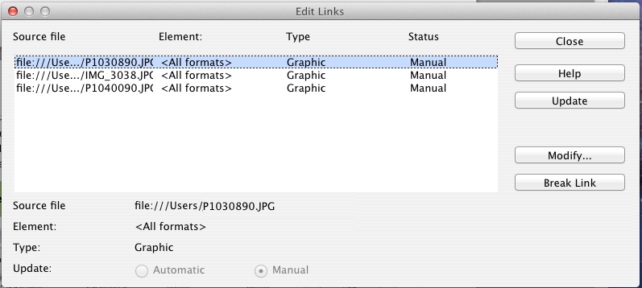
Figure : The Edit Links dialog

Inserting an Image from the Clipboard
Using the clipboard, you can copy images into an AOO document from another AOO document and from other programs. To do this:
- Open both the source document and the target document.
- In the source document, select the image to be copied.
- Move the mouse pointer over the selected image and press Ctrl+C to copy the image to the clipboard.
- Switch to the target document.
- Click to place the cursor where the graphic is to be inserted.
- Press Ctrl+V to insert the image.
Caution | If the application from which the graphic was copied is closed before the graphic is pasted into the target, the image stored on the clipboard could be lost.

Inserting an Image Using a scanner
If a scanner is connected to your computer, AOO can call the scanning application and insert the scanned item into the AOO document as an image. To start this procedure, place the cursor where you want the graphic to be inserted and choose Insert > Picture > Scan > Select Source.
Although this practice is quick and easy, it is unlikely to result in a high-quality image of the correct size. You may get better results by scaning material into a graphics program and cleaning it up there before inserting the resulting image into AOO.

Inserting an Image from the Gallery
The Gallery provides a convenient way to group reusable objects such as graphics and sounds that you can insert into your documents. The Gallery is available in all components of AOO. See “Managing the Gallery“ on page 268. You can copy or link an object from the Gallery into a document.
To insert an object:
- Choose the Gallery deck in the Sidebar or the menu Tools > Gallery or click the Gallery icon on the Standard toolbar (in Writer and Calc) or the Drawing toolbar (in Impress and Draw).
- Select a theme.
- Select an object with a single click.
- Drag and drop the image into the document. (See Figure 240.)
- You can also right-click on the object and choose Insert > Copy.
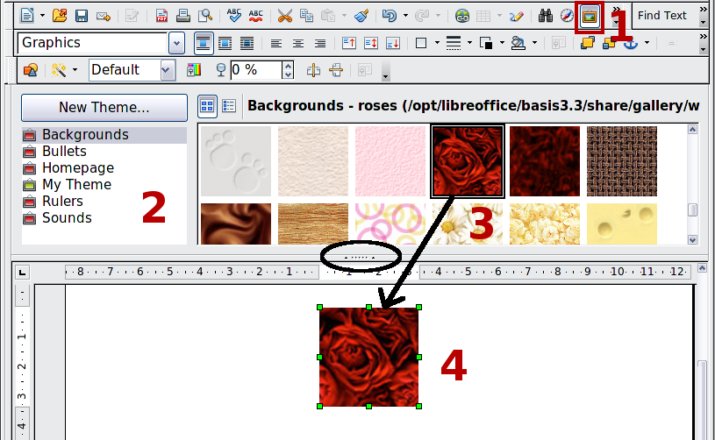
Figure . Copying a graphic object from the Gallery into a document (the oval marks the Hide/Show button for the Gallery)
To insert an object as a link:
- Access the Gallery with any of the methods just explained and select a theme.
- Select an object with a single click, then while pressing the Shift and Control keys, drag and drop the object into the document.

Inserting an Image as a Background
To insert an image as the background to a page or paragraph:
- Select a theme in the Gallery.
- Select an object with a single click, right-click on the object, and choose Insert > Background > Page or > Paragraph.

Modifying and Positioning Graphics
Apache OpenOffice provides many tools for resizing, modifying, filtering, and positioning graphics; wrapping text around graphics; and using graphics as backgrounds and watermarks. These tools are described in relevant chapters of the other guides. Some sophisticated adjustments of the graphics are best done in an image manipulation program and the results brought into AOO, rather than using AOO’s inbuilt tools.

Managing the Gallery
Graphics in the Gallery are grouped by themes, such as Bullets, Rulers, and Backgrounds. You can create other groups or themes and add your own pictures or find extensions containing more graphics.
The box on the left, or above in the Sidebar, the gallery window lists the available themes. Click on a theme to see its contents displayed in the Gallery window.
You can display the Gallery in Icon View (Figure 241) or Detailed View, and you can hide or show the Gallery by clicking on the Hide button (similar to the Hide button for the Navigator and the Styles and Formatting window when they are docked).
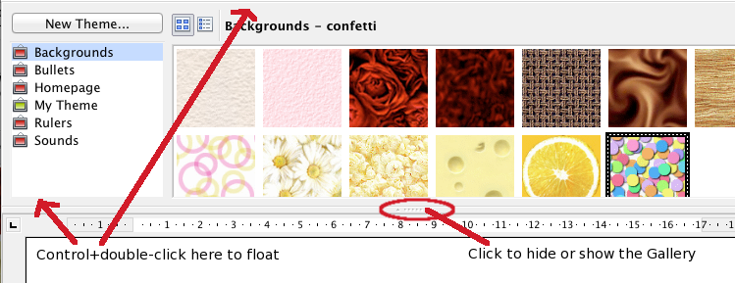
Figure . Icon view of one theme in the Gallery
When the Gallery is called with Tools > Gallery or with the icon on the Standard toolbar, it is docked above the workspace by default. To expand the Gallery, position the pointer over the line that divides it from the top of the workspace. When the pointer changes to parallel lines with arrows, click and drag downward. The workspace resizes in response.
As with other docked windows, you can “float” the Gallery from its position above the workspace or in the Sidebar by moving the mouse pointer over an edge of the Gallery window, holding down the Control key, and double-clicking. Repeat this procedure to dock the Gallery again.
The default themes are locked; no items can be added to or deleted from these themes. The locked themes are easily recognizable by right-clicking on them; the only available option in the pop-up menu is Properties.
In a default installation, only My Theme is customizable, although new themes can be added as explained in “Adding a New Theme to the Gallery” on page 271.

Adding Objects to the Gallery
You may wish to add to the Gallery any images that you use frequently, for example, a company logo. You can then very easily insert these graphics into a document later.
You can add images only to “My Theme” or to any other theme that you have created; these are indicated by a green icon in the list of themes. You cannot add images to the built-in themes, indicated by an icon of another color.
Method 1 (selecting a file):
- Right-click on the desired theme and select Properties from the context menu.
- In the theme’s Properties dialog, go to the Files page and click the Find Files button.
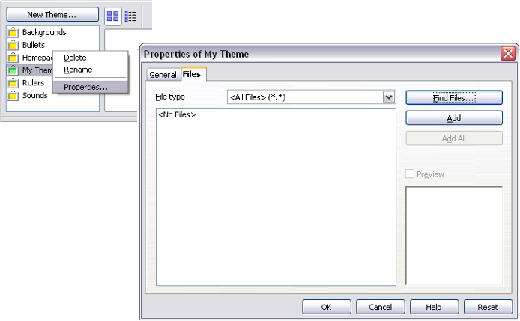Figure . Gallery Properties dialog
- The Select path dialog (not shown) opens. You can enter the path for the file’s directory in the Path text box, or you can navigate to locate the file’s directory.
- Click the Select button to start the search. A list of graphic files is then displayed in the Properties dialog. You can use the File type drop-down list to limit the files displayed.
- To add all the files shown in the list, click Add All. Otherwise, select the files to add and then click Add. (Hold down either the Shift key or the Control key while you click on the files.)
Method 2 (drag and drop)
You can drag and drop an image into the Gallery from a document.
- Open the document containing an image you want to add to the Gallery, and display the Gallery theme to which you want to add it.
- Position the mouse pointer above the image, without clicking.
- If the mouse pointer changes to a hand symbol, the image refers to a hyperlink. In this case, press the Alt key while you click the image, to select it without activating the link. If the mouse pointer does not change to a hand symbol, you can simply click the image to select it.
- Once the image is selected, evident from the green selection handles around it, release the mouse button. Click again on the image, keeping the mouse button pressed for more than two seconds. Without releasing the mouse button, drag the image into the document.
- Release the mouse button.

Deleting Images from the Gallery
To delete an image from a theme that you created:
- Right-click on the name of the image file or its thumbnail in the Gallery.
- Click Delete on the pop-up menu. A message appears, asking if you want to delete this object. Click Yes.
Note | Deleting the name of a file from the list in the Gallery does not delete the file from the hard disk or other location.

Adding a New Theme to the Gallery
To add a new theme to the Gallery:
- Click the New Theme button above the list of themes (Figure 241).
- In the Properties of New Theme dialog, click the General tab and type a name for the new theme.
- Click the Files tab and add images to the theme, as described earlier.

Deleting a Theme from the Gallery
You can delete only themes that you have added to the Gallery; you cannot delete any of the inbuilt themes. To delete a theme from the Gallery:
- Go to the list of themes and select the one you wish to delete.
- Right-click on the theme, then click Delete on the pop-up menu.

Location of the Gallery and the Objects in It
Graphics and other objects shown in the Gallery can be located anywhere on your computer’s hard disk or on a network drive. Listings in the Gallery refer to the location of each object. When you add graphics to the Gallery, the files are not moved or copied; only the location of each new object is added as a reference.
In a work group, you may have access to a shared Gallery (where you cannot change the contents unless authorized to do so) and a user Gallery, where you can add, change, or delete objects.
The location of the user Gallery is specified in Tools > Options > OpenOffice > Paths. You can change this location, and you can copy your gallery files (*.sdv) to other computers.
Gallery contents provided with AOO are stored in a different location. You cannot change this location.

Creating an Image Map
An image map defines areas of an image (called hot spots) with hyperlinks to web addresses, other files on the computer, or parts of the same document. Hot spots are the graphic equivalent of text hyperlinks. Clicking on a hot spot causes Apache OpenOffice to open the linked page in the appropriate program (for example, the default browser for an HTML page; AOO Calc for a *.ods file; a PDF viewer for a .pdf file). You can create hotspots of various shapes and include several hotspots in the same image.
To use the image map editor:
- In your AOO document, select the picture where you want to define the hotspots.
- Choose Edit > ImageMap from the menu bar. The ImageMap Editor (Figure 243) opens.
- Use the tools and fields in the dialog (described on the next page) to define the hotspots and links necessary.
- Click the Apply icon to apply the settings.
- When done, click the Save icon to save the image map to a file, then click the X in the upper right corner to close the dialog.
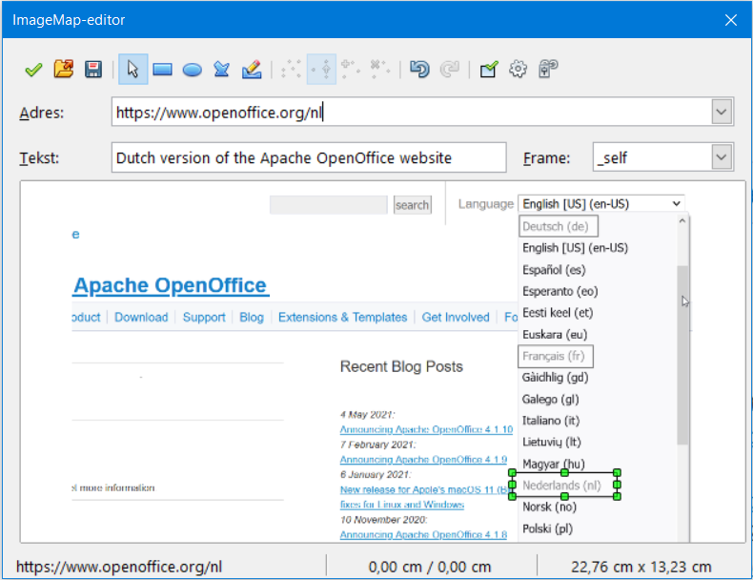Figure : The dialog to create or edit an image map
The main part of the dialog shows the image on which the hotspots are defined. A hotspot is identified by a line indicating its shape.
The toolbar at the top of the dialog contains the following tools:
- Apply button: click this button to apply the changes.
- Load, Save, and Select icons.
- Tools for drawing a hotspot shape: these tools work in exactly the same way as the corresponding tools in the Drawing toolbar.
- Edit, Move, Insert, Delete Points: advanced editing tools to manipulate the shape of a polygon hotspot. Choose the Edit Points tool to activate the other tools.
- Active icon: toggles the status of a selected hotspot between active and inactive.
- Macro: associates a macro with the hotspot instead of just associating a hyperlink.
- Properties: sets the hyperlink properties and adds the Name attribute to the hyperlink.
Below the toolbar, specify for the selected hotspot:
- Address: the address pointed to by the hyperlink. You can also point to an anchor in a document; to do this, write the address in this format: file:///<path>/document_name#anchor_name.
- Text: type the text that you want to be displayed when the mouse pointer is moved over the hotspot.
- Frame: where the target of the hyperlink will open: pick among _blank (opens in a new browser window), _self (opens in the active browser window), _top or _parent.
Tip | The value _self for the target frame will usually work just fine. It is therefore not recommended to use the other choices unless absolutely necessary.

Using Apache OpenOffice’s Drawing Tools
You can use Apache OpenOffice’s drawing tools to create graphics such as simple diagrams using rectangles, circles, lines, text, and other predefined shapes. You can also group several drawing objects to make sure they maintain their relative position and proportion.
You can place the drawing objects directly on a page in your document, or you can insert them into a frame.
You can also use the drawing tools to annotate photographs, screen captures, or other illustrations produced by other programs, but this is not recommended because:
- You cannot include images in a group with drawing objects, so they may get out of alignment in your document.
- If you convert a document to another format, such as HTML, the drawing objects and the graphics will not remain associated; they are saved separately.
In general, if you need to create complex drawings, it is recommended to use Apache OpenOffice Draw, which includes many more features such as layers, styles, and so on.

Creating Drawing Objects
To begin using the drawing tools, display the Drawing toolbar (Figure 244) by clicking View > Toolbars > Drawing.
If you are planning to use the drawing tools repeatedly, you can tear off this toolbar and move it to a convenient place on the window.

1 | Select | 5 | Free-form Line | 9 | Symbol Shapes | 13 | Stars
2 | Line | 6 | Text | 10 | Block arrows | 14 | Points
3 | Rectangle | 7 | Callouts | 11 | Flowcharts | 15 | Fontwork Gallery
4 | Ellipse | 8 | Basic Shapes | 12 | Callouts | 16 | From File
 |  |  |  |  |  | 17 | Extrusion On/Off
Figure . The Drawing toolbar
To use a drawing tool:
- Click in the document where you want the drawing to be anchored. You can change the anchor later, if necessary.
- Choose the tool from the Drawing toolbar (Figure 244). The mouse pointer changes to a drawing-functions pointer .
- Move the cross-hair pointer to the place in the document where you want the graphic to appear and then click and drag to create the drawing object. Release the mouse button. The selected drawing function remains active, so you can draw another object of the same type.
- To cancel the selected drawing function, press the Esc key or click on the Select icon (the arrow) on the Drawing toolbar.
- You can now change the properties (fill color, line type and weight, anchoring, and others) of the drawing object using either the Drawing Object Properties toolbar (Figure 245) or the choices and dialogs reached by right-clicking on the drawing object.

Set or Change Properties for Drawing Objects
To set the properties for a drawing object before you draw it:
- On the Drawing toolbar (Figure 244), click the Select tool.
- On the Drawing Object Properties toolbar (Figure 245), click on the icon for each property and select the value you want for that property.
- For more control, or to define new attributes, you can click on the Area or Line icons on the toolbar to display detailed dialogs.
1 | Line | 5 | Line Color | 9 | To Foreground | 13 | Alignment
2 | Arrow Style | 6 | Area | 10 | To Background | 14 | Change Anchor
3 | Line Style | 7 | Area Style / Filling | 11 | Bring to Front | 15 | Ungroup
4 | Line Width | 8 | Rotate | 12 | Send to Back | 16 | Group
Figure . Drawing Object Properties toolbar
The default you set applies to the current document and session. It is not retained when you close the document or close Writer, and it does not apply to any other document you open. The defaults apply to all the drawing objects except text objects.
To change the properties for an existing drawing object:
- Select the object.
- Continue as described above.
You can also specify the position and size, rotation, and slant and corner radius properties of the drawing object:
- Right-click on the drawing object and then choose Position and Size from the pop-up menu. The Position and Size dialog is displayed.
- Choose any properties, as required.
Many of the tools to change the Area, Line, and Position and Size of objects are available in the Properties deck of the Sidebar once the object is drawn, and it is selected.

Resizing a Drawing Object
An object is resized similarly to an image. Select the object, click on one of the eight handles around it and drag it to its new position. For a scaled resizing, select one of the corner handles and keep the Shift key pressed while dragging the handle to its new position.
For more sophisticated control of the size of the object, choose Format > Object > Position and Size from the menu bar. Use the Position and Size dialog to set the width and height independently. If the Keep ratio option is selected, then the two dimensions change so that the proportion is maintained, allowing for a scaled resizing.

Grouping Drawing Objects
To group drawing objects:
- Select one object, then hold down the Shift key and select the others you want to include in the group. The bounding box expands to include all the selected objects.
- With the objects selected, choose Format > Group > Group (in Draw the menu is Modify > Group) from the menu bar or right-click and choose Group > Group (in Writer and Calc) or Group (in Impress and Draw) from the pop-up menu.
Note | You cannot include an embedded or linked graphic in a group with drawing objects.

Using Fontwork
With Fontwork you can create graphical text art objects to make your work more attractive. There are many settings for text art objects (line, area, position, size, and more), so you have many choices. You will surely find one that fits your document.
Fontwork is available with each component of AOO, but you will notice small differences in the way that each component displays it.

The Fontwork Toolbars
You can use two different toolbars for creating and editing a Fontwork object.
- Go to View > Toolbars > Fontwork.
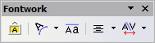
Figure . The floating Fontwork toolbar
- If you click on an existing Fontwork object, the Formatting toolbar changes to display the Fontwork options as shown in Figure 251. The contents of this toolbar vary depending on the AOO component with which it is being used.

Creating a Fontwork Object
- On the Drawing or Fontwork toolbar, click the Fontwork Gallery icon . If the Drawing toolbar is not visible, go to View > Toolbars > Drawing to display it.
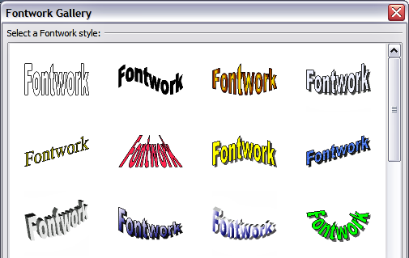
Figure . The Fontwork Gallery
- In the Fontwork Gallery, select a Fontwork style, then click OK. The Fontwork object will appear in your document. Notice the colored squares around the edge (indicating that the object is selected) and the yellow dot; these are discussed in “Moving and Resizing Fontwork Objects” on page 280.
- Double-click the object to edit the Fontwork text. Type your own text in place of the black Fontwork text that appears over the object.

Figure . Editing Fontwork text
- Click anywhere in a free space or press Esc to apply your changes.

Editing a Fontwork Object
Now that the Fontwork object is created, you can edit some of its attributes. To do this, you can use the Fontwork toolbar, the Properties deck of the Sidebar, the Formatting toolbar, or menu options as described in this section. If the selected Fontwork object is a 3D object, you can also use the 3D-Settings toolbar.

Using the Fontwork Toolbar
Make sure that the Fontwork toolbar, shown in Figure 246, is visible. If you do not see it, go to View > Toolbars > Fontwork. Click on the different icons to edit Fontwork objects.
 | Fontwork Shape: Edits the shape of the selected object. You can choose from a palette of shapes. | 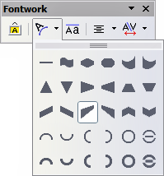  Figure . Fontwork toolbar showing palette of shapes
 | Fontwork Same Letter Heights: Changes the height of characters in the object. Toggles between normal height (some characters taller than others, for example capital letters, d, h, l and others) and all letters the same height.

Figure . Left: normal letters; right: same letter heights
 | Fontwork Alignment: Changes the alignment of characters. Choices are left align, center, right align, word justify, and stretch justify. The effects of the text alignment can only be seen if the text spans over two or more lines. In the stretch justify mode, all the lines are filled completely. | 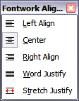
 | Fontwork Character Spacing: Changes the character spacing and kerning in the object. For custom spacing, input a percentage value: 100% is normal spacing; less than 100% is tight spacing; more than 100% is expanded spacing. | 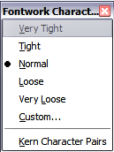

Using the Formatting Toolbar
Now let us go further and customize the Fontwork object with several more attributes.
Click on the Fontwork object. The Formatting toolbar changes to show the options for editing the object. (The toolbar shown in Figure 251 appears when you use Fontwork in Writer.)
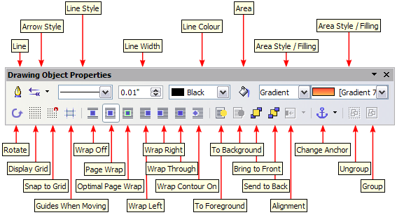
Figure . Formatting toolbar for a Fontwork object in Writer
This figure shows the toolbar floating. In its default, docked position it is one of the toolbars located below the menu bar. The example toolbar has also been customized to show all the available options; by default only a subset of these options is shown. Many of the icons that are available by default on the Formatting toolbar are also available on the Properties deck of the Sidebar.
On the Formatting toolbar you have a large choice of options for customizing your object. These choices are the same as the ones for other drawing objects. For more information, see the Draw Guide.
Line options
Line icon: Opens a dialog with three tabs: Line, Line Styles, Arrow Styles. Use the Line tab to edit the most common properties of the line around the selected Fontwork object, by choosing from previously-defined attributes including line style, line color, and arrow styles. Use the Lines Styles and Arrow Styles tabs to edit the properties of line and arrow styles, and define new styles. On the Sidebar, this dialog is accessed with the small icon at the right end of the panel Line title bar.
Arrow Style icon: Choose from the different arrow styles.
Line Style box: Choose from the available line styles.
Line Width box: Set the width of the line.
Line Color box: Select the color of the line.
Area options
Area icon: Opens a dialog with seven tabs: Area, Shadow, Transparency, Colors, Gradients, Hatching, Bitmaps. On the Sidebar, this dialog is accessed with the small icon at the right end of the panel Area title bar.
- Area tab: Choose from the predefined list a color, bitmap, gradient or hatching pattern to fill the selected object.
- Shadow tab: Set the shadow properties of the selected object.
- Transparency tab: Set the transparency properties of the selected object.
- Colors tab: Modify the available colors or add new ones to appear on the Area tab.
- Gradients tab: Modify the available gradients or add new ones to appear on the Area tab.
- Hatching tab: Modify the available hatching patterns or add new ones to appear on the Area tab.
- Bitmaps tab: Create simple bitmap patterns and import bitmaps, to make them available on the Area tab.
Area Style / Filling boxes: Select the type of the fill of the selected object. For more detailed settings, use the Area icon.
Positioning options
Rotate icon: Rotate the selected object manually using the mouse to drag the object.
To Foreground icon: Move the selected object in front of the text.
To Background icon: Move the selected object behind the text.
Alignment icon: Modify the alignment of the selected objects.
Bring to front icon: Move the selected object in front of the others.
Send to back icon: Move the selected object behind the others.
Change Anchor icon: Choose between anchoring options:
- To Page—The object keeps the same position in relation to the page margins. It does not move as you add or delete text.
- To Paragraph—The object is associated with a paragraph and moves with the paragraph. It may be placed in the margin or another location.
- To Character—The object is associated with a character but is not in the text sequence. It moves with the paragraph but may be placed in the margin or another location. This method is similar to anchoring to a paragraph.
- As Character—The object is placed in the document like any character and moves with the paragraph as you add or delete text before the object.
Ungroup icon: Ungroup the selected objects, so you can manage them individually.
Group icon: Group the selected objects, so you can manage them as a single object.

Using Menu Options
You can use some choices on the Format menu to anchor, align, arrange and group selected Fontwork objects, wrap text around them, and flip them horizontally and vertically.
You can also right-click on a Fontwork object and choose many of the same options from the pop-up menu. The pop-up menu also provides quick access to the Line, Area, Text, and Position and Size dialogs. The Text dialog offers only a few options for Fontwork objects and is not discussed here. On the Position and Size dialog, you can enter precise values concerning size and position. For more information on all of these menu options, see the Draw Guide.

Using the 3D-Settings Toolbar
If the selected Fontwork object is a 3D object, you can also use the options on the 3D-Settings toolbar. You can also change a 2D Fontwork object into a 3D object (or change a 3D object into a 2D object) by clicking the Extrusion On/Off icon on the 3D-Settings toolbar. For more information, see the Draw Guide.
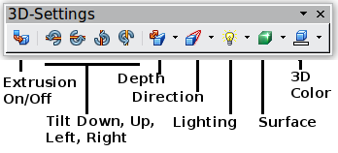
Figure : 3D-Settings toolbar

Moving and Resizing Fontwork Objects
When you select a Fontwork object, eight colored squares (known as handles) appear around the edge of the object, as shown below. You can drag these handles to resize the object.
A yellow dot also appears on the object. This dot may be along an edge of the object, or it may be somewhere else; see figure to right for an example. If you hover the pointer over this yellow dot, the pointer turns into a hand symbol. You can drag the dot in different directions to distort the object.  Hovering the pointer over other parts of the object turns the pointer into the usual symbol for dragging the object to another part of the page. | 
For precise control of the location and size of the object, use the Position and Size dialog.

Chapter 11
Setting Up and Customizing Apache OpenOffice

Choosing Options for All of Apache OpenOffice
This section covers some of the settings that apply to all the components of Apache OpenOffice. For information on settings not discussed here, see the online help.
Click Tools > Options, or on macOS OpenOffice > Preferences. The list in the left-hand box of the Options – OpenOffice dialog varies depending on which component is open. The illustrations in this chapter show the list as it appears when a Writer document is open.
Click the marker (+ or triangle) by OpenOffice on the left-hand side. A list of pages opens. Selecting an item in the list causes the right-hand side of the dialog to display the relevant page.
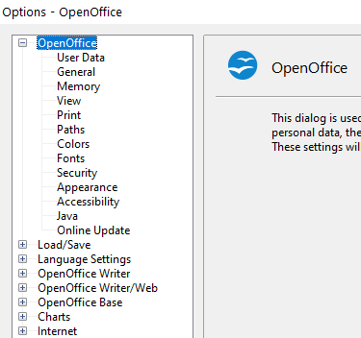Figure : OpenOffice options
Note | The Back button has the same effect on all pages of the Options dialog. It resets the options to the values that were in place when you opened Apache OpenOffice.

User Data Options
The name or initials stored in the OpenOffice – User Data page are used for several things, including document properties (created by and last edited by information) and the name of the author of notes and changes. You should ensure that the correct information appears here. Fill in the form (shown in Figure 254), or amend or delete any existing incorrect information.
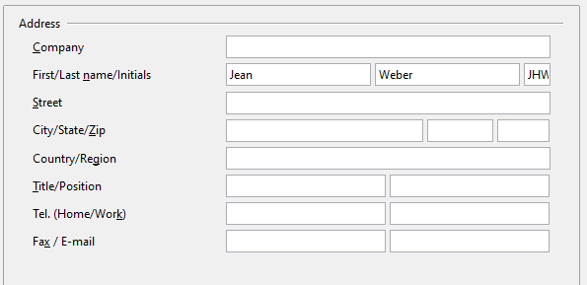Figure : Filling in user data

General Options
The options on the OpenOffice – General page are described below.
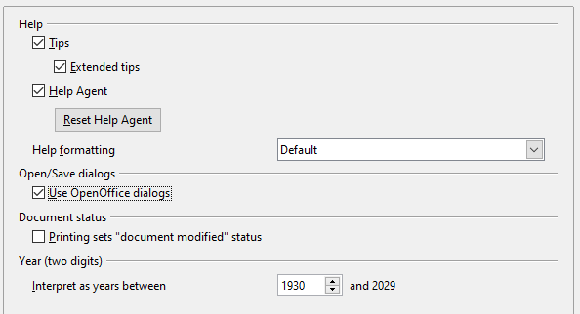Figure : Setting general options for OpenOffice
Help—Tips
When Tips is active, one or two words will appear when you hold the mouse pointer over an icon or field, without clicking.
Help—Extended tips
When Extended tips are active, a brief description of the function of a particular icon or menu command or a field on a dialog appears when you hold the mouse pointer over that item.
Help Agent
To turn off the Help Agent, deselect this option. To restore the default behavior, click Reset Help Agent.
Help formatting
High contrast is an operating system setting that changes the system color scheme to improve readability. To display Help in high contrast (if your computer’s operating system supports this), choose one of the high-contrast style sheets from the pull-down list.
High-contrast style | Visual effect
Default | Black text on white background
High Contrast #1 | Yellow text on black background
High Contrast #2 | Green text on black background
High Contrast Black | White text on black background
High Contrast White | Black text on white background
Open/Save dialogs
To use the standard Open and Save dialogs for your operating system, deselect the Use OpenOffice dialogs option. When this option is selected, the Open and Save dialogs supplied with OpenOffice will be used. See Chapter 1 (Introducing Apache OpenOffice) for more about the OpenOffice Open and Save dialogs. This book uses the OpenOffice Open and Save dialogs in illustrations.
Print dialogs—Use OpenOffice dialogs
(macOS only) To use the standard Print dialogs for your operating system, deselect the Use OpenOffice dialogs option. When this option is selected, the Print dialogs supplied with OpenOffice will be used. This book uses the OpenOffice Print dialogs in illustrations.
Document Status
If this option is selected, then the next time you close the document after printing, the print date is recorded in the document properties as a change, and you will be prompted to save the document again, even if you did not make any other changes.
Year (two digits)
Specifies how two-digit years are interpreted. For example, if the two-digit year is set to 1930, and you enter a date of 1/1/30 or later into your document, the date is interpreted as 1/1/1930 or later. An “earlier” date is interpreted as being in the following century; that is, 1/1/20 is interpreted as 1/1/2020.

Memory Options
In the Options dialog, click OpenOffice > Memory.
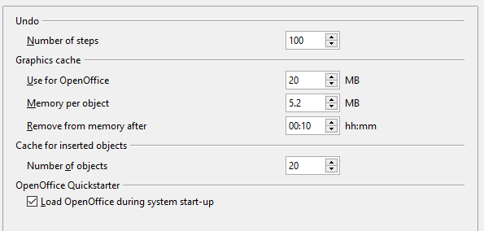Figure : Choosing Memory options for OpenOffice
These options control how the program uses your computer’s memory and how much memory it requires. Before changing them, you may wish to consider the following points:
- More memory can make Apache OpenOffice faster and more convenient (for example, more undo steps require more memory); but the trade-off is less memory available for other applications, and you could run out of memory altogether.
- If your documents contain a lot of objects such as images, or the objects are large, Apache OpenOffice’s performance may improve if you increase the memory for OpenOffice or the memory per object. If you find that objects seem to disappear from a document that contains a lot of them, increase the number of objects in the cache. (The objects are still in the file even if you cannot see them on screen.)
- To load the Quickstarter (an icon on the desktop or in the system tray) when you start your computer, select the option near the bottom of the dialog. This makes Apache OpenOffice start faster; the trade-off is that AOO uses some memory even when not being used. This option (sometimes called Enable systray quickstarter) is not available on all operating systems.

View Options
The options on the OpenOffice – View page affect the way the document window looks and behaves. Some of these options are described below. Set them to suit your personal preferences.
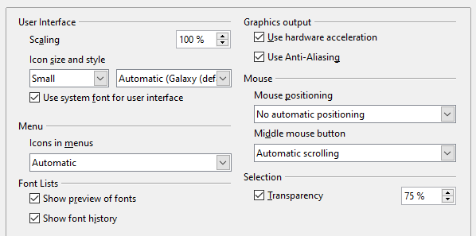Figure : Choosing View options for AOO applications
User Interface—Scaling
If the text in the help files or on the menus of the AOO user interface is too small or too large, you can change it by specifying a scaling factor. Sometimes a change here can have unexpected results, depending on the screen fonts available on your system. However, it does not affect the actual font size of the text in your documents.
User Interface—Icon size and style
The first box specifies the display size of toolbar icons (Automatic, Small, or Large). The Automatic icon size option uses the setting for your operating system. The second box specifies the icon style (theme); here the Automatic option uses an icon set compatible with your operating system and choice of desktop: for example, KDE or Gnome on Linux.
User Interface—Use system font for user interface
If you prefer to use the system font (the default font for your computer and operating system) instead of the font provided by AOO for the user interface, select this option.
User interface—Screen font anti-aliasing
(Not available in Windows; not shown in Figure 257.) Select this option to smooth the screen appearance of text. Enter the smallest font size to apply anti-aliasing.
Menu—Icons in menus
Choosing Automatic or Show displays icons in addition to words in menus.
Font Lists—Show preview of fonts
Causes the font list to look like Figure 258, Left, with the font names shown as an example of the font; with the option deselected, the font list shows only the font names, not their formatting (Figure 258, Right). The fonts you will see listed are those that are installed on your system.
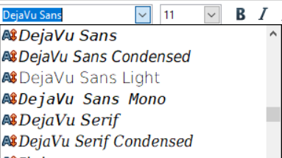 | 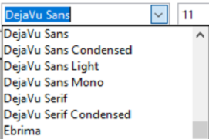
Figure : Font list (Left) With preview; (Right) Without preview
Font Lists—Show font history
Causes the last five fonts you have assigned to the current document to be displayed at the top of the font list. Otherwise, fonts are shown in alphabetical order.
Graphics output—Use hardware acceleration
Directly accesses hardware features of the graphical display adapter to improve the screen display. Not supported on all operating systems and AOO distributions.
Graphics output—Use anti-aliasing
Enables and disables anti-aliasing, which makes the display of most graphical objects look smoother and with fewer artifacts. Not supported on all operating systems and AOO distributions.
Tip | Press Shift+Ctrl+R to restore or refresh the view of the current document.
Mouse positioning
Specifies if and how the mouse pointer will be positioned in newly opened dialogs.
Middle mouse button
Defines the function of the middle mouse button.
- Automatic scrolling—dragging while pressing the middle mouse button shifts the view.
- Paste clipboard—pressing the middle mouse button inserts the contents of the “Selection clipboard” at the cursor position.
The “Selection clipboard” is independent of the normal clipboard that you use by Edit > Copy/Cut/Paste or their respective keyboard shortcuts. Clipboard and “Selection clipboard” can contain different contents at the same time.
Function | Clipboard | Selection clipboard
Copy content | Edit > Copy Ctrl+C | Select text, table, or object.
Paste content | Edit > Paste Ctrl+V pastes at the cursor position. | Clicking the middle mouse button pastes at the mouse pointer position.
Pasting into another document | No effect on the clipboard contents. | The last marked selection is the content of the selection clipboard.
Selection—Transparency
Determines the appearance of selected text or graphics, which appear on a shaded background. To make the shaded background more or less dark, increase or decrease the Transparency setting.
If you prefer selected material to appear in reversed color (typically white text on a black background), deselect this option.

Print Options
On the OpenOffice – Print page, set the print options to suit your default printer and your most common printing method.
In the Printer warnings section near the bottom of the page, you can choose whether to be warned if the paper size or orientation specified in your document does not match the paper size or orientation available for your printer. Having these warnings turned on can be quite helpful, particularly if you work with documents produced by people in other countries where the standard paper size is different from yours.
Tip | If your printouts are incorrectly placed on the page or chopped off at the top, bottom, or sides, or the printer is refusing to print, the most likely cause is page size incompatibility.
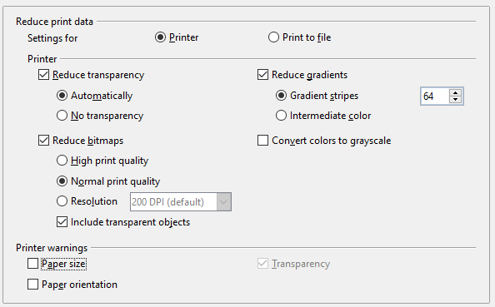Figure : Choosing general printing options to apply to all AOO components

Path Options
On the OpenOffice – Paths page, you can change the location of files associated with, or used by, OpenOffice to suit your working situation. In a Windows system, for example, you might want to store documents by default somewhere other than Documents folder.
To make changes, select an item in the list shown in Figure 260 and click Edit. On the Select Path dialog (not shown; may also be titled Edit Paths), add or delete folders as required, and then click OK to return to the Options dialog. Note that some items can have at least two paths listed: one to a shared folder (which might be on a network) and one to a user-specific folder (normally on the user’s personal computer).
Tip | You can use the entries in the OpenOffice – Paths dialog to compile a list of files, such as those containing AutoText, that you need to back up or copy to another computer.
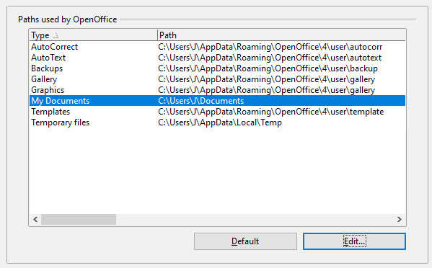Figure : Viewing the paths of files used by OpenOffice

Color Options
On the OpenOffice – Colors page, you can specify colors to use in AOO documents. You can select a color from a color table, edit an existing color, and define new colors. These colors are stored in your color palette and are then available in all components of AOO.
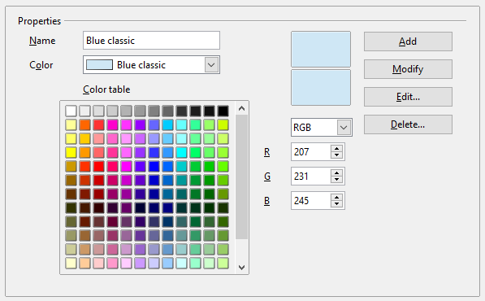Figure : Defining colors to use in color palettes in AOO
To modify a color:
- Select the color to modify from the list or the color table.
- Enter the new values that define the color. If necessary, change the settings from RGB (Red, Green, Blue) to CMYK (Cyan, Magenta, Yellow, Black) or vice versa. The changed color appears in the lower of the two color preview boxes at the top.
- Modify the Name as required.
- Click the Modify button. The newly defined color is now listed in the Color table.
Alternatively, click the Edit button to open the Color Picker dialog, shown in Figure 262. Here you can select a color from the color window on the left; or you can enter values in the boxes on the right, using your choice of RGB, CMYK, or HSB (Hue, Saturation, and Brightness) values.
The color window is linked directly with the color input fields on the right; as you choose a color in the window, the numbers change accordingly. The lower color field on the left shows the value of the selected color on the left and the currently set value from the color value fields on the right.
Modify the color components as required and click OK to exit the dialog. The newly defined color now appears in the lowest of the color preview boxes shown in Figure 261. Type a name for this color in the Name box, then click the Add button. A small box showing the new color is added to the Color table.
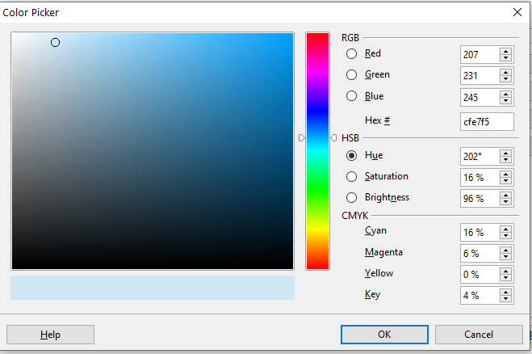Figure : Choosing colors
Another way to define or alter colors is through the Colors page of the Area dialog, where you can also save and load palettes, a feature that is not possible here. In Calc, draw a temporary draw object and use the context menu of this object to open the Area dialog. If you load a palette in one component of AOO, it is only active in that component; the other components keep their own palettes.

Font Options
You can define replacements for any fonts that might appear in your documents. If you receive from someone else a document containing fonts that you do not have on your system, OpenOffice will substitute fonts for those it does not find. You might prefer to specify a different font from the one the program chooses.
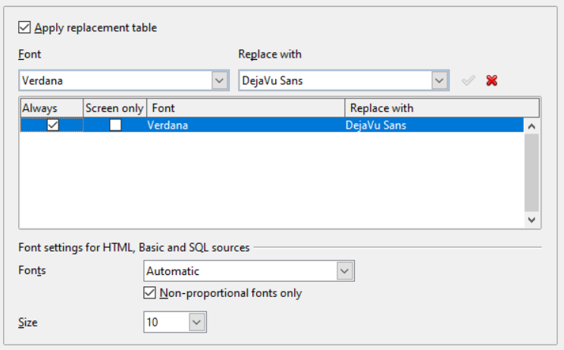Figure : Defining a font to be substituted for another font
On the OpenOffice – Fonts page:
- Select the Apply Replacement Table option.
- Select or type the name of the font to be replaced in the Font box. (If you do not have this font on your system, it will not appear in the drop-down list in this box, so you need to type it in.)
- In the Replace with box, select a suitable font from the drop-down list of fonts installed on your computer.
- The checkmark to the right of the Replace with box turns green. Click on this checkmark. A row of information now appears in the larger box below the input boxes. Select the options under Always and Screen only.
- In the bottom section of the page, you can change the typeface and size of the font used to display source code such as HTML and Basic (in macros).

Security Options
Use the OpenOffice – Security page (Figure 264) to choose security options for saving documents and for opening documents that contain macros.
Security options and warnings
If you record changes, save multiple versions, or include hidden information or notes in your documents, and you do not want some recipients to see that information, you can set warnings to remind you to remove it, or you can have AOO remove some of it automatically. Note that (unless removed) much of this information is retained in a file whether the file is in AOO’s default OpenDocument format, or has been saved to other formats, including PDF.
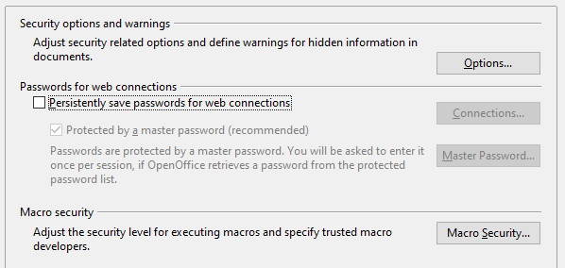Figure : Choosing security options for opening and saving documents
Click the Options button to open a separate dialog with specific choices (Figure 265).
Macro security
Click the Macro Security button to open the Macro Security dialog (not shown here), where you can adjust the security level for executing macros and specify trusted sources.

Security Options and Warnings
The following options are on the Security options and warnings dialog (Figure 265).
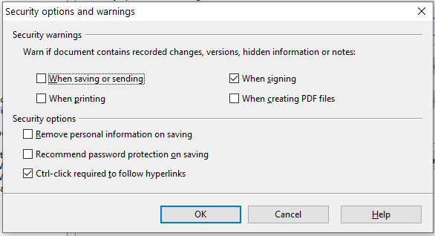Figure : Security options and warnings dialog
Remove personal information on saving
Select this option to always remove user data from the file properties when saving the file. To manually remove personal information from specific documents, deselect this option and then use the Reset button under File > Properties > General.
Ctrl-click required to follow hyperlinks
Many people find creation and editing of documents easier when accidental clicks on links do not activate the links.
The other options on this dialog should be self-explanatory.

Appearance Options
Writing, editing, and (especially) page layout are often easier when you can see the page margins (text boundaries), the boundaries of tables and sections (in Writer documents), page breaks in Calc, grid lines in Draw or Writer, and other features. In addition, you might prefer to use colors that are different from AOO’s defaults for such items as note indicators or field shadings.
On the OpenOffice—Appearance page, you can specify which items are visible, and the colors used to display various items.
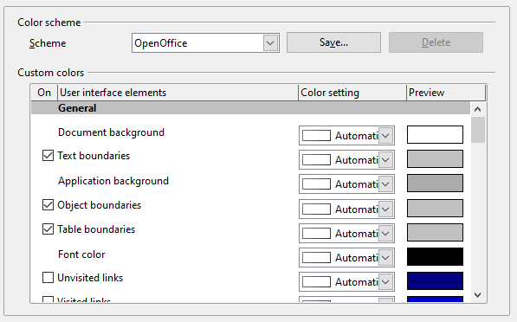Figure : Showing or hiding text, object, and table boundaries
- To show or hide items such as text boundaries, select or deselect the options next to the names of the items.
- To change the default colors for items, click the down-arrow in the Color Setting column by the name of the item and select a color from the pop-up box.
- To save your color changes as a color scheme, click Save, type a name in the Scheme box; then click OK.

Accessibility Options
Accessibility options include whether to allow animated graphics or text, how long help tips remain showing, some options for high contrast display, and a way to change the font for the user interface of the OpenOffice program.
Accessibility support relies on Java technology for communications with assistive technology tools. See Java Options below. The Support assistive technology tools option is not shown on all AOO installations. See Assistive Tools in OpenOffice in the Help for other requirements and information.
Select or deselect the options as required.
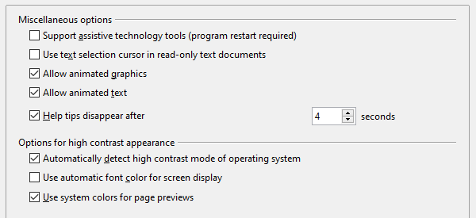Figure : Choosing accessibility options

Java Options
If you install or update a Java Runtime Environment (JRE) after you install OpenOffice, or if you have more than one JRE installed on your computer, you can use the OpenOffice—Java options page to choose the JRE for AOO to use.
If you are a system administrator, programmer, or other person who customizes JRE installations, you can use the Parameters and Class Path pages (reached from the Java page) to specify this information.
If you do not see anything listed in the middle of the page, wait a few seconds while AOO searches for JREs on the hard disk.
If AOO finds one or more JREs, it will display them there. You can then select the Use a Java runtime environment option and (if necessary) choose one of the JREs listed.
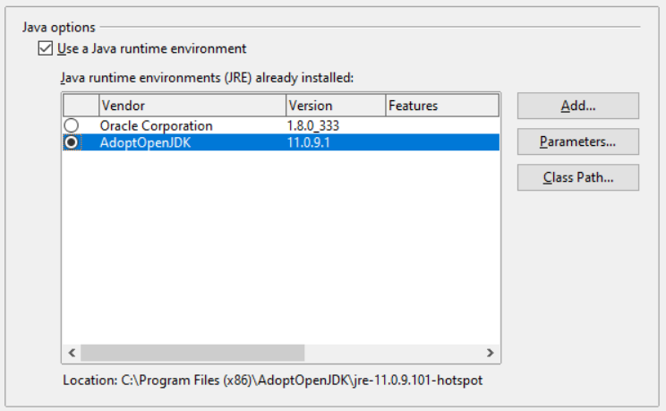
Figure : Choosing a Java runtime environment

Online Update Options
On the OpenOffice—Online Update page, you can choose whether and how often to have AOO check the AOO website for program updates. If the Check for updates automatically option is selected, an icon appears at the right-hand end of the menu bar when an update is available. Click this icon to open a dialog where you can decide to download the update.
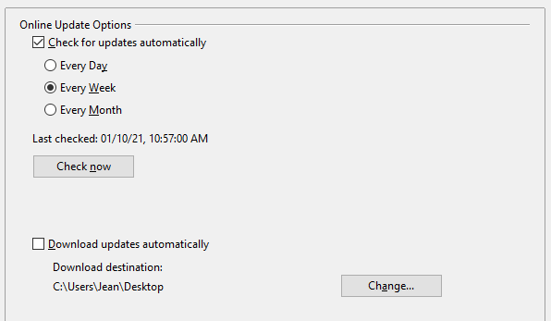Figure : Configuring Online Update
If the Download updates automatically option is selected, the download starts when you click the icon. To change the download destination, click the Change button and select the required folder in the file browser window.

Choosing Options for Loading and Saving Documents
You can set the Load/Save options to suit the way you work.
If the Options' dialog is not already open, click Tools > Options. Click the expansion symbol (+ or triangle) to the left of Load/Save.
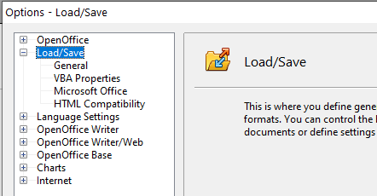Figure : Load/Save options

General Load/Save Options
Most of the choices on the Load/Save—General page are familiar to users of other office suites. Some items of interest are described below.
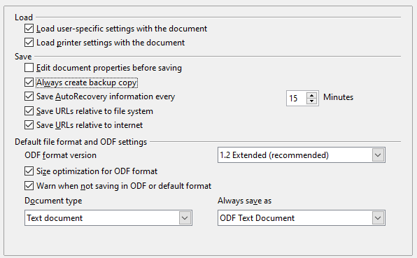Figure : Choosing Load and Save options
Load user-specific settings with the document
When you save a document, certain settings are saved with it. Some settings (printer name, data source linked to the document) are always loaded with a document, whether this option is selected. If you select this option, these document settings are overruled by the user-specific settings of the person who opens it. If you deselect this option, the user’s personal settings do not overrule the settings in the document. For example, your choice (in the options for Writer) of how to update links is affected by the Load user-specific settings option.
Load printer settings with the document
If this option is not selected, the printer settings that are stored with the document are ignored when you print it using the Print File Directly icon. The default printer in your system will be used instead.
Edit document properties before saving
If you select this option, the Document Properties dialog pops up to prompt you to enter relevant information the first time you save a new document (or whenever you use Save As).
Save AutoRecovery information every
Choose whether to enable AutoRecovery and how often to save the information used by the AutoRecovery process.
AutoRecovery writes a temporary file that can be used to recover unsaved work if OpenOffice should crash. This does not overwrite the original file, and it is not a substitute for saving your work periodically.
Save URLs relative to file system / internet
Relative addressing to a file system is only possible if the source document and the referenced document are both on the same drive. A relative address always starts from the directory in which the current document is located. It is recommended to save relatively if you want to create a directory structure on an Internet server.
Default file format and ODF settings
ODF format version
AOO by default saves documents in OpenDocument Format (ODF) version 1.2 Extended. While this allows for improved functionality, there may be backwards compatibility issues. When a file saved in ODF 1.2 Extended is opened in an earlier version of OpenOffice (using ODF 1.0/1.1), some advanced features may be lost. Two notable examples are cross-references to headings and the formatting of numbered lists. If you plan to share documents with people who are still using very old versions of OpenOffice, save the document using ODF version 1.0/1.1.
Size optimization for ODF format
OpenOffice's documents are XML files. When you select this option, AOO writes the XML data without indents and line breaks. If you want to be able to read the XML files in a text editor in a structured form, deselect this option.
Document type
If you routinely share documents with users of Microsoft Office, you might want to change the Always save as attribute for documents to one of the Microsoft Office formats. The more complicated the documents are, the more likely that the formatting of the non-native file type will be imperfect.
Note | Although AOO can open files in the .docx, .xlsx, and .pptx formats produced by Microsoft Office 2007 and later versions, it cannot save in those formats.

VBA Properties Load/Save Options
On the Load/Save – VBA Properties page, you can choose whether to keep any macros in Microsoft Office documents that are opened in OpenOffice.
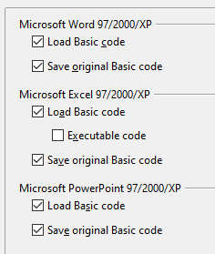
Figure : Choosing Load/Save VBA Properties
- If you choose Save original Basic code, the macros will not work in AOO but are retained if you save the file into Microsoft Office format.
- If you choose Load Basic code, the changed code is saved in an AOO document but is not retained if you save into a Microsoft Office format.
- If you are importing a Microsoft Excel file containing VBA code, you can select the option Executable code. Whereas normally the code is preserved but rendered inactive (if you inspect it with the StarBasic IDE you will notice that it is all commented), with this option the code is ready to be executed.

Microsoft Office Load/Save Options
On the Load/Save – Microsoft Office page, you can choose what to do when importing and exporting Microsoft Office OLE objects (linked or embedded objects or documents such as spreadsheets or equations).
Select the [L] options to convert Microsoft OLE objects into the corresponding OpenOffice OLE objects when a Microsoft document is loaded into AOO (mnemonic: “L” for “load”).
Select the [S] options to convert OpenOffice OLE objects into the corresponding Microsoft OLE objects when a document is saved in a Microsoft format (mnemonic: “S” for “save”).
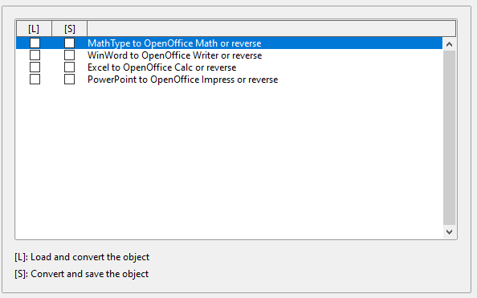Figure : Choosing Load/Save Microsoft Office options

HTML Compatibility Load/Save Options
Choices made on the Load/Save – HTML Compatibility page affect HTML pages imported into OpenOffice and those exported from AOO. See HTML documents; importing/exporting in the Help for more information.
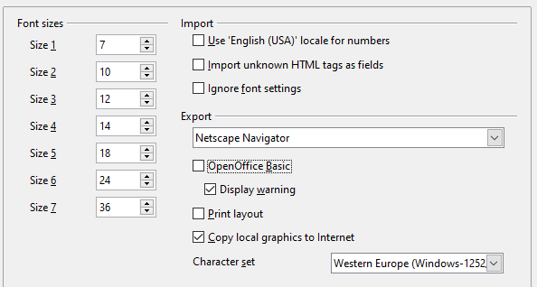Figure . Choosing HTML compatibility options
Font sizes
Use these fields to define the respective font sizes for the HTML <font size=1> to <font size=7> tags, if they are used in the HTML pages. (Many pages no longer use these tags.)
Import—Use 'English (USA)' locale for numbers
When importing numbers from an HTML page, the decimal and thousands separator characters differ according to the locale of the HTML page. The clipboard, however, contains no information about the locale. If this option is not selected, numbers will be interpreted according to the Language of—Locale setting in Tools > Options > Language Settings > Languages (see page 301). If this option is selected, numbers will be interpreted as for the English (USA) locale.
Import – Import unknown HTML tags as fields
Select this option if you want tags that are not recognized by AOO to be imported as fields. For an opening tag, an HTML_ON field will be created with the value of the tag name. For a closing tag, an HTML_OFF will be created. These fields will be converted to tags in the HTML export.
Import – Ignore font settings
Select this option to have AOO ignore all font settings when importing. The fonts that were defined in the HTML Page Style will be used.
Export
To optimize the HTML export, select a browser or HTML standard from the Export box. If OpenOffice Writer is selected, specific OpenOffice Writer instructions are exported.
Export—OpenOffice Basic
Select this option to include AOO Basic macros (scripts) when exporting to HTML format. You must activate this option before you create the OpenOffice Basic macro; otherwise the script will not be inserted. OpenOffice Basic macros must be located in the header of the HTML document. Once you have created the macro in the OpenOffice Basic IDE, it appears in the source text of the HTML document in the header.
If you want the macro to run automatically when the HTML document is opened, choose Tools > Customize > Events.
Export—Display warning
When the OpenOffice Basic option (see above) is not selected, the Display warning option becomes available. If the Display warning option is selected, then, when exporting to HTML, a warning is shown that OpenOffice Basic macros will be lost.
Export—Print layout
Select this option to export the print layout of the current document as well. The HTML filter supports CSS2 (Cascading Style Sheets Level 2) for printing documents. These capabilities are only effective if print layout export is activated.
Export—Copy local graphics to Internet
Select this option to automatically upload the embedded pictures to the Internet server when uploading using FTP.
Export—Character set
Select the appropriate character set for the export.

Choosing Language Settings
You may need to do several things to set the language settings to what you want:
- Install the required dictionaries
- Change some locale and language settings
- Choose spelling options

Install the Required Dictionaries
AOO automatically installs several dictionaries with the program. To add other dictionaries, be sure you are connected to the Internet, and then use Tools > Language > More Dictionaries Online. AOO will open your default web browser to a page containing links to additional dictionaries that you can install. Follow the prompts to select and install the ones you want.

Change Locale and Language Settings
You can change some details of the locale and language settings that AOO uses for all documents, or for specific documents.
In the Options dialog, click Language Settings > Languages.
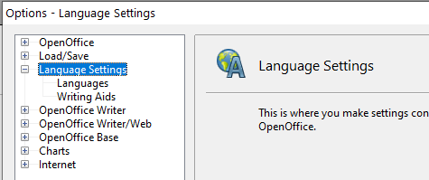Figure : Language Setting options
On the right-hand side of the Language Settings – Languages page (Figure 277), change the User interface, Locale setting, Default currency, and Default languages for documents as required. In the example, English (USA) has been chosen for all the appropriate settings.
If you want the language (dictionary) setting to apply to the current document only, instead of being the default for all new documents, select the option labeled For the current document only.
If necessary, select the options to enable support for Asian languages (Chinese, Japanese, Korean) and support for CTL (complex text layout) languages such as Urdu, Thai, Hebrew, and Arabic. If you choose either of these options, the next time you open this dialog, you will see some extra choices under Language Settings, as shown in Figure 276. These choices (Searching in Japanese, Asian Layout, and Complex Text Layout) are not discussed here.
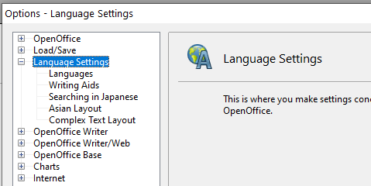Figure : Extra pages available when enhanced language support options are selected
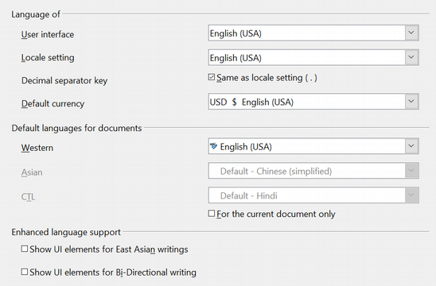Figure : Choosing language options

Choose Spelling Options
To choose the options for checking spelling, click Language Settings > Writing Aids. In the Options section of the page (Figure 278), select the settings that are useful for you.
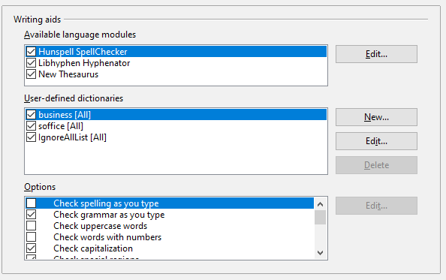Figure : Choosing languages, dictionaries, and options for checking spelling
Some considerations:
- If you do not want spelling checked while you type, deselect Check spelling as you type.
- If you use a custom dictionary that includes words in all upper case and words with numbers (for example, AS/400), select Check uppercase words and Check words with numbers.
- Check special regions including headers, footers, frames, and tables when checking spelling.
Here you can also check which user-defined (custom) dictionaries are active by default, and add or remove dictionaries, by clicking the New or Delete buttons.
Note | OpenOffice does not have a grammar checker, but you can install a grammar checker extension such as LanguageTool and access that tool from Tools > Spelling and Grammar. See “Adding Functionality with Extensions” on page 313 for more information.

Choosing Internet Options
Use the Internet Options pages to define search engines and save proxy settings for use with OpenOffice.
If you are using a Unix- or Linux-based operating system (including macOS), an additional page of E-mail options is available, where you can specify the e-mail program to use when you send the current document as e-mail. Under Windows the operating system’s default e-mail program is always used.
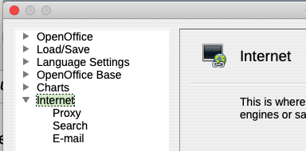Figure : Internet options available to Linux and macOS users

Controlling AutoCorrect Functions
Some people find some or all of the items in the AutoCorrect function annoying because they change what you type when you do not want it changed. Many people find some AutoCorrect functions quite helpful; if you do, then select the relevant options. But if you find unexplained changes appearing in your document, this is a good place to look to find the cause.
To open the AutoCorrect dialog, click Tools > AutoCorrect Options. (You need to have a document open for this menu item to appear.)
In Writer, this dialog has five tabs, as shown in Figure 280. In other components of Apache OpenOffice, the dialog has only four tabs.
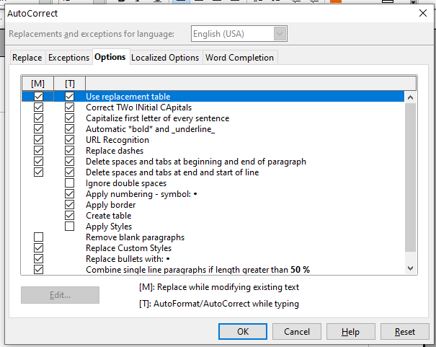Figure : The AutoCorrect dialog in Writer, showing the five tabs and some of the choices

Customizing Apache OpenOffice
You can customize menus, toolbars, and keyboard shortcuts in OpenOffice, add new menus and toolbars, and assign macros to events. However, you cannot customize context (right-click) menus.
Other customizations are made easy by extensions that you can install from the OpenOffice website or from other providers.
Note | Customization to menus and toolbars can be saved in a template. To do so, first save them in a document and then save the document as a template as described in Chapter 2 (Styles and Templates).

Customizing Menus
You can add and rearrange items on the menu bar, add items to menus, and make other changes.
To customize menus:
- Choose Tools > Customize.
- On the Customize dialog, go to the Menus page.
- In the Save In drop-down list, choose whether to save this changed menu for the application (for example, OpenOffice Writer) or for a selected document (for example, MyDoc.odt).
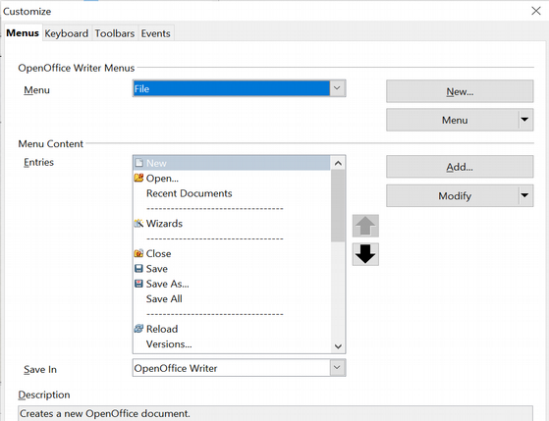Figure : The Menus page of the Customize dialog
- In the section OpenOffice [name of the program (example: Writer)] Menus, select from the Menu drop-down list the menu that you want to customize. The list includes all the main menus as well as submenus (menus that are contained under another menu). For example, in addition to File, Edit, View, and so on, there is File | Send and File | Templates. The commands available for the selected menu are shown in the central part of the dialog.
- To customize the selected menu, click on the Menu or Modify buttons. You can also add commands to a menu by clicking on the Add button. These actions are described in the following sections. Use the up and down arrows next to the Entries list to move the selected menu item to a different position.
- When you have finished making all your changes, click OK (not shown in illustration) to save them.

Creating a New Menu
In the Customize dialog, click New to display the dialog shown in Figure 282.
- Type a name for your new menu in the Menu name box.
- Use the up and down arrow buttons to move the new menu into the required position on the menu bar.
- Click OK to save.
The new menu now appears on the list of menus in the Customize dialog. (It will appear on the menu bar itself after you save your customizations.)
After creating a new menu, you need to add some commands to it, as described in “Adding a Command to a Menu” on page 308.
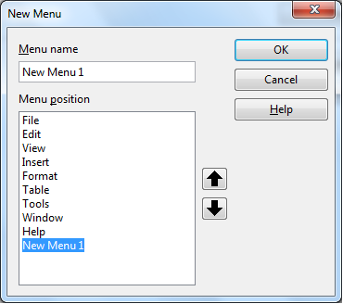
Figure : Adding a new menu

Modifying Existing Menus
To modify an existing menu, select it in the Menu list and click the Menu button to drop a list of modifications: Move, Rename, Delete. Not all of these modifications can be applied to all the entries in the Menu list. For example, Rename and Delete are not available for the menus supplied by AOO.
To move a menu (such as File), choose Menu > Move. A dialog similar to the one shown in Figure 282 (but without the Menu name box) opens. Use the up and down arrow buttons to move the menu into the required position.
To move submenus (such as File | Send), select the main menu (File) in the Menu list and then, in the Menu Content section of the dialog, select the submenu (Send) in the Entries list and use the arrow keys to move it up or down in the sequence.
In addition to renaming, you can specify a keyboard shortcut that allows you to select a menu command when you press Alt+ an underlined letter in a menu command.
- Select a menu entry.
- Click the Modify button and select Rename.
- Add a tilde (~) in front of the letter that you want to use as an accelerator. For example, to select the Save All command by pressing Alt+V (after opening the File menu using Alt+F), enter Sa~ve All.
Caution | Be careful when using these shortcuts. In the example above, if the File menu is not already open, then pressing Alt+V opens the View menu; if some other menu is open, Alt+V might activate some other command.

Adding a Command to a Menu
You can add commands to the supplied menus and to menus you have created. On the Customize dialog, select the menu in the Menu list and click the Add button in the Menu Content section of the dialog.
On the Add Commands dialog (Figure 283), select a category and then the command, and click Add. The dialog remains open, so you can select several commands. When you have finished adding commands, click Close. Back on the Customize dialog, you can use the up and down arrow buttons to arrange the commands in your preferred sequence.
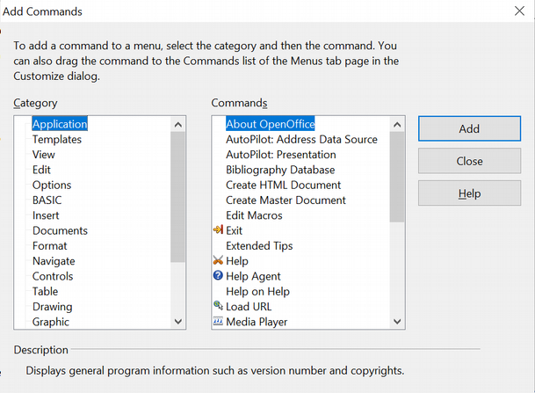Figure : Adding a command to a menu

Modifying Menu Entries
In addition to changing the sequence of entries on a menu or submenu, you can add submenus, rename or delete the entries, and add group separators.
To begin, select the menu or submenu in the Menu list near the top of the Customize page, then select the entry in the Entries list under Menu Content. Click the Modify button and choose the required action from the drop-down list of actions.
Most of the actions should be self-explanatory. Begin a group adds a separator line after the highlighted entry.

Customizing Toolbars
You can customize toolbars in several ways, including choosing which icons are visible and locking the position of a docked toolbar, as described in Chapter 1 (Introducing Apache OpenOffice). This section describes how to create new toolbars and add other icons (commands) to the list of those available on a toolbar.
To get to the toolbar customization dialog, do any of the following:
- On the toolbar, click the arrow at the end of the toolbar and choose Customize Toolbar.
- Choose View > Toolbars > Customize from the menu bar.
- Choose Tools > Customize from the menu bar and pick the Toolbars page (Figure 284).
To customize toolbars:
- In the Save In drop-down list, choose whether to save this changed toolbar for the application (for example, Writer) or for a selected document.
- In the section OpenOffice <name of the program (example: Writer)> Toolbars, select from the Toolbar drop-down list the toolbar that you want to customize.
- You can create a new toolbar by clicking on the New button, or customize existing toolbars by clicking on the Toolbar or Modify buttons, and add commands to a toolbar by clicking on the Add button. These actions are described below.
- When you have finished making all your changes, click OK to save them.
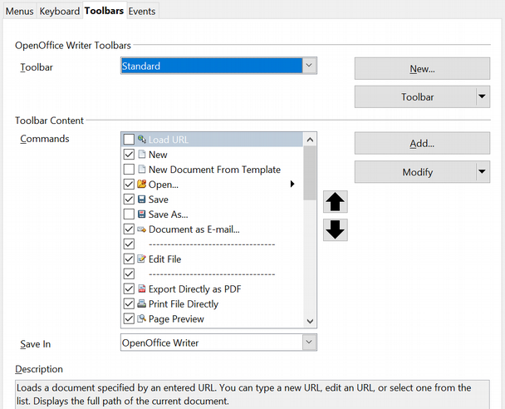Figure . The Toolbars page of the Customize dialog

Creating a New Toolbar
To create a new toolbar:
- Choose Tools > Customize > Toolbars from the menu bar.
- Click New. On the Name dialog, type the new toolbar's name and choose from the Save In drop-down list where to save this toolbar: for the application (for example, Writer) or for a selected document.
The new toolbar now appears on the list of toolbars in the Customize dialog. After creating a new toolbar, you need to add some commands to it, as described below.

Adding a Command to a Toolbar
If the list of available buttons for a toolbar does not include all the commands you want on that toolbar, you can add commands. When you create a new toolbar, you need to add commands to it.
- On the Toolbars page of the Customize dialog, select the toolbar in the Toolbar list and click the Add button in the Toolbar Content section of the dialog.
- The Add Commands dialog is the same as for adding commands to menus (Figure 283). Select a category and then the command, and click Add. The dialog remains open, so you can select several commands. When you have finished adding commands, click Close. If you insert an item which does not have an associated icon, the toolbar will display the full name of the item: the next section describes how to choose an icon for a toolbar command.
- Back on the Customize dialog, you can use the up and down arrow buttons to arrange the commands in your preferred sequence.
- When you are done making changes, click OK to save.

Choosing Icons for Toolbar Commands
Toolbar buttons usually have icons, not words, on them, but not all the commands have associated icons.
To choose an icon for a command, select the command and click Modify > Change icon. On the Change Icon dialog, you can scroll through the available icons, select one, and click OK to assign it to the command.
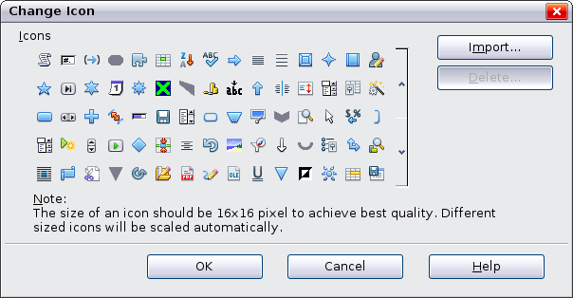
Figure : Change Icon dialog
To use a custom icon, create it in a graphics program and import it into AOO by clicking the Import button on the Change Icon dialog. Custom icons must be 16 x 16 or 26 x 26 pixels in size and in the PNG file format.

Assigning Shortcut Keys
In addition to using the built-in keyboard shortcuts (listed in the included Help), you can define your own. You can assign shortcuts to standard AOO functions or your own macros and save them for use with the entire Apache OpenOffice suite.
Caution | Be careful when reassigning your operating system’s or AOO’s predefined shortcut keys. Many key assignments are universally understood shortcuts, such as F1 for Help, and are always expected to provide certain results. Although you can easily reset the shortcut key assignments to the AOO defaults, changing some common shortcut keys can cause confusion, frustration, and possible data loss or corruption, especially if other users share your computer.
To adapt shortcut keys to your needs, use the Customize dialog, as described below.
- Select Tools > Customize > Keyboard. The Customize dialog opens.
- To have the shortcut key assignment available in all components of OpenOffice select the OpenOffice button.
- Next select the required function from the Category and Function lists.
- Now select the desired shortcut keys in the Shortcut keys list and click the Modify button at the upper right.
- Click OK to accept the change. Now the chosen shortcut keys will execute the function chosen in step 3 above whenever they are pressed.
Note | All existing shortcut keys for the currently selected Function are listed in the Keys selection box. If the Keys list is empty, it indicates that the chosen key combination is free for use. If it were not, and you wanted to reassign a shortcut key combination that is already in use, you must first delete the existing key.  Shortcut keys that are greyed out in the listing on the Customize dialog, such as F1 and F10, are not available for reassignment.

Example: Assigning Styles to Shortcut Keys
You can configure shortcut keys to quickly assign styles in your document. Some shortcuts are predefined, such as Ctrl+0 for the Text body paragraph style, Ctrl+1 for the Heading 1 style, and Ctrl+2 for Heading 2. You can modify these shortcuts and create your own.
- Click Tools > Customize > Keyboard. The Keyboard page of the Customize dialog (Figure 286) opens.
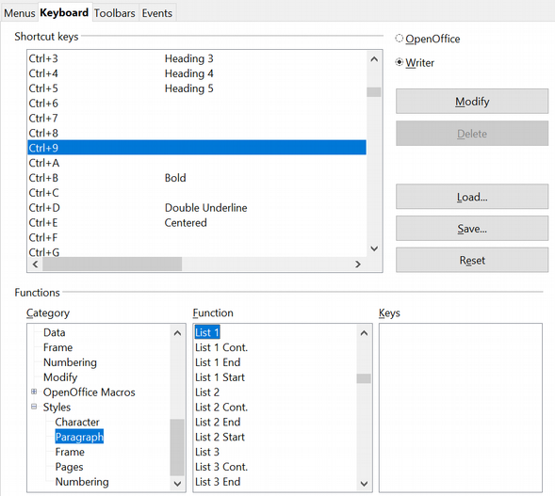Figure . Defining keyboard shortcuts for applying styles
- To have the shortcut key assignment available only with one component (for example, Writer), select that component’s name in the upper right corner of the page; otherwise select OpenOffice button to make it available to every component.
- Choose the shortcut keys you want to assign a style to. In this example, we have selected Ctrl+9.
- In the Functions section at the bottom of the dialog, scroll down in the Category list to Styles. Click the expansion symbol (usually a + sign or triangle) to expand the list of styles.
- Choose the category of style. (This example uses a paragraph style, but you can also choose character styles and others.) The Function list will display the names of the available styles for the selected category. The example shows some of AOO’s predefined styles.
- To assign Ctrl+9 to be the shortcut key combination for the List 1 style, select List 1 in the Function list, and then click Modify. Ctrl+9 now appears in the Keys list on the right, and List 1 appears next to Ctrl+9 in the Shortcut keys box at the top.
- Make any other required changes, and then click OK to save these settings and close the dialog.

Saving Changes to a File
Changes to the shortcut key assignments can be saved in a keyboard configuration file for use at a later time, thus permitting you to create and apply different configurations as the need arises. To save keyboard shortcuts to a file:
- After making your keyboard shortcut assignments, click the Save button at the right of the Customize dialog (Figure 286).
- In the Save Keyboard Configuration dialog, select All files from the Save as Type list.
- Next enter a name for the keyboard configuration file in the File name box, or select an existing file from the list. If you need to, browse to find a file from another location.
- Click Save. A confirmation dialog appears if you are about to overwrite an existing file, otherwise the file will be saved immediately.

Loading a Saved Keyboard Configuration
To load a saved keyboard configuration file and replace your existing configuration, click the Load button at the right of the Customize dialog, and then select the configuration file from the Load Keyboard Configuration dialog.

Resetting the Shortcut Keys
To reset all the keyboard shortcuts to their default values, click the Reset button near the bottom right of the Customize dialog. Use this feature with care as no confirmation dialog will be displayed; the defaults will be set without any further notice or user input.

Adding Functionality with Extensions
An extension is a package that can be installed into OpenOffice to add new functionality.
Although individual extensions can be found in different places, the official extension repository is at https://extensions.openoffice.org/. Some extensions are free of charge; others are available for a fee. Check the descriptions to see what licenses and fees apply to the ones that interest you.

Installing Extensions
To install an extension, follow these steps:
- Download an extension and save it anywhere on your computer.
- In AOO, select Tools > Extension Manager from the menu bar. In the Extension Manager dialog (Figure 287), click Add. (Your Extension Manager dialog may show no installed extensions or a different set of extensions.)
- A file browser window opens. Find and select the extension you downloaded and click Open. The extension begins installing. You may be asked to accept a license agreement.
- When the installation is complete, the extension is listed in the Extension Manager dialog.
Tip | To get extensions that are listed in the repository, you can open the Extension Manager and click the Get more extensions online link.
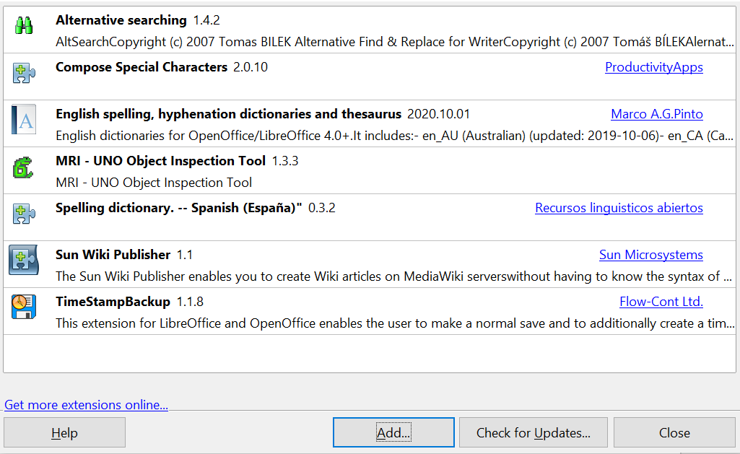
Figure : Using the Extension Manager
Note | To install a shared extension, you need write access to the Apache OpenOffice installation directory.

